A Guide to Performing Rendezvous and Docking Maneuvers in Kerbal Space Program

Docking ships together will allow you to do several important things that would otherwise be impossible. It allows you to refuel ships in orbit, which means you can launch your rockets with less fuel. Docking also allows you to assemble large ships or space stations from smaller sections in orbit, instead of trying to launch it all at once. Another way to use docking is to have a small landing craft attached to a larger spacecraft, which can greatly reduce the amount of fuel needed to land on another planet or moon.
This guide will teach you how to perform rendezvous and docking maneuvers in four steps: matching planes with the target craft, setting up and performing an intercept burn, matching velocity with target at closest approach, and final docking maneuvers.
The rendezvous and docking process usually takes about an hour, but this time can be greatly increased if your computer is running slowly, or greatly decreased if you time your launch properly. Also, this estimate does not include the time it will take to build and launch two ships, which could add on several more hours.

What you should already know
This guide is written under the assumption that you are already familiar with Kerbal Space Program. You should already know the following things:
- How to build rockets
- Basic terminology like NavBall, apoapsis, periapsis, prograde, and retrograde
- How to launch rockets into orbit
- Kerbal Space Program’s basic controls
- How to create and execute maneuver nodes
If any of the above concepts are new to you, this guide is not the right place to start.

What you will need
In order to perform rendezvous and docking maneuvers, you will need two spacecraft: a target craft, which will remain in a constant orbit, and a docking craft, which will perform all of the maneuvers required for rendezvous and docking. Both the target craft and the docking craft will require some special components in their construction:
- Both craft need to have at least one docking port. There are several docking ports to choose from, all of which are found in the ‘Utility’ tab of the Vehicle Assembly Building:
Note: Docking ports come in three sizes: large, medium, and small. In order for your craft to dock together, they must have docking ports of the same size. The Clamp-O-Tron Jr. is small, the Clamp-O-Tron Sr. is large, and all the others are medium.
  - Clamp-O-Tron Docking Port
  - Clamp-O-Tron Docking Port Jr.
  - Clamp-O-Tron Docking Port Sr.
  - Clamp-O-Tron Shielded Docking Port
  - Inline Clamp-O-Tron
  - Mk2 Clamp-O-Tron.
Both the docking craft and the target craft used in this guide have standard Clamp-O-Tron Docking Ports.
- Both craft should have batteries and a way to generate electricity, which can be solar panels or RTGs
- The docking craft should have a tank of RCS fuel and RCS thrusters. RCS fuel tanks are found in the ‘Fuel’ tab of the Vehicle Assembly Building, and RCS thrusters are found in the ‘Command and Control’ tab. It is best to arrange the RCS thrusters symmetrically around the docking craft’s center of mass, and in 4x symmetry, located on the top, bottom, and sides of the craft. This will be important for final docking maneuvers. An example of what this setup looks like can be seen in Figure 1.
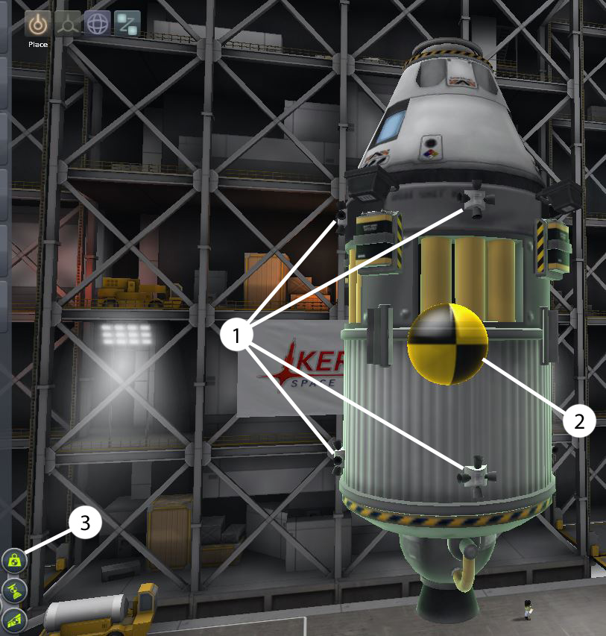
Figure 1: RCS thruster arrangement
1) RCS thrusters, placed with 4X symmetry enabled. 2) Vehicle center of mass. RCS thrusters should be evenly distributed around this. 3) Press this button in the Vehicle Assembly Building to show/hide center of mass

- The docking craft should have an SAS unit (found in the ‘Command and Control’ tab), an engine, enough fuel to perform several maneuvers in orbit, and forward-facing lights (found in the ‘Utilities’ tab), just in case you have to perform docking maneuvers in the dark.

Phase 1: Matching Planes with the Target Craft
- After you have launched both the target craft and the docking craft into orbit, take control of the docking craft.

- Switch to the map view, find your target craft, and left click on it. In the menu that pops up, click the ‘Set as Target’ option. This will cause the target craft’s orbit to turn green, and will cause the target craft’s apoapsis and periapsis to appear. Two new markers will appear as well: the Ascending Node and the Descending Node. These mark the points where the docking craft’s orbital plane intersects the target craft’s orbital plane, and can be seen in figure 2.

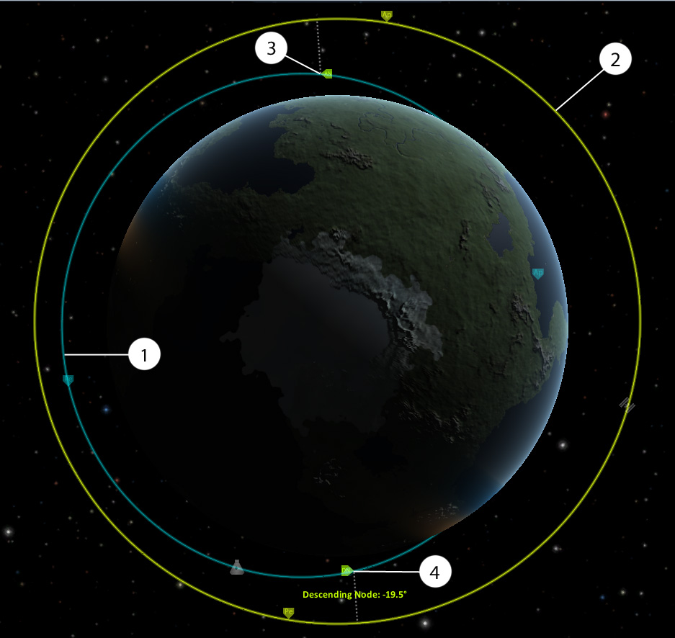
Figure 2: Orbits in Different Planes
1) docking craft orbit 2) target craft orbit 3) ascending node 4) descending node

Hover over either the ascending or descending node with your mouse. This will show you the plane angle, the angle difference between the orbital planes of your docking craft and your target craft, as seen in figure 2. If this number is between -0.2° and 0.2°, your docking craft is already close enough to being in the same plane as your target craft, and you can proceed directly to phase 2. Otherwise, you will need to match planes with the target craft.
Note: If your phase angle reads as NaN°, that means you are in EXACTLY the same plane as the target.

- Create a new maneuver node as close as possible to either the ascending node or the descending node. In order to give yourself enough time to set up a plane change for the first time, I recommend choosing the one furthest away from your docking ship’s current location. If you chose the ascending node, drag the normal - vector of the maneuver node. If you chose the descending node, drag the normal + vector of the maneuver node. These vectors can be seen in Figure 3.

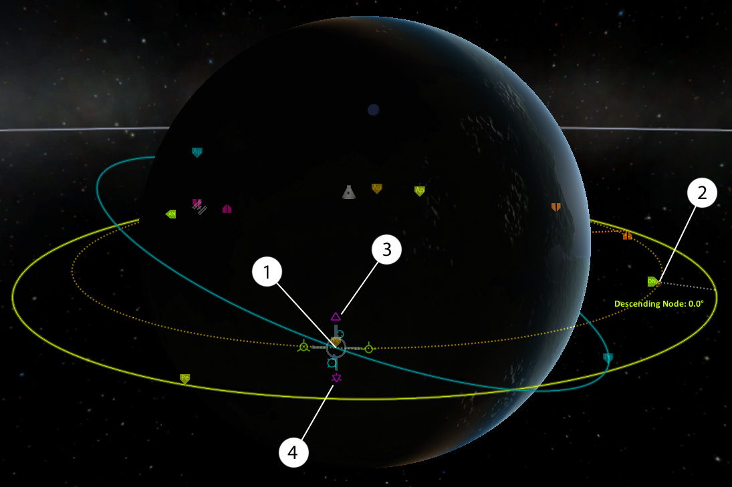
Figure 3: Plane Change Maneuver
1) maneuver node, placed at current location of descending node 2) predicted new location of descending node, after maneuver 3) normal + vector 4) normal - vector

As you drag the normal vector, you will see your predicted post-maneuver orbit path move closer into the plane of the target craft. When you get close to the correct plane, the ascending and descending nodes will move away from their initial positions. This is because it is nearly impossible to set up a maneuver node in exactly the right location. When the nodes start to move, mouse over one of them to see what angle it is at. Then keep slowly moving the normal vector further until the plane angle is at 0.0°. If you drag the normal vector too far, the ascending and descending nodes will switch locations, and the plane angle will start increasing. If this happens, drag the opposite normal vector to move the plane angle back towards 0.0°.

- Once your predicted new plane angle has been reduced to 0.0°, execute the maneuver node. After executing the maneuver, check your actual plane angle, as the maneuver node predictions are not perfect. If the actual plane angle is more than 0.3°, set up another plane change maneuver to get closer to the target craft’s orbital plane.

Phase 2: Intercept
- First, you will need to circularize your docking craft’s orbit. This is done in one of two ways: by performing a retrograde burn at the lowest point in your orbit, or by performing a prograde burn at the highest point in your orbit. It is best to pick whichever point is farthest away from your target craft’s orbit.

- Next, create a maneuver node at any point in your orbit, and move the tangent vector until either the highest or lowest point of your docking craft’s orbit touches your target craft’s orbit. A few more nodes should now appear, which show the locations of your docking craft and your target craft at their closest approach, as shown in Figure 4. Hovering over these markers with the mouse will display your distance from the target craft at your closest approach.

- Move your maneuver node along your orbit, and check your closest approach distance to see how it changes
- If the closest approach distance decreases, continue to move your maneuver node in the same direction until your closest approach distance drops below 2km.
- If the closest approach distance increases, move the maneuver node in the opposite direction until your closest approach distance drops below 2km.
- In some cases, you may need to wait several orbits until you can set up a successful intercept.

- Execute your maneuver node.
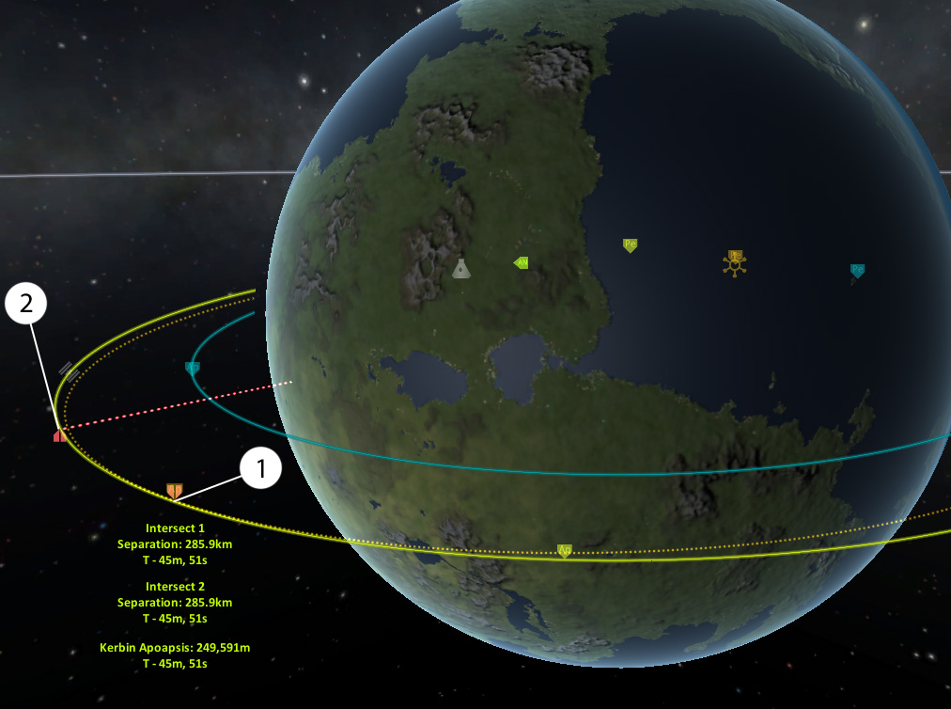
Figure 4: Intercept Maneuver
1) point where the Docking Craft crosses the Target Craft’s orbit (Intersect 1) 2) target position at Intersect 1

Phase 3: Matching Velocity at Closest Approach
Caution: Be very careful when time-accelerating towards the point of closest approach. The predicted distance at closest approach is not always accurate, and it is very easy to accidentally smash your ships together at several hundred meters per second.
- Click the box above your NavBall that displays your velocity. This will change the velocity displayed between orbital, surface, and target velocity. For matching velocity with your target, you will need to know your velocity relative to the target, so set your NavBall to display target velocity.

- When you get to within one minute of closest approach, point your docking craft in the retrograde direction. Then, about 10 seconds before closest approach, fire your engines. Keep firing your engines, with your craft pointed retrograde, until your velocity reaches 0.0 m/s.

Phase 4: Final Docking Maneuvers

- Point your docking craft towards your target craft and accelerate to about 20 m/s. Continue moving towards the target craft at this speed until you are about 200 m away, then perform another retrograde burn to return to a velocity of 0.0 m/s. Right click on your docking craft’s docking port and select ‘control from here’. Then, right click on your target craft’s docking port and select ‘set as target’.

- Press the ‘R’ key to activate your RCS control system. From this point onward, you will move your docking craft with RCS thrusters instead of your main engine. With RCS thrusters, you will be able to move your craft in any direction without needing to point in that direction first. The RCS controls are not very intuitive, so take a little time to familiarize yourself with them:
- ‘H’ will move your craft forward
- ‘N’ will move your craft backward
- ‘I’ will move your craft down
- ‘K’ will move your craft up
- ‘J’ will move your craft left
- ‘L’ will move your craft right

- Once you are comfortable with the controls, use RCS to move closer to the target craft. Carefully and slowly move closer to the target docking port, but don’t get closer than about 15m. Align your docking port to be close to concentric with the target docking port, and use your NavBall to ensure your docking craft is pointed directly at the target, as shown in Figure 5.
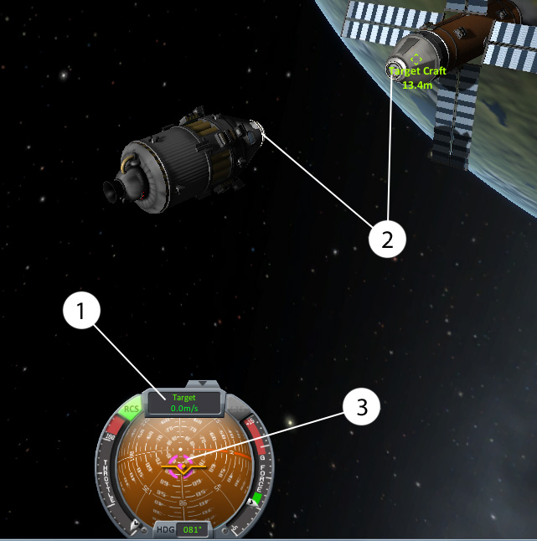
Figure 5: Docking Alignment Before Final Approach
1) ensure your target velocity is 0.0 m/s 2) Ensure your docking port is aligned properly with the target docking port 3) aiming for the middle of the pink marker will point your ship directly at your target

- Use RCS thrusters to align your velocity vector with your target vector, and move towards the target docking port at no more than 1 m/s. When you close to within 2 meters of the target docking port, the magnetic locking mechanism will pull your docking ports together, and your camera will re-align itself with the combined vessel’s center of mass.

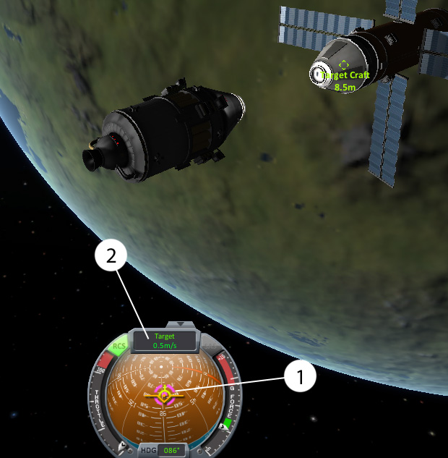
Figure 6: Final Approach
1) target vector, velocity vector, and heading vector are all lined up 2) target velocity under 1 m/s

Congratulations! You have just successfully docked two spacecraft together in orbit.

All graphics in this guide are gameplay images of Kerbal Space Program that were recorded and edited by Coleman Hostetler

