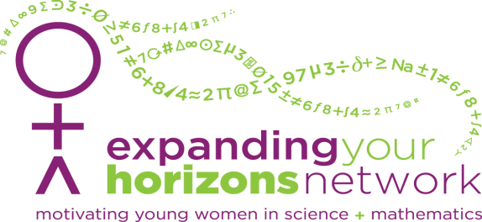
CALL FOR PROPOSALS
2016 EYH STEM Career Day for Young Women
Who: Faculty, Graduate students, Undergraduate students, Professionals
What: 60 minute hands-on workshops in Science, Technology, Engineering, and Math (STEM) designed for the EYH STEM Career Day.
    - Sessions: 10:45-11:45 am, 1:00-2:00pm, 2:15-3:15 pm
    - Audience: Young women in grades 6-8 and 9-12 (some parents/guardians)
    - ~15-25 students per session, students will be accompanied to each workshop by volunteer mentors who will also assist with activities at the workshops.
When: Saturday, January 30th, 2016 (Sunday, Jan. 31st inclement weather date)
How: All proposals can be submitted to Michael Zeman, Director of Science Outreach the Eberly College of Science via email (mjz120@psu.edu) no later than December 11th, 2015.
Payment: Workshops are submitted on a volunteer basis. No compensation can be provided. Partial funds are available to cover workshop materials. Lunch and a T-shirt are provided for all instructors/volunteers.
Info: Please contact the Science Outreach Office for more information about the EYH program or content session proposals: (814) 865-0083, sciencecamps@science.psu.edu.
2016 STEM Career Day For Young Women Workshop
Proposal Guidelines
Submit workshop proposal to Michael Zeman (mjz120@psu.edu) by December 11th
The office of Science Outreach is currently seeking faculty, students, student groups, and industry professionals in Science, Technology, Engineering, and Math (STEM) disciplines to conduct content workshops on Saturday, January 30th for the EYH STEM Career Day for Young Women at University Park, PA.
Workshops:
- 60 minute hands-on workshops, plan to run your workshop at least once for middle school girls and once for high school girls.
- ~15-25 participants per workshop
- Participants will be accompanied by volunteer mentors to each workshop
- The student workshops provide an opportunity for middle school and high school girls to engage in career exploration in STEM fields.
What to include on your proposal:
- Title
- Presenter(s)
- Objective(s)
- Content Area/Discipline
- Brief description
- Outline/schedule for the 60 minutes
- Materials (some limited funds are available for the purchase of workshop materials and cover costs of printing handouts, etc.)
- Facilities needed/requested
Appropriate Activities:
- Classroom hands-on activities, lab hands-on activities, team-building activities, demonstrations, instruction, discussion, debate, etc.
Characteristics of target audience:
- Female middle school students, Grade 6-8 (age range 11-15), and Grades 9-12 (ages 15-18)
- Able to formulate own beliefs, take responsibility for action, make their own decision about friends, activities, career and lifestyle, competent in abstract thought
- Deeply curious and creative, seeking inspiration.

