Emelia Conte
Professor Lori Bedell
CAS 137H, Section 005
7 November 2014
Pink is for Girls and Blue is for Boys…or is it?
Upon walking into the baby section of any department store, there is a clear divide. Typically, one wall is dominated by pink, frilly dresses reminiscent of Disney princesses, while its counterpart is decorated in multiple shades of blue, surrounded by images of footballs and monster trucks. Most people believe this phenomenon is simply an unalterable fact of society. However, the current association of pink with girls and blue with boys has not always been the case; in fact, in the pre-World War II era, boys predominantly wore pink, while girls were typically dressed in blue, and gender neutral clothing was prevalent even before this distinction was made. Despite this, WWII was not the only contributing factor for the establishment of today’s baby color practices; the switch from a blue for girls, pink for boys clothing convention to today’s commonplace resulted from ideologies developed during WWII and the growth of mass marketing in American culture, and fluctuated after its establishment as social movements faded in and out of American history. Nonetheless, this paradigm shift is not a trivial change in American culture; the newfound association of gender with specific colors caused a stubbornness toward traditional gender roles and a fear of nonconformity to these ideals.
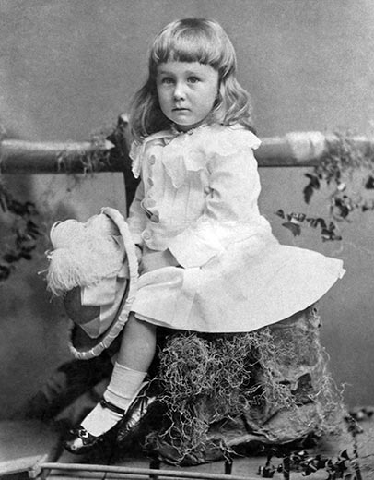
Prior to the founding of the blue for girls and pink for boys pre-WWII model, all children were traditionally dressed in gender neutral clothing. According to Jo Paoletti, author of Pink and Blue: Telling the Boys from the Girls in America, all children used to wear long, white dresses, which made it easier for parents to change diapers and allowed them the opportunity of simply bleaching dirty clothing without the worry of ruining a colorful outfit. Surprisingly to Americans today, boys did not stop wearing these dresses until the age of 6, when they also got their first haircuts (Maglaty). Figure 1, right, a famous picture of Franklin Delano Roosevelt at two and a half years old, depicts this popular attire, and many paintings from the era show both young boys and girls playing in their gender neutral dresses. Despite the immense popularity of this movement in the 1800’s, the age of gender neutral clothing ended with the introduction of pastel colors for babies into the American market.
Figure 1. FDR at two and a half years, 1884
Around the mid-nineteenth century, manufacturers began selling baby clothes in pastel colors of pink and blue. However, instead of using pink to identify girls and blue to identify boys as Americans do today, most parents used exactly the opposite conventions. In fact, several magazines of the era discuss the proper attire for babies of each gender. In a 1914 edition of the Sunday Sentinel, writers advise mothers to “‘use pink for the boy and blue for the girl, if you are a follower of convention’” (Yoon), and the Earnshaw’s Infants’ Department’s 1918 magazine states that “‘the generally accepted rule is pink for the boys, and blue for the girls. The reason is that pink, being a more decided and stronger color, is more suitable for the boy, while blue, which is more delicate and dainty, is prettier for the girl’” (Maglaty). The reasons for this convention vary, but are primarily based on the symbolism behind the colors at the time of their introduction into baby clothing. Anne Fausto-Sterling, author of Sex/Gender: Biology in a Social World, reveals that pink stood for strength and courage, qualities stereotypically encouraged in men, while blue represented faith and constancy, characteristics of a “good wife” (Fausto-Sterling 109). Other arguments relate the colors to the Roman goddess and god, Venus and Mars. Mars, the Roman god of war, was typically associated with the color red, leaving Venus to be linked to blue (Callahan). Additionally, religious institutions typically connect the Virgin Mary, the mother of Jesus, with the color blue, and thus females were typically clothed in blue as an acknowledgement of Mary’s religious significance. Regardless, these customs slowly began to morph throughout the 1920’s into a closer semblance of today’s commonplace.
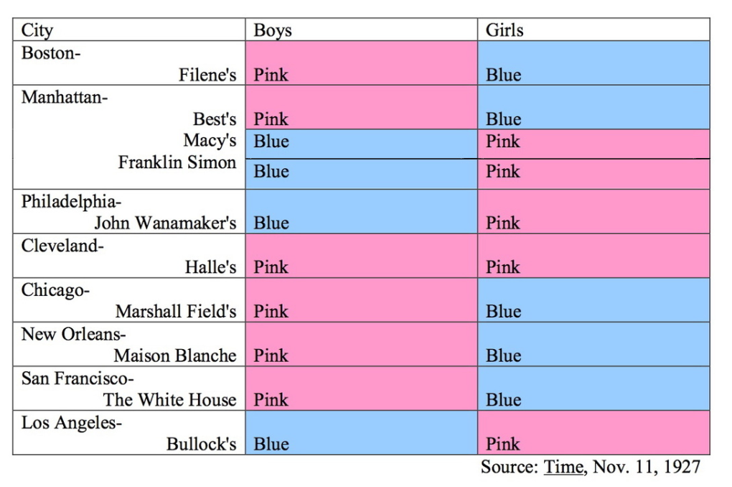
In 1927, a Time Magazine survey instilled uncertainty about the typical conventions of gender linked colors. Figure 2, below, shows that upon interviewing several department stores throughout the United States, publishers discovered that although there was a slight preference of blue for girls and pink for boys, the votes were almost equally split between the convention of the early 1900’s and that of today (Time). This inconsistency signaled that a change in the acceptance of the blue for girls and pink for boys model for clothing was rapidly approaching.
Figure 2. Times Magazine Baby Color Preference Chart, 1927

During World War II, the shift to today’s view of sex-appropriate colors underwent its most influential period of development. By far, the most controversial factor for the color-gender association switch is the labeling of homosexuals by Adolf Hitler. During WWII, Hitler commanded that homosexual prisoners be characterized more obviously in concentration camps, and thus branded their clothing with a pink triangle (Bates). Some people researching this shift trust that as a result of this order, pink was more closely associated with femininity, as homosexuality was seen as a disgrace to men during this time period (Ford). It is a popular belief that this association further argued that the pink for girls convention be adopted into American culture. However, it is important to note there are many doubts associated with this theory. Jo Paoletti argues that although the pink triangles were used, they were mainly concentrated to the Dachau camp, and that their use was not limited to homosexuals; sexual offenders were given the same pink triangle upon entering concentration camps (Paoletti). Additionally, it is possible that the recognition of this branding occurred too long after the color changes occurred, and thus played little to no part in influencing the shift. Regardless, it is still important to note this factor, which may have at least contributed to the reaffirmation of the color change in American society.
In contrast, the most direct influence of the shift in baby color conventions was the change in American preference of color association as a result of direct influences of the war. While men were overseas fighting the Axis powers in WWII, Rosie the Riveter became a popular image of women dawning their “factory blues” and contributing to the war effort. Women were filling what were commonly known as men’s jobs that became deserted after men left home to fight in WWII, defying the gender stereotypes of the age that required that women be involved only in domestic affairs (Stamberg). However, when the men returned from war, women were kicked out of their factory positions and instead donned their aprons for household tasks. Once again, blue signified common male workers, so women needed a new color to use as an identifier, opening up the floor for the acceptance of pink as a universally feminine hue.
In addition to the influence of the reclaiming of factory jobs by men, the military uniforms of WWII also contributed to the association of blue with boys. WWII uniforms were sewn from blue cloth, so as a result, blue was associated with masculinity (Fausto-Sterling 110). Images of soldiers in blue uniforms defending the United States made their way back home, and thus the color was quickly related the men who so bravely fought to protect democracy.
Furthermore, the emergence of mass marketing forced a change in the association of sex-appropriate colors. After the industrial revolution, more goods could be produced at a lower cost because of the increased technology and more efficient production methods available to manufacturers. WWII propelled the manufacturing process further ahead, since a small supply of consumer items during the war led to an increased demand for products due to accumulated wealth immediately following the war’s conclusion, a new highway system allowed goods to be transported more quickly and in larger quantities, and newly developed war technology accommodated for increased communication between consumers and producers (McCann). Thus, mass marketing emerged, and manufacturers could more easily get their products, including pink and blue baby attire, to the market, significantly increasing their already high sales.
Because of the emergence of department stores, annual sales for manufacturers totaled over $17 million yearly in 1900, and by the 1920’s, women’s positions as households’ chief purchasers of consumer goods inspired companies to make women their target audience (Koehn). Manufacturers believed that there is no better way to appeal to mothers than through products for their children, and the easiest way for companies to incentivize the purchasing of extra merchandise by mothers was gender specific clothing. In order to create more revenue, manufacturers created a specific baby color code to accommodate the preferences adopted by Americans as a result of World War II, thus completing the switch to today’s pink for girls and blue for boys convention.
Despite the switch of baby attire colors after WWII, today’s current baby clothes associations faded away for a period of time during the women’s liberation movement. During the mid-1960’s, women began to fight for equal rights and pay in the workplace, which translated into more conservative fashion choices. Pants and pantsuits became increasingly popular as women began to wear “less feminine” apparel (Maglaty). Furthermore, the popular association of 1960’s liberationists with “bra-burning,” although a myth, clearly depicts liberationists’ rejection of “feminine” clothing, and this resulted in a drastic response by manufacturers (Lee). Women were not buying pink for their children because they believed that the color implied that women are weak. Following natural economic principles, manufacturers stopped producing pink clothing in response to the decreased demand for these items by female consumers. In fact, in the Sears, Roebuck catalogs during the 1970’s, no pink toddler clothing was shown for two years, since the thought of the time was, “‘If we dress our girls more like boys and less like frilly little girls…they are going to have more options and feel freer to be active’” (Maglaty). However, the women’s liberation movement clearly did not have a lasting effect on the contemporary color associations in the United States.
As the women’s liberation movement passed, current baby clothing standards were once again adopted into American culture. The main reason for this transformation was the development of pre-natal testing in the 1980’s, which allowed parents to know the gender of their coming baby during the early stages of pregnancy. If parents were aware of the gender of their baby, they could shop for “boy” or “girl” specific products, and stores could sell more specialized merchandise since parents with multiple children would purchase gender specific items for children of each sex (Maglaty). Although manufacturers took advantage of this scientific advancement by re-implementing standard baby attire colors, clothing was not the only product that became specialized; manufacturers noticed the same increase in sales with differentiation of cribs, toys, food, and other baby merchandise, so companies widened the pre-existing gap between boys and girls through their adoption of new gender-specific products. As Jo Paoletti noticed, “‘All of a sudden it wasn’t just a blue overall; it was a blue overall with a teddy bear holding a football’” (Maglaty). Similarly, mothers who grew up in the time of the women’s liberation movement rejected the unisex look for their own daughters, consuming more pink, specialized products despite their own mothers’ aversion to them (Maglaty). Thus, the new age of gender specific color associations and increasing consumerism dawned in America.
Although a change in accepted baby colors may not appear to be a life-changing shift, the residual effects of gender-color association are massive. One of the most prevalent ways this phenomenon has caused problems in America is by encouraging gender stereotypes. Between two and three years of age, children become aware of the importance placed on gender and show high motivation to discover what is for “boys” and what is for “girls” (Fine). It is at this delicate developmental time that American manufacturing targets and takes its toll on kids’ sense of gender association. Manufacturers use their knowledge that children look for ways to classify their gender to their advantage in order to sell specialized products. When children see advertisements with kids of their same gender playing with a specific toy, which is usually color coded to match the conventions of that sex, they identify the toy with their gender and are more likely to play only with these toys in order to more closely associate with children of their sex. JeongMee Yoon, a South Korean photographer, recently captured this phenomenon in a series of snapshots, two of which are exhibited in Figure 3 and Figure 4, below, that she calls the Pink and Blue project, where she photographs girls surrounded by pink “girl” toys and boys engulfed in blue “boy” toys (Yoon). These photos clearly depict the success of the marketing strategies companies employ that ultimately enlarge the gap between boys and girls.
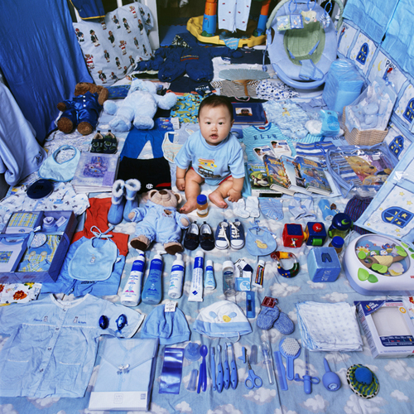
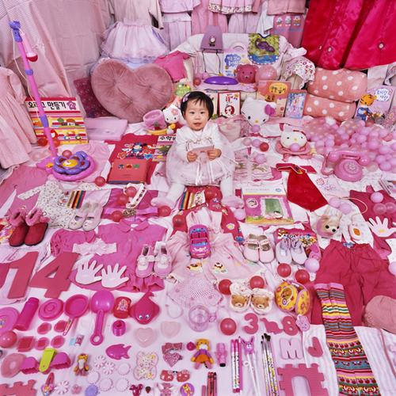
Figure 3. Dayeun and Her Pink Things, 2006 Figure 4. Jake and His Blue Things, 2007
What makes this targeting even more unfair is that manufacturers do not arbitrarily choose toys to market to each gender; companies carefully assign toys that encourage children of each sex to adopt specific ideologies. Typically, “boy” toys (i.e. fire trucks, toy guns, and action figures) promote competition, control, agency, and dominance to encourage boys to maintain power over their female counterparts. However, “girl” toys (i.e. tea sets, dolls, and horses) typically promote cooperation and nurturance, which are thought to be submissive behaviors appropriate for a woman that make her easier to manipulate (Fine). Even at fast food institutions like McDonald’s, Happy Meals come with either “boy” toys or “girl” toys; only sometimes the toys are considered gender neutral. In fact, Antonia Ayres-Brown, a Connecticut high school student, recently challenged McDonald’s about these gender specific toys, and eventually received affirmation from the company’s CEO that McDonald’s policies would be re-evaluated to ensure that toys are distributed without reference to gender (Samakow). Despite this and similar efforts, these ideas still exist, especially in gender specific books like the Daring Book for Girls and the Dangerous Book for Boys. Topics covered by the “boy” book include making a bow and arrow, fishing, and grammar skills (Iggulden ix), while the girls’ book simplifies the interests of girls to be, or implies that the interests of a girl should only stretch so far as, slumber parties, friendship bracelets, and princesses (Buchanan vi). Instances like this restrict the accepted behaviors of boys and girls unfairly, preventing girls who may enjoy computer science, or boys who may aspire to become fashion designers, from developing their interests simply out of antiquated tradition.
Furthermore, studies show that children think very rigidly about gender differences. In an experiment conducted by Marianne Taylor, Marjorie Rhodes, and Susan Gelman, researchers of psychology at the University of Michigan, the women discovered that “children…assume that girls always play with makeup and tea sets and boys always collect baseball cards and play with fire trucks, even if the girls and boys were never exposed to these things” (Brown). The reason behind these beliefs stems from the fact that humans have a strong drive to remember information that is consistent with what they know or think they know. Recognizing constants helps them navigate through unfamiliar or “scary” environments; if a child is in an unfamiliar situation, they are comforted by their knowledge of a few universal truths, and in this case, a girl’s innate desire to play with tea sets as opposed to fire trucks is a universal truth (Brown). However, the initial establishment of this line of thinking comes from parents, who from a very early age determine a child’s gender associations based on the influence of society, and from manufacturers, who advertise specific products to children of each gender. Therefore, the role of gender-associated colors is indicative and influential in the promotion of unfair gender stereotypes and forces the stagnation of this issue, since the convention is now so widespread.
Still, gender stereotypes are not the only unintended consequence of determining sex-appropriate clothing; this commonplace also creates irrational fear of children who do not want to conform to these societal standards. There have been many publicized stories about boys wanting to wear dresses that have received mixed responses from the public. One little boy’s insistence on defying gender stereotypes inspired an accepting mother to write a children’s novel called My Princess Boy, which encourages children to “embrace uniqueness” (Dube). However, not all people are so open to discussions about boys breaking these societal norms. The reason for the negative responses to these stories mainly stems from people’s concept of “women’s” clothes. As previously mentioned, young boys wore dresses in the early 1800’s, so there is precedent for this desire. Yet, because the idea of a boy wearing a dress violates today’s standard of dress, people have difficulty imagining that these behaviors can be acceptable. The issue of non-conformity is especially prominent in religious communities. In one Catholic advice forum, a father was told that his son’s “feminine behaviors,” which included watching a television show about a princess and holding his wrist limply, needed to be corrected (B.A.). The site continues by identifying multiple suspicious, nonconforming behaviors, including “girly” stance and high pitched, nasally voices among other traits, and another article labels this phenomenon as “Childhood Gender Identity Disorder” (Fitzgibbons). The forum even goes as far as to suggest enrolling their son in a martial arts class or taking him out fishing and hunting more often, thinking that his current effeminate behaviors automatically imply homosexuality and that the suggested activities are for “men.” However, what these religious leaders fail to consider is that effeminacy is not just feminine; having early “feminine tendencies” is not a guarantee that a boy will become, or is, homosexual. While this problem is more prevalent in and severe for boys who defy societal norms, girls who play with trucks or throw footballs are also scolded for rejecting the standards that manufacturers encourage.
This fear of nonconformity to accepted ideals is truly concerning, as it causes some children to feel uncomfortable in their own skin. There are many news reports about children who have committed suicide because other students called them derogatory names implying homosexuality. Caitlin Ryan, director of Adolescent Health Initiatives at the Cesar Chavez Institute at San Francisco State University, estimates that kids who experienced high levels of rejection were 8.5 times more likely to have attempted suicide (Shapiro). The fact that these stereotypes can cause the death of innocent children is truly terrifying, and color-gender associations strongly contribute to discrimination against those who do not conform.
Therefore, the paradigm shift of sex-appropriate colors for babies as a result of WWII determinants and an emerging system of mass marketing in the 1950’s United States is not isolated to effects during the 1950’s; it also significantly impacts society today. The color-gender associations of a blue for boys, pink for girls marketing phenomenon are used in ploys to sell more specialized merchandise to consumers. Although solely blue and pink merchandising has become appropriated by manufacturers for use as a seemingly innocent marketing tool, it also effectively encourages common gender stereotypes that are harmful for a child’s progression in society. More dramatically, these gender-color associations create a fear of the unknown, as girls who break these stereotypes are typically looked down upon as naïve, while boys who more closely relate to “feminine” products and behaviors are relentlessly abused and scolded by members of religious groups and members of society as a whole. Nonconforming boys are mocked for homosexuality, which reduces self-esteem and leads to increased adolescent suicides. Although there is nothing directly wrong with slight color preferences among gender, Americans today have pushed the sex-appropriateness of pink and blue, an ultimately superficial and useless classification, to a level that is beyond an acceptable point for allowing people of both genders freedom to pursue their interests and be who they want to be. When picking the “wrong” colored shirt out of the closet inspires harassment that may lead to the death of a child, a change needs to be made.
Works Cited
1884. Smithsonian.com. By Jeanne Maglaty. Web. 21 Oct. 2014. <http://www.smithsonianmag.com/arts-culture/when-did-girls-start-wearing-pink-1370097/?no-ist=&page=2>.
B., A. "Should Boys with Feminine Tendencies Be Corrected?" Letter to Marian Horvat, Ph.D. 6 June 2013. Should Boys with Feminine Tendencies Be Corrected? Tradition in Action, Inc., 6 June 2013. Web. 21 Oct. 2014. <http://www.traditioninaction.org/Questions/G009_Boys.html>.
Bates, Claire. "Should We Not Dress Girls in Pink?" BBC News. BBC, 01 Aug. 2009. Web. 21 Oct. 2014. <http://news.bbc.co.uk/2/hi/uk_news/magazine/7817496.stm>.
Brown, Christia S., Ph.D. "Children's Ideas About Gender Differences May Surprise You." Psychology Today. Sussex Publishers, LLC, 16 Apr. 2014. Web. 21 Oct. 2014. <http://www.psychologytoday.com/blog/beyond-pink-and-blue/201404/childrens-ideas-about-gender-differences-may-surprise-you>.
Buchanan, Andrea J., Miriam Peskowitz, and Alexis Seabrook. The Daring Book for Girls. New York: Collins, 2007. Print.
Callahan, Colleen R. "History of Children's Clothing." LoveToKnow. LoveToKnow Corp., n.d. Web. 20 Oct. 2014. <http://fashion-history.lovetoknow.com/fashion-history-eras/history-childrens-clothing>.
Dube, Rebecca. "The mom of a 'princess boy' speaks out." TODAY Parents. NBCNews.com, 3 Jan. 2011. Web. 23 Oct. 2014. <http://www.today.com/parents/mom-princess-boy-speaks-out-1C7399112>.
Fausto-Sterling, Anne. "Pink and Blue Forever." Sex/Gender: Biology in a Social World. New York: Routledge, 2012. 109-11. Print.
Fine, Cordelia. "Why Are Toys So Gendered?" Slate Magazine. The Slate Group, n.d. Web. 21 Oct. 2014. <http://www.slate.com/articles/health_and_science/new_scientist/2014/04/girl_and_boy_toys_childhood_preferences_for_gendered_toys_are_not_innate.html>.
Fitzgibbons, Richard, and Joseph Nicolosi. "When Boys Won't Be Boys: Childhood Gender Indentity Disorder." CERC. Catholic Education Resource Center, 2001. Web. 21 Oct. 2014. <http://www.catholiceducation.org/articles/homosexuality/ho0045.html>.
Ford, Milt. "A Brief History of Homosexuality in America." Allies and Advocates. Grand Valley State University, 14 May 2013. Web. 30 Oct. 2014. <http://www.gvsu.edu/allies/a-brief-history-of-homosexuality-in-america-30.htm>.
Iggulden, Conn, and Hal Iggulden. The Dangerous Book for Boys. New York: Collins, 2007. Print.
Koehn, Nancy F. "Consumerism and Consumption." Gale Digital Collections. Gale Cengage Learning, n.d. Web. 21 Oct. 2014. <http://www.gale.cengage.com/pdf/whitepapers/gdc/Consumerism_whtppr.pdf>.
Lee, Jennifer. "Feminism Has a Bra-Burning Myth Problem." Time. Time, 12 June 2014. Web. 21 Oct. 2014. <http://time.com/2853184/feminism-has-a-bra-burning-myth-problem/>.
Maglaty, Jeanne. "When Did Girls Start Wearing Pink?" Smithsonian.com. Smithsonian Institution, 7 Apr. 2011. Web. 21 Oct. 2014. <http://www.smithsonianmag.com/arts-culture/when-did-girls-start-wearing-pink-1370097/?no-ist=&page=2>.
McCann, John M. "The Changing Nature of Consumer Goods Marketing & Sales." Changing Marketing. Duke University, 10 Mar. 1995. Web. 21 Oct. 2014. <http://people.duke.edu/~mccann/cpg/cg-chg.htm>.
Miller, Chris. "From Powdered Wigs to Camouflage: The Ever-Changing Style of the U.S. Army." The Atlantic. Atlantic Media Company, 06 Sept. 2012. Web. 21 Oct. 2014. <http://www.theatlantic.com/national/archive/2012/09/from-powdered-wigs-to-camouflage-the-ever-changing-style-of-the-us-army/262024/2/>.
Paoletti, Jo. "Did The Nazi Triangle Inspire Pink Symbolism?" Web log post. Gender Mystique. Weebly, 17 Jan. 2012. Web. 21 Oct. 2014. <http://www.pinkisforboys.org/blog/category/color%20symbolism>.
Samakow, Jessica. "It Might Be The End Of Gendered Toys At McDonald's, And You Have A Teen To Thank For It." The Huffington Post. TheHuffingtonPost.com, 21 Apr. 2014. Web. 30 Oct. 2014. <http://www.huffingtonpost.com/2014/04/21/mcdonalds-boys-and-girls-toys-_n_5186803.html>.
Shapiro, Joseph. "Study: Tolerance Can Lower Gay Kids' Suicide Risk." NPR. NPR, 29 Dec. 2008. Web. 23 Oct. 2014. <http://www.npr.org/templates/story/story.php?storyId=98782569>.
Stamberg, Susan. "Girls Are Taught To 'Think Pink,' But That Wasn't Always So." NPR. NPR, 1 Apr. 2014. Web. 21 Oct. 2014. <http://www.npr.org/2014/04/01/297159948/girls-are-taught-to-think-pink-but-that-wasnt-always-so>.
Time Magazine 1927 Baby Color Survey. Digital image. Gender Mystique. Weebly, n.d. Web. 23 Oct. 2014. <http://www.pinkisforboys.org/gallery.html>.
Wolchover, Natalie. "Why Is Pink for Girls and Blue for Boys?" LiveScience. TechMedia Network, 01 Aug. 2012. Web. 21 Oct. 2014. <http://www.livescience.com/22037-pink-girls-blue-boys.html>.
Yoon, JeongMee. Dayeun and Her Pink Things. 2007. JeongMee Yoon's Official Website. Web. 21 Oct. 2014. <http://www.jeongmeeyoon.com/aw_pinkblue.htm>.
Yoon, JeongMee. Jake and His Blue Things. 2006. JeongMee Yoon's Official Website. Web. 21 Oct. 2014. <Yoon, JeongMee. Dayeun and Her Pink Things. 2007. JeongMee Yoon's Official Website. Web. 21 Oct. 2014. .>.
Yoon, JeongMee. "The Pink and Blue Project." JeongMee Yoon's Official Website. JeongMee Yoon, n.d. Web. 21 Oct. 2014. <http://www.jeongmeeyoon.com/aw_pinkblue.htm>.

