No Helmets, No Problem?
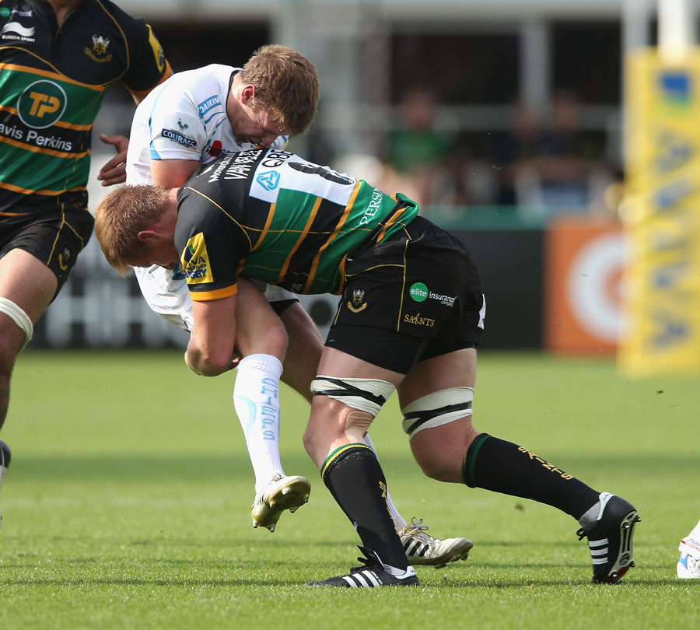

Rugby has a reputation for being a brutal game. Anyone who has watched or played the sport can tell you it lives up to its reputation. One of the major distinctions between rugby and football is the fact that rugby players do not wear helmets and generally do not have any sort of head protection. Yet despite not having the head protection, it has been reported rugby players suffer fewer concussions than their football counterparts.﻿

What is it about the sport of rugby that the concussion problem, while still taken seriously, is not at the high risk level it is in other full-contact sports such as football? Tackling technique in rugby plays a huge role in the lesser impact of head injuries on the sport. Football players tend to tackle in an improper way. The tackler's head feels the impact of almost every hit. Compare this to rugby where proper tackling techniques are taught. Rugby players get their heads off to the side of the tackle. This helps avoid too much impact to the tackler's head.

While tackler's are at risk from bad technique, it's obvious the person being tackled is similarly at risk of head injuries. In football, it seems that the tackler just slams into the ball-carrier. This puts the person being tackled as well as the tackler at risk. It doesn't help that football players tackle higher than rugby players do, risking direct head contact. Rugby players are taught a technique called wrapping. This technique has rugby players wrapping themselves around the ball-carrier and brings him to the ground instead of just slamming into him. Rugby players aim lower, and with the wrapping technique, don't put the ball-carrier at risk of injuries to the knees or legs.

While the rugby technique for tackling is successful, there is a struggle to integrate this exact style to football. As noted, football is a game that is more separated by inches than rugby. Tackling lower in football using the football style of tackling could potentially injure the ball-carrier. Regardless, there needs to be a change in the tackling technique in football if the risk of concussions in the game is to be lowered. Rugby doesn't have it all figured out either. There are risks of concussions in the sport as well as an increasing risk of other injuries. However, they seem to be a step ahead of football in concussion management, which is becoming more and more scrutinized with each report.

http://www.theguardian.com/sport/shortcuts/2013/jan/28/american-football-rugby-more-dangerous

http://www.thepostgame.com/blog/eye-performance/201310/rugby-football-concussions-tackling-safety-technique

http://www.brain-injury-law-center.com/latest-news/head-injuries-rugby-vs-football/

