Using the “ID Scheduled Students” Database

This documentation corresponds with the ID Scheduled Students.accdb database. It was created in 2013 by Michelle Stine, Analysis and Planning Associate in collaboration with Curt Marshall, Coordinator of Multicultural and Recruitment Programs for the College of Arts and Architecture.

Getting Started
ID Scheduled Students identifies students after Drop/Add who have not yet paid their tuition bill but who are accruing housing charges. It contains four queries that will identify and return all ethnicities, billing, and housing information for SCHEDuled students within the current semester.
Access to the following databases / tables is required to run these queries:
- Bursar
- Student (additional access is required for all 3 areas below)
  - Ethnicity tables
  - Housing tables
  - Academic-level student information
Upon receiving the database, attempt to double click on the dbo.uf_student_sem_curr link and see if you can open it. If you can, proceed to Step 1 below. If you receive an ODBC error, follow the steps at http://ais.its.psu.edu/services/warehouse/windows.asp. The database is looking for a Machine DSN called ‘warehouse’, and the simplest solution is to create one on your computer if it does not already exist. If you are using Access 2010, the link’s Access 2007 instructions are very similar.

Once you have verified a working DSN, you are ready to run the queries.
- Run the query 1 create tbl_1_students. This query calls on the first query, 0 get SCHED students, and puts it in a table called tbl_1_students so it can be used to drive the information required from the housing and billing tables.
Note: the 0 get SCHED students is a cross-tab query. The cross-tab can be used to get multiple ethnicities for a student. It takes data that has multiple rows per student (in this case, one row for each ethnicity) and flattens the information so each column represents a possible value, as shown in the examples below:
dbo_student_ethnicity_indcs
student_id | ethnicity_indc | ethnicity_indc_desc | multiple_ethnicities_indc
123 | HSP | Hispanic | Y
123 | BLK | Black | Y

tbl_1_students (our created table)
student_id | multiple_ethnicities_indc | ASN | BLK | HSP | INT | UDL | WHT
123 | Y |  | 1 | 1

- Run the query 2 get billing info. This query uses the list of students created in the first two queries to get related name and billing information.
Note the arrows on the joins. They specify that ALL records from tbl_1_students should be returned even if there are no corresponding records in the other tables. A regular join would only return records where there were corresponding records in both tables—a much lower number and not what is wanted for this query.
Note also the third column, tbl_1_students.*. The * will select all fields from tbl_1_students without having to name them specifically. The * is important so all ethnicity columns are captured. Due to the way 0 get SCHED students works, an ethnicity column is only created when someone specifies they belong to that group. If no one in a particular group of students specifies HAW, for example, this column will not be created. However, if, during the next semester, someone does report they are HAW, the column will automatically be created. The tbl_1_students table is subject to change each time the queries are run, based the student ethnicities pulled by the 0 get SCHED students query.
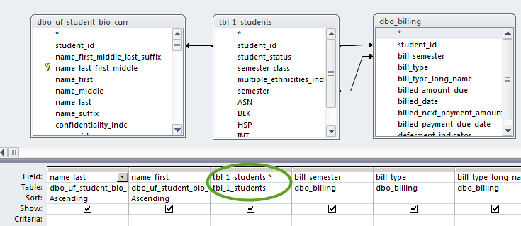

- Finally, run query 3 get housing info.
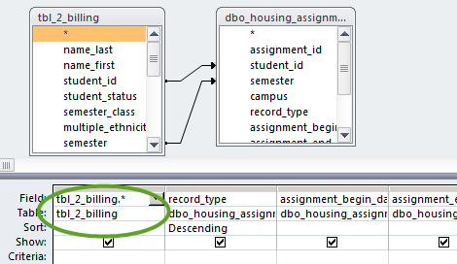
Note that this query also uses outer join arrows for student_id and semester, as well as the * that includes all fields in tbl_2_billing.
Students in SCHED status with housing contracts will float to the top. Students 123 and 456 are both accruing housing charges. However, Student 123 has a very small current balance. On the other hand, Student 456 had a large prior balance and still has a large current balance. Student 789 has also not paid the tuition bill but is not living on campus.

record_type | assignment_status | assignment_begin_date | residence_hall_code | student_id | student_status | bill_semester | bill_ type | bill_type_long_name | billed_amount_due | billed_date
CURRENT | ACCEPTED | 1/5/2013 | HESR | 123 | SCHED | 201213SP | E2 | SEMESTER BILL | 9940.5 | 1/4/2013
CURRENT | ACCEPTED | 1/5/2013 | HESR | 123 | SCHED | 201213SP | G2 | STUDENT ACCOUNT STATEMENT | 120 | 3/8/2013
CURRENT | ACCEPTED | 1/5/2013 | BEAM | 456 | SCHED | 201213SP | E2 | SEMESTER BILL | 19584 | 11/9/2012
CURRENT | ACCEPTED | 1/5/2013 | BEAM | 456 | SCHED | 201213SP | G2 | STUDENT ACCOUNT STATEMENT | 14325 | 3/8/2012
 |  |  |  | 789 | SCHED | 201213SP | E2 | SEMESTER BILL | 9383 | 11/17/2012
 |  |  |  | 789 | SCHED | 201213SP | G2 | STUDENT ACCOUNT STATEMENT | 9383 | 3/8/2013

