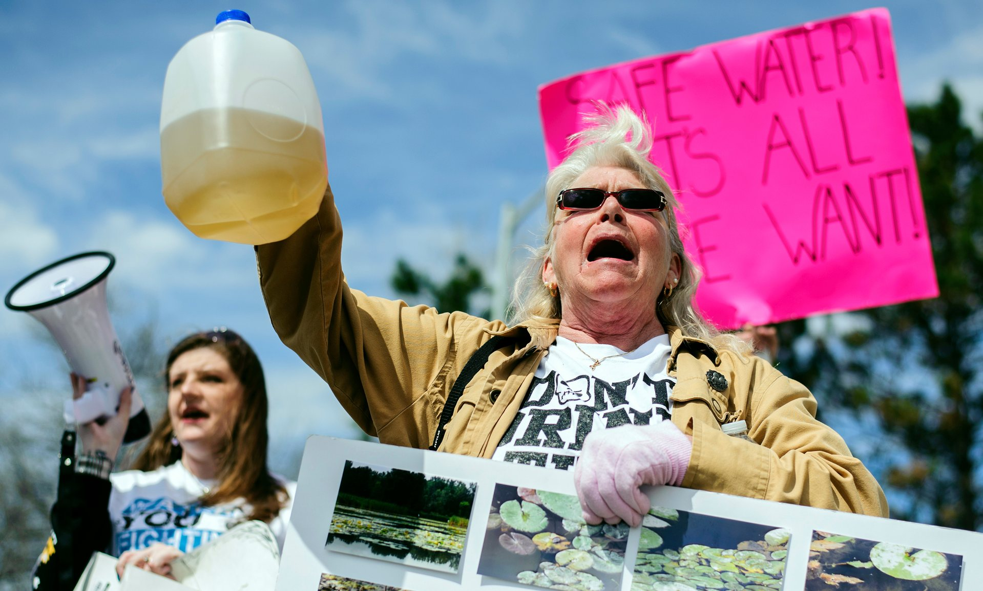

THE FLINT WATER CRISIS: Retroactive Actions Lead to a Pressing Need for Reform
“Communities have taken positive steps for more than two decades to reduce lead exposure from water and other sources… but there is clearly much more to be done. The Flint crisis lays bare a simple fact: As long as there are lead pipes in the ground or lead plumbing in homes, some risk remains. As a society, we should seize this moment of increased awareness about lead risks to develop solutions for getting the lead out.”

As stated by David LaFrance, the CEO of the American Water Works Association, the Flint Water Crisis remains an important reminder of the dangers of lead poisoning and the need for action. Reform is not easy, however, it is necessary to protect the health of all Americans, especially children. If adequate steps, both short term and long term, are not taken, the United States runs the risk of repeating the atrocities of Flint—or perhaps an even worse public health crisis.

A History of Neglect
Lead exposure has been known to be dangerous for centuries. Dioscorides, in the first century A.D. stated that “lead makes the mind give way.” The first industrial hygiene act passed in the American colonies restricted the use of lead to distill liquor. However, while lead’s dangers were recognized early on, in the 19th and early 20th centuries it became the lesser of two evils. Lead pipes were installed throughout the country because lead was considered better than concrete or iron due to its malleability and durability. At the time, health officials were not worried about the occasional lead epidemic because they were more concerned with treating typhoid and other diseases. As the 20th century progressed, the lead industry became more powerful, and at its height, more than fifty percent of the water pipes installed in America’s cities were made of lead.

Ineffective Legislation
Lead is different from other toxic contaminants because of where it affects the water. Lead is not found in the water that comes directly from the source or treatment plants, rather, it is found in plumbing and service lines. In 1986, after a study demonstrated that “one in five of the nation’s drinking water systems carried more lead than considered safe,” the Clean Water Drinking Act was passed. This was the first piece of anti-lead exposure legislation. While the act emphasized the removal of lead pipes, it was not heavily enforced, and it caused many municipalities to simply lower the levels of lead entering the water through the use of chemicals rather than systematically replace pipes. The anti-leaching agents were cheaper, and also took less time than the physical removal of pipes.
A few years later, in 1991, the Environmental Protection Agency felt as though they too should help to reduce the amount of lead piping throughout the country. With that, they published the Lead and Copper Rule, which targets the monitoring of both lead and copper at the taps of customers. “The rule established a maximum contaminant level goal of zero for lead in drinking water,” while previously the standard had been 50 ppb. While this did lead to an improvement in legislation and an amendment to the Clean Water Drinking Act that set higher standards for “pipe, plumbing fittings, fixtures, solder, and flux,” it was also largely ineffective. The failures and shortcomings of both pieces of legislation set the stage for the health disasters that were to come.

Washington D.C.: A Precursor
Flint was not the first instance that the government responded inadequately to a lead poisoning crisis. In 2001, half of a million individuals in Washington D.C. were exposed to lead-contaminated water. This fact was not discovered until 2004. Individuals in charge tried to downplay the situation and even attempted to suppress the results of the water tests, and as a means to solve the problem, they simply treated the pipes with a newly developed disinfectant. The pipes were not replaced, and legislators did not take any other actions to prevent future crises. Another disaster was inevitable—but when and where remained unknown. This all changed with Flint.

Flint, Michigan

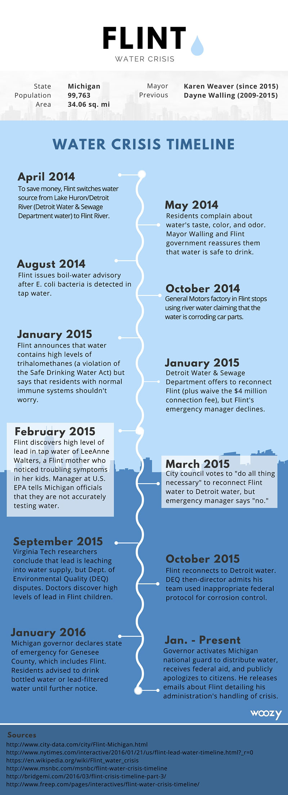
In April 2014, as a way to save money, Michigan decided to change Flint’s source of water from Lake Huron to the Flint River until a new supply line leading to Lake Huron was complete. Residents immediately began to notice that the “water looked, smelled and tasted funny.” The water was discovered to be 19 times more corrosive than when the source of the drinking water was Lake Huron. “To make matters worse, the addition of ferric chloride to reduce the formation of trihalomethanes from organic matter increased the corrosivity of the Flint River water.” The high levels of chloride only aided in the seepage of lead into the water. The lead even eroded the water mains, which were made of iron, causing the water to turn an even darker brown. Once this was discovered, the city switched back to its original water source, however, the tap water was still not safe to drink, as lead lingered in the water supply.
“In Flint, 4 in 10 families live below the poverty line, unemployment is high, and the majority of the population is black.” Many individuals have drawn a parallel between Flint’s socioeconomic factors and the crisis that unfolded. Residents of Flint, who are “57% black, 37% white, 4% Latino and 4% mixed race,” have been called the victims of environmental racism by citizens and elected officials alike. Others reject this claim; however, there is no denying the trend that poor and black communities are more likely to experience lead poisoning.
The high levels of lead in the water had devastating effects, many of which are still unknown. While adults only absorb three to ten percent of “an oral dose of water-soluble lead,” children have the ability to absorb forty to fifty percent. Additionally, lead has the ability to effect intelligence and behavior in children, and the extent of lead poisoning in children in the case of Flint will not be made clear for years to come.
Following the crisis, individuals and officials tried to gain control of the situation. Bottled water and filters were handed out to the residents as a means of disaster relief. While plans have been proposed to remove the piping from the city, there has been little progress. In the city alone, it is estimated that it will cost about $1.5 billion to replace the water pipes and remedy the situation. Much of the delay is because involved parties do not want to take responsibility for Flint’s shortcomings. Many individuals blame Michigan’s governor, Rick Snyder, while others choose to point their fingers at the Environmental Protection Agency or Michigan’s Department of Environmental Quality. Snyder did apologize for the atrocities, saying, “to begin, I'd like to address the people of Flint. Your families face a crisis, a crisis you did not create and could not have prevented… I am sorry and I will fix it.” However, this begs the question: how will legislators fix the wrongdoings of the past to not only secure the health of the citizens of Flint, but residents of the entire United States as well?
"Water Crisis Timeline." Woozy. Woozy, n.d. Web. 7 Apr. 2016. <http://blog.woozylabs.com/a-complete-timeline-of-the-flint-water-crisis/>.

Reform

Increase the Transparency of the Environmental Protection Agency
In order to prevent another disaster of the same magnitude as Flint, reform efforts need to occur. For example, the Environmental Protection Agency should be more transparent and should be held accountable for their past failures. Long before the crisis hit the media, an EPA employee reported the contaminated problem to their superior. However, the EPA “declined to make that information public, and instead tried behind the scenes to get the Michigan Department of Environmental Quality to take action to solve the problem.” A similar situation occurred in Washington D.C. in 2001. If the EPA is held to a higher standard, they will face an increased amount of pressure, which will motivate action. Thus, increasing transparency and accountability will help prevent future crises.

Increase Lead Exposure Awareness
Lead exposure awareness also needs to be increased. In order for individuals to know how to minimize the effects of lead poisoning, as well as how to spot the initial signs of lead in their water, education must be emphasized. This would complement the need for improved EPA transparency because the organization would be partially responsible for informing individuals of high risk areas. This also fosters a stronger bond between the EPA and constituents.
National Drinking Water Advisory and Council Chair Jill Jonas emphasized the need for education in addition to pipe removal, noting that actions such as replacing the piping will need “significant financial resources and time. During this time it is essential to have in place a robust effort of consumer education and engagement to assure ongoing protection from exposure to lead in drinking water.”

Enforce and Update Legislation
It is evident that the Clean Water Drinking Act and the Lead and Copper Rule have failed the American people. They were enacted to prevent large health crises, but Flint proves that they were unsuccessful. While both documents, as well as other pieces of anti-lead exposure legislation, were written with good intentions and the hopes of enacting positive change, they are inadequate because of their lack of enforcement. Not only should these documents be amended to apply to society today, they should also impose stricter enforcement and regulations. Governments and communities alike must take action.

De-Politicize the Environment
Societal change needs to occur so that the environment is not politicized. Health professionals should work closer with politicians to not simply guarantee economic stability, but to ensure that the health of citizens are held at the highest standard. Most experts believe that the atrocities of Flint could have been eliminated if a health professional had been working in conjunction with the government. Lawrence Clark, principal of an engineering firm that focuses upon sustainability consulting, stated “One important lesson to be learned from this is that important financial decisions cannot be made in a vacuum… If all of the technical factors had been considered prior to the switch in water supplies being made, the outcome could have been very different.”
Additionally, due to party politics, the EPA’s budget has been reduced by the Republican-dominated Congress. Thus, they have little ability to allocate funds. The Republican Congress has also criticized the EPA for interfering with “state-led problems” which aides in confusion as to who should be in control of monitoring lead levels and initiating crisis relief. There is not a clearly defined line as to whether specific public health crises should be handled by the state or federal government, and this blurred line leads to delays in action.

Recognize the Needs of Those Below the Poverty Line
"You can't just pick up and move when you have no resources and no one to fall back on." Kim Foreman, executive director of Environmental Health Watch, articulated an important point: individuals living below the poverty line cannot relocate and do not want their complaints to cause eviction. It is not just piping that causes poisoning in these communities, however. Disadvantaged families “are exposed to more lead than their wealthier counterparts because they are more likely to live in houses in poor repair that still harbor deteriorating lead paint, to live in urban neighborhoods with greater soil and dust lead concentrations from traffic and industrial activities, and to have nutritional deficiencies that increase lead absorption.” They are unable to afford chemicals, filters, and other necessary commodities to help prevent lead poisoning. Additionally, these badly maintained areas are often overlooked by government officials, specifically officials who believe that there is no profitable opportunities in these communities
A long history of discrimination and segregation in many cases has caused the poorest families to also be racial minorities. According to the Centers for Disease Control and Prevention, “from 1999 to 2004, black children nationally were 1.6 times more likely to test positive for lead in their blood than were white children.” Many argue that this is the result of environmental racism, and whether or not that is true, there is no denying that these statistics need to change, which cannot occur until the needs of these individuals are recognized.

Replace Lead Piping Proactively
Lead piping needs to be replaced proactively. According to the American Water Works Association, an estimated 6.1 million lead service lines remain in areas throughout the United States, spanning a distance of three to six million miles and reaching 15 to 22 million Americans. To make matters worse, “data collected by the Center for Disease Control and Prevention shows that over 40 percent of the states that reported lead test results in 2014 have higher rates of lead poisoning among children than Flint.” The best way to combat this is to initiate a systematic removal of lead lines, rather than just doing so in the wake of crisis.

Potential State and Federal Responses
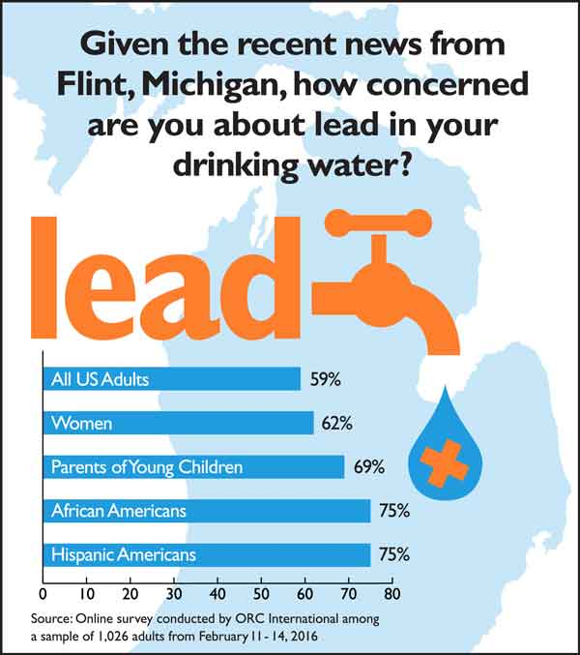
Americans, especially parents, African Americans, and Hispanic Americans, are exceptionally concerned with the amount of lead that is in their drinking water. Action must be taken, sooner rather than later. For if the government does not act, it is very likely that another disaster of the same magnitude as Flint—or worse—will occur. While proactive measures will be costly, they will save funds in the long run. Ultimately, to enforce these reforms, the Lead and Copper Rule should be updated to include every step of the process—from education through to the physical removal of pipe lines.
Concern Among Americans About Lead in Drinking Water. SafBaby. SafBaby, 17 Feb 2016. Web. 7 Apr. 2016. <http://www.safbaby.com/lead-in-your-water-get-a-test-kit/>.

First: Educate Constituents
Communities and households deserve to be informed of the levels of lead in the piping systems throughout the country. Therefore, the transparency of documents, specifically those created by the EPA and other government agencies must be increased. The Lead and Copper Rule also needs to be reformed to stress the education of constituents. For example, the rule should require that the Consumer Confidence Report should be updated more frequently, with the addition of a “targeted outreach to consumers with lead service lines and other vulnerable populations.” While all individuals should be properly educated, there should be a target emphasis on the education and “participation of citizens and stakeholders, specifically from low-income neighborhoods, neighborhoods with high concentration of [lead service lines], and parent groups.” It should be mandatory for both residents and home buyers to be notified of the presence of lead in their community or home.

Second: Ensure Adequate Communication
Federal and state governments, along with organizations such as the EPA, must improve communication to ensure swift action as well as to guarantee accountability. A committee branch of the EPA that proposes legislation to Congress, the National Drinking Water and Advisory Council (NDWAC) Lead and Copper Rule Working Group (LCRWG), should be expanded. Individuals should work closer with not only federal officials, but state legislatures as well to ensure that every state is not only working to solve the issue of lead contamination, but also to ensure that high risk areas are receiving the federal and state attention that is necessary.

Third: Require the Complete Removal of Pipe Lines
Pipe lines should be replaced proactively and completely. The Lead and Copper Rule should be reformed so that merely partial replacement of lead service lines should be banned. Targeting the areas with the highest levels of lead poisoning through systematic replacement lowers the chances of environmental racism and action based upon socioeconomic status. Communities with the highest levels of lead in their water would be treated first, an action which needs to be completed on a need basis rather than on income or race.
The removal of the pipes will cost upfront, but will prevent the necessity for funds to be allocated in crisis response. By waiting until the wake of crisis to attempt to fix problems, many unexpected costs rise. For example, due to the health ramifications of lead poisoning in children, there becomes a greater need for both special education and juvenile correction programs due to the effect that lead exposure has on IQ. Dr. David Bellinger, a Professor in the Department of Environmental Health at Harvard, spoke about these unanticipated costs in regards to Flint:
Although the cost of repairing Flint’s water infrastructure is uncertain, estimates range
as high as $1.5 billion. The cost of reducing the corrosivity of the Flint River water at the time of the change would have been minimal, perhaps $100 per day— proving again that prevention is generally cheaper than remediation and treatment. More money will be spent in the courts, since multiple lawsuits have already been filed. Imagine what could have been achieved for the people of Flint if the funds that will now be needed to repair the damage and litigate lawsuits could instead have been used to pursue goals such as improving the schools, de-leading homes, or funding programs providing job training, early education, or treatment and prevention for substance abuse or domestic abuse.
It is estimated that replacing all of the lead pipes throughout the United States would cost about $30 billion in total. The estimate of replacing each line would be approximately $5,000. However, it should be noted that some of these pipe lines are utility lines, while others are owned by households. Thus, it would be a combined effort of both the government and individuals paying to replace the pipes. Inevitably, one of the most difficult aspects of replacing lead pipes would be easing the financial burden, especially upon households. There are multiple ways in which this can be achieved, however, such as through a “low-income deferred payment program,” household reimbursements, “property tax assessments,” or even by “providing credit to a certified plumber.” The government and citizens must work in cooperation in order to fund the removal of the pipe lines.
Frostenson, Sarah, and Sarah Kliff. "The Risk of Lead Poisoning Isn’t Just in Flint." Vox. Vox, 6 Apr. 2016. Web. 7 Apr. 2016. http://www.vox.com/a/lead-exposure-risk-map; Lower levels are indicated in a deep blue and the areas at the highest risk are indicated in a dark red.

Risk of Lead Poisoning Throughout the United States

Looking to the Future
We must not react, we must act. We must not live for the present, we must look forward to the future. The future of the quality of life in America. The future of our children. We must learn from our mistakes, and be careful not to repeat them. The United States’ health policy should not solely rely on the persistence of citizens to enact change, as was the case in Flint. If government officials do not act, the atrocities of Flint will repeat itself. Thousands of children will be susceptible to lead poisoning, and millions of government dollars will be spent trying to rectify the situation.
The effects of lead poisoning are known. So are the various approaches to eliminating this problem. What is lacking, however, is the political strength and will to enact change. René Dubos, an environmentalist, once stated that lead poisoning “is so well-defined, so neatly packaged, with both causes and cures known, that if we don’t eliminate this social crime, our society deserves all the disasters that have been forecast for it.” The United States has yet to fully respond to this statement, but one thing is certain: helpless individuals and children do not deserve to suffer at the hand of complacent government officials.

Endnotes "AWWA Supports Recommendation for Complete Removal of Lead Service Lines." Water Quality Products. Scranton Gillette Communications, 10 Mar. 2016. Web. 7 Apr. 2016. <http://www.wqpmag.com/awwa-supports-recommendation-complete-removal-lead-service-lines>.
Bellinger, David. "Lead Contamination in Flint — An Abject Failure to Protect Public Health." The New England Journal of Medicine (2016): n. pag. Web. 7 Apr. 2016. <http://www.nejm.org/doi/full/10.1056/NEJMp1601013>.
Ibid.
Sellers, Chris. "Piping as Poison: The Flint Water Crisis and America's Toxic Infrastructure." U.S. News. U.S. News, n.d. Web. 7 Apr. 2016. http://www.usnews.com/news/articles/2016-01-25/piping-as-poison-the-flint-water- crisis-and-americas-toxic-infrastructure; Wang, Yanan. "Untold Cities across America Have Higher Rates of Lead Poisoning than Flint." The Washington Post. Washington Post, 4 Feb. 2016. Web. 7 Apr. 2016. <https://www.washingtonpost.com/news/morning-mix/wp/2016/02/04/untold-cities-across-america-have-higher rates-of-lead-poisoning-than-flint/>.
Sellers, "Piping as Poison: The Flint Water Crisis and America's Toxic Infrastructure." U.S. News. U.S. News, n.d. Web. 7 Apr. 2016. http://www.usnews.com/news/articles/2016-01-25/piping-as-poison-the-flint-water-crisis-and-americas-toxic-infrastructure
"AWWA Supports Recommendation for Complete Removal of Lead Service Lines." Water Quality Products. Scranton Gillette Communications, 10 Mar. 2016. Web. 7 Apr. 2016. <http://www.wqpmag.com/awwa-supports recommendation-complete-removal-lead-service-lines>.
Sellers, "Piping as Poison: The Flint Water Crisis and America's Toxic Infrastructure." U.S. News. U.S. News, n.d. Web. 7 Apr. 2016. http://www.usnews.com/news/articles/2016-01-25/piping-as-poison-the-flint-water-crisis-and-americas-toxic-infrastructure
Ibid.
Lead and Copper Rule." United States Environmental Protection Agency. United States Environmental Protection Agency, n.d. Web. 7 Apr. 2016. <https://www.epa.gov/dwreginfo/lead-and-copper-rule>.
Ibid.
Sellers, "Piping as Poison: The Flint Water Crisis and America's Toxic Infrastructure." U.S. News. U.S. News, n.d. Web. 7 Apr. 2016. http://www.usnews.com/news/articles/2016-01-25/piping-as-poison-the-flint-water-crisis-and-americas-toxic-infrastructure; Atkin, Emily. "Does the EPA Bear Responsibility for Flint?" Think Progress. Center for American Progress Action Fund, 26 Jan. 2016. Web. 7 Apr. 2016. <http://thinkprogress.org/politics/2016/01/26/3741139/epa-flint-water-crisis/>.
Atkin, Emily. "Does the EPA Bear Responsibility for Flint?" Think Progress. Center for American Progress Action Fund, 26 Jan. 2016. Web. 7 Apr. 2016. <http://thinkprogress.org/politics/2016/01/26/3741139/epa-flint-water-crisis/>.
Sellers, "Piping as Poison: The Flint Water Crisis and America's Toxic Infrastructure." U.S. News. U.S. News, n.d. Web. 7 Apr. 2016. http://www.usnews.com/news/articles/2016-01-25/piping-as-poison-the-flint-water-crisis-and-americas-toxic-infrastructure
Botelho, Greg. "No Simple Fix: Infrastructure, Health Issues Loom Large in Flint Water Crisis." CNN. Turner Broadcasting System, Inc., 19 Jan. 2016. Web. 7 Apr. 2016. http://www.cnn.com/2016/01/19/us/flint-water-crisis-whats-next/; "Water Crisis Timeline." Woozy. Woozy, n.d. Web. 7 Apr. 2016. <http://blog.woozylabs.com/a-complete-timeline-of-the-flint-water-crisis/>.
Botelho, "No Simple Fix: Infrastructure, Health Issues Loom Large in Flint Water Crisis." CNN. Turner Broadcasting System, Inc., 19 Jan. 2016. Web. 7 Apr. 2016. http://www.cnn.com/2016/01/19/us/flint-water-crisis-whats-next/; Bellinger, "Lead Contamination in Flint — An Abject Failure to Protect Public Health." The New England Journal of Medicine (2016): n. pag. Web. 7 Apr. 2016. <http://www.nejm.org/doi/full/10.1056/NEJMp1601013>.
Bellinger, "Lead Contamination in Flint — An Abject Failure to Protect Public Health." The New England Journal of Medicine (2016): n. pag. Web. 7 Apr. 2016. <http://www.nejm.org/doi/full/10.1056/NEJMp1601013>.
Hanna-Attisha, Mona, et al. "Elevated Blood Lead Levels in Children Associated With the Flint Drinking Water Crisis." American Journal of Public Health 106.2 (2016): n. pag. American Public Health Association. Web. 7 Apr. 2016. <http://ajph.aphapublications.org/doi/full/10.2105/AJPH.2015.303003>.
Botelho,"No Simple Fix: Infrastructure, Health Issues Loom Large in Flint Water Crisis." CNN. Turner Broadcasting System, Inc., 19 Jan. 2016. Web. 7 Apr. 2016. <http://www.cnn.com/2016/01/19/us/flint-water-crisis-whats-next/>.
Bellinger, "Lead Contamination in Flint — An Abject Failure to Protect Public Health." The New England Journal of Medicine (2016): n. pag. Web. 7 Apr. 2016. <http://www.nejm.org/doi/full/10.1056/NEJMp1601013>.
Martinez, Michael. "Flint, Michigan: Did Race and Poverty Factor into Water Crisis?" CNN. Turner Broadcasting System, Inc., 28 Jan. 2016. Web. 7 Apr. 2016. <http://www.cnn.com/2016/01/26/us/flint-michigan-water-crisis-race-poverty/>.
Hanna-Attisha, et al. "Elevated Blood Lead Levels in Children Associated With the Flint Drinking Water Crisis." American Journal of Public Health 106.2 (2016): n. pag. American Public Health Association. Web. 7 Apr. 2016. <http://ajph.aphapublications.org/doi/full/10.2105/AJPH.2015.303003>.
Ibid.
Botelho, "No Simple Fix: Infrastructure, Health Issues Loom Large in Flint Water Crisis." CNN. Turner Broadcasting System, Inc., 19 Jan. 2016. Web. 7 Apr. 2016. <http://www.cnn.com/2016/01/19/us/flint-water-crisis-whats-next/>.
Botelho, "No Simple Fix: Infrastructure, Health Issues Loom Large in Flint Water Crisis." CNN. Turner Broadcasting System, Inc., 19 Jan. 2016. Web. 7 Apr. 2016. http://www.cnn.com/2016/01/19/us/flint-water-crisis-whats-next/; Atkin, "Does the EPA Bear Responsibility for Flint?" Think Progress. Center for American Progress Action Fund, 26 Jan. 2016. Web. 7 Apr. 2016. <http://thinkprogress.org/politics/2016/01/26/3741139/epa-flint-water-crisis/>.
Botelho, "No Simple Fix: Infrastructure, Health Issues Loom Large in Flint Water Crisis." CNN. Turner Broadcasting System, Inc., 19 Jan. 2016. Web. 7 Apr. 2016. http://www.cnn.com/2016/01/19/us/flint-water-crisis-whats-next/;
Atkin, "Does the EPA Bear Responsibility for Flint?" Think Progress. Center for American Progress Action Fund, 26 Jan. 2016. Web. 7 Apr. 2016. <http://thinkprogress.org/politics/2016/01/26/3741139/epa-flint-water-crisis/>.
Ibid.
"AWWA Supports Recommendation for Complete Removal of Lead Service Lines." Water Quality Products. Scranton Gillette Communications, 10 Mar. 2016. Web. 7 Apr. 2016. <http://www.wqpmag.com/awwa-supports-recommendation-complete-removal-lead-service-lines>.
Sellers, "Piping as Poison: The Flint Water Crisis and America's Toxic Infrastructure." U.S. News. U.S. News, n.d. Web. 7 Apr. 2016. http://www.usnews.com/news/articles/2016-01-25/piping-as-poison-the-flint-water-crisis-and-americas-toxic-infrastructure
Lyons, "How to Prevent Another Flint Water Crisis." Environmental Leader. Business Sector Media, 1 Feb. 2016. Web. 7 Apr. 2016. <http://www.environmentalleader.com/2016/02/01/how-to-prevent-another-flint-water-crisis/>.
Atkin, "Does the EPA Bear Responsibility for Flint?" Think Progress. Center for American Progress Action Fund, 26 Jan. 2016. Web. 7 Apr. 2016. <http://thinkprogress.org/politics/2016/01/26/3741139/epa-flint-water-crisis/>.
Dissell, Rachel, and Brie Zeltner. "Race, Racism and Lead Poisoning: Toxic Neglect." Cleveland. Advance Ohio, 22 Oct. 2015. Web. 7 Apr. 2016. <http://www.cleveland.com/healthfit/index.ssf/2015/10/race_racism_and_lead_poisoning.html>.
Bellinger, "Lead Contamination in Flint — An Abject Failure to Protect Public Health." The New England Journal of Medicine (2016): n. pag. Web. 7 Apr. 2016. <http://www.nejm.org/doi/full/10.1056/NEJMp1601013>.
Ibid.
Ibid.
Dissell and Zeltner, "Race, Racism and Lead Poisoning: Toxic Neglect." Cleveland. Advance Ohio, 22 Oct. 2015. Web. 7 Apr. 2016. <http://www.cleveland.com/healthfit/index.ssf/2015/10/race_racism_and_lead_poisoning.html>.
"AWWA Supports Recommendation for Complete Removal of Lead Service Lines." Water Quality Products. Scranton Gillette Communications, 10 Mar. 2016. Web. 7 Apr. 2016. http://www.wqpmag.com/awwa-supports-recommendation-complete-removal-lead-service-lines; Sellers, "Piping as Poison: The Flint Water Crisis and America's Toxic Infrastructure." U.S. News. U.S. News, n.d. Web. 7 Apr. 2016. http://www.usnews.com/news/articles/2016-01-25/piping-as-poison-the-flint-water-crisis-and-americas-toxic-infrastructure; "Lead Service Line Analysis Examines Scope of Challenge" ["American Water Works Association"]. American Water Works Association. N.p., 10 Mar. 2016. Web. 7 Apr. 2016. <http://www.awwa.org/resources-tools/public-affairs/press-room/press-release/articleid/4074/lead-service-line-analysis-examines-scope-of-challenge.aspx>.
Wang, "Untold Cities across America Have Higher Rates of Lead Poisoning than Flint." The Washington Post. Washington Post, 4 Feb. 2016. Web. 7 Apr. 2016. <https://www.washingtonpost.com/news/morning-mix/wp/2016/02/04/untold-cities-across-america-have-higher-rates-of-lead-poisoning-than-flint/>.
Sellers, "Piping as Poison: The Flint Water Crisis and America's Toxic Infrastructure." U.S. News. U.S. News, n.d. Web. 7 Apr. 2016. <http://www.usnews.com/news/articles/2016-01-25/piping-as-poison-the-flint-water-crisis-and-americas-toxic-infrastructure>.
Concern Among Americans About Lead in Drinking Water. SafBaby. SafBaby, 17 Feb. 2016. Web. 7 Apr. 2016. <http://www.safbaby.com/lead-in-your-water-get-a-test-kit/>.
Clarifications Needed to Strengthen the Lead and Copper Rule Working Group’s Recommendations for Long Term Revisions to the Federal Lead and Copper Rule. N.p.: Northeast-Midwest Institute, 2015. Flint Water Study. Web. 7 Apr. 2016. <http://flintwaterstudy.org/wp-content/uploads/2015/11/NEMWI-LCR-recommendations.pdf>.
Ibid.
Ibid.
Wang, "Untold Cities across America Have Higher Rates of Lead Poisoning than Flint." The Washington Post. Washington Post, 4 Feb. 2016. Web. 7 Apr. 2016. <https://www.washingtonpost.com/news/morning-mix/wp/2016/02/04/untold-cities-across-america-have-higher-rates-of-lead-poisoning-than-flint/>.
Bellinger, "Lead Contamination in Flint — An Abject Failure to Protect Public Health." The New England Journal of Medicine (2016): n. pag. Web. 7 Apr. 2016. <http://www.nejm.org/doi/full/10.1056/NEJMp1601013>.
"Lead Service Line Analysis Examines Scope of Challenge" ["American Water Works Association"]. American Water Works Association. N.p., 10 Mar. 2016. Web. 7 Apr. 2016. <http://www.awwa.org/resources-tools/public-affairs/ press-room/press-release/articleid/4074/lead-service-line-analysis-examines-scope-of-challenge.aspx>.
Strategies to Obtain Customer Acceptance of Complete Lead Service Line Replacement. Denver: American Water Works Association, 2005. American Water Works Association. Web. 7 Apr. 2016. <http://www.awwa.org/Portals/0/files/legreg/documents/StrategiesforLSLs.pdf>.
Bellinger, "Lead Contamination in Flint — An Abject Failure to Protect Public Health." The New England Journal of Medicine (2016): n. pag. Web. 7 Apr. 2016. <http://www.nejm.org/doi/full/10.1056/NEJMp1601013>.
Ibid. Cover Image: Owens, Sam. "How Michigan's Flint River Came to Poison a City." The Gaurdian. Guardian News and Media Limited, 18 Jan. 2016. Web. 7 Apr. 2016.<http://www.theguardian.com/environment/2016/jan/18/michigan-flint-river-epa-lead-contamination-mdeq-pollutants-water-safety-health>

