The Lack of Physicians’ Familiarity with
LGBT Health and its Consequences
By Zachary Zydonik April 7, 2016

In the past year, 83.2 percent of all adults in the United States visited a health care professional.¹ An even higher percentage of children, 92.4 percent, visited their health care provider.² The number of Physician office visits grew to 928.6 million in 2014 alone.³ With the number of newly insured people under Obamacare surpassing 17 million, physicians are bound to receive an influx of patients.⁴ Whether it is a routine check-up or an urgent medical problem, the point is clear, Americans care about their health.
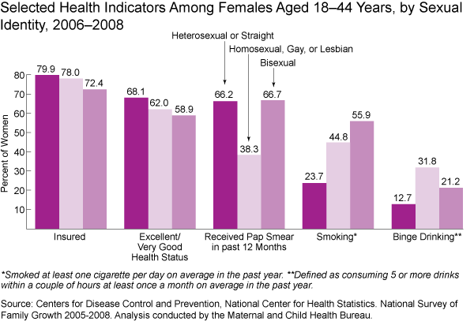
Unfortunately, lesbian, gay, bisexual, and transgender (LGBT) patients are not receiving the same quality of medical care and advice from their health care professionals that heterosexual patients receive. LGBT individuals have increased health risks in areas ranging from chronic disease, sexually transmitted infections, mental health, and immunodeficiency virus infections.⁵ The percentage of gay men that reported an eating disorder was 17 percent compared to 3.4 percent of heterosexual men that participated in a study sponsored by the National Institute for Health.⁶ Gay and bisexual men also have a higher risk of contracting other diseases, including but not limited to HIV and anal cancer.⁷ Similarly, lesbian and bisexual women acknowledge circumventing routine gynecological visits more often than heterosexual women, resulting in omission of proactive cervical cancer smears and increased chances of developing cervical lesions.⁸ LGBT women also have a higher risk for breast cancer due to an increasing (50-200 percent) trend of cigarette use among this category of persons.⁹ Likewise, transgender individuals that undergo reassignment surgery or hormone therapy experience an enhanced risk for liver abnormalities, heart disease, endometrial cancer, and prostates cancer.¹⁰ LGBT adolescents are three times more likely to commit suicide, experience homelessness at a higher rate, and are more likely to suffer from drug abuse, as well as prostitution.¹¹ The American Journal of Public Health reports that “ lesbian, gay, and bisexual adults were more than twice as likely to have cardiovascular disease as straight adults.”¹² Another study, by Annals of Behavioral Medicine, exposed that lesbian, gay and bisexual young adults, aged 12-22, “were less likely to take part in physical activity and were 46-76 percent less likely to participate in team sports, raising concerns for associated complications like obesity, diabetes, and cardiovascular complications later in life.”¹³
45
The necessity to develop a community of physicians that understand LGBT related health issues comes at a time when new studies reveal that a larger portion of the population requires this community-specific treatment. The Centers for Disease Control and Prevention (CDC) reports that gay men alone make up two percent of the entire United States population.¹⁴ However, a study from Pediatrics that surveyed over 7,000 adolescents found that of the 9.3 percent that identified as being sexually active with a member of the same sex, 38.9 percent identified themselves as heterosexual.¹⁵ A study among the male adult population had similar results, reporting that 72.8 percent of men who had sex with other men identified as heterosexual.¹⁶ So when a patient discloses that he is heterosexual to his physician, that physician has to consider exactly what the label heterosexual means to the patient, instead of moving onto the next question listed on the routine patient history checklist.
“If the goal of the medical interview is to assess and address risk, then questions must be both specific and directed toward particular sexual practices, not simple categories.”⁴³
Although physicians may be aware that LGBT individuals possess additional health risks, many are not aware, or properly trained, on how to address these risks. Medical professionals often report not asking patients sexual orientations, or not understanding what to do with the information once obtained. A National Transgender Discrimination Survey in 2010 reported that researchers were informed that 50 percent of the transgender community surveyed said that they had to teach their healthcare providers about transgender care.¹⁷ Another survey done by Lambda Legal described 56 percent of lesbians, gays and bisexuals, as well as 70 percent of transgender individuals experiencing barriers in their receipt of proper healthcare.¹⁸ An example of doctors failing to provide appropriate medical advice was recognized by the CDC as follows:
“According to the CDC, in 2010, 63 percent of new HIV infections affected men who have sex with men; yet only 49 percent of gay and bisexual men age 18-24 were aware that they had been infected with the virus. At the same time, 24 percent of gay and bisexual men report never using condoms. Most striking is the fact that despite these statistics, 56 percent of gay and bisexual men say that a doctor has never recommended that they be tested for HIV. In the same study, almost half of gay and bisexual men reported never discussing their sexual practices with their physician.” ¹⁹
Such evidence validates that lesbian, gay, bisexual, and transgender (LGBT) individuals experience poorer health than the general population. Although significant gains have been made concerning other societal issues, such as same-sex marriage, LGBT health has received little to no attention from the medical perspective. Progress in providing improved medical care to this population is stagnated due to professionals’ inexperience with the issue. Research, specifically conducted by the National Institutes of Health, lacks in the area of LGBT health. The absence of LGBT health curriculum in medical schools, coupled with patients’ limited willingness to be open with their doctors, significantly contribute to the problem at hand.

LGBT Individuals Afraid of the Doctor’s Office
The first step in attaining proper treatment for LGBT individuals is to reveal their actual sexuality and gender identity to their doctors. Although this seems straightforward, many members of the LGBT community conceal their sexuality from their healthcare provider out of fear of discrimination, adverse judgment, and/or negative feedback.
The RAND Corporation and UCLA aimed to determine exactly how many lesbian, gay and bisexual teenagers were honest about their sexual orientation with their doctors. The survey was administered to lesbian, gay, and bisexual teenagers who volunteered to be part of the study while at an LGBT convention. Dr. Garth D. Meckler, head of the study, commented that he expected the participants would mainly be “out” or open about their sexuality due to the environment in which they were recruited.²⁰ 70 percent of the participants did confirm that the majority of their friends, family and community knew of their sexuality, however, surprisingly, only 35 percent reported that their doctor knew, and of this percentage only 21 percent conveyed that their doctors had initiated the discussion.²¹ The teenagers who took part in the study confessed that they would have been more open about their sexuality had their physicians commenced the conversation or inquired as to their sexuality. Of the teens surveyed, 64 percent confirmed that they would be inclined to disclose their sexuality if their physician simply asked them.²² Dr. Meckler commented on the findings, stating, ““Very few physicians were regularly discussing sexuality, even though sex is one of the major developmental challenges and health risks at that age.”²³ He also opined that those members that are not open about their sexuality, even if directly asked by their doctor, may still find it difficult or impossible to reveal their sexuality.²⁴ Various studies have similar findings. A study of 492 men located in New York City, New York, found that 39 percent of the men that had sex with other men had not disclosed their habits to their doctor.²⁵
Further apprehensions of a breach of confidentiality and privacy have been disclosed as reasons by LGBT persons for their struggle in disclosing their sexual identification to their physicians. Although medical records are confidential pieces of documentation, there are instances of stolen medical information, as seen in Texas in 2011 when the privacy of approximately three million digital records was compromised.²⁶ Accordingly, those LGBT persons who are not open in the community about their identification and prefer that this information not be released are naturally further reluctant to divulge on the basis of compromise.
Doctors agree that when a patient has an honest relationship with his or her physician, that patient typically receives a better quality of medical care.²⁷ Even though there are cases when privacy may be compromised, the instances remain rare. LGBT individuals have been provided additional security in disclosure of their identification by protections from discrimination promulgated and enacted under the Affordable Care Act.²⁸ Since the barriers for LGBT individuals have been disassembled due to new policy changes, the only remaining factor capable of withholding an open relationship between patient and doctor is the environment which the doctor creates within the clinic or practice.
There are several steps that physicians may take to ensure their offices provide a comfortable setting to LGBT individuals. LGBT literature may be included among the magazines in waiting rooms, and a sign that indicates that the office is non-discriminatory and open to confidentially discuss health concerns should be visible to patients. These efforts create an environment that LGBT persons can rest assured that they will not be judged. Physicians’ websites may also include a blurb mentioning that they maintain non-discriminating practices and are open to patients of all gender identities and sexualities. If doctors are uncomfortable in addressing these topics with patients directly, they should have available forms wherein patients may disclose their identification if they so desire. Nevertheless, the doctor should show some effort to address the issue. A welcoming atmosphere to LGBT individuals represents a major step in improving LGBT health.

Medical Schools Lack the Proper Curriculum
In October 2015, a new mandate was issued to healthcare providers requiring that the sexual orientation and gender identity of patients be included in all electronic patient files.²⁹ This initiative means that the likelihood of productive talks concerning LGBT health will increase, as doctors are finally liable to question their patients on the matter. However, the more concerning query remains as to whether or not medical professionals have the proper training or resources to treat their patients effectively, as well as answer any medical questions concerning LGBT individuals.
A study published in the Journal of the American Medical Association questioned deans from 132 medical schools throughout the United States and Canada to determine the amount of LGBT curricula that students cover.³⁰ The study exposed that “the median reported time dedicated to teaching LGBT-related content in the entire curriculum was 5 hours.”³¹ It was also revealed that 9 of the schools surveyed taught nothing related to this content during preclinical years and 44 schools taught nothing of the sort during clinical years.³² The deans were further asked to identify if they covered 16 topics that the study considered to be the core curricula for LGBT-related studies.³³ The range of coverage by the schools varied, but the majority rated themselves as “fair” when addressing the topics.³⁴ The following table demonstrates the results:³⁵
The participating universities, although rating themselves predominately as “fair” when covering LGBT topics, utilize an astonishingly insignificant amount of time covering LGBT topics. Recognizing that the curriculum at many medical schools was incomplete regarding LGBT health, the Advisory Committee on Sexual Orientation, Gender Identity, and Sex Development under the Association of American Medical Colleges established a recommended baseline curriculum to be included in medical students’ studies.³⁶ The document was a “314-page comprehensive guideline titled Implementing Curricular and Institutional Climate Changes to Improve Health Care for Individuals Who Are LGBT, Gender Nonconforming, or Born with DSD: A Resource for Medical Educators the goal of which is to ‘provide education about the health needs of individuals who are LGBT, gender nonconforming, and/or born with DSD [disorders of sexual development].’”³⁷ The paper lays the foundation upon which more curriculum for medical schools concerning LGBT health may be built upon.
"Things that create disproportionate burdens for the LGBT community are not being taught in medical schools."
- Kristen Eckstrand- Chair of the AAMC Advisory Committee on Sexual Orientation, Gender Identity, and Sex Development⁴⁴
Since recent policy changes require physicians to recognize the identities that their patients associate with in medical records, it is time that medical schools prepare students on how to handle such confrontations, as well as prepare students to be able to efficiently provide relevant medical advice to the different groups among the LGBT community. The road to improved LGBT health requires that physicians become educated about the problems specific to those individuals.

Research for LGBT Health is Sparse
A major setback to advancing LGBT health is the lack of official medical studies assessing the community. While topics such as HIV among homosexual men have been researched extensively, and research efforts with a specific focus on LGBT Health have improved, many areas remain largely ignored. The Institute of Medicine (US) Committee on Lesbian, Gay, Bisexual, and Transgender Health Issues and Research Gaps and Opportunities identified a few priority areas which it recommends the National Institutes of Health (NIH) focus its research.³⁸ The committee specifically suggests an increase in life-course perspective studies to better understand “a range of health issues that occur throughout life” and lists the benefits of such a study as follows:
Longitudinal cohort studies, which are largely absent from LGBT research, are an excellent way of gaining insight into health issues by following participants over a period of time. Such studies would be useful for understanding many health issues related to sexual and gender minorities, including the development of gender-variant youth in their social contexts, the effects of pathways to family formation on the health of sexual and gender minorities, men who have sex with men in the context of HIV, identity as an LGBT person (i.e., member of a sexual and/or gender minority) over the life course, and changes in patterns of substance use over time.³⁹
Other perspectives for studies that the committee hopes is to see the NIH implement and include intersectional, social ecological, minority stress, as well as cross-cutting.⁴⁰ The report goes further to bring attention to the need for research regarding LGBT health in the areas of demographics, social influences, inequities in health care, intervention, and transgender-specific health needs.⁴¹
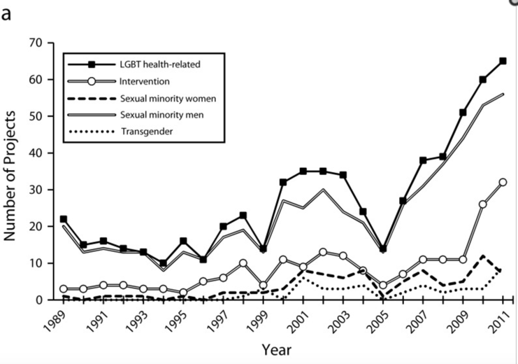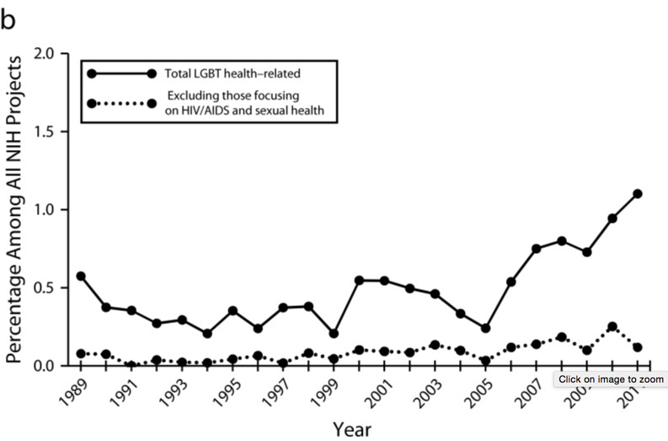
42
Continuing the trend toward higher research funding for LGBT health will effectively raise the group’s level of overall health because physicians will be better suited to effectively apply the studies to emerging cases. The information gained may be incorporated with new curricula at medical schools enabling students coming out of medical school to effectively address the various health risks that LGBT individuals face.

The Cohort Effort Promoting LGBT Health
Raising the health of the LGBT community is no easy feat by any means. It will take the efforts of patients, physicians, medical schools, and the NIH to see any major changes to LGBT healthcare. Raising awareness of the securities set in place for patients to be open to their doctors should encourage LGBT individuals to discuss their health concerns with their medical providers. Altering the curriculum in medical school to aid in educating physicians on the proper treatment of these individuals will allow patients to receive the medical assistance they require, and further studies under the NIH will aid in development of this curricula. This cohort effort will effectively improve the quality of LGBT healthcare, so that doctor visits will be equally beneficial to all individuals.

Endnotes
- Centers for Disease Control and Prevention, “Ambulatory Care Use and Physician office visits,” available at http://www.cdc.gov/nchs/fastats/physician-visits.htm (last accessed April 2016)
- Ibid.
- Ibid.
- Sarah Ferris, “Early Cues to ObamaCare’s Impact,” The Hill (2015), available at http://thehill.com/policy/healthcare/243513-early-clues-to-obamacares-impact (last accessed April 2016)
- Juno Obedin-Maliver and others, “Lesbian, Gay, Bisexual, and Transgender–Related Content in Undergraduate Medical Education,” The Journal of the American Medical Association (2011), available at http://jama.jamanetwork.com/article.aspx?articleid=1104294 (last accessed April 2016)
- National Center for Biotechnology Information, “Health care problems of lesbian, gay, bisexual, and transgender patients,” available at http://www.ncbi.nlm.nih.gov/pmc/articles/PMC1070935/ (last accessed April 2016)
- Ibid.
- Ibid.
- National Center for Biotechnology Information, “Health care problems of lesbian, gay, bisexual, and transgender patients,” available at http://www.ncbi.nlm.nih.gov/pmc/articles/PMC1070935/ (last accessed April 2016); Daniel Marchalik, “Yes, Your Doctor Really Needs to Ask About Your Sexual Orientation and Gender Identity,” Slate (2016), available at http://www.slate.com/blogs/outward/2016/02/29/why_doctors_need_to_ask_patients_about_sexuality_and_gender_identity.html (last accessed April 2016)
- National Center for Biotechnology Information, “Health care problems of lesbian, gay, bisexual, and transgender patients,” available at http://www.ncbi.nlm.nih.gov/pmc/articles/PMC1070935/ (last accessed April 2016)
- Ibid.
- Daniel Marchalik, “Yes, Your Doctor Really Needs to Ask About Your Sexual Orientation and Gender Identity,” Slate (2016), available at http://www.slate.com/blogs/outward/2016/02/29/why_doctors_need_to_ask_patients_about_sexuality_and_gender_identity.html (last accessed April 2016)
- Ibid.
- Centers for Disease Control and Prevention, “HIV Among Gay and Bisexual Men,” available at http://www.cdc.gov/hiv/group/msm/ (last accessed April 2016)
- Daniel Marchalik, “Yes, Your Doctor Really Needs to Ask About Your Sexual Orientation and Gender Identity,” Slate (2016), available at, http://www.slate.com/blogs/outward/2016/02/29/why_doctors_need_to_ask_patients_about_sexuality_and_gender_identity.html (last accessed April 2016)
- Ibid.
- Jaime M. Grant and others, “National Transgender Discrimination Survey Report on Health and Health care” (2010), available at http://www.thetaskforce.org/static_html/downloads/reports/reports/ntds_report_on_health.pdf (last accessed April 2016)
- Lambda Legal, “When Healthcare isn’t Caring,” available at http://www.lambdalegal.org/sites/default/files/publications/downloads/whcic-report_when-health-care-isnt-caring_1.pdf (last accessed April 2016)
- Centers for Disease Control and Prevention, “HIV Among Gay and Bisexual Men,” available at http://www.cdc.gov/hiv/group/msm/ (last accessed April 2016)
- RAND Corporation, “Few Lesbian, Gay, Bisexual Teens Tell Their Doctor Their Sexual Orientation,” available at http://www.rand.org/news/press/2006/12/28.html (last accessed April 2016)
- Ibid.
- Ibid
- Ibid
- Ibid
- Sewell Chan, “Many Gays Don’t Tell Doctors Their Sexuality, Study Finds,” The New York Times (2008), available at http://cityroom.blogs.nytimes.com/2008/07/23/many-gays-dont-tell-doctors-their-sexuality-study-finds/?_r=0 (last accessed April 2016)
- Rose Eveleth, “Doctors Should Include Gender Identity and Sexual Orientation in Medical Records,” Smithsonian (2013), available at http://www.smithsonianmag.com/smart-news/doctors-should-include-gender-identity-and-sexual-orientation-in-medical-records-71982/?no-ist (last accessed April 2016)
- Lambda Legal, “Disclosing Your Sexual Orientation or Gender Identity to Healthcare Providers: The Effect of New HIPAA Regulations,” available at http://www.lambdalegal.org/publications/disclosing-your-sexual-orientation-or-gender-identity-to-healthcare-providers-the-effect-of-new-hipaa-regulations (last accessed April 2016)
- Eveleth, “Doctors Should Include Gender Identity and Sexual Orientation in Medical Records,” Smithsonian (2013), available at http://www.smithsonianmag.com/smart-news/doctors-should-include-gender-identity-and-sexual-orientation-in-medical-records-71982/?no-ist (last accessed April 2016)
- Federal Register, “2015 Edition Health Information Technology (Health IT) Certification Criteria,” available at https://www.federalregister.gov/articles/2015/10/16/2015-25597/2015-edition-health-information-technology-health-it-certification-criteria-2015-edition-base (last accessed April 2016)
- Juno Obedin-Maliver and others, “Lesbian, Gay, Bisexual, and Transgender–Related Content in Undergraduate Medical Education,” The Journal of the American Medical Association (2011), available at http://jama.jamanetwork.com/article.aspx?articleid=1104294 (last accessed April 2016)
- Ibid.
- Ibid.
- Ibid.
- Ibid.
- Ibid.
- Daniel Marchalik, “Teaching LGBT Issues in the New Era of Medical Education,” Slate (2016), available at http://www.slate.com/blogs/outward/2016/02/05/can_a_novel_make_medical_students_more_sensitive_to_lgbt_issues.html (last accessed April 2016)
- Ibid.
- Institute of Medicine Committee on Lesbian, Gay, Bisexual and Transgender Health, “The Health of Lesbian, Gay, Bisexual, and Transgender People: Building a Foundation for Better Understanding,” available at http://www.ncbi.nlm.nih.gov/books/NBK64812/ (last accessed April 2016)
- Ibid.
- Ibid.
- Ibid.
- Robert W. S. Coulter, “Research funded by the National Institutes of Health on the health of lesbian, gay, bisexual, and transgender populations,” available at http://www.ncbi.nlm.nih.gov/pubmed/24328665 (last accessed April 2016)
- Daniel Marchalik, “Yes, Your Doctor Really Needs to Ask About Your Sexual Orientation and Gender Identity,” Slate (2016), available at http://www.slate.com/blogs/outward/2016/02/29/why_doctors_need_to_ask_patients_about_sexuality_and_gender_identity.html (last accessed April 2016)
- Julie Beck, “What Doctors Don’t Know About LGBT Health,” The Atlantic (2014), available at http://www.theatlantic.com/health/archive/2014/11/what-doctors-dont-know-about-lgbt-health/382792/ (last accessed April 2016)
- Health Resources and Services Administration, “LGBT Health,” available at http://www.hrsa.gov/lgbt/ (last accessed April 2016)

