April 1, 2018
Lydia Carey

the dangers of single-use plastics
an issue brief

A WORLD OF PLASTIC: INTRODUCTION
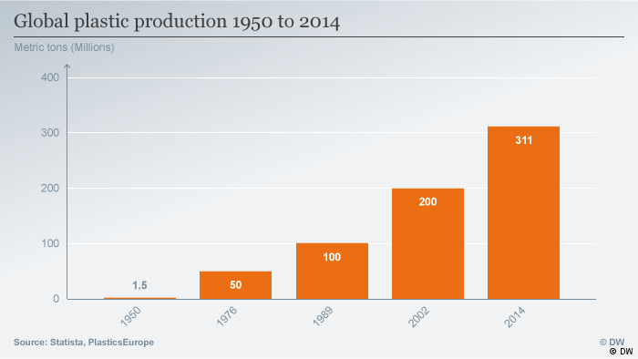
We live in an era of convenience, and plastic. Almost everything we use is manufactured from or packaged in some type of polymer; from the food we buy, to the utensils we eat with, to the bottles we drink from, to the hygiene products we use. It is used so commonly and for good reason—plastic is versatile, lightweight, flexible, moisture resistant, durable, strong and relatively inexpensive. Since 1950, the world has increased our global plastic production from 1.5 million metric tons, to 311 million metric tons in 2014. Our demand for plastic continues to rise, and estimates predict over 400 million metric tons were produced globally in 2017. Over the next 20 years, we can expect to see that figure double if we maintain our current production habits. Plastic packaging and similar single-use plastics are the main culprits, representing 26% of the total volume of plastics used. Single-use plastics are the largest portion of all plastics produced, and we are constantly in contact with them. They can be defined as products that are used once and thrown away or sometimes recycled, such as plastic straws, utensils, cups, water bottles, and bags. The substance has become pervasive in our lives, but not without serious health and environmental consequences.
The extremity of the health consequences associated with our plastic-dependent lifestyles are contested, yet most scientists agree the effects are not positive. Leaching of chemicals into food products by packaging and chewing on plastic toys by children have been linked to dangerous health outcomes such as various cancers, birth defects, impaired immunity, endocrine disruption, and developmental and reproductive effects to name a few. It is stipulated that the effects of plastic on the health of our population are unknown because the use of plastic is protected by powerful commercial interests and is a relatively new substance. Research on low-dosage plastic exposure is scarce because it is difficult to find a control group and requires large amounts of participants. Since there are hundreds of different plastic formulas, and many potential chemical additives in each one, it is difficult to test all of them before new ones are created. However, as consumers become more aware and demand to know more about their products, studies involving the health dangers of plastics are becoming more frequent. Bisphenol A (BPA), a common chemical found in polycarbonate plastics like bottled water, has been consistently criticized for causing endocrine disruption and interfering with hormonal function. The US Food and Drug Administration (FDA) has stated that BPA has “potential effects [of BPA] on the brain, behavior and prostate gland of fetuses, infants, and children,” reversing their previous statement from 2008 claiming it was safe. Other chemical additives in plastic, known as “plasticizers,” are often toxic and untested. It is questionable how many toxins we ingest from the plastics that are constantly in contact with our bodies, but a majority of leaders in the field agree that the effects are negative, and that the dangers of plastic will continue to worsen as it is further integrated into every sphere of our lives.
The environmental consequences of our overuse of plastic products are vast and serious in nature. As sustainability and environmental awareness increases, consumers are becoming increasingly interested in doing their part to mitigate the effects of Climate Change and pollution caused by the products they use. Single-use plastics make up the largest portion of plastic produced worldwide, and are one of the most easily controllable sources of polymers in the industry, as they can be immediately reduced with existing technology. This issue brief will focus specifically on the negative effects of these plastics on the natural environment. Furthermore, it will discuss the ways in which the government, businesses, and individuals can work to decrease our societal dependence on single-use plastic.

ENVIRONMENTAL IMPACT
  - Waste of Resources in Production
Plastic is made from crude oil that has been refined into petroleum or natural gas, in a complicated chemical process. In 2010, approximately 191 million barrels of petroleum and 412 billion cubic feet of natural gas were used in the United States to make plastic products. Nearly 8% of the world’s oil consumption goes towards the production of plastic. Procurement of these fossil fuels, through methods such as drilling, fracking, and hydraulic fracking, results in great environmental degradation and disruption to ecosystems. The amount of oil and natural gas on this planet is limited and finite, and at the rate we are exploiting these resources, we may run out within this century. As we move away from nonrenewable resources as a society, we cannot continue demanding mass amounts of a material that is produced from fossil fuels.
  - Landfill Space
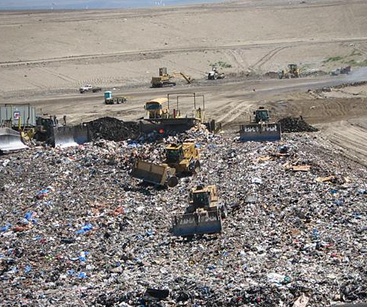
According to the Environmental Protection Agency (EPA), in 2014, the United States threw away 33.6 million tons of plastic, and 75.5% of that plastic went to the waste stream. Only 9.5% was recycled, and 15% was combusted as electricity or heat. The plastic that enters the waste stream either gets lost and ends up polluting land and water ecosystems, or is sent to a landfill, taking between 500 to 1,000 years to decompose. Plastics cause a problem from their production to their disposal, and the effects can last for centuries.
Trash landfills, otherwise known as garbage dumps, pose significant threats to the environment such as leaked toxins, leachates, and greenhouse gases all of which contribute to Climate Change. Plastic makes up 13% of all landfill trash. Today’s landfills have improved thanks to advancements in lining technology and strict government regulations; however, due to the massive, constant flow of garbage through the waste system, it is difficult to contain possible side effects. When plastics do finally break down, they can release toxic substances that leak into soil and groundwater supplies. If these toxins come into contact with other substances in the landfill, such as battery acid or electronic waste, they may create an unknown chemical reaction that increases toxicity. The dangerous liquid is called leachate, and is formed when water runs through decomposing garbage. Since leachate is toxic, it ruins the health of living organisms that it comes into contact with, and contaminates groundwater reservoirs that may be used for human consumption. Landfills also release greenhouse gases like carbon dioxide and methane into the atmosphere, contributing to rising global temperatures that are causing Global Climate Change. Because plastics constitute a considerable portion of landfill space, take so long to decompose, and are so prevalently used by humans, it is sensible to target them when trying to reduce human environmental impact. Each American throws away, on average, 185 pounds of plastic annually. This excessive use is building up and overwhelming landfill systems.
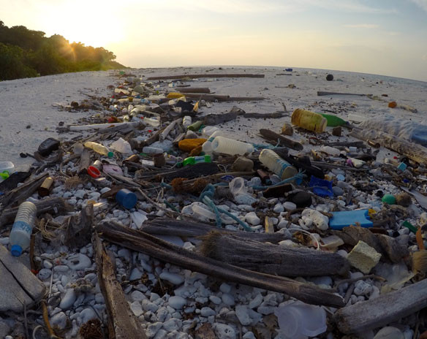
Ocean Pollution
It is estimated that 12.7 million metric tons of plastic entered the ocean in 2010. Millions of tons of plastic are floating around in the ocean, creating garbage patches and leaching chemicals into the water as the material breaks down. The majority of ocean plastics are made up of light-weight and small disposable plastics that easily slip through the waste stream process and into waterways, such as plastic bags, bottles, straws, and utensils. So much plastic has entered the oceans that concentrations of marine litter in the North Pacific Ocean have been named the “Great Pacific Garbage Patch.” The garbage patch, pictured below, is a swirling junkyard of small, difficult to collect plastic trash that floats around, containing 79,000 tons of plastic in 618,000 square miles. That is the equivalent of 500 Boeing 747 jets. This plastic debris kills animals like fish, seabirds, and marine mammals when they mistake the garbage for food. Plastic in the ocean has affected 267 species around the world, “including 86% of all sea turtle species, 44% of all seabird species and 43% of all marine mammal species. The impacts include fatalities as a result of ingestion, starvation, suffocation, infection, drowning, and entanglement.”
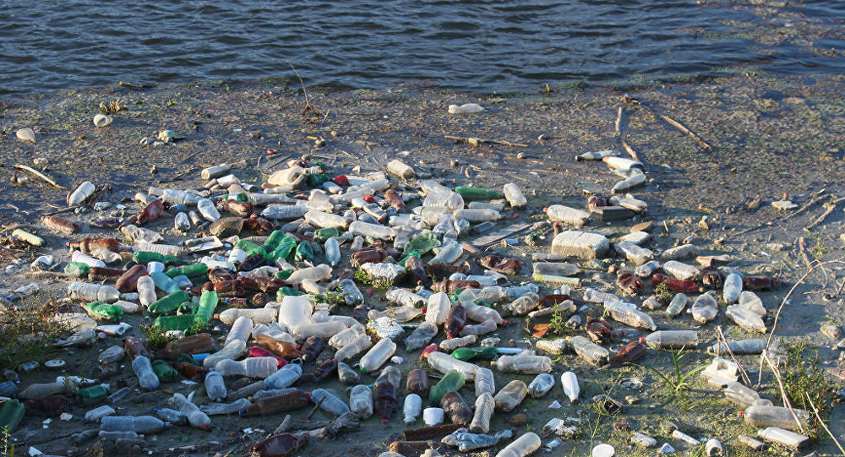
Plastic that floats through the water also collects and accumulates pollutants, transporting them to new areas along with, in some cases, invasive marine species. Invasive marine species in their nonnative habitats can completely disrupt the way an ecosystem functions. Sunlight exposure causes plastics in the ocean to break down into tiny pieces, known as microplastics. When marine animals ingest these microplastics that have been floating and accumulating pollutants, the toxins are absorbed into their bodies. This has led to plastic entering the human food chain, as it is becoming impossible for fish to avoid plastic in the ocean. Scientists are increasingly finding that larger populations of fish, like salmon, have ingested plastic pieces.
Marine ecosystems have been permanently damaged due to the addition of unnatural plastic pollutants in the water. A majority of these plastics were produced using valuable fossil fuels, used one time, and carelessly thrown away. A 2016 report by the World Economic Forum predicted that if we continue with current rates of plastic production, and failure to properly dispose of them, plastic in the ocean will outnumber fish, pound for pound by 2050.
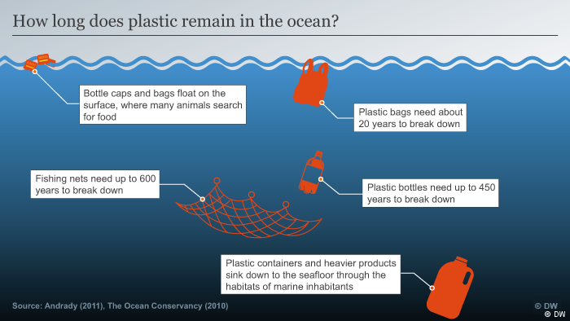
  - Carbon Footprint
The carbon footprint of plastic is around 6 kilograms of CO2 released for each kilogram of plastic produced. One study by a non-profit research group claims that the amount of energy involved with producing one plastic bottle is equivalent to filling the bottle one-quarter full with oil. The transportation of raw materials to make plastics, the formation of plastic additives, and the cleaning, filling, and storing of plastics also requires energy inputs that should be considered. In order to curb the rise in global temperatures that is causing polar ice to melt and sea levels to rise, reducing the amount of carbon released into the atmosphere is crucial, and the carbon footprint of plastic must be reduced to limit its negative effects.
  - The Problems with Recycling
Recycling is one of the best mechanisms in place to negate the harmful effects that plastics have on the environment. It provides opportunities to “reduce oil usage, carbon dioxide emissions, and the quantities of waste requiring disposal.” It diverts plastics away from landfills and natural habitats and repurposes them for a new life. However, a major drawback to this approach is that most single-use disposable plastics are not accepted by municipal recycling programs across the United States. Tiny plastic straws, utensils, and bags are not usually recyclable because it is not economical for a plant to deal with these uniquely shaped and textured materials. Instead, recycling plants focus on the collection of bottles, jugs, and jars, because they provide a better return and can create higher-grade plastics once recycled. Oftentimes, recycling provides a false sense of security for consumers to purchase as many plastic items as they want, guilt-free. However, recycling is an energy intensive process that includes the collection and transportation of recyclables to a plant. Additionally, the pollutants are released during the recycling process. Micheal C. Munger, in his article “Recycling: Can It Be Wrong, When It Feels so Right?,” states that “Recycling, including the costs of collecting the waste in tiny, mixed amounts, transporting the waste to a handling facility, sorting it, cleaning it, repackaging it, and then transporting it again, often for great distances, to a market that will buy the commodity for some actual use, is almost always more expensive than landfilling that same waste in a local facility.” Landfills, though, are definitely not the long-term, sustainable, or environmentally-friendly answer for dealing with garbage, as previously discussed. It seems as though the most sensible, economically efficient, and environmentally friendly solution to reduce the harmful effects of plastic is to reduce how much we use overall.

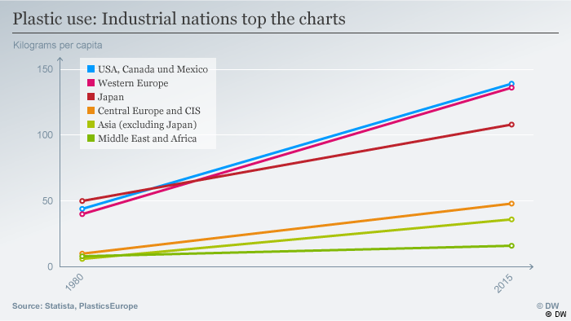
OUR RESPONSIBILITY
Single-use plastics pose a significant challenge to the United States government, businesses and consumers.
The main moral argument is founded on the idea that it is illogical for an object we use for less than an hour to require vast amounts of valuable natural resources and last hundreds of years harming the natural environment. There has already been considerable harm to ocean ecosystems, and continued killing of ocean life for the convenience of plastic use. Marine garbage patches are not only aesthetically unpleasant, they accumulate pollutants, are ingested by fish, and are entering our food chain, directly impacting our lives. We must ask ourselves if using a plastic straw or drinking from a plastic water bottle is worth the life of a sea turtle, or even worth ruining one of Earth’s most unique and wonderful habitats. We should care because a healthy environment is crucial for the continuation of the human race, Climate Change continues to pose a significant threat to global stability, and because our desire to protect our current and future planet is a reflection of our character as a society. On an individual level, there are extra steps we can take to refuse the proliferation of disposable plastics in our daily lives.
As a country, our government can take action to promote alternatives to plastic and reduce damage to our planet. As depicted by the chart above, the United States, Canada, and Mexico are major contributors to overall plastic use. Unfortunately, less developed countries overseas are dealing with the effects of United States mass consumption. The photo below depicts a trash-covered beach in Manilla, Philippines. The Philippines do not have the wealth, political power, or governmental infrastructure that the United States possesses to handle a problem of this magnitude on their own. Nor should they have to, since the United States is largely responsible for a majority of single-use plastic consumption worldwide.

POLICY LEVEL SOLUTIONS
  - Ban forms of Single-use plastic
A commonly proposed solution to deter the use of single-use plastics is to make them completely illegal by law. Many countries have enacted bans on particularly pesky plastic materials such as plastic bags and Styrofoam products. The single-use plastic bag is one of the biggest culprits of ocean and water pollution, leading to the creation of microplastics and their infiltration into our food and water supply. California was the first US state to completely outlaw plastic bags and require a 10-cent minimum charge for recycled paper bags, reusable plastic bags, and compostable bags. While the bill was initially met with public backlash, reusable bags were quickly adopted when there was an incentive in place to make an effort.
Commercial interests and big giants in the plastic industry, such as the American Chemical Council, continue to lobby the US government not to enact any new policies banning plastic, assigning responsibility for plastic pollution to anti-litter campaigns and individual discretion. They allocate millions of dollars to support policies that protect plastic use and in some cases, increase it. The reality is that even though public education against littering is important, it doesn’t solve our drastic overconsumption and overuse issues. The US uses plastic in extremely excessive amounts without thinking about where it goes once we are done with it and toss it in the garbage. Prevention of excessive plastic use is altogether more cost effective and better for the environment. The government has the greatest ability to enact and influence a transition from disposable items to sustainable, reusable, and compostable products.
Advantages
Plastic bag bans create a new industry for reusable bag manufacturers to flourish, creating new jobs and expanding the economy. Because the bags are banned and stores no longer have to provide them for free, the cost of goods should theoretically be lower. In the United States, the average person uses ten plastic bags per week, causing extreme strain on resources and frequently polluting a variety of habitats. A ban on plastic bags would influence a cultural change, similar to that of a ban on smoking indoors. As a result, this practice would become socially unacceptable.
Disadvantages
A ban on plastic bags imposes a one-time, upfront cost to consumers to purchase a reusable bag, which can cost anywhere from $1.00 and up. A ban might also affect the plastic bag manufacturing industry and reduce jobs. This policy could cause public backlash against the ban and bitterness or a negative attitude towards eco-friendly initiatives.
  - Tax Forms of Single-use Plastic
Placing a legal fee on plastic bags has been praised as a compromise between a complete ban and 100% free use. There are many examples of places where taxes on plastic bags have created social change and successfully reduced the amount of plastic being used. In Ireland, plastic bags were as prolific as they are in the United States now. After there was a 15 cent euro fee placed on bags in 2002, annual use dropped from 328 bags per person to 14 per person by 2014. A survey conducted a year after the tax was imposed found that 90% of participants were using reusable bags to avoid the fee, while also reporting that litter had decreased.
A plastic bag tax would reduce the cost that businesses have to pay to provide bags for free. A tax also forces the population creating the negative social cost to pay for it themselves. In other words, consumers are paying for the negative environmental costs they are incurring. Consumers would hopefully become more eco-conscious and aware of how their actions and consumption impact the environment because of the introduction of the tax. The disadvantages of a tax on plastic bags are similar to that of a ban, but perhaps there will be less public backlash with a less harsh method.
  - Incentivize Adoption of Plastic Alternatives
The government could incentivize plastic alternatives by giving tax breaks to businesses who are eco-friendly and produce less waste. By allowing businesses to save money, this policy would incentivize businesses to invest in environmentally conscious processes, packaging, and products. Contrary to the common belief that switching to eco-friendly alternative methods will cost more money, those alternatives are often cheaper in the long run. In addition, businesses and companies with ‘green’ or ‘eco-friendly’ brands are more appealing to young consumers and can attract more customers. While it is understood that a business’s top priority is to make a profit, this does not necessarily require the exploitation of plastic or neglect of environmental concerns.

BUSINESS LEVEL SOLUTIONS
  - Adopt Plastic Alternatives
Businesses have a responsibility to do their part in lessening the amount of waste they produce. As previously mentioned, environmentally-friendly policies and products attract a broad consumer base who share similar values about environmental conservation. By offering compostable take-out containers, for example, a restaurant demonstrates their commitment to bettering the community they are a part of. Restaurants can further this commitment by eliminating plastic straws, water bottles, and take-out bags. Companies can encourage their employees to use less plastic in the workplace by offering free reusable water bottles instead of single-use plastic ones. The adoption of these plastic alternatives represents an effort by managers and owners to do their part in reducing waste and making a difference.
  - Encourage and Promote Recycling
Businesses can research local recycling programs and protocols, educate employees, and educate customers on the correct recycling rules and regulations in the area. Doing so diverts plastic waste, and encourages awareness of how much plastic that is actually consumed. Simply having a recycling bin available in the workplace can make the biggest difference. One study showed that bin convenience and a consistent recycling program can drastically increase waste diversion in an office workplace.

INDIVIDUAL LEVEL SOLUTIONS
As individuals, there are things we can do in the next fifteen minutes that will drastically reduce our plastic consumption and therefore reduce the amount of plastic that ends up in the environment. By making simple and consistent changes to our lifestyles, we can make a large impact even as just one individual.
  - Invest in Reusable Items
One way to impact the amount of plastic that the population contributes to the waste stream is to limit the amount of plastic in your own life. Glass or metal straws are relatively cheap, and are safer for you than plastic straws because they do not leach chemicals into the liquid. This is also true for Styrofoam and plastic Tupperware containers. Limiting personal use of plastic utensils, plastic coffee cups, and plastic dining ware is fairly low cost because it only requires a one-time investment of a few dollars into items you will reuse again and again.
  - Lobby your Representative
As citizens with elected officials, we have the civic duty to hold our government representatives accountable for environmental changes we wish to see. One option is to contact local government representatives and ask if they have ever considered a tax or ban on single-use plastics, such as plastic bags. Additionally, we can gather group of friends, family, and environmental supporters together to sign a petition or run a campaign that demonstrates public constituent support for a government-imposed ban, educating the community along the way. Many townships and municipalities across the United States have successfully won over wealthy plastic industry lobbyists to pass legislation regarding plastic, which has led to the drastic reduction of plastic use in those areas and the rapid adoption of reusable tote bags.

  - Spread Awareness
For the next holiday, consider buying your loved ones reusable presents, such as a nice tote bag or a beautiful glass straw. Tell your friends and family on social media why plastic pollution is a problem and why it matters to you. Encourage your friends to make the same lifestyle changes that you have, and lead by example. Sustainability and being eco-friendly is a social movement that happens when people educate each other in a respectful and civil way.

CONCLUSION
Plastics have become so ingrained in our society and daily lives that we rarely give it a second thought to just throw them away after a single use. We only have one Earth, and one home. It is our responsibility to speak for and protect the environment, because it cannot speak for itself. It is crucial to future generations that we invest in feasible and practical long-term solutions that will ensure the protection of wildlife and the natural environment. The current rate of overuse of disposable plastics is not sustainable as we go into the future. This needed change can be sparked by recognizing our responsibility to the planet on a policy, business, and individual level. It is not too late to have an impact on the world of plastic, yet change must begin today.

REFERENCES

Anthony Andrady, “Plastics and The Environment,” Research Triangle Institute (2003): 143, accessible at http://allaboutmetallurgy.com/wp/wp-content/uploads/2016/11/Plastics-and-Environment.pdf
http://www.dw.com/en/six-data-visualizations-that-explain-the-plastic-problem/a-36861883
http://advances.sciencemag.org/content/3/7/e1700782.full
http://www3.weforum.org/docs/WEF_The_New_Plastics_Economy.pdf
Ibid.
Neeti Rustagi, S. K. Radhan, and Ritesh Singh, “Public health impact of plastics: An overview,” Indian Journal of Occupational and Environmental Medicine (Sep-Dec 2011): accessible at https://www.ncbi.nlm.nih.gov/pmc/articles/PMC3299092/
Rolf Halden, “Plastics and health risks,” Annual Review Public Health (2010): accessible at https://www.annualreviews.org/doi/abs/10.1146/annurev.publhealth.012809.103714; summary by Richard Harth, “Perils of plastics: risks to human health and the environment,” Arizona State University (March 2010): accessible at https://biodesign.asu.edu/news/perils-plastics-risks-human-health-and-environment
Halden, “Plastics and health risks”
Ibid.
“What’s Wrong with Plastic, Anyway?” My Plastic Free Life (2007): accessible at https://myplasticfreelife.com/2007/07/whats-wrong-with-plastic-anyway/
“Plastic bags and plastic bottles – CO2 emissions during their lifetime,” Time for Change (2009): accessible at https://timeforchange.org/plastic-bags-and-plastic-bottles-CO2-emissions
“The End of Fossil Fuels,” Ecotricity: accessible at https://www.ecotricity.co.uk/our-green-energy/energy-independence/the-end-of-fossil-fuels
“Advancing Sustainable Materials Management: 2014 Facts,” Environmental Protection Agency (2014): accessible at https://www.epa.gov/sites/production/files/2016-11/documents/2014_smmfactsheet_508.pdf
“Approximate Time it Takes for Garbage to Decompose in the Environment,” U.S. National Park Service and National Oceanic and Atmospheric Administration Marine Debris Program: accessible at https://www.des.nh.gov/organization/divisions/water/wmb/coastal/trash/documents/marine_debris.pdf
“Advancing Sustainable Materials Management: 2014 Facts,” Environmental Protection Agency (2014)
“The Problem with Landfill,” Environment Victoria (June 2013): accessible at https://environmentvictoria.org.au/resource/problem-landfill/
Ibid.
Ibid.
Ibid.
“Advancing Sustainable Materials Management: 2014 Facts,” Environmental Protection Agency (2014)
Jenna Jambeck, Roland Geyer, Chris Wilcox, Theodore Siegler, Mirriam Perryman, Anthony Andrary, “Plastic Waste Inputs from Land into the Ocean,” Science magazine (February 2015): accessible at http://science.sciencemag.org/content/347/6223/768.full
“Single-use plastic,” Marine Safe: accessible at http://www.marinesafe.org/the-problem/single-use-plastic/
Russell Mclendon, “What is the Great Pacific Ocean Garbage Patch?” Mother Nature Network (March 2018): accessible at https://www.mnn.com/earth-matters/translating-uncle-sam/stories/what-is-the-great-pacific-ocean-garbage-patch
L. Lebreton et. al., “Evidence that the Great Pacific Garbage Patch is rapidly accumulating plastic,” Scientific Reports 8 (March 2018): accessible at https://www.nature.com/articles/s41598-018-22939-w
Ibid.
D.W. Laist, "Impacts of marine debris: entanglement of marine life in marine debris including a comprehensive list of species with entanglement and ingestion records," Marine Debris: Sources, Impacts, and Solutions: Springer-Verlag (1997)
Ibid.
Ibid.
“Industry Agenda: The New Plastics Economy, Rethinking the future of plastics,” World Economic Forum (January 2016): accessible at http://www3.weforum.org/docs/WEF_The_New_Plastics_Economy.pdf
“Plastic bags and plastic bottles – CO2 emissions during their lifetime,” Time for Change (2009)
Marie-Luise Blue, “What is the Carbon Footprint of a Plastic Water Bottle?” Sciencing (March 2018): accessible at https://sciencing.com/carbon-footprint-plastic-bottle-12307187.html
http://rstb.royalsocietypublishing.org/content/364/1526/2115
Micheal C. Munger, “Recycling: Can It Be Wrong, When It Feels so Right?” (June 2013): accessible at https://www.cato-unbound.org/2013/06/03/michael-c-munger/recycling-can-it-be-wrong-when-it-feels-so-right
Jefferson Hopewell et. al., “Plastics recycling challenges and opportunities” The Royal Society Publishing (June 2009): accessible at http://www.ncsl.org/research/environment-and-natural-resources/plastic-bag-legislation.aspx
D.W. Laist, “Impacts of marine debris: entanglement of marine life in marine debris including a comprehensive list of species with entanglement and ingestion records” (1997)
Ibid.
Joseph Curtin, “Let’s Bag Plastic Bags,” The New York Times (March 2013): accessible at https://www.nytimes.com/2018/03/03/opinion/sunday/plastic-bags-pollution-oceans.html
Ibid.
Ibid.
Ibid.
Ibid.
Josh Weiss and Susie Poppick, “Going green, more green,” CNBC (April 2016): accessible at https://www.cnbc.com/2016/04/18/run-a-green-business-make-money.html#slide=1
Ibid.
“Workplace Recycling: New Research,” Recycling @ Work: accessible at https://www.kab.org/sites/default/files/RecyclingatWork_Workplace-Recycling-Fact-Sheet.pdf PHOTO CITATIONS - Green Bottle in Water: The Inerti https://www.theinertia.com/environment/200-nations-signed-resolution-promising-to-reduce-plastic-in-the-ocean/ - Increase in Plastic Use Chart: BBC News http://www.bbc.com/news/science-environment-42264788 - Roosevelt Regional Landfill: CNBC https://www.cnbc.com/2010/09/27/Americas-Largest-Landfills.html?slide=2 - Sdfa - Great Pacific Garbage Patch: Sputnik International https://sputniknews.com/environment/201803221062811738-Great-Pacific-Garbage-Patch-Now-Bigger-Than-Texas/ - Plastic in Ocean Graphic: BBC News http://www.bbc.com/news/science-environment-42264788 - Plastic use by country: BBC News http://www.bbc.com/news/science-environment-42264788 - Manilla Plastic Beach: Huffington Post https://www.huffingtonpost.com/entry/our-beaches-are-branded-with-plastic-pollution_us_5a1df88de4b0e9a1b9c7b4bc

