Advocacy Project Explanation & Justification
Over the past month, a large portion of media has been focused on the issue of gun violence and school safety in America. Following the shooting at Marjory Stoneman Douglas High School in Parkland, Florida, a major kairotic moment regarding the issue arose. The students involved in the attack decided to take action and start the March For Our Lives movement, a campaign that embodies the idea of keeping America’s schools safe. For my advocacy project, I attended the local State College March For Our Lives event and photographed some of the participants of the march. I asked individuals to write on a whiteboard the reason(s) for their activism concerning the exigence.
My goal for this project is to spread awareness on the issue of school safety, but more importantly, I want to share the passion that State College has for the March For Our Lives movement. For this reason, the subjects of my pictures were the participants of the march. I decided not to be photographed so that I could simply relay the voices of the State College community without inserting my bias. The responses of the people involved were the key messages that I was trying to communicate through this project. As an added bonus, I was able to capture some other public stances on the issue by photographing signs made by some of the marchers. Their messages were further voiced through the chosen body language of my photographed subjects as well as their facial expressions. After compiling and reading the views of the State College community members, I found that the main messages were the principles at the core of the March For Our Lives movement: keep children safe and regulate firearms in the United States.
Since I wanted to take a visual approach to this project, I thought about the best ways to go about spreading visual media. Some things that came to mind were posters, billboards, buses, websites and social media. I decided to take the social media route as it would allow me to reach a much broader audience as compared to the options that would simply circulate around the Penn State area. I ruled out the website option as sites are typically harder to publicize because people are not as inclined to leave the forum on which they are viewing media. Among the social media platforms, I chose two that are highly geared toward displaying photos: Facebook and Instagram. The links to both of my pages are listed at the bottom of the page.
As I have chosen social media as my means to spread my messages, my target audience is comprised of the people on social media. It is my ambition that I am able to reach someone that can make a change such as a local, state, or federal legislator. One of the photographs I took could influence a policy maker to view the issue of school safety with a different perspective.
To spread awareness of my social media pages, I followed March For Our Lives pages for different cities around the country as well as the verified March For Our Lives page. I reached out to the “March For Our Lives #STL,” “March For Our Lives Chicago,” “March For Our Lives – Parkland,” and “March For Our Lives” pages on Twitter and asked if they would create a post to advertise my account, but unfortunately, I did not get any responses. I did, however, get contacted by The Bradford Era – my hometown’s local newspaper – to answer some questions regarding my participation in the March For Our Lives event. I talked with a journalist over Facebook Messenger. I have included screenshots of our conversation below since the article has not yet been published. Additionally, I followed some of my friends from Penn State and my home town on my social media accounts.
To monitor my success, I will check the number of followers and likes I have on my pages and posts. In regard to the Bradford Era article, I can visit the newspaper’s site to follow any conversation or debate that ensues in response to the article’s publishing. Beyond these things, the overall gauge of success for this campaign is legislation. If the March For Our Lives movement is able to motivate the American government to take action on the school safety and gun violence issue, then the advocacy operation would prove effective.

Facebook Page: https://www.facebook.com/March-For-Our-Lives-State-College-594008900938714/
Instagram Account: https://www.instagram.com/iwillmarchstatecollege/

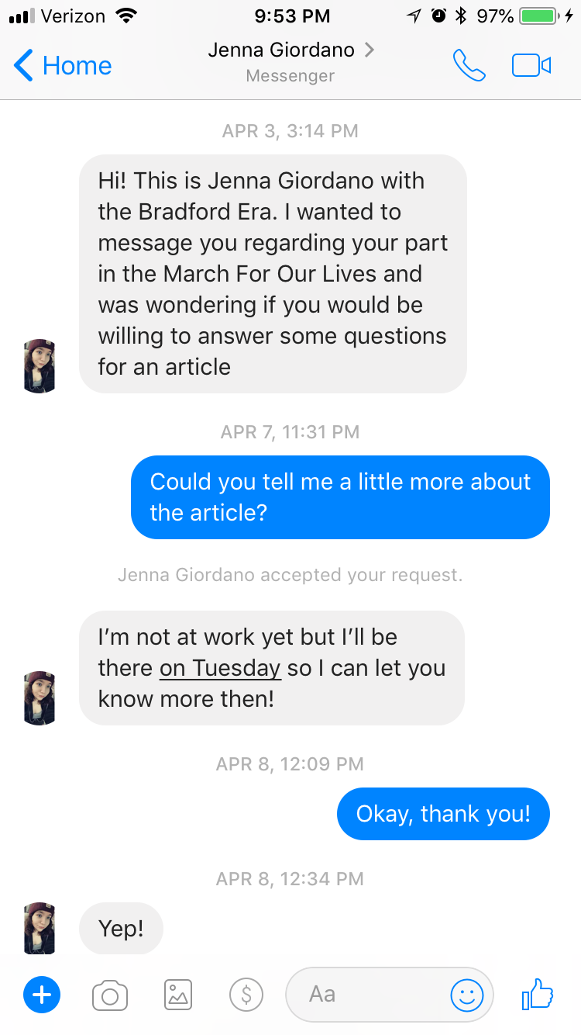
Messages with Jenna Giordano
