Shaving Cream Art Demo
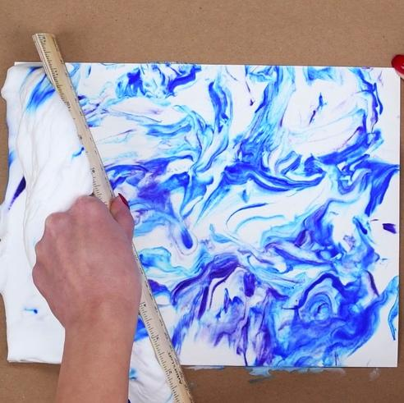

Materials:
- Shaving cream
- Paper plate
- Stirring utensil (spoon, straw, etc.)
- Food coloring
- Index card/cardstock
- Plastic ruler (not necessary)
- Paper towels (for cleanup)

Instructions:
- Spread some shaving cream into a thin layer onto your paper plate.
- Add your favorite colors with the food coloring. You only need 1 drop of each color you use.
- Gently mix in the food coloring with the shaving cream using your popsicle stick or spoon.
  - If you mix too much, you will only get a single color.
- Press the index card or cardstock onto your shaving cream mixture.
- Remove the index card from the shaving cream and wipe off the existing shaving cream with your popsicle stick or a plastic ruler.
- Now you have a beautiful piece of art that you made using science!

Activity Extensions:
- If you would like to keep exploring, dip your index card in oil before you dip it into the shaving cream. What happens?

When you dip the card in oil, the food coloring doesn’t stick to the index card at all. This is because the food coloring and the index card are both water loving (hydrophilic). When you dip the index card into oil, you are making it water hating (hydrophobic). This is why oil and water don’t mix. Now, the food coloring will not stick to the paper anymore because you changed the properties of the index card.

- What happens if you dip the index card in water?

When you dip the index card in water, the food coloring will stick to the index card because you are just making the paper more water loving. Since the food coloring is also water loving, it will stick to the index card and not the shaving cream. In this case, you are not changing the properties of the paper so the experiment will work in a relatively similar way.

What’s happening?
In this demo, we are exploring hydrophobic and hydrophilic interactions. Those are fancy words, but they mean pretty simple things. Hydrophobic means water fearing and hydrophilic means water loving.
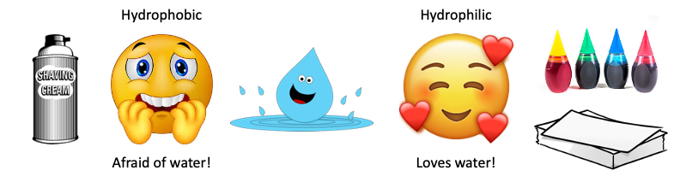

In this demo, the shaving cream is hydrophobic (afraid of water) and the paper and the food coloring are hydrophilic (loves water). When you put the paper on top of your shaving cream, the food coloring would rather stick to the paper than the shaving cream. This is because the food coloring and the paper are alike (both hydrophilic) while the shaving cream is different (hydrophobic).

https://www.sciencebuddies.org/stem-activities/paper-marbling

Floating Tattoos

Materials:
- Clean glass or ceramic surface (preferably plate)
  - Ex: Pyrex pans, plates, bathtubs, glass bowls, etc.
- Dry erase marker (any color, preferably new)
- Warm water
- A measuring cup with a spout

Procedure:
- Draw a fun picture on the surface with a dry erase marker.
  - We recommend drawing your picture in the middle of your plate. It is best to fill in your picture with your marker. We advise thick lines rather than thin lines.
- Slowly pour the warm water (the warmer the better) over the plate using the measuring cup.
  - Let the ink dry for at least 3 minutes.
- The drawing will lift off of the surface and float around.
  - Drawing animals is cute because they will dance around!
  - Try drawing a fisherman and individual fish so he can “catch” them as he moves.
  - Get creative!
- Stick your hand in the water.
  - The dry erase drawing will stick to your skin like a tattoo!
  - Remove by rubbing or with water.

What’s happening?
Dry erase markers are made of alcohol and silicon oils that allow it to be removed from white boards.
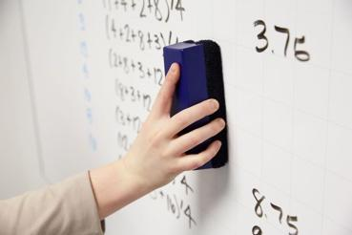

When you draw on the surface with your dry erase marker, the alcohol evaporates, leaving you with just oils.

As water is added, the oils (hydrophobic = afraid of water) will float to the top to avoid as much contact with water as possible.

https://studio5.ksl.com/5-fun-science-experiments-to-try-at-home/

