The Effect of Hofmeister Salts on Egg Whites:
A High School Chemistry Lab

Teacher’s Preparatory Guide

Three 45-minute class periods

Lesson Overview
Students will be able to identify and explain how the chemical identity of salts and their concentration affects the temperature at which egg proteins precipitate from solutions. Students will refer to the Hofmeister series which shows the ions in order of their ability to “salt- out” or “salt- in” proteins. In this lab, students will record the cloud-point temperature for filtered egg white mixed with various concentrations of two salts within the series, namely NaCl or NaI. The change in temperatures will be compared with the cloud-point of filtered egg white alone, and the pattern will be analyzed to determine the effect of the identity of the particular anions present as well as the concentration of salts to the cloud-point temperature of egg white.

Content Framework Summary

- In 1888 Franz Hofmeister ranked the ions based on their ability to “salt-out” or “salt- in” proteins. The Hofmeister series named after him has become the subject of many researches in recent years. Salts in solutions play a significant role in biology. Cations and anions can affect surface tension, water activity and even solubility behavior of macromolecules such as polypeptides or proteins. Anions appear to have a larger effect than cations, and are usually ordered CO₃ ²⁻> S0₄ ²⁻ > S₂O₃²⁻ >HP0₄²⁻ > F⁻> Cl⁻> Br⁻>NO₃⁻ >I⁻ >Cl0₄⁻>SCN⁻ while the order of cations is usually given as NH₄⁺ >K⁺>Na⁺>Li⁺>Mg^{2+>}Ca²⁺ >guanidinium.[1]

- Early members of the series have high charge density which tends to increase solvent surface tension and cause nonpolar molecules or proteins to collapse in itself (“salting-out”) in effect they strengthen the hydrophobic interaction which decreases protein solubility. By contrast, later salts in the series have low charge density which makes the ions bind closely to the protein molecules thus increasing their solubility ("salting-in”) and in effect, they weaken the hydrophobic effect.

- Denaturation is the process by which protein molecules lose their native state (quaternary, tertiary or secondary structure), by changing its viscosity or color through the application of heat or compounds such as acids, bases, salts or organic solvents.

Enduring Understandings

- Proteins are made of long chains of amino acids, which are the building blocks of proteins. An egg white, which is composed of about 40 different proteins contain both hydrophilic and hydrophobic amino acids. There are about 40 proteins present in egg whites, ovalbumin is the most abundant with 54%. Lysozyme is also present at 3.5%.

- At room temperature proteins are folded, and at high temperatures they unfold and denature. Then these unfolded proteins become stable when they aggregate.

- The solubility of proteins is influenced by the identity and concentration of salts present. In 1888 Franz Hofmeister showed this in the order called Hofmeister or lyotropic series [2].

- The structure and interactions of matter at the bulk scale are determined by intermolecular forces within and between atoms.

Essential Questions

- What is the Hofmeister series?
- How does the identity and concentration of salts affect the temperature at which proteins precipitate out in solutions?
- Why do we care about protein folding or unfolding?

National Science Education Standards Grades 9­12

Science practices
Engaging in scientific investigation requires not only skill but also knowledge that is
specific to each practice. The eight science practices are as follows:

1. Asking questions.
2. Developing and using models.
3. Planning and carrying out investigations.
4. Analyzing and interpreting data.
5. Using mathematics and computational thinking.
6. Constructing explanations.
7. Engaging in argument from evidence.
8. Obtaining, evaluating, and communicating information

Content Standard A. Physical Science

HS-PS1-3. Plan and conduct an investigation to gather evidence to compare the structure of substances at the bulk scale to infer the strength of electrical forces between particles.
Structure and Properties of Matter
• The physical properties of compounds reflect the nature of the interactions among its molecules.
• Carbon atoms can bond to one another in chains, rings, and branching networks to form a
variety of structures, including synthetic polymers, oils, and the large molecules essential to life.

Content Standard B. Chemical Reactions

HS-PS1-5. Apply scientific principles and evidence to provide an explanation about the effects of changing the temperature or concentration of the reacting particles on the rate at which a reaction occurs.

Chemical Reactions
- Hydrophobic and hydrophilic properties of substances reflect the nature of intermolecular forces of attractions between molecules.
- Molecular interactions or non-covalent interactions are attractive or repulsive forces between molecules and between non-bonded atoms.
- In biological systems, proteins fold into globular structures called native states, which are stabilized by molecular interactions.

Day 1 –Lesson Review on Atoms & Ions & Exploring the Hofmeister Series

Note to teachers: If you just talked about atoms and ions in the previous lesson with your students you can go ahead with “Exploring the Hofmeister Series” part and skip the review of ions part. If not, you have to give them a quick review on Atoms, Ions and how salts are formed.

Materials:

- Exploring the Hofmeister series worksheet

Video clips:

- “Science reveals what happens when you boil an egg” (stop at 0.48 secs)
https://www.youtube.com/watch?v=3QHOnLh3ziQ

- Instructional video produced this 2019 RET by Dr. Cremer, Chad, & Jo

Objective: Students will be able to arrange salts/ions in the order as to which would easily “salt-out” or “salt-in” with proteins.
Essential question: What is the Hofmeister Series?

Engage: (15 mins)
- Provide a predict, observe and explain (POE worksheet) to students and let them pay attention. With everyone’s eyes on you ask the question “Predict what would happen to this egg white if I add this to this water in the beaker, and I heat it up?” Give the students a minute to write their prediction.

- Ask a few students about their prediction, and then let them watch and observe as you mix the egg white in the beaker (hot plate, on low heat). Write down at least 2 observations and write a possible explanation on how or why this happened. Have students address the following prompts.
- Observation: What changes did you see on the egg white, and the water on the beaker?
- Explanation: How was the egg white affected by the temperature of the water in the beaker?
- Have students list down a concept web with their partner about what they know an egg white is made up of, and why or how it changed its appearance with temperature.
  - Ask the partners to come to a consensus on the different aspects and clarify through whole group discussion, as needed.

Teacher Note: During this activity, student’s prior knowledge of Biology concepts on macromolecules, such as proteins (polypeptides) and their structures, building blocks (amino acids), and denaturation is determined.

After the partners have shared to the whole class, the teacher shows the video clip

“Science reveals what happens when you boil an egg” (stop at 0.48 secs)
https://www.youtube.com/watch?v=3QHOnLh3ziQ

From the video clip they will be able to gather information, recall and write down important terms such as: denaturation, coiling, or uncoiling of proteins.

Explore:

- Facilitate a discussion around the following prompt:
What do you think would happen to the egg white if we heat it up in a beaker with water but this time you add salt in it?

Write your hypothesis on the worksheet. Use the” If…then”….format.

- Have students watch the instructional video by Chad Drexler & Jo Virtudes

https://youtu.be/Fn7jM6AhzPg

This video would give them a background on the principle behind the Hofmeister series and their ion-specific effects on proteins.
- Check for understanding and explain further if students needed clarification.

Evaluate:
  - Let your students do the: Sequencing anion: “Salt-out > Salt-in” of the worksheet. Have them use the Hofmeister series to predict which ions will raise the “Cloud-point temperature or “Salt- out”, which ions will lower the Cloud-point temperature or “Salt-in”.
  - Wrap up the lesson by letting students write in their own words, “How important is the Hofmeister series in solutions?
  - Check for understanding.

Announce to students: After reviewing about atoms, cations and anions and exploring about the Hofmeister series you will work with your groups in Day 2 to gather data by performing a lab with different salts on egg whites and evaluate your results.

Day 2-3: Effect of Hofmeister Anions on Egg Whites (lab)

Advanced preparation is needed for Day 2 lab

Materials

Per class
- 50 ml filtered egg white (prepared from 4-5 large fresh eggs)
- Refrigerator (to keep the egg white)
- Sodium chloride solution (5 M)
- Sodium Iodide solution (5 M) –store in an amber bottle, if using a clear container cover with aluminum foil

Prepare the following stock solutions using an analytical balance:

• 50 ml of filtered egg white: Get 4-5 large fresh eggs; wash and clean; separate the egg whites from egg yolk; whisk the egg whites into a fine foam; place in a beaker to settle overnight in a refrigerator; filter the egg white using a coffee filter; keep in a sealed container, and store in a refrigerator ready for the lab
- 20 ml of 5 M NaCl: dissolve 5.844 g in 20 ml DI water
- 20 ml of 5 M NaI: dissolve 14.9894 g in 20 ml DI water
- Also, from the above stock solutions, prepare 3M NaCl and 3M NaI solutions
(Use the formula: C₁V₁= C₂V₂)

Materials per lab group

- Three, 2 ml glass vials or test tubes (make sure thermometers would fit)
- Distilled water
- Ice (crushed preferred)
- Thermometers or temperature probes (Vernier temp probe/Labquest; digital thermometer)
- Hot plate
- 100 ml beaker
- A piece of paper with black and white lines taped at the back of the beaker (optional)
- Iron stand and clamps to set-up and hold the thermometer as it is placed inside the vial
- Tongs
- Worksheet per student

Safety Information for students

- Students must wear safety glasses, gloves, and closed toed shoes.
- Students should exercise caution when working with glass and heating elements.
- Students should not over heat closed containers.

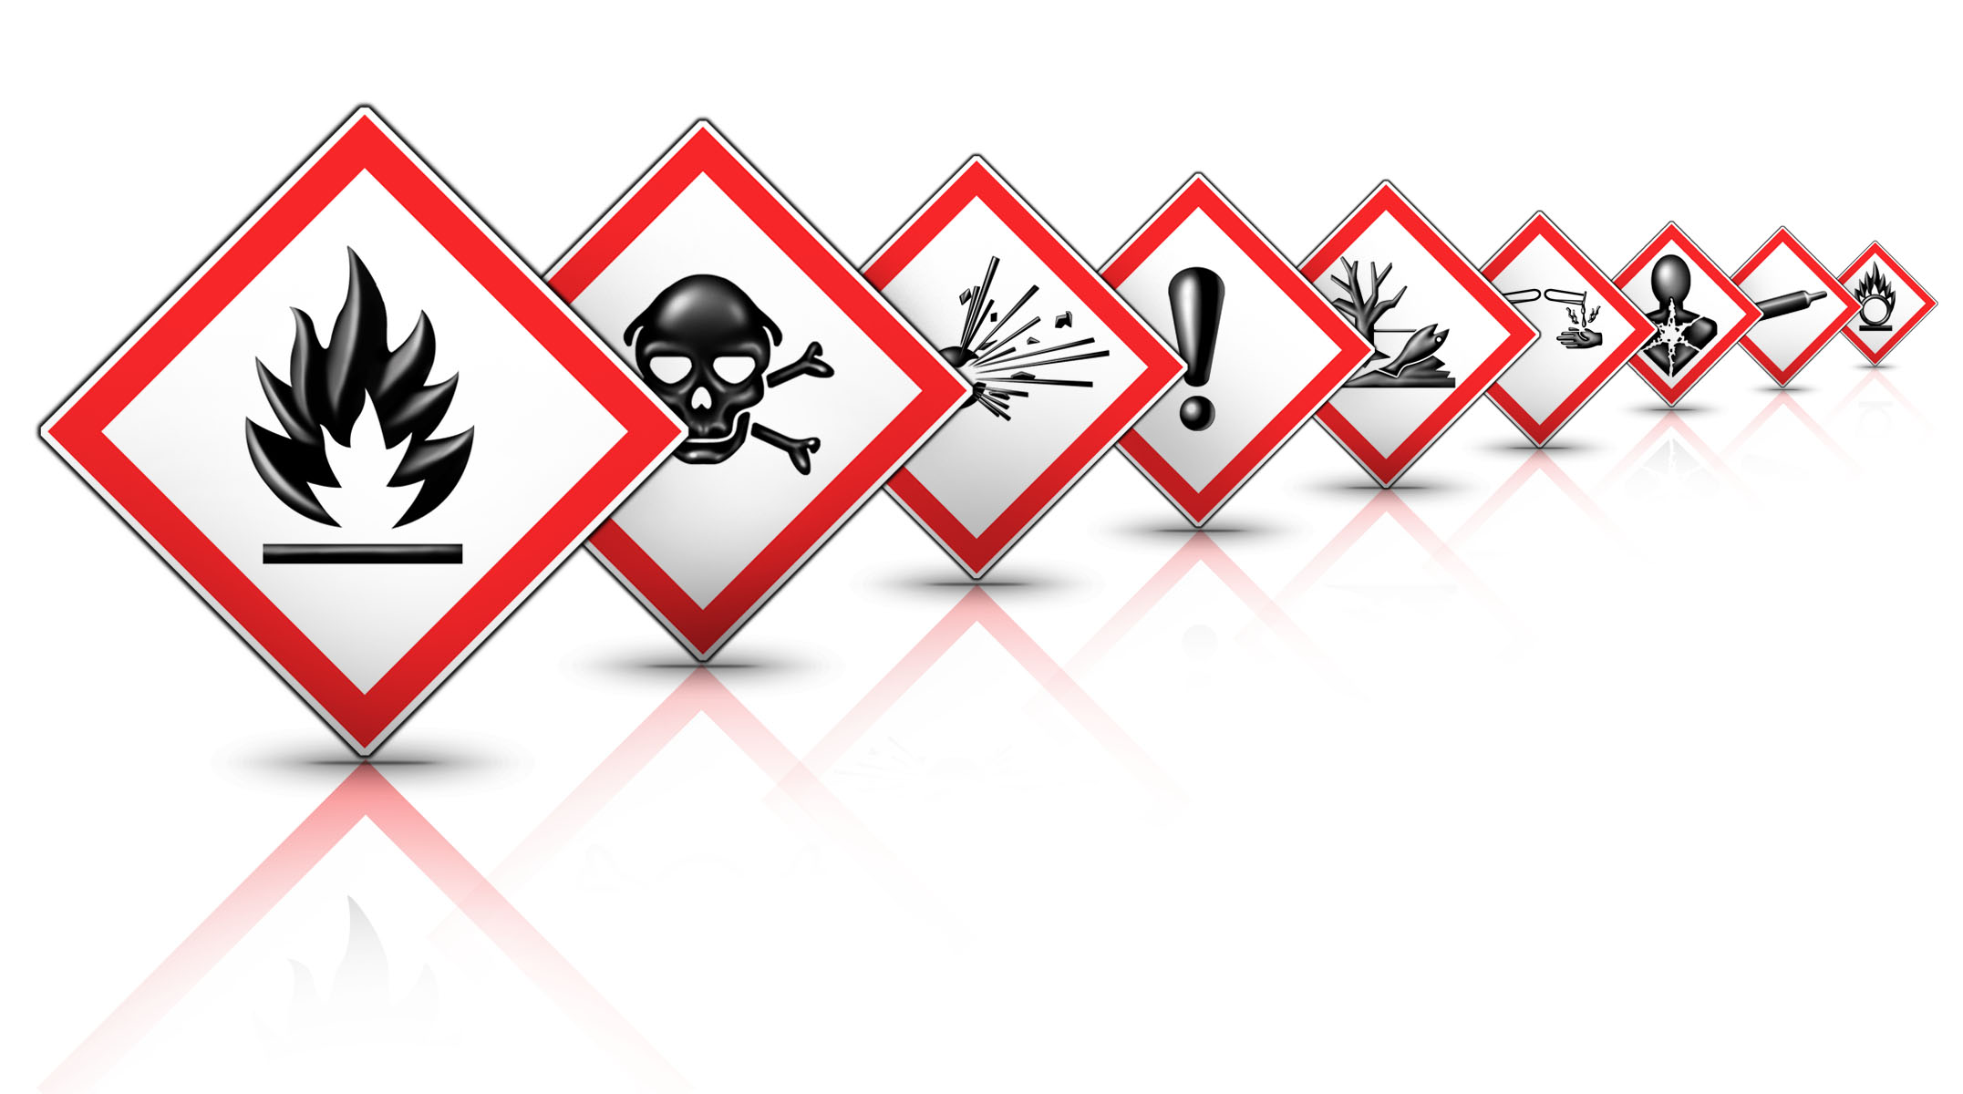
See SDS for full chemical information.

NaCl; Sodium Chloride - Skin irritant; Serious eye irritant; May cause respiratory irritation.[3]

NaI, Sodium Iodide-Very hazardous in case of ingestion. Hazardous in case of eye contact (irritant), of inhalation. Slightly hazardous in case of skin contact (irritant, permeator).[4]

Effect of Hofmeister Salts on Egg Whites (lab)

Objective: Students will be able to describe how salts impact the behavior of proteins.

Essential question: How does the identity and concentration of salts affect the temperature at which proteins precipitate out in solutions?

Engage: (5 min.)

1. Teacher will pass out cards with pictures of folded proteins, unfolded proteins and aggregated proteins, and will ask them to sequence the card which would be the protein structure at room temperature, when heated and the final stabilized structure.
2. Teacher will walk around the room and have a casual conversation with students and ask why they arranged it the way they did. Allow the students to read the background information on the lab worksheet to obtain supporting information.
3. Before starting the lab, supplement students understanding on the structure of proteins and the effect of temperature.

Note to teacher: It is also important that the teacher show the instructional video clip produced along with this lesson that will show an overview of this lab with easy-to-follow instructions.

Explore: (30 min.)
- Using equitable grouping strategy, have the class divided into groups of four.
- Remind students of safety considerations.
- Have them get their lab worksheets, read background information and formulate hypothesis.
- Have students get their materials and work to gather data by following the procedure in the experiment with different salts on egg whites.
- Circulate and provide support to students as they complete the investigation.

Evaluate: (5 min.)
- Have students organize, complete their data table, create a bar graph to show a visual representation of their data, and answer the analysis questions.

Elaborate/ Explain: (10 min.)
- Students refer to key terms and definitions to help them formulate their reasoning.
- The teacher can make clarifying statements if students need some feedback.

Extend: (5-10 min.)

Ask the question: Why do we care about protein folding and unfolding?

- Lots of diseases from Parkinson’s and Sickle cell anemia to Cataract formation in the eyes as well as all Neurodegenerative diseases involve protein misfolding.
- Frying eggs, making Jello, cooking dinner are related to protein denaturation and aggregation.
- Ion specific effects play an important role for interactions at the air/water interface and are important in atmospheric chemistry

Evaluate/Assess:

The teacher can use a quick informal assessment on the fourth day before proceeding to the next lesson to check for student’s understanding of the Hofmeister series.

- Facilitate a post- lab discussion regarding the data and results from the lab in the previous day.
Ask the following questions:
- Which salt lowered the cloud-point temperature? Explain.
- Which salt raised the cloud-point temperature & why?
- Which salt had the ability to induce the denaturation of protein ( from folded to unfolded state)?
- Which salt had the ability to stabilize the folded state the protein in egg white?
- Who confirmed or rejected his/her hypothesis? Why?

Teacher Resources:

The following related literatures on the Hofmeister series were useful resources in developing the lesson. It will be beneficial if the teacher read through them to get a substantial background information.

The video clip produced by Chad Drexler & Jo Virtudes is also an excellent teaching resource. Please see the link below.

- Jungwirth, Pavel, and Paul S. Cremer. "Beyond Hofmeister." Nature Chemistry 6.April 2014 (2014): 26163. Cremer Research Group Publications. Web. 9 July 2015. <http://sites.psu.edu/cremer/?page_id=26>.
- Zhang, Y., & Cremer, P. S. (2009). The Inverse and Direct Hofmeister Series for Lysozyme. Proceedings of the National Academy of Sciences of the United States of America, 106(36), 15249–15253. http://doi.org/10.1073/pnas.0907616106

- Video: “The Effect of Hofmeister Salts on Egg Whites: A High School Chemistry Lab”.
https://youtu.be/Fn7jM6AhzPg

Student Resources:
- Hofmeister series
- Student worksheet # 1 -POE worksheet
- Student worksheet # 2 - Effect of Hofmeister Anions on Egg Whites (lab worksheet)

Key terms:
- Cloud-point temperature- onset of light scattering when aggregates form which makes the solution turn cloudy.
- Salting-out - when ions are excluded from the polymer surface resulting to decreased protein solubility.
- Salting- in - when ions are bound tightly to the polymer surface resulting to increased protein solubility.
- Charge density- is the amount of charge spread out over a certain area.
- High charge density ions- bind water molecules strongly; strongly hydrated ions [5].
- Low charge density ions- bind water molecules weakly; weakly hydrated ions [5].

References:

1. Hofmeister, F Arch. Exp. Pathol. Pharmakol (Leipzig) 24, 247-260 (1888)
2. Hofmeister, F Arch. Exp. Pathol. Pharmakol (Leipzig) 25, 1-30, (1888)
3. http://www.sciencelab.com/msds.php?msdsId=9927593
4. http://www.sciencelab.com/msds.php?msdsId=9927270
5. Charge density-dependent strength of hydration and biological structure. Collins, K. D. (1997). Charge density-dependent strength of hydration and biological structure. Biophysical Journal, 72(1), 65–76.

6. Jungwirth, Pavel, and Paul S. Cremer. "Beyond Hofmeister." Nature Chemistry 6.April 2014 (2014): 26163. Cremer Research Group Publications. Web. 9 July 2015. <http://sites.psu.edu/cremer/?page_id=26>.

7. Zhang, Y., & Cremer, P. S. (2009). The Inverse and Direct Hofmeister Series for Lysozyme. Proceedings of the National Academy of Sciences of the United States of America, 106(36), 15249–15.

