The Effect of Hofmeister Salts on Egg Whites:
A High School Chemistry Lab

Student Worksheets

Worksheet #1

Chemistry
Name_____________________________________Period___________Date____________________

Exploring the Hofmeister Series
Objective: Arrange salts/ions in the order with which they easily “salt-out “or “salt-in” proteins.
Essential question: What is the Hofmeister Series?
A. Directions: 1. Write your prediction first. Your teacher will show a demo with egg whites placed on a beaker with water and heated up on a hot plate.
2. Observe what happens and write at least 2 things in the second column.
3. Write a possible explanation in the third column.
Predict | Observe | Explain
What would happen to the egg white when added to water and heated? | What changes did you see on the egg white, and the water on the beaker? | How was the egg white affected by the temperature of the water in the beaker?

B. Concept map. With a partner draw a concept map about: What makes up egg whites & why or how it changed its appearance with temperature. (Hint: Recall your knowledge on Macromolecules/Biology)

C. What happens when you fry an egg:

In your own words, write what happens when you cook an egg_____________________________

___________________________________________________________________________________

D. Brainstorm with your partner: What would happen to egg white if you put it in a beaker with water, you heat it up but this time there is salt in it? Write you hypothesis below using “If….then…statement”
Hypothesis:
If_________________________________________________________then____________________________________________________________________________________________
E. Sequencing anions: “Salt-out > Salt-in”
Hofmeister series of anions: S0₄ ²⁻ > HP0₄²⁻ > acetate > Cl⁻ >N0₃⁻ > Br ⁻>Cl0₃⁻ >I⁻ >Cl0₄⁻ >SCN⁻
Arrange the salts below in the order with which they will salt-out or salt-in proteins in water from left to right. Use the Hofmeister series to complete the series below:
Fill in the table below:
“Salt-out” “Salt-in”

- NaCl
- NaSCN
- NaBr
- NaC₂H₃0₂
- NaI
- NaN0₃
- Na₂S0₄
- NaCl0₄

F. In your own words discuss what you have learned about the “Hofmeister series”? How is it useful in knowing the effects of salts in solutions?
____________________________________________________________________________
__________________________________________________________________________________________
__________________________________________________________________________________________
__________________________________________________________________________________________
__________________________________________________________________________________________

Worksheet #1 (Teacher’s guide)

Name_____________________________________Period___________Date____________________

Exploring the Hofmeister Series
Objective: Students will be able to arrange salts/ions in the order as to which would easily salt-out or salt-in with proteins.
Essential question: What is the Hofmeister Series?
A. Directions: 1. Write your prediction first. Your teacher will show a demo with egg whites placed on a beaker with water and heated up on a hot plate.
2. Observe what happens and write at least 2 things in the second column.
3. Write a possible explanation in the third column.
Predict | Observe | Explain
What would happen to the egg white when added to water and heated ?  Student’s answers may vary:  Mostly it would be based on prior knowledge of cooking eggs. | What changes did you see on the egg white, and the water on the beaker?  The water turned cloudy;  The egg whites come together as white solid (they clumped to each other.) | How was the liquid egg white affected by the temperature of the water in the beaker?  At room temperature proteins are curled/folded, at higher temperature they denature or uncurl/unfold.

B. Concept map. With a partner draw a concept map about: What makes up egg whites & why or how it changed its appearance with temperature.( Hint:Recall your knowledge on Macromolecules/Biology)
Egg-white proteins are long molecules, made up of chains of amino acids linked together.  Students can draw a chain of polypeptide to represent proteins | In a raw egg, these proteins are curled and folded to form a compact ball.  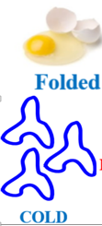 | When you cook an egg, these proteins uncurl and form new bonds with one another.  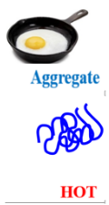

C. What happens when you boil an egg: Show the students this clip here: https://www.youtube.com/watch?v=3QHOnLh3ziQ

In your own words, write what happens when you cook an egg: When you cook an egg, the protein structure changes from folded to unfolded which is called denaturation.

D. Brainstorm with your partner: What would happen to egg white if you put it in a beaker with water , you heat it up but this time there is salt in it? Write you hypothesis below using “ If….then…statement”
Hypothesis:
If salt is added to egg white in water, mixed and heated up, then it would raise or lower the temperature at which the solution would turn cloudy.
E. Sequencing anions : “Salt-out> Salt-in”
Have the students watch a video clip on: The Hofmeister series and Thermoresponsive polymers
https://www.youtube.com/watch?v=AjYeJKVbnBc&feature=youtu.be (start at 4:07-4:56)
Hofmeister series of anions:
SO₄ ²⁻ >HPO₄²⁻ > acetate> Cl⁻ >NO₃⁻ > Br ⁻>ClO₃⁻ >I⁻ >ClO₄⁻ >SCN⁻
Arrange the salts below in the order of which will easily “salt-out” or “salt-in” with polymers from left to right. Use the Hofmeister series to complete the series below:
Fill in the table below:
“Salt-out” “Salt-in”
Na₂SO₄ | NaC₂H₃O₂ | NaCl | NaNO₃ | NaBr | NaI | NaClO₄ | NaSCN

- NaCl
- NaSCN
- NaBr
- NaC₂H₃O₂
- NaI
- NaNO₃
- Na₂SO₄
- NaClO₄
F. In your own words discuss what you have learned about the “ Hofmeister series”? How is it useful in knowing the effects of salts in solutions?
The Hofmeister series is a ranking of ion-specific effects originally discovered by Franz Hofmeister in 1888. It is very important in knowing that different salts affect how proteins precipitate out in solutions. Macromolecule phase behavior are strongly influenced on the identity and concentration of the salts added in solution.

Worksheet #2

Name_________________________________Period___________Date____________________

Effect of Hofmeister Salts on Egg Whites (lab)

Objective: Be able to describe how salts impact the behavior of proteins.

Essential question: How does the identity and concentration of salts affect the temperature at which proteins precipitate out of solutions?

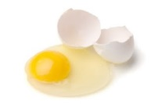
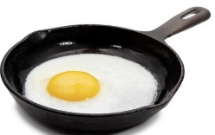
Background:

Denaturation is the process by which protein molecules lose their native state through the application of heat or compounds such as acids, bases, salts or organic solvents. At room and physiological temperatures proteins are folded, and at high temperatures they denature. The temperature at which this change occurs can be strongly influenced by the addition of salts such as NaCl and NaI. Different anions lower or raise the precipitation temperature according to the Hofmeister series, which is a ranking of ion-specific effects originally discovered by Franz Hofmeister in 1888. Cations and anions can affect surface tension, water activity and even solubility behavior of macromolecules such as polypeptides or proteins. Anions appear to have a larger effect than cations, and are usually ordered: CO₃ ²⁻> SO₄ ²⁻ > S₂O₃²⁻ >HPO₄²⁻ > F⁻> Cl⁻> Br⁻>NO₃⁻ >I⁻ >Cl0₄⁻>SCN⁻ . Early members of the series have high charge density which tends to increase solvent surface tension and cause nonpolar molecules to collapse in itself (“salting-out”), in effect they strengthen the hydrophobic interaction which decreases protein solubility. By contrast, later salts in the series have low charge density which makes the ions bind to the protein molecules thus increasing their solubility ("salting-in”) and in effect, they weaken the hydrophobic effect. In this lab, you will learn how salts impact the behavior of macromolecules, particularly proteins in egg whites.

Key terms:
- Cloud-point temperature- it is the temperature at which aggregates form which makes the solution turn cloudy.
- Salting-out - when ions are excluded from the polymer surface resulting to decreased protein solubility.
- Salting- in - when ions are bound tightly to the polymer surface resulting to increased protein solubility.
- Charge density- is the amount of charge spread out over a certain area.
- High charge density ions- bind water molecules strongly; strongly hydrated ions.
- Low charge density ions- bind water molecules weakly; weakly hydrated ions.

Materials for each lab group:
A. This is 1:1 ratio of salt solution to filtered egg white using 5M NaCl and NaI

- Three 4 ml glass vials or test tubes
Vial #1 ( 2 ml DI water + 2 ml filtered egg white)
Vial #2 ( 2 ml 5 M NaCl + 2 ml filtered egg white)
Vial #3 ( 2 ml 5 M NaI+ 2 ml filtered egg white)

B. This is 1:3 ratio of salt solution to filtered egg white using 3M NaCl and NaI

- Three 4 ml glass vials or test tube
Vial #1 ( 1 ml DI water + 3 ml filtered egg white)
Vial #2 ( 0. 6ml 5 M NaCl+ 0.4 ml distilled water + 3 ml filtered egg white)
(This now is your 3M NaCl + FEW)
Vial #3 ( 0.6ml 5 M NaI+ 0.4 ml distilled water + 3 ml filtered egg white)
(This now is your 3M NaI + FEW)

- Distilled water
- Ice (crushed preferred)
- Thermometers or temperature probes
- Hot plate
- 100 ml beaker
- A piece of paper with black and white lines taped at the back of the beaker (optional)
- Iron stand and clamps to set-up and hold the thermometer as it is placed inside the vial
- Tongs
- Student worksheets

Safety Information for students

- Students must wear safety glasses, gloves and closed toed shoes.
- Students should exercise caution when working with glass and heating elements.
- Students should not over heat closed containers.

- Hypothesis
Write a hypothesis about which salt (NaCl, or NaI) could raise or lower the temperature of egg whites in solution the most. Use the “ if….then”…format.

If _________________________________________________ then____________________
____________________________________________________________________________.

- Procedure
- Wear safety glasses and gloves, and get the lab materials for your group. Do not open the vials unless told by your teacher.
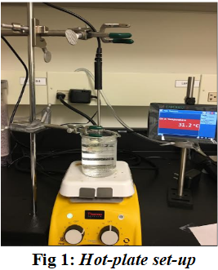
- Fill the 100 ml beaker with approximately 75 ml of tap water. Prepare the set- up shown in Fig 1 using iron clamps to place the vial inside the beaker with water and a thermometer placed inside the vial.

- Make sure the solution is evenly mixed by carefully swirling the vial before you clamp it inside the water bath. Place the thermometer inside the vial making sure the probe is not touching the sides and the bottom. Turn the hot plate into a low heat setting.
Figure 1 Hot plate set-up
- You will record the cloud-point temperature, in your data table. Note the temperature when the solution starts to get cloudy. This is the onset of scattering of light which is indicated by cloudy or milky white solution. Turn off the hot plate.

- You will repeat this procedure for all your samples.

- When you are about to do the next vial, make sure you dump off half of the hot water from your beaker an replace it with cold water or ice to cool down the water temperature. You will then re-heat the hot plate to a low setting.

- After the cloud-point temperatures have been recorded for all your samples, clean up, return the materials, except the hot plate. Allow time for the hot plate to cool before putting away.

- Data Collection: Record your data in the table below

Vial # | Species | Cloud-point  Temperature (ºC)
1 | 2 ml Distilled H₂O + 2 ml egg white
2 | 2 ml 5 M NaCl + 2 ml egg white
3 | 2 ml 5 M NaI + 2 ml egg white

Vial # | Species | Cloud-point  Temperature (ºC)
1 | 1 ml Distilled H₂O + 3 ml egg white
2 | 1 ml 3 M NaCl + 3 ml egg white
3 | 1 ml 3 M NaI + 3 ml egg white

- Analyze results: Create a bar graph to visually represent your data above. Use different colored pencils and create a legend.

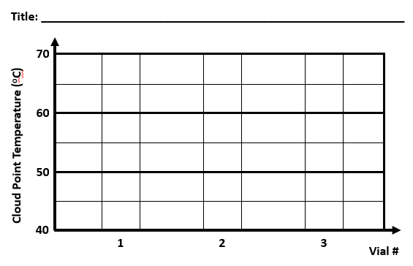
- Draw conclusion

- From your data and graph above, compare which of the solutions from the three vials raised or lowered the cloud point temperature _____________________________________________
____________________________________________________________________________

- How do your results for Vial # 2 ( with NaCl) and # 3 ( with NaI) compare with vial #1 (no salt)? Refer to the change in temperature ( ) from the data table to support your answer.

____________________________________________________________________________
____________________________________________________________________________
____________________________________________________________________________

- Briefly describe how the chemical identity of the salt impacts the behavior of proteins to precipitate out in solution. (Discuss in terms of the position of the anion in the Hofmeister series and the and the charge density ( low or high) of the ion. )__________________________________________

Checking for Understanding:
- Circle one: Which salt had the ability to induce the denaturation of the protein in egg white that lowered the cloud-point temperature?( NaCl, or NaI)

- Circle one: Which salt had the ability to stabilize the folded state of the protein in egg white that caused to raise the cloud-point temperature?
( NaCl, or NaI)

Extension: Conduct online research on “ Why we need to learn about protein folding and unfolding and its impact in chemical and biological processes”.

References:
    - Hofmeister, F Arch. Exp. Pathol. Pharmakol ( Leipzig) 24, 25; 1-30; 247-260 (1888)

    - Charge density-dependent strength of hydration and biological structure. Collins, K. D. (1997). Charge density-dependent strength of hydration and biological structure. Biophysical Journal, 72(1), 65–76.

    - Jungwirth, Pavel, and Paul S. Cremer. "Beyond Hofmeister." Nature Chemistry 6.April 2014 (2014): 261¬63. Cremer Research Group Publications. Web. 9 July 2015. <http://sites.psu.edu/cremer/?page_id=26>.

    - Zhang, Y., & Cremer, P. S. (2009). The inverse and direct Hofmeister series for lysozyme. Proceedings of the National Academy of Sciences of the United States of America, 106(36), 15249–15253.

Chemistry Student Worksheet #2 (Teacher’s guide)

Name_________________________________Period___________Date____________________

Effect of Hofmeister Salts on Egg Whites (lab)

Objective: Students will be able to describe how salts impact the behavior of proteins.

Essential question: How does the identity and concentration of salts affect the temperature at which proteins precipitate out in solutions?

Background:

Denaturation is the process by which protein molecules lose their native state by changing its viscosity or color through the application of heat or compounds such as acids, bases, salts or organic solvents. At room and physiological temperatures proteins are folded, and at high temperatures they denature. The temperature at which this change occurs can be strongly influenced by the addition of salts such as NaCl and . Different anions lower or raise the precipitation temperature according to the Hofmeister series, which is a ranking of ion-specific effects originally discovered by Franz Hofmeister in 1888. Cations and anions can affect surface tension, water activity and even solubility behavior of macromolecules such as polypeptides or proteins. Anions appear to have a larger effect than cations,[3] and are usually ordered :
CO₃ ²⁻> SO₄ ²⁻ > S₂O₃²⁻ >HPO₄²⁻ > F⁻> Cl⁻> Br⁻>NO₃⁻ >I⁻ >Cl0₄⁻>SCN⁻. Early members of the series have high charge density which tends to increase solvent surface tension and cause nonpolar molecules to collapse in itself (“salting-out”), in effect they strengthen the hydrophobic interaction which decreases protein solubility. By contrast, later salts in the series have low charge density which makes the ions bind closely to the protein molecules thus increasing their solubility ("salting-in”) and in effect, they weaken the hydrophobic effect. In this lab, you will learn how salts impact the behavior of macromolecules, particularly proteins in egg whites.

Key terms:
Cloud-point temperature- onset of light scattering which makes the solution turn cloudy or milky white.
- Salting-out - when ions are excluded from the polymer surface resulting to decreased protein solubility.
- Salting- in - when ions are bound tightly to the polymer surface resulting to increased protein solubility.
- Charge density- is the amount of charge spread out over a certain area.
- High charge density ions- bind water molecules strongly; strongly hydrated ions [2].
- Low charge density ions- bind water molecules weakly; weakly hydrated ions [2].

Materials for each lab group:
Note: Depending on available time, the teacher may only let students do one of the conditions below or both.
A. This is 1:1 ratio of salt solution to filtered egg white using 5M NaCl and NaI

- Three 4 ml glass vials or test tubes
Vial #1 ( 2 ml DI water + 2 ml filtered egg white)
Vial #2 ( 2 ml 5 M NaCl + 2 ml filtered egg white)
Vial #3 ( 2 ml 5 M NaI+ 2 ml filtered egg white)

B. This is 1:3 ratio of salt solution to filtered egg white using 3M NaCl and NaI

- Three 4 ml glass vials or test tube
Vial #1 ( 1 ml DI water + 3 ml filtered egg white)
Vial #2 ( 0. 6ml 5 M NaCl+ 0.4 ml distilled water + 3 ml filtered egg white)
(This now is your 3M NaCl + FEW)
Vial #3 ( 0.6ml 5 M NaI+ 0.4 ml distilled water + 3 ml filtered egg white)
(This now is your 3M NaI + FEW)

- Distilled water
- Ice (crushed preferred)
- Thermometers or temperature probes (Vernier temp probe/labquest; Digital thermometer)
- Hot plate
- 100 ml beaker
- A piece of paper with black and white lines taped at the back of the beaker (optional)
- Iron stand and clamps to set-up and hold the thermometer as it is placed inside the vial
- Tongs
- Student worksheets

Safety Information for students

- Students must wear safety glasses ,gloves and closed toed shoes.
- Students should exercise caution when working with glass and heating elements.
- Students should not over heat closed containers.

  - Hypothesis
Write a hypothesis about which salt ( NaCl, or NaI) could raise or lower the temperature of egg whites in solution the most. Use the “ if….then…format.

Students write a hypothesis and choose one from the salts above as to which they think would raise or lower the temperature of egg whites in solution.

  - Procedure
1.Wear safety glasses and gloves, and get the lab materials for your group. Do not open the vials unless told by your teacher.

2. Fill the 100 ml beaker with approximately 75 ml of tap water. Prepare the set- up shown in Fig 1 using iron clamps to place the vial inside the beaker with water and a thermometer placed inside the vial.

3. Make sure the solution is evenly mixed by carefully swirling the vial before you clamp it inside the water bath. Place the thermometer inside the vial making sure the probe is not touching the sides and the bottom. Turn the hot plate into a low heat setting.

4.You will record the cloud-point temperature, in your data table. Note the temperature when the solution starts to get cloudy. This is the onset of scattering of light which is indicated by cloudy or milky white solution. Turn off the hot plate.

5.You will repeat this procedure for all your samples.

6.When you are about to do the next vial, make sure you dump off half of the hot water from your beaker an replace it with cold water or ice to cool down the water temperature. You will then re-heat the hot plate to a low setting.

7.After the cloud-point temperatures have been recorded for all your samples, clean up, return the materials, except the hot plate. Allow time for the hot plate to cool before putting away.

  - Data Collection: Record your data in the table below
Vial # | Species | Cloud-point  Temperature (ºC)
1 | 2 ml Distilled H₂O + 2 ml egg white | 58.5
2 | 2 ml 5 M NaCl + 2 ml egg white | 62.6 | Vial 2 temp- Vial 1 temp
3 | 2 ml 5 M NaI + 2 ml egg white | 57.1 | Vial 3 temp- Vial 1 temp

Vial # | Species | Cloud-point  Temperature (ºC)
1 | 1 ml Distilled H₂O + 3 ml egg white | 57.5
2 | 1 ml 3 M NaCl + 3 ml egg white | 59.6 | Vial 2 temp- Vial 1 temp
3 | 1 ml 3 M NaI + 3 ml egg white | 56.2 | Vial 3 temp- Vial 1 temp

  - Analyze results: Create a bar graph to visually represent your data above. Use different colored pencils and create a legend.
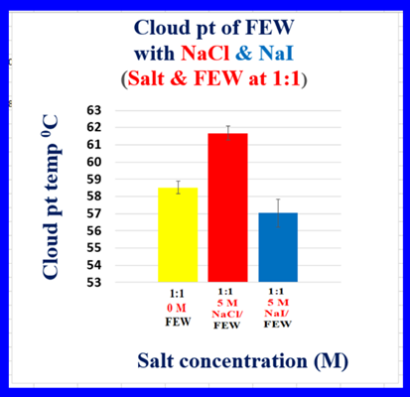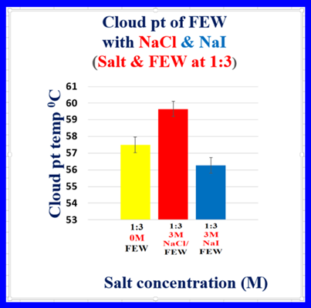

- Draw conclusion

    - From your data and graph above, compare which of the solutions from the three vials in each condition raised or lowered the temperature to reach a cloud point. NaCl solution raised the temperature for the solution to get cloudy , while NaI lowered the temperature for the solution to get cloudy.

    - How do your results for Vial # 2, & #3 compare with vial #1 without salt in it? Refer to the change in temperature ( ) from the data table to support your answer.
The egg white with DI water (which is the control vial ) reached around 60 degrees ( or whatever temp your students got from the experiment) before the solution turned cloudy, but the one with NaCl was way higher than the temperature obtained in the control vial , while the one with NaSCN went lower in temperature compared to the control vial.

    - Briefly describe how the chemical identity of the salt impacts the behavior of proteins to precipitate out in solution. Discuss in terms of the position of the anion in the Hofmeister series and the charge density ( low or high) of the ion.

Ions differ in their ability to salt out proteins in solution. SCN⁻ ions have low charge density, which makes them bind directly with the polymer which induces its unfolding thereby reaching its cloud-point. On the other hand, high- charge density ions, like Cl⁻ remain hydrated and are excluded from the polymer which results in stabilizing the folded state thus requiring higher temperature (to unfold the proteins) before reaching a cloud-point.

    - Confirm or Reject your Hypothesis:
Students either confirm or reject their hypothesis and state the reason why.
Checking for Understanding:
- Circle one: Which salt had the ability to induce the denaturation of the protein in egg white that it lowered the cloud-point temperature?( NaCl, or NaI)

- Circle one: Which salt had the ability to stabilize the folded state of the protein in egg white that caused to raise the temperature for the solution to turn cloudy?
( NaCl, or NaI)

Extension: Conduct an online research on “ Why we need to learn about protein folding and unfolding and its impact in chemical and biological processes.

Note: The teacher can provide a rubric for this assignment.

Students could come up with different diseases such as Parkinson’s disease, Sickle cell anemia, Cataract formation and all Neurodegenerative diseases.

