Wordpress: You will need access to a server(PSU) and domain which is at an extra cost if you don’t want the extension “.wordpress.com”. They have a layout and options of webpage layouts catered the to specific need of the users.

Freelance options:
Sites.psu.edu/Transmedianarratives
The domain and servers are already offered there. No extra cost. The themes are very limited and not customizable immediately. Lives on a PSU server and the domain name is not customizable unless requested. Run by wordpress

Plans offered:
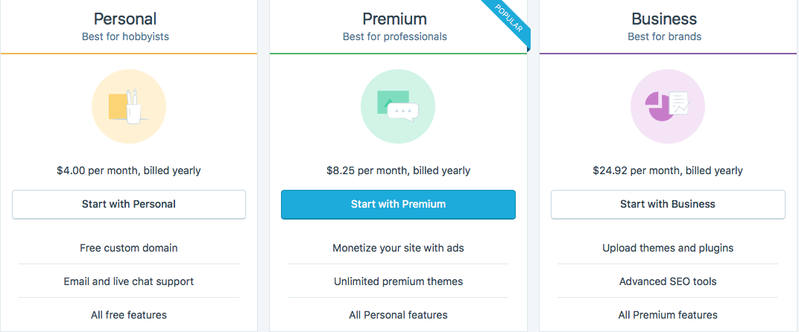

Wix: This website hosting program provides all Servers and domain as one package with a payment plan. Has 500 website designs which are useful but also subject to customizing through HTML writing. The free domain name offers a your-username.wix.com/sitename/page-url
” limits in comparison to the paid subscriptions.

Plans Offered:
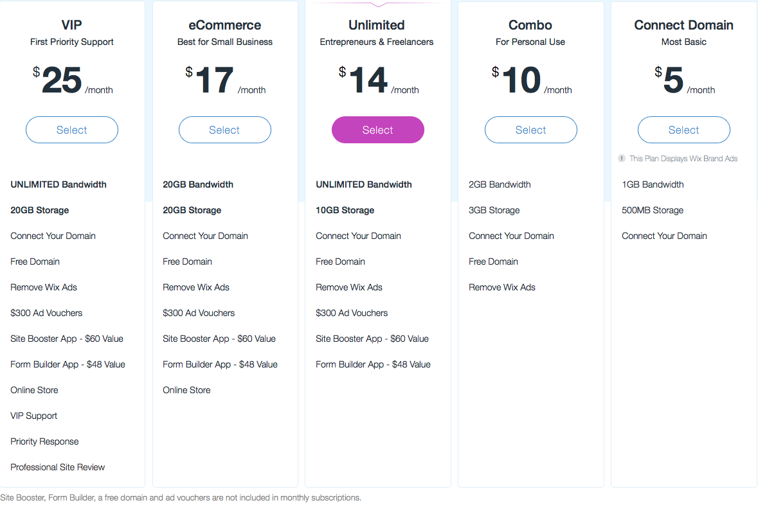

Squarespace:
This hosting service offers a domain under “your-username.squarespace.com”. Similar to Wix in its offering of various themes but like Wix it does limit customization and additions. Only offers 25+ designs but are compatible on mobile devices (Wix has some themes that lack this feature). There is no FREE plan with Squarespace.

Plans: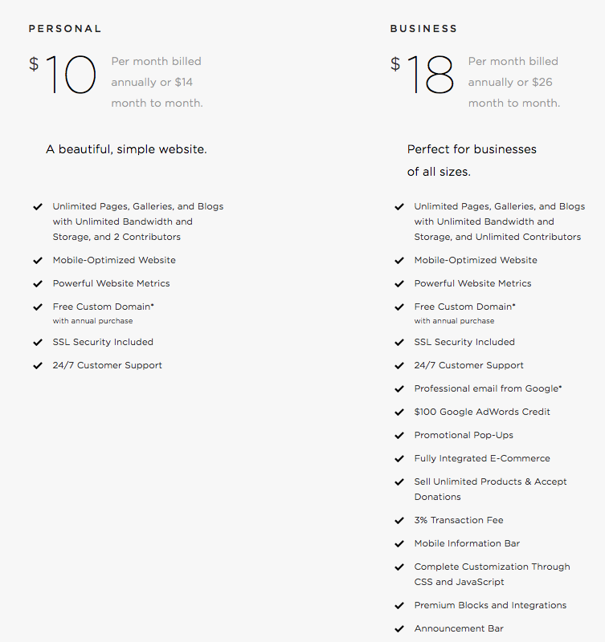

Transmedianarratives.psu.edu
This option will have to be requested to main campus. If in the worst case scenario we do have to leave the program PennState owns it. This is fully customizable through Dreamweaver but will take longer than any of the other options above due to the level of coding and server hosting.
B

