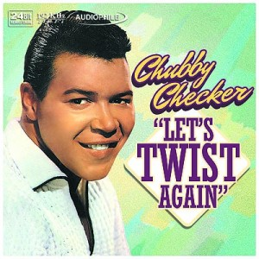
NOT
- Park the chair facing the wall
- Stand and pivot
- Don’t do the twist!

