Let’s fight COVID together:
REMIND THE STAFF TO:
WEAR MASK OVER the NOSE and MOUTH
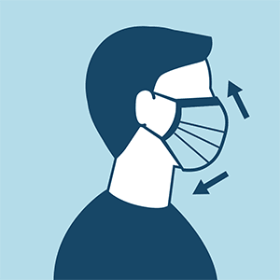
USE lots of HAND SANITIZER
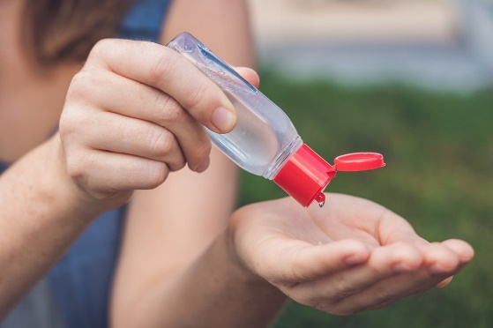
NOT TOUCH anything BEFORE caring for YOU

