Penn State RET in Interdisciplinary Materials

Teacher’s Preparatory Guide

Connecting the Dots in Electricity

Purpose: This lab is designed to help students understand the interrelationships between the three concepts that are the basics for understanding electricity – voltage, current, and resistance.

Objectives: The physical relationships between current, voltage, and resistance is defined by the equation known as Ohm’s Law. In this lab student’s will collect data about each of these three items and use this data to determine the Ohm’s Law relationships on their own.

Time required this lab is designed for 3 class periods

Level: High school

Next Generation Science Standards;

HS-PS3-1

Create a computational model to calculate the change in the energy of one component in a system when the change in energy of the other component(s) and energy flows in and out of the system are known.

HS-PS3-5.

Develop and use a model of two objects interacting through electric or magnetic fields to illustrate the forces between objects and the changes in energy of the objects due to the interaction.

Florida Standards:

SC.912.P.10.14

Differentiate among conductors, semiconductors, and insulators.

SC.912.P.10.15

Investigate and explain the relationships among current, voltage, resistance, and power.

Teacher Background: The study of the relationship of current, voltage, and resistance as defined by Ohm’s Law is a basic curriculum requirement in most all physics classes. Like many, I introduced the formula and had the students solve math problems. I was concerned that there was no inquiry activity for the students to discover Ohm’s Law on their own so I created this lab to address that. I designed a circuit board designed to support the completion of the lab.

Materials
- Ohm’s Law Lab circuit board
- Multi-meter
- Lab instructions
- Graph paper
- New D cell batteries – 5 per circuit board

Advance Preparation To carry out this lab you need a class set of the circuit board I designed for the lab. It can be duplicated on a bread board from the attached design blueprint, but it is not as rugged. You will also need the material listed above. Make sure you have fresh D cell batteries as performance is inconsistent if the batteries are weak. Labs teams can consist of 2-3 students. Prior to the lab, the materials for each team should be set out at an appropriate lab location.

Safety Information students should wear safety goggles while working in the lab

Teaching Strategies Inquiry drives labs are designed to create productive struggle for students. This lab fits that criteria. After the students review a short summary of the concepts of current, resistance, and voltage the instructions for the lab review the board layout and then provide directions for the collection of data. After the data is collected it is graphed and from the graph the students will be able to derive Ohm’s Law on their own. The formula (y = ax +b) for a linear relation should be explained prior to the start of the graphing process.

Resources: The Ohm’s Law Lab board can be used for multiple experiments. Deriving Ohm’s Law is just one. Students can also explore the impact of resistors placed in serial, parallel, or combination arrangements to study the impact voltage, resistance, and current across the entire circuit as well as though individual resistors.

Directions for the activities This lab is designed for three class periods. One for set-up, one for data collection/graphing, and one for discussion. A lab report should be included and completed outside of class. Use whatever lab report format you have established with you class for this task.

Procedure Students should follow the procedures laid out in the lab for set-up, data collection, and graphing. Students will very likely need instruction and help in how to use a multi-meter to collect data on voltage, current, and electricity. However, pictures for multi meter settings and where to place the probes to take the reading are included in the student instructions. They will likely also need help with graphing and interpreting graphed data.

Student Worksheet or Guide

Connecting the Dots in Electricity

Introduction

We know what electricity is. It hides behind all those plugs around the house. Just plug something in or flip a switch and electricity flows and something works or the lights go on. Is electricity really that simple? If it is then what is that electrical panel in the garage for? Do we really need it? And did you notice the plug for the dryer is different than the one for the washer? How come? Why are you told not to push your fingers or stuff metal objects into the electrical outlet? How does somebody get electrocuted? And if electricity is easy to understand how do you explain students going to college for four years to become electrical engineers. Maybe the concept really is more complicated than we think?

Materials

- Ohm’s Law Lab circuit board
- Multi-meter
- Lab instructions
- Graph paper
- New D cell batteries – 5 per circuit board
- Calculator
- ruler

The behavior of electricity is bounded by three interrelated concepts – voltage, current, and resistance. Before reading further, use your prior knowledge to come up with a description for each.

Voltage:

Current:
________________________________________________________

________________________________________________________

Resistance:
________________________________________________________

________________________________________________________

Electricity Background:

For electricity to work electrons need to move so that energy can be passed along. The measurement of that movement is called “current” and we measure it in a unit called amperes or amps for short. To get electrons to move you need to push them along. They don’t flow by themselves. The measurement of that push is called “voltage” and is measured in volts. The reason we want electricity to flow is so we can do something with it like run the toaster or turn on a light. In physics terms, we want it to do “work”. Doing that work slows down the flow of electric energy and often converting it into another form of energy such as heat energy for a toaster or light energy for a lightbulb. This conversion or slowdown of energy flow is called resistance because it inhibits the unrestricted flow of electric energy. We measure resistance in a unit called “ohms”. Inside products a resistor can be used just to manage the proper flow of electricity between components. In this application, a resistor looks like a tiny tube with colored bands on it and wires attached at both ends.

Now let’s get the official definitions – go to google and record the definitions for voltage, current, and resistance. Describe how the compared to your original description.

Voltage:

Current:

Resistance:

Procedures:

A valid experiment is limited to only two variables, the independent variable and the dependent variable. Do you remember which is which? Write your description below – no Googling!

Independent Variable:

Dependent Variable:

Since we are dealing with three potential variables [current, voltage, resistance] we will collect data for two at a time and hold the third variable constant.

Data Collection #1 Resistance is constant, voltage is the independent variable, and current is the dependent variable.
In our first data collection, we will keep voltage constant and look at the relationship between current and resistance. We will repeat this process with different voltages.
Place 2 D cell batteries in the first two battery holders. Record the number of volts you are using on the data chart. Just because the batteries say they are 1.5 volts do not write that down. Batteries lose voltage as they wear down so measure the actual voltage. Use the pictures below that share you where to place the two probes and where to set the dial on the multimeter to get the proper reading.

Actual Battery voltage: 2 D cells: _______________ 3 D cells: _____________________
4 D cells: _______________ 5 D cells: _____________________

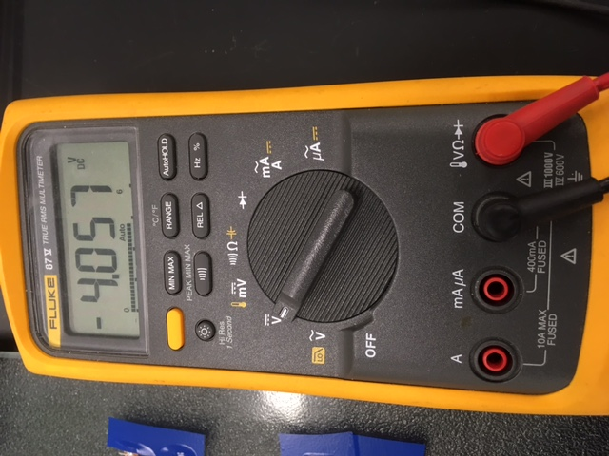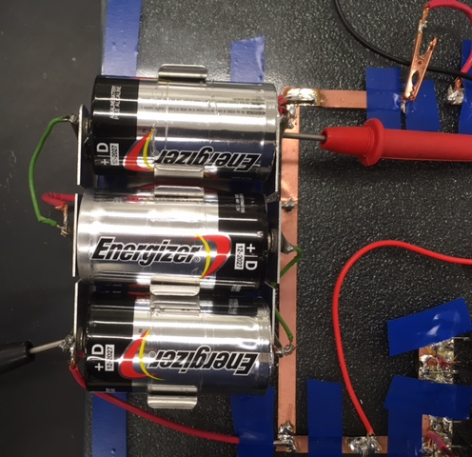

Set the resistance by connecting the two black leads on each side of the 5th resistor down from the top:

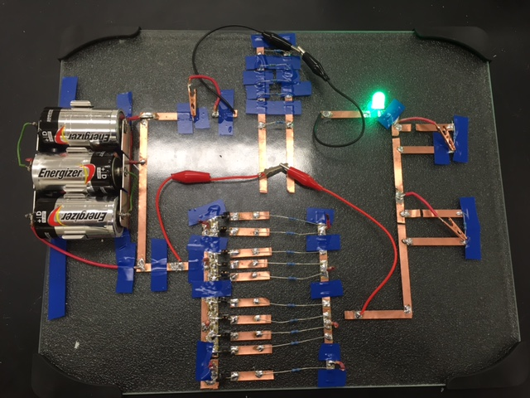

What is the resistance in Ohms of that resistor? You can find out by disconnecting the circuit and placing the probes on either side of the resistor and set the multimeter to measure ohms. See the pictures to set this up correctly. Remember there will only be one resistance value while we collect data on changes in voltage and current.

Values of resistor in ohms: _______________

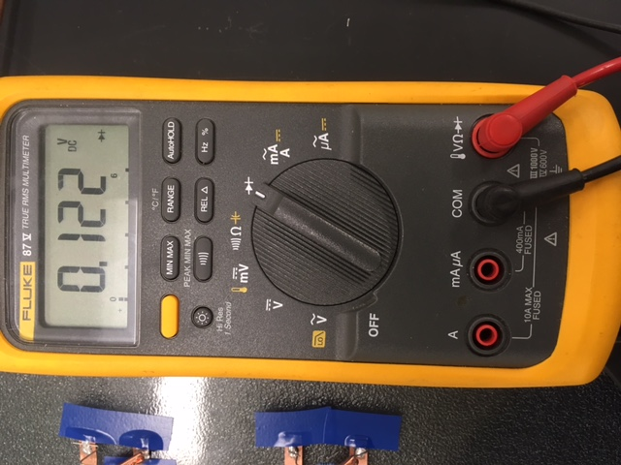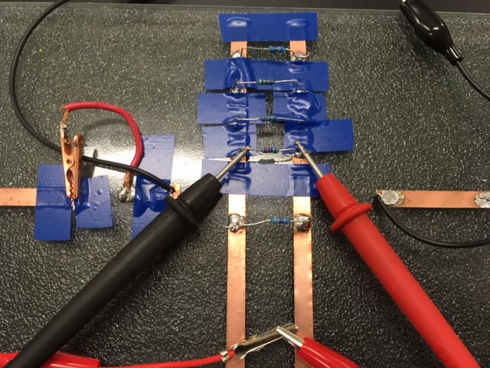

Data Collection: voltage in relationship to current.

Resistance  in ohms | Number of  batteries | Actual voltage  in volts | Measurement of  current in amps

To collect actual voltage readings, refer to the earlier pictures on how to set up the multimeter and where to place the probes.

Use the pictures below to set up the multimeter to measure current and where to place the probes on the circuit board to get the proper measurement.

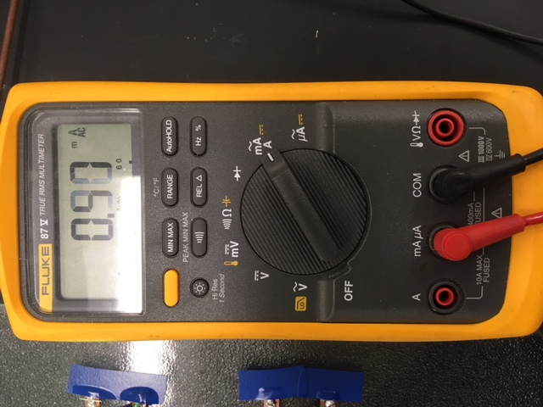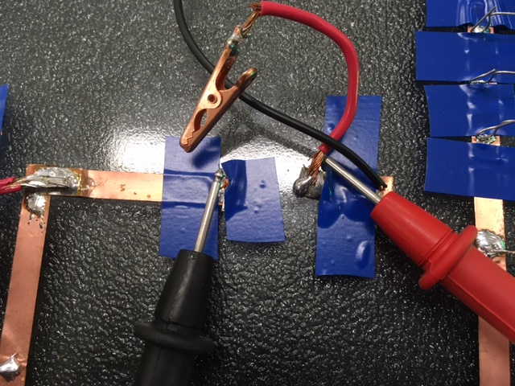

Graph your data for voltage in relationship to current. Don’t forget to a proper scale set-up to maximize your graph size. And don’t forget to include 0,0 as a valid data point as no voltage means no current.

Current
In amps

Voltage in volts

What relationship does your graph suggest exists between a given voltage and the current produced?

________________________________________________________________________________

What is the slope value of the line on your graph? Is the line basically straight?

_______________________________________________________________________________________

What does the slope value suggest about the relationship between a change in voltage and the change in current it will produce?

______________________________________________________________________________________

If we added two more batteries at 1.5 volts each, what do predict the new current value would be? Show the math you used to determine that new current value.

Predict:_________________Math:___________________________________________________

Data collection #2: Voltage is constant, resistance is the independent variable, and current is the dependent variable.

Voltage: insert 2 D cell batteries into the battery holder. Measure to get the actual voltage of the batteries and record that value. Remember it will not be 1.5 volts times two!

Actual voltage from 2 D cell batteries: _____________________

To adjust resistance, we are going to add one more resistor for each measurement. This means adjusting the circuit layout to include more resistors. You already saw how to put one resistor in the circuit by clipping the black wires on either side of the 5th resistor down from the top. You also learned earlier how to measure the resistance value with the circuit off by touching the multimeter probes on either side of the resistor and placing the multimeter setting at the top position to get an accurate reading.
To get the current reading for reach resistor set up you will use the same process you used in data collection one. Follow the picture you used in data collection one to make sure your meter and probe connections are set up correctly. Now, let’s collect some data!

4
3
2
1

How to add resistors for data collection #2:
1
For 1 resistor as shown in the above diagram, connect a black wire clip on both side of the resistor circled in yellow.

For two resistors, move the red wire clip, as seen in oval 2, from the top side to the bottom side of the resistor. This has already been done as shown in the picture. Keep the first resistor hooked up as it was.

For three resistors, move the red wire clip from the top side to the bottom side of the resistor in oval 3. This has already been done as shown in the picture. Keep the set-up for the first two resistors the same.

For four resistors in series connect the red clip wires on either side of the bottom resistor shown in oval 4. This has not been done in the drawing. Leave the set up for the other three resistors the same.

Before you begin collecting data you should determine the actual resistance of each resistor you are working with. You will do this the same way you did at the start of data collection #1. With the circuit off, set the multimeter to measure ohms and touch the probes to either side of the resistor. You can round this value to the next value of ten [10,20,30,40, etc.]

Voltage in volts for  2 D cells | Number of resistors in series | Resistance in olms | Current in amps
 | 1
 | 2
 | 3
 | 4
 | 5 (future)

Now we are going to repeat this process using 4 D cell batteries instead of two. Follow the same process to measure 1, then 2, then 3, then 4 resisters in series so disconnect all the connections you made after collecting your last data for 2 D cell batteries and 4 resistors and start over.

Voltage in volts for  4 D cells | Number of resistors in series | Resistance in olms | Current in amps
 | 1
 | 2
 | 3
 | 4
 | 5

What do you notice about the relationship of your current measurements for the same number of resistors when you compare the results of the readings for 2 D cells with the readings for 4 D cells?

_______________________________________________________________________________________

_______________________________________________________________________________

What pattern, if any did you see when you compared the measurements?

_______________________________________________________________________________

Now draw the graph of your data. Put the data for 2 D cells and 4 D cells on the same graph. Make sure to scale your graph so both sets of data can be plotted.

Current
in amps

Resistance in ohms

Data Collection #3: Current is constant, voltage is the independent variable, and resistance is the dependent variable.

As you may have noticed already, changing voltage or resistance changes the current so data collection #3 is a little trickier than the first two. For this data collection we are going to set up one D cell battery and one resistor (the one connected by the two black wires clips) to determine the initial current of the circuit. Remember to measure the actual voltage of the D cell batteries as you go. You likely have learned by now that just because the battery has 1.5 volts printed on the side of the battery doesn’t mean it still has 1.5 volts of power inside.

After getting the initial current value, you are going to add batteries to the circuit one at a time. With no other changes, you will see that the current goes up each time we add a battery just like it did in data collection #1. To keep current the same you are going add resistors into the circuit until the current is very close to the initial value you established for one battery and one resistors. This will mean following the same process you did when you added in additional resistors in data collection #2. To get total resistance just add up the resistance values for each individual resistor.

Current in Amps | Number of batteries | Actual voltage | Number of resistors | Total resistance
 | 1
 | 2
 | 3
 | 4
 | 5

Now graph your results for voltage and resistance when current is constant.

Resistance in ohms

Voltage in volts

What type of relationship do you see as you plot change in resistance in relationship to change in voltage?
__________________________________________________________________________________
__________________________________________________________________________________
__________________________________________________________________________________

You now have the data you need to start to identify the relationship between voltage, current, and resistance and to construct a mathematical model [equation] the would represent the relationship between all three mathematically.

Data collection #1: change in voltage compared to change in current:

What type of relationship did you see between voltage and current in data collection #1?

_______________________________________________________________________________

_______________________________________________________________________________

How might you express this in math terms?

_______________________________________________________________________________

Data collection #2: change in resistance compared to change in current:

What type of relationship did you see between resistance and current in data collection #2?

_______________________________________________________________________________

_______________________________________________________________________________

How might you express this in math terms?

_______________________________________________________________________________

Data collection #3: change in voltage compared to change in resistance:

What type of relationship did you see between voltage and resistance in data collection #3?

_______________________________________________________________________________

_______________________________________________________________________________

How might you express this in math terms?

_______________________________________________________________________________

Now let’s compare all three:

Mathematical relationship between voltage and current. [examples – direct relationship: when voltage goes up the current goes up by the same ration or indirect relationship: when voltage goes up current goes down by the same ratio]

_________________________________________________________________________________

Mathematical relationship between resistance and current.

_________________________________________________________________________________

Mathematical relationship between resistance and voltage.

_________________________________________________________________________________

Ohm’s Law is the formula that pulls all three variables together into one equation. Based on what you have learned make a prediction of what the Ohm’s Law equation is. Use “V” to represent voltage, use “I” to represent current, and use “R” to represent resistance.

Ohms Law Formula – your prediction Ohms Law Formula – actual

How did your equation compare with the actual one?

________________________________________________________________________________

How was it similar or different?

________________________________________________________________________________

