**Shaver’s Creek Environmental Center Field Trip**

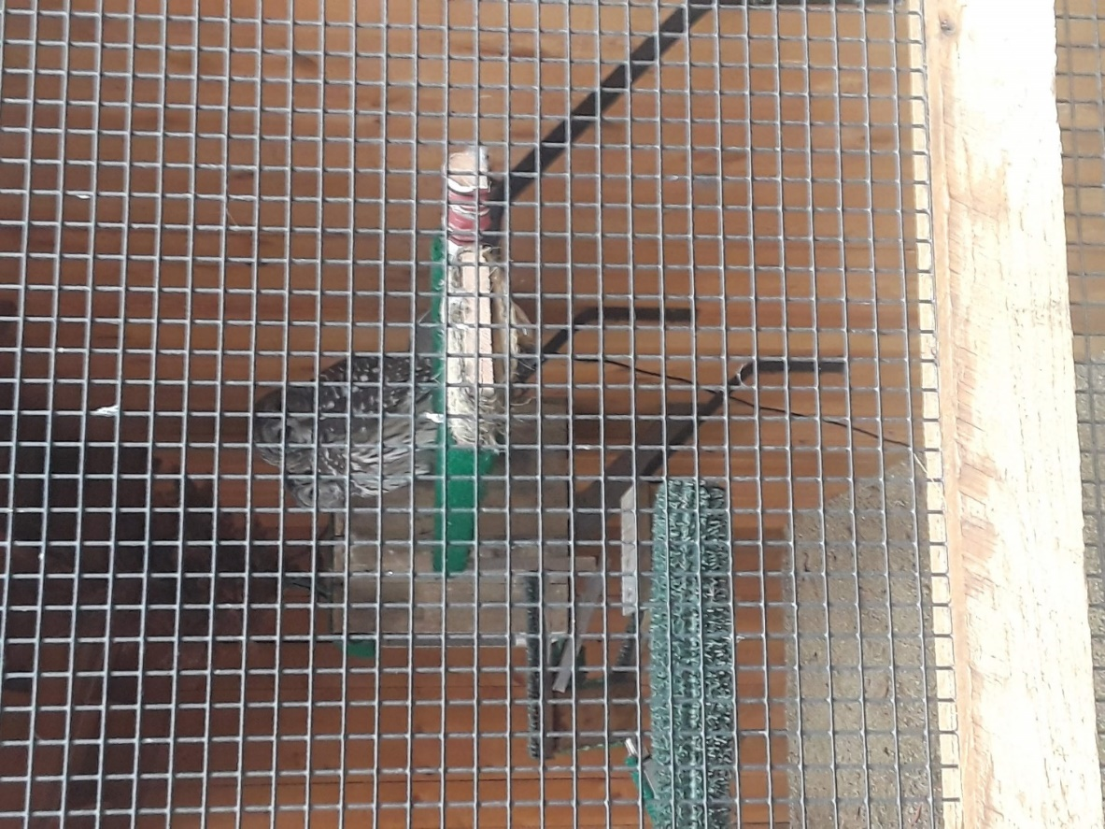**WILDL 207 – Outdoor Recreation**

**December 13, 2019 Posts from students**:

**Chris Sabol**

The Outdoor Recreation class took a trip to Shaver's Creek Environmental Center and we learned about what the Center does, what it takes to run a nature center including animal care, maintenance, camps, planning and much more. The class also got to see the animals. Two barred owls *(Strix varia*).

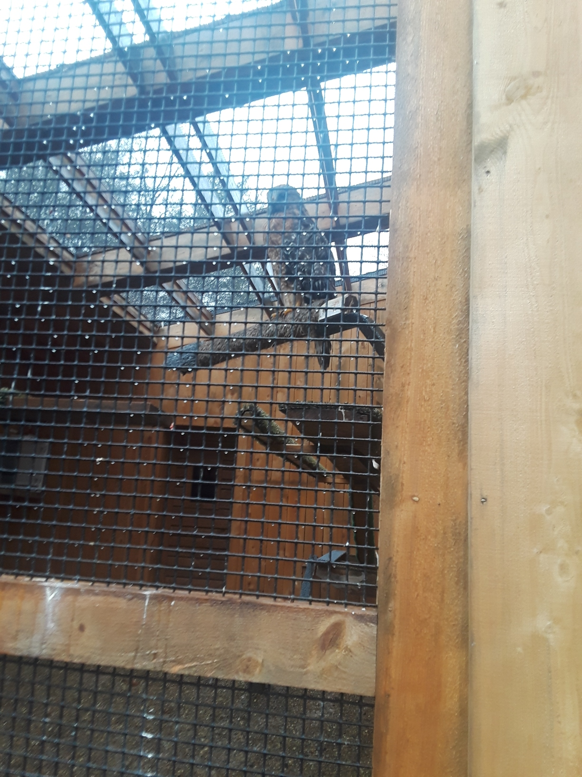**Tori Siegle**

Our class visited Shaver's Creek and I got to see my intern advisor again, Doug Wentzel. He was amazing this summer. I also got to see how much the Center has changed since I was there this summer. Some of the HERP island got new signs and some turtles were moved. My favorite part of the entire visit was going up and seeing the raptor center. Red-shouldered hawk (*Buteo lineatus*).

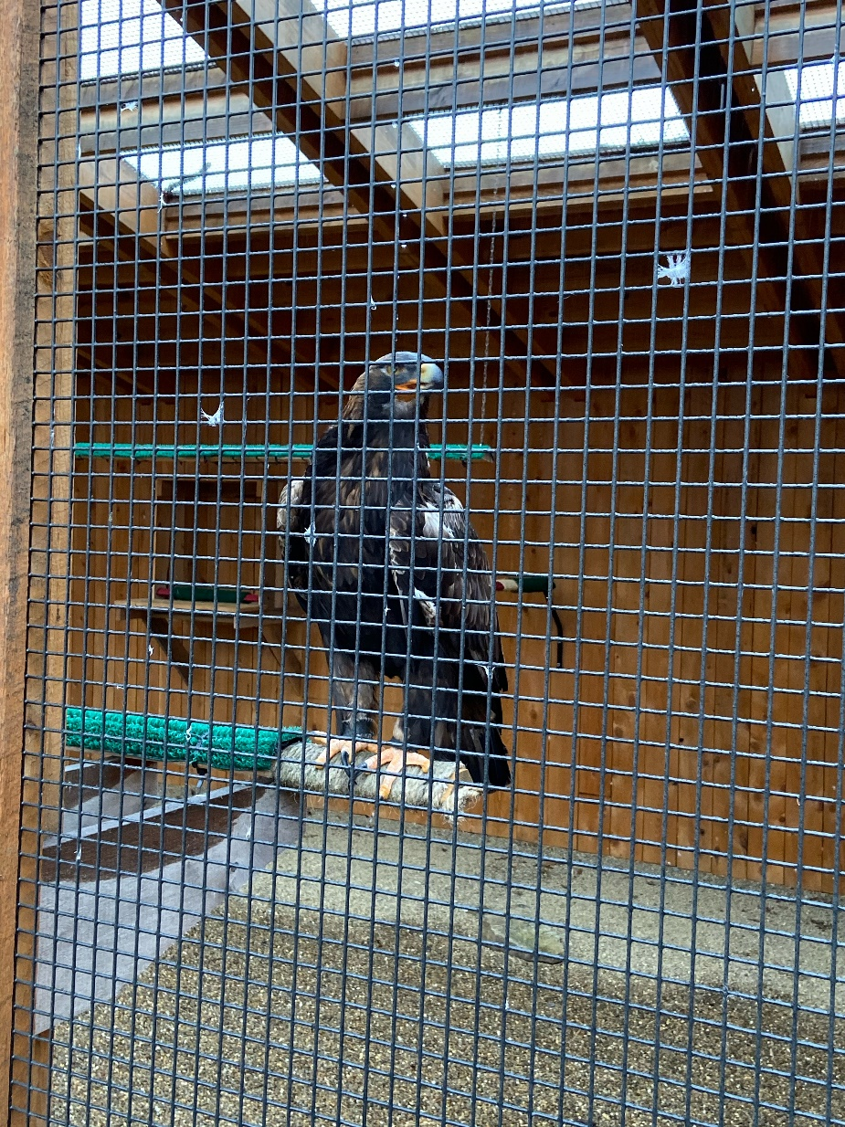

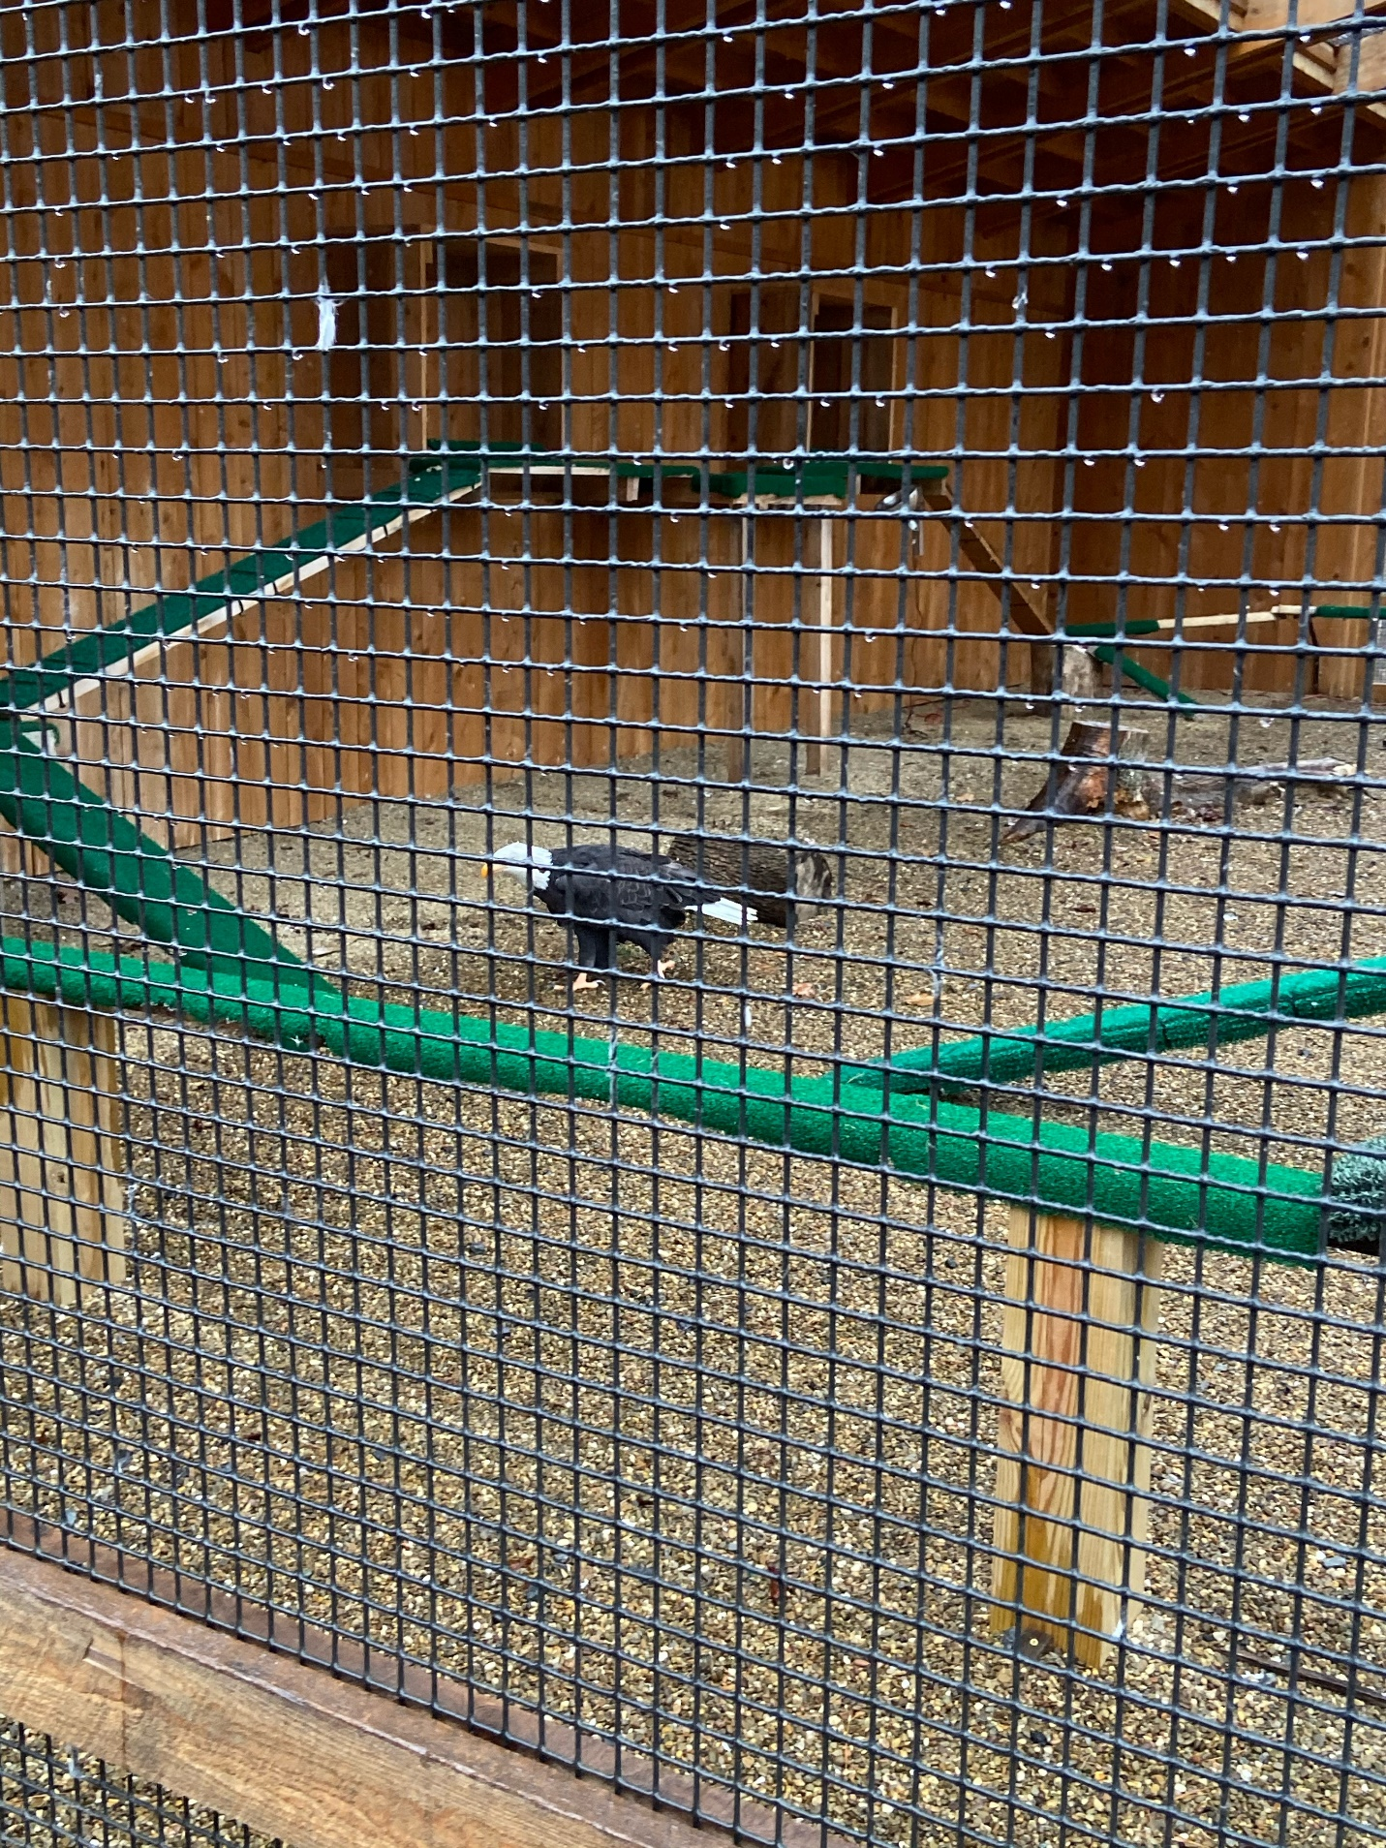**Jake Bumbaugh**

Our outdoor recreation went to Shaver’s Creek where we met with Doug Wentzel, Naturalist and Program Director. We saw all their reptiles, raptors, and places to recreate, including Lake Perez. Bald eagle (*Haliaeetus leucocephalus).*

It was neat how all the raptor cages faced the same direction and were systematically laid out. This way a more dominant predator was not putting fear into another bird from staring at it all day. Golden eagle (*Aquila chrysaetos).*

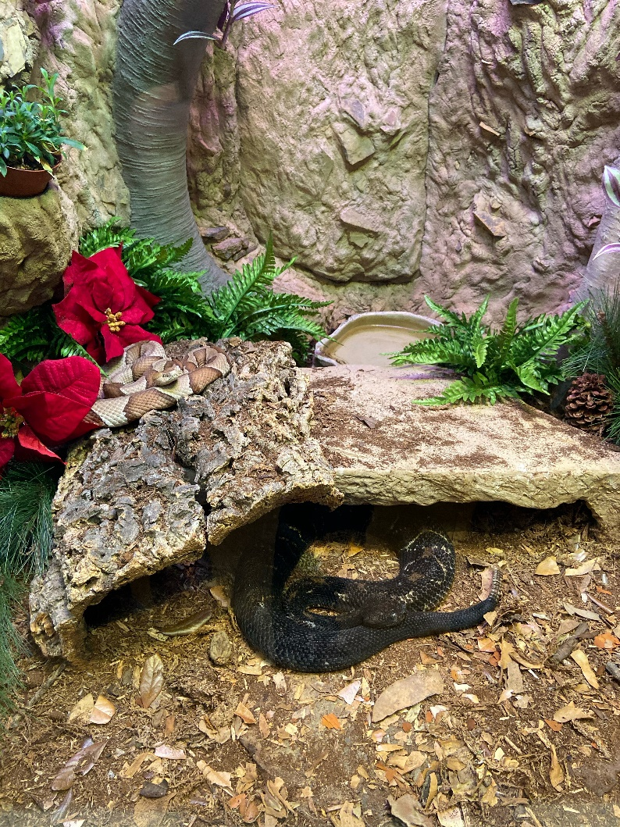Another of Jake Bumbaugh’s favorite reptiles! Eastern copperhead (*Agkistrodon contortrix)* and especially the timber rattlesnake (*Crotalus horridus)*

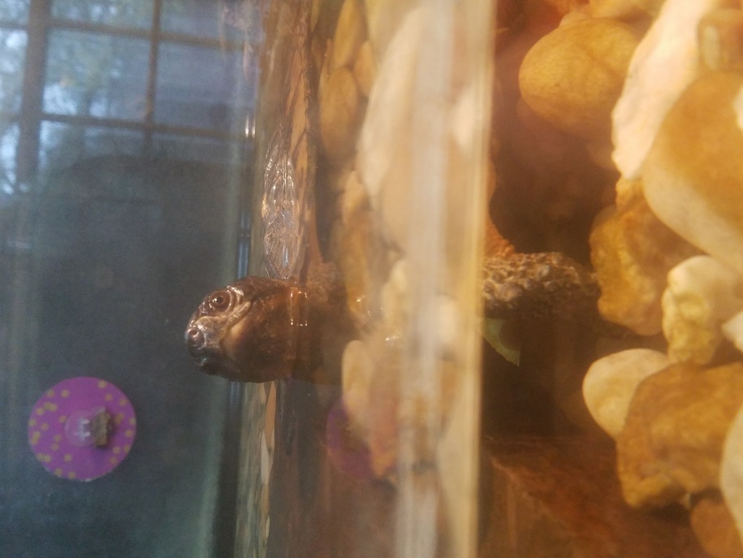**Jake Jeffries**

I would like to thank the staff at Shaver’s Creek for taking the time to give us a tour. Shaver’s Creek has beautiful classrooms and amazing animal exhibits. I would recommend this place to anyone with an interest in the great outdoors!

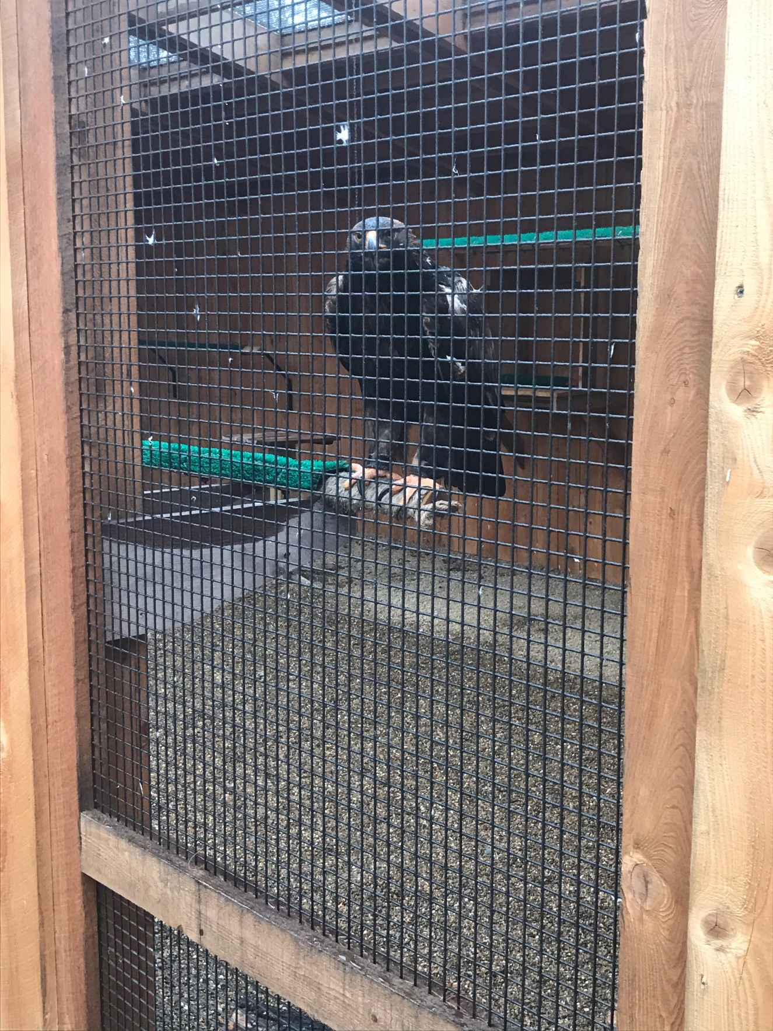**Jake Sunderland**

Shaver’s Creek has some neat exhibits. My favorite was the wildlife feeding center and watching the birds and squirrels. Another neat area was the bird enclosures they have; the golden eagle was my favorite.

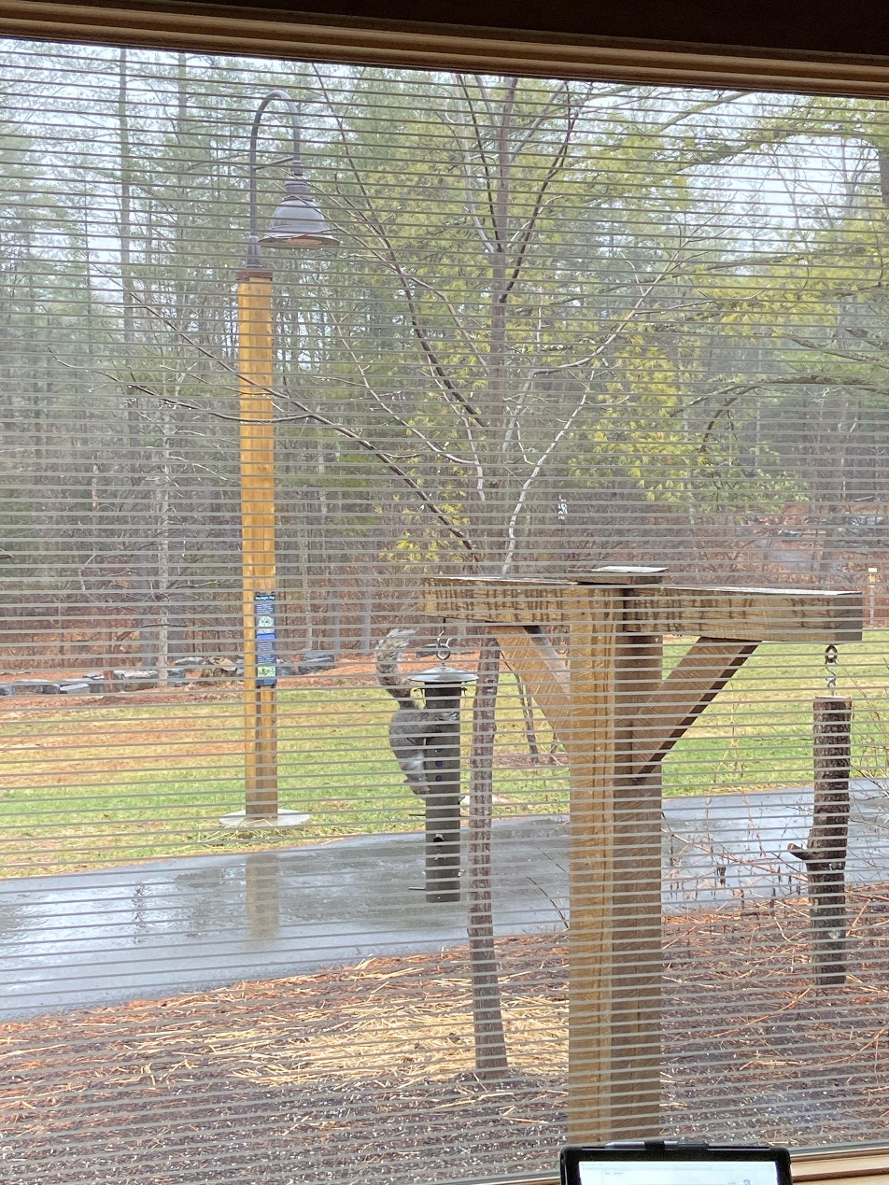**Craig Houghton**

Thanks to Doug Wentzel and all the Shaver’s Creek staff for a great educational afternoon!

My lesson for the day: This is a “Wildlife” feeding station, NOT a “Bird” feeding station. By changing the name, I don’t have to worry about chasing squirrels off the feeders! (Thanks to Jake Bumbaugh and Jake Sunderland for the photos).

