Documentation style guide

Screenshots
- Screenshots should only be used when they clearly enhance the text.
- They should only include the minimum portion of the screen or interface necessary to convey the information. Example of incorrect usage:
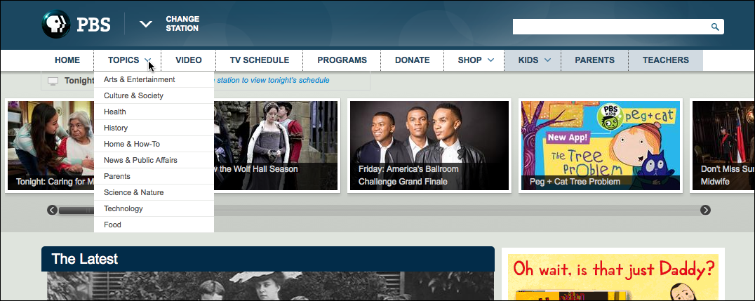Figure 1: Topics drop-down menu
Example of correct usage:
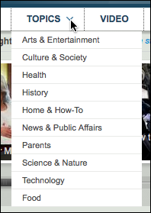
Figure 1: Topics drop-down menu
- Screenshots should include a 1 px black outline. (Tip: You can use Evolution's border style to achieve this.)
- Drawing attention. Arrows (to point out non-interactive items on the interface) should be red with a 1 px black outline (rarely used). For interactive items such as links and buttons, use a screenshot capturing tool that includes the active mouse pointer, such as Grab for the Mac or Snagit for the PC. Finally, you can use opacity techniques to highlight portions of an interface (rather than specific items).
Example of screenshot capture with interactive item:
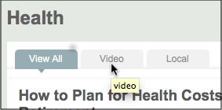
Figure 2: Active mouse pointer within screenshot
Example of use of opacity to highlight a region of an interface:
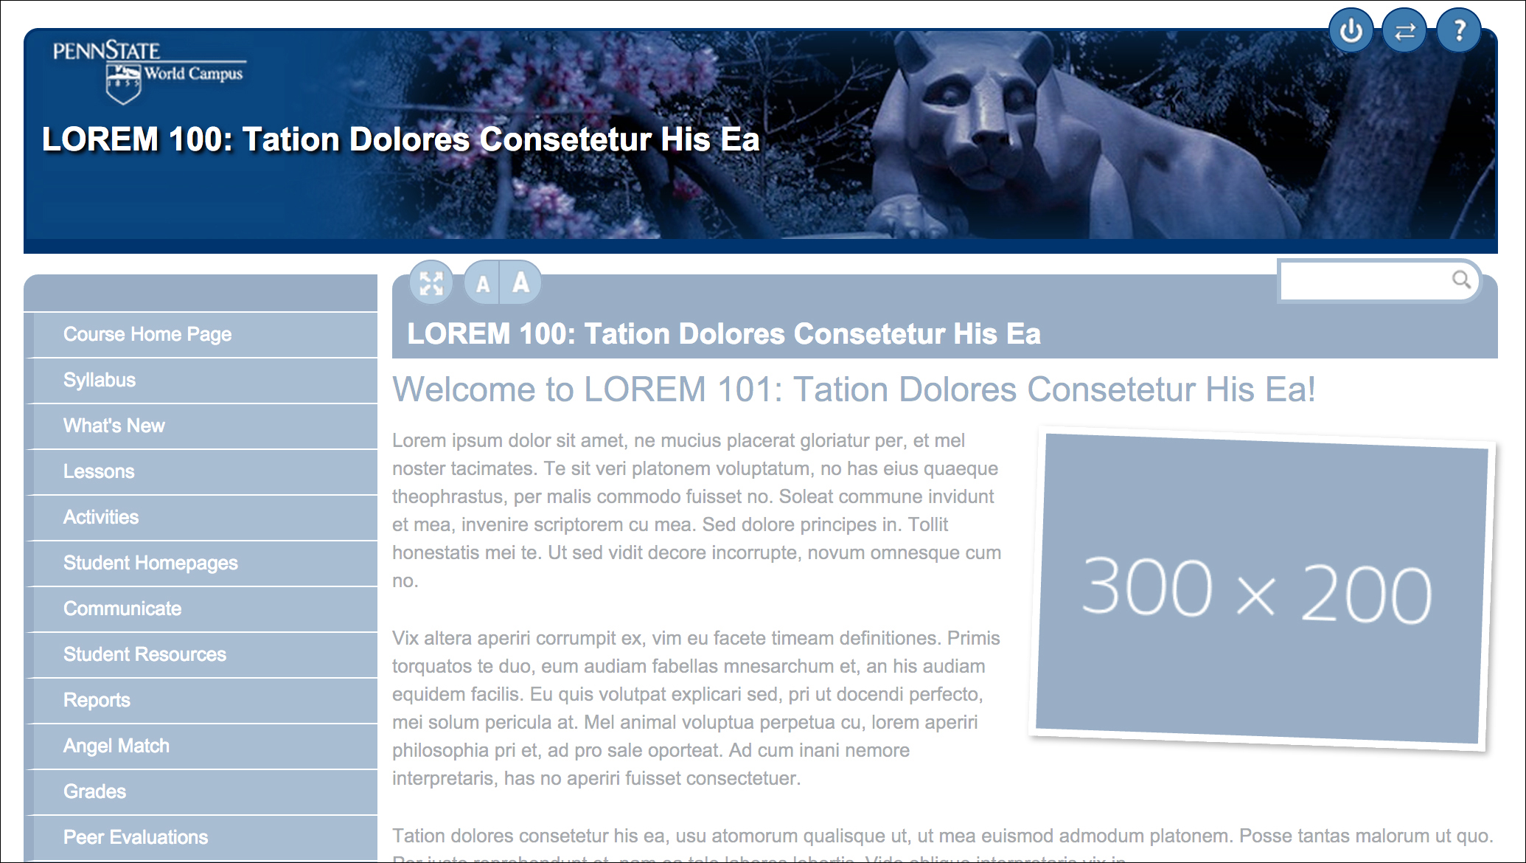
Figure 3: Example of opacity technique highlighting course header
- Descriptive text should always appear above the image being referred to. Exception: For multiple steps that are associated with an image, have an image description before the image and all related action steps together, below the image. (It is usually desirable to avoid this exception when possible and follow Rule 2 above, showing only the minimum portion of the screen to convey what is necessary for a step.) Also, refer to the guidelines for interface explanations below.
- Alt text should always be included within an <img> tag. If the image is for decorative purposes only, you should use empty quotes for the alt attribute’s value.
- Include a caption without a period. Caption text should be similar to alt text, with the alt text providing more description if necessary. Caption should appear directly below the image, be bold faced, in a somewhat smaller font size (80-100% of paragraph text size), and be left-aligned with it. It should also include a figure number with a colon, as follows:
Figure 1: An example of figure
- Figure numberings should start over for each page (each page of documentation should be its own self contained instruction set)

Hint: If you are documenting using Evolution, use the "Figure with Caption" snippet in order to insert a standards-compliant format, and then follow the above conventions. This is the same as HTML5's <figure><img/><figcaption/></figure>.

Tables
- Row and column data identified as headers should be marked up with <th> tags with defined scope.
- First row will often be defined as headers.
- Never leave cells blank; put in a dash if there is no data.
- Include a caption without a period. Caption format should be Table x: Descriptive text
- Table numberings start over for each page (self contained instruction set)
*Note: Table and Figure numbering are separate from one another. A page can have a Table 1 and a Figure 1.

Example of correctly formatted Table:

Name | Favorite purse color | Favorite shoe color
Heather | Blue | -
Janine | Yellow | Black
Table 1: Favorite colors of items

Headings – In Evolution, use template h3, h4, h5

Code
- Always use fixed-width code font when showing code examples or file names or paths. (Tip: Evolution's computer code or HTML5's <code/> tag does this.)
- Use italics for variables. (In Evolution, use the variable style in template or var tag)
Interface explanation
- Text should always appear after graphic.
- Provide brief introductory text before image.
- Provide a numbered list in a different format from what is used to describe step-by-step processes for explaining items on the graphic. For example, if you are using 1, 2, 3, etc. for step-by-step processes, use Roman numerals for an interface explanation. Or simply use a different font or style for the numbering.
- Graphic should include numbers corresponding with the numbers on the list. Numbers should be easy to see and in red with black outlines.
- Tip: You can combine this method with the dynamic images in Evo (opacity technique) to highlight each region.
Numbered list (steps)
- Numbered lists should always be used when explaining step-by-step processes.
- Each step should include only one action. Hint: If needed, each step should answer the following: Where are you? What should you do? What will you should you expect to happen? (eg., From the File menu, click Save As... and the Save As dialog box will appear.)
- Only actions performed by the user should be included as steps; things that occur as a result of user actions should not be separate steps (e.g. “new window opens”)
Bulleted lists
- Two items minimum in a bulleted list.
- Used when items do not require sequenced action (or when not referring to a numbered interface)
Bold Face
- Use bold face only when referring to items in an interface (links, buttons, etc), or
- Use bold face when introducing a new term that is to be defined
Calling Attention
- Additional optional information should be in a callout that is easy to read and does not attract too much attention (eg., in Evolution, the new colorbox with it's light grey borders and background)
- Important information that should call attention should use a callout that is somewhat easy to read and attracts more attention than optional information (eg., Evolution's colorbox uses a colored box that is still somewhat easy to read, but uses color to attract attention).
- Critical information should be use a callout style that is bright and infrequently used (eg., Evolution's “Yellow Note” is bright yellow and hard to miss).
User Names - no confidential information should appear in screen shots if at all possible. This includes real names or user IDs. FPS accounts can be created using fake names for the purpose of demonstrating in a PSU Web-Access (or Kerberos) enabled system.

Usage
- Drop-down menu, not drop down or dropdown
- Dialog box refers to a box with only one pane/tab. Use dialog box, not dialog. Wizard refers to an interface with multiple steps/panes/tabs
- Window is a whole new window/session, but a pop-up is a dialog box or wizard that appears
- Tooltip a short snippet of text that appears on focus or hover
- Use the names that the interface gives to items. Consider what is used for accessible labels as well. (eg., ARIA labeled-by, etc.)
- Do not omit an ellipsis. It tells the user to expect a dialog box or a wizard. (eg., Save As... had a dialog box before completing the action. Save does not; it just completes the action.)
- Use Tip (not Hint) and indent below the actions or items that they're associated with
- screenshot, not screen shot

