Quick Tips for Setting Up Repeat Course Tasks

Step-By-Step
- Go to the LD Task Management app in Quickbase. If you do not see it across your Quickbase tabs, you should find it listed under the My Apps link on the top right of the Quickbase interface.
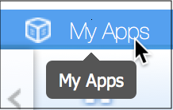
Figure 1: My Apps
- The first time you use the app, scroll down and check out the Master Repeat Template under Master Templates. Follow the instructions for Setting Up a Custom Template, http://tinyurl.com/tasktemplate. Examine all 21 tasks, and if you desire, you can add or subtract tasks to reflect your typical workflow for setting up repeat courses.
- Set up all your repeat course tasks for the upcoming semester. Do this by clicking on the Choose Semester drop-down menu, and selecting the correct upcoming semester from the list.
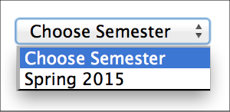
Figure 2: Choose Semester
- Select the template you wish to use in the following drop-down menu. You will be using the template you set up in Step 2 (unless you’re opting to use the Master Repeat Template).
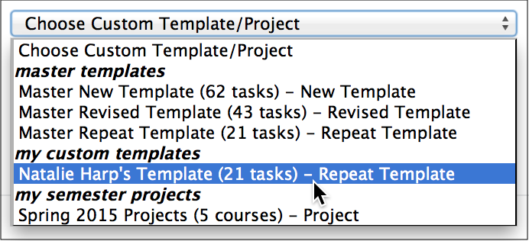
Figure 3: Choose template
- Click on the Create/Update Semester Project button.
- You can then see a task list divided by course in the My Semester List of Courses area. First you will need to select the semester to display from the drop-down list, and click the View Semester Project button.
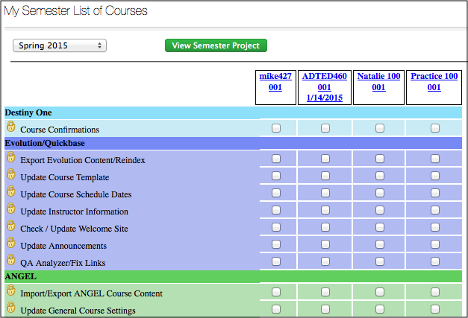
Figure 4: My Semester List of Courses
- You will work from this list throughout the semester, checking off tasks as they are completed!

Additional Tips/Best Practices
- You may have a need to add custom tasks for particular courses, where these tasks do not apply to your entire course portfolio. Do so after you have followed the steps for setting up repeat course tasks. Read more about adding custom tasks to individual courses: http://tinyurl.com/coursetasks
- The purpose of the Task Management app is to assist your workflow and keep you on track when preparing repeat courses for the new semester. It is also to allow the reassigning of incomplete tasks when an IPS is unable to perform their duties (because of a planned leave or unexpected illness).
- It is recommended that you start with a custom template, even if you do not change any of the tasks from the Master Repeat Template. Using your own custom template is the only thing that will allow you to add custom tasks to individual courses that will be carried over to future semesters.
- It is recommended that when you’re developing a custom template based on the Master Repeat Template, you not change the wording of any of the tasks you’re keeping. This will ensure consistency in the event that someone needs to take over your work.
- Until you are added as an IPS to a course in Quickbase, you will not have access to repeat tasks for that course, nor will they be included in your My Semester List of Courses
- When you are marking tasks as complete, the system will not give any feedback that your actions are being recorded, but rest assured that they are. Take care that you are marking the correct tasks.

Further Information and Help
Extensive documentation on the LD Task Manager application is available in WCLD 101. If you have additional questions or concerns, you can email the ET Consultants group at L-WCLDIT-CONSULTING@LISTS.PSU.EDU or submit a ticket through Quickbase.

