Statement of Purpose: The ET Consultants provide technology training to Learning Design, the faculty that work with Learning Design or teach World Campus classes, and other partners across the university (such as learning designers who use Evolution or design World Campus classes). Example of systems we offer training on:
- The LMS (e.g. ANGEL, Blackboard)
- Blackboard Collaborate
- PBWorks
- Sites
- Quickbase
- Evolution
- Accessible content
In many cases training on these technologies is also provided by ITS Training Services, such as for the LMS or for Sites, or by the vendor in the case of Quickbase or third-party course technologies. In such cases, we may refer trainees to outside training, while offering additional training or consulting as it relates to specific applications within the World Campus. This decision is made by analyzing needs and the available resources that we have.

Process

The following process should be used in preparing training materials and training events for any training to be delivered by the ET Consultant Group.
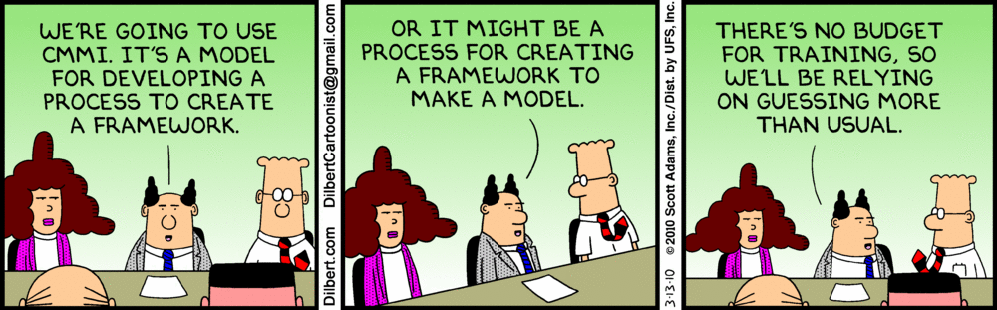

Needs Analysis: Needs analysis, in our case, consists of determining what the difference is between what our learners already know, understand, or are able to do, and what they need to know to do their jobs or achieve their professional goals. Parts of this statement deserve a closer look:
- What our learners already know (we might alternately refer to our learners as trainees): What is the baseline of understanding or ability? For example, if we are tasked with leading a workshop on accessible HTML, we might determine that our learners already have a fundamental working knowledge of HTML, based on a knowledge of basic job roles, interviews/surveys with managers/supervisors, and/or interviews/surveys with the learners themselves. The more information that is gathered, the better, however, we must be mindful of time and cost constraints and make the best use of both to get the best and most complete information.
- What our learners need to know: We may, in fact, begin needs assessment by determining what, exactly, learners will need to know at the end of the training. What skills, behaviors, and attitudes will learners need in order to perform their jobs well? Examples might include (for accessibility training):
  - Knowledge: where to go for help, what the law is (basic facts)
  - Skills: how to create accessible HTML (ability to perform a task)
  - Attitudes: Understanding of the “why” of accessibility (appeal to emotions or empathy)
Needs assessment can often be incorporated into the training itself, in the form of a pre-test, survey, or initial interactive discussion of a topic. (For example, if you are leading an accessibility seminar or workshop, you might start the workshop by asking participants to explain the background and experience they already have on the topic, giving an example of a project they’ve worked on.)

One final note on needs assessment. It is possible, through the formal needs assessment process, to demonstrate that the problem is not one that is best solved by a training solution, or is one that should be only partially addressed by training. This can occur when, for example, a product interface is so poor that it is best dealt with by vendor improvements before training can begin.

Design and Development: Design and development might start with looking at data, feedback, and observations about prior training offerings (results of the “Evaluation” piece we’ll get to later) - what of this can be universally applied to improving future training opportunities? In particular, how might it be applied to the training experience at hand? For example, say again that you are you are tasked with leading a training workshop on an accessibility topic, and past feedback has indicated that participants felt that not enough time was devoted to a topic of similar scope. You might begin by planning for a longer event than the prior one. Pilot testing may further refine the allotted time, but we’ll get to that a little later.

The Design and Development phase will likely end up taking the largest chunk of your time during the process, so plan for this accordingly. You will be designing materials including slides and handouts in the case of face-to-face (F2F) training, and online course materials in the case of online or hybrid training. You will also be planning for physical space and time requirements, and other logistics such as lunch or breaks, in the case of F2F or hybrid training.

From the needs analysis step you already completed at this point, you have a pretty good idea of what the scope of material you are going to need to cover is. Combined with the evaluations of prior training offerings, you have a starting point with which to estimate the time required for training, and thus the time required for training development. It is hard to estimate exactly how much time will be required to plan and develop training materials for a training event, but a rough estimate is 40-100 hours, and this depends on your prior knowledge, the amount and quality of existing documentation and training material, whether media will need to be developed or incorporated, etc. Fully online training typically takes longer to develop than F2F training, anywhere from about 70 up to 300 hours or more per hour of training, again depending on many factors such as the system you’re working with, how much interactivity the online training will demand, the complexity of media, etc. See the article “Time to Develop One Hour of Training” at ASTD for more in-depth exploration of the topic of training development time.

Design/development of training, then, can be broken down roughly as follows, for planning purposes. (These steps are presented as a linear series, though in reality, you may be doing any of these things at various points during the development process):
- Research and consultation with subject matter expert(s): How much time and energy you devote to this step really depends on your existing knowledge of the product you’re training on, the availability of subject matter experts (e.g., the programming team in the case of Evolution), the maturity of the product, the scope of the required training, etc. The reason why the maturity of the product comes into play is that when a product is brand new or in development, there may be glitches in the functionality or interface, or just poor, incomplete, or nonexistent documentation available. It is part of the IT Consultant’s job to document these glitches or bugs (by testing the product against use cases or working with a pilot team) and communicate them to the product vendor, so this can definitely add to training development time. It is sometimes necessary to include workarounds as part of training, though this is not ideal.
- Design of training materials and a training plan: “Design” here means thinking through and documenting the objectives of the learning that will take place, as well as the path that learners will take to achieve these objectives. Training is not the same as documentation, so you must think in terms of a learning path and not just in terms of the information you are trying to convey. A key training concept is that of “scaffolding” - starting out with simpler concepts and then using those to build up to more complex ones. There are other strategies that can be used to help make the learning enjoyable and effective, such as “chunking” of the materials, frequent breaks for discussion or other interactive activities, self-checks, and icebreakers. Aim to not overwhelm the trainees with too much information in one long chunk of material, as this may have the opposite effect from what you intend; your learners will give up and will retain very little of the material.
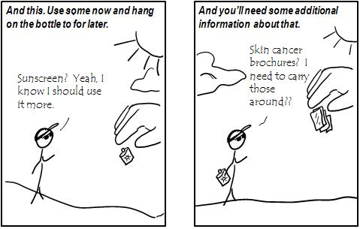

- Development of published materials: This is getting down to the nitty-gritty - the writing of content and the production of materials. You may be working with a team on this, especially when incorporating multimedia elements.
Pilot testing and Refinement: Ideally, a pilot test or “run-through” with a small group that is representative of the intended trainees will take place before training is offered more widely. This will give you a chance to do a practice run with the training plan and materials that you developed. Pay attention to the questions that arise during your pilot run - these are areas that may be incorporated into the final training materials/plan. For questions that you can’t or have difficulty answering, consult the subject matter expert again and be sure to include these areas as well in the final training. Finally, pay attention to the clock - did you allot too much or too little time for the training (hint: schedule at least 1 ½ times your planned training time for the pilot test to account for possible overage). If you are pilot testing online training, record how much time it takes to complete (you might include this in a pilot test survey question).

If you have the time, you might convene the pilot group for a focus group session in order to best understand what went right and what could be improved about the training. However, if time is not on your side, a simple survey administered to the pilot group will suffice. If it is a very small group, you can accomplish this through email or even quick 1-1 conversations, but if is large enough, you might want to use SurveyMonkey or Google Forms to gather data.

Once you have refined your training materials and training plan, or online module(s), based on feedback from the pilot, you may upload those materials to the ET Consultants’ shared Training Materials folder in Google Docs. If the training is to be delivered online, it is still appropriate to upload a Training Plan (which might include information about notifying people about the training, a continuation of feedback collection, and a plan for the periodic revision of online materials).
Implementation: Implementation includes the coordination of elements that will make the training happen, as well as the training delivery itself. You might need any of the following as you plan for your training event:
- a room of sufficient size for the number of trainees. Think deeper about the room requirements - what technology will be needed in the room? Do you plan to record the event? Do you need a particular arrangement of chairs and can you move tables around?
- someone to be on hand to assist with technical issues
- coordination of co-trainers or subject matter experts that might need to be there
- someone to take notes or observe the training
- Think in advance about what technology you will need to bring with you to the event, and what participants will need to bring. For example, you may need to set up an Adobe Connect or Blackboard Collaborate room for recording or meeting remotely with participants.
- Participants may be required to bring their own laptops or install software ahead of the event.
- Make sure there are enough handouts for everyone

For the training itself, you (or the trainer or trainers if someone else will be delivering training) will be generally following the training plan that you developed and refined through pilot testing.

Evaluation: Evaluation comes generally in the form of a summary of responses to a survey. The survey may or may not be the same one you used in pilot testing (see appendix for an example). Evaluation can also come from feedback from the trainer, and from any unsolicited feedback from participants. The results from evaluation will be used to further refine and improve the training for possible future offerings, and to improve generally any future training offered by the ET Consultant team.
APPENDIX: Training Survey example

1. Rate the preparedness of your facilitator(s).
- Minimally prepared
- Optimally prepared
Explanation (optional)
2. How knowledgeable was the trainer about the subject matter?
- Minimally knowledgeable
- Somewhat knowledgeable
Explanation (optional)
Adequately knowledgeable
- very knowledgeable
- optimally knowledgeable
Explanation (optional)
3. Rate the trainer's ability to answer questions.
- Minimal
- Optimal
Explanation (optional)
4. Rate the organization of the training content.
- minimally organized
- optimally organized
Explanation (optional)
5. Rate the clarity of the content presented.
- Minimally clear
- Optimally clear
Explanation (optional)
6. How did you feel about the pacing of the training?
- too slow
- a little slow
- time was just right
- a little fast
- too fast
Explanation (optional)
7. How relevant do you feel the training was to your work?
- minimally relevant
- optimally relevant
Explanation (optional)
8. Rate the timeliness of the training.
- minimal
- optimal
Explanation (optional)
9. Rate the usefulness of the training.
- minimally useful
- optimally useful
Explanation (optional)
10. Would you recommend this training to others?
- Yes
- No
Explanation (optional)
11. Did you find the time for practice and feedback after the training to be useful?
- Yes
- No
Explanation (optional)
12. What did you like about this training?
13. Any suggestions for improvement?

