Bench-top Pulsed UV system

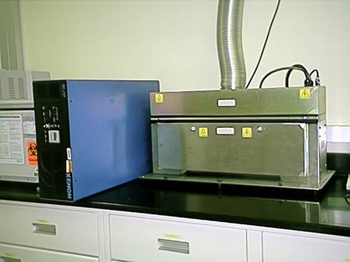

The SteriPulse-XL®3000 Pulsed UV-Light System (Xenon Corporation, Wilmington, MA) includes a chamber (0.64 ×0.15×0.19 m) with several shelf settings.

The system has an energy output of 1.27 J/cm2 per pulse at 1.8 cm below the xenon bulb. The xenon bulb pulses 3 times per second, with each pulse lasting 360 μsec. A polychromatic burst was produced with each pulse emitting wavelengths ranging from 100 to 1,100 nm. Over 54% of the emitted energy was in the UV spectrum.

Pilot-Scale Pulsed UV system with Conveyor

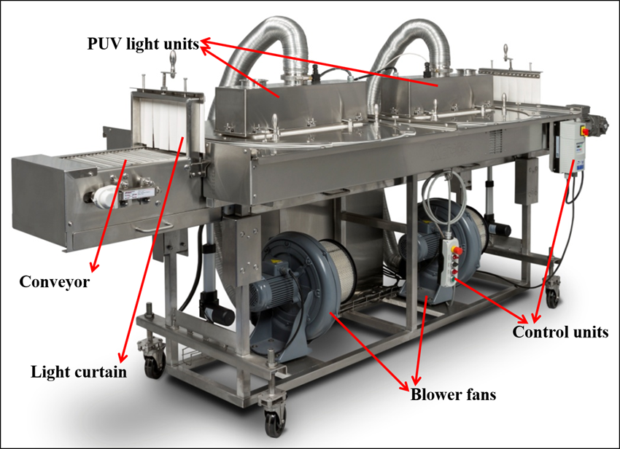

This is a pilot scale PUV light treatment system with conveyer (Model RC-802, Xenon Corporation, Wilmington, MA). This system same pulsed UV light system, but includes two light boxes in serious to provide more treatment time as the conveyor passes the products underneath. Below are the specifications for the chamber and conveyor.

|  |  |
| --- | --- |
| Belt | 12-inch wide, open mesh Teflon coated fiberglass with SS alligator splice |
| Speed | 1 - 100 feet/minute (FPM); (VFD 20-100Hz); nominal speed 50 FPM |
| Frame | Stainless steel construction with swivel locking casters |
| Linear Actuators | Adjustable UP and DOWN; each end |
| Lamp Height above belt | Adjustable 1 - 6 inches |
| Light Shield Housing | 5-inch high above belt, 13 x 93.87-inch (W x L) |