Learning Outcomes Assessment Handbook

A guide to assessing academic programs at Penn State

Office of Planning & Assessment
Last Modified: February 2020

Table of Contents
Introduction 1
What is Learning Outcomes Assessment? 1
Why Assess? 2
Student Learning 2
Accreditation 2
What is a program? 2
The Assessment Cycle 2
1a. Establish/Revise Program Learning Objectives 3
1b. Curriculum Map 3
2. Choose Learning Objective(s) to Assess 4
3. Choose and Design Assessment Methods 4
4. Collect Assessment Data and Evidence 4
5. Review Evidence and Determine Action 4
6. Complete/Submit Report 5
7. Implement Changes (If Necessary) 5
8. Determine Impact of Changes 5
Components of Learning Outcomes Assessment 5
Program Learning Objectives (PLOs) 5
Two Approaches to Organizing PLOs 6
Establishing Program Learning Objectives 7
Establishing Learning Objectives for Graduate Programs 7
Strategies for Writing PLOs 8
Examples of Well-written Learning Objectives 8
Examples of poorly written learning objectives 9
Curriculum Map 10
Creating a Curriculum Map 11
Determining Introduced/Practiced/Mastered Placement on a Curriculum Map 14
Using a Curriculum Map to Choose Annual Assessments 14
Choose a Learning Objective to Assess 15
Choose and Design Assessment Methods 16
Scoring Guides (Rubrics) 17
Performance Criterion 18
Collect Assessment Data/Evidence 18
Review Evidence and Determine Action 19
Report Submission 19
Implementing Changes and Determining the Impact 21
Program Learning Objectives (PLOs) 22
Where can I go with questions? 22

Introduction
This document serves as a general guide to the Learning Outcomes Assessment (LOA) process at Penn State. Redundancies are built into the document by design. The first few sections provide the basis for learning outcomes assessment – what it is (and is not) and why we do it. Following those sections is a graphic of the learning outcomes assessment cycle with brief descriptions of each step. The final section repeats the assessment cycle descriptions with additional detail that describes how to conduct assessment and expectations for exemplary assessments. Within the final section is a segment on how to complete Penn State’s annual assessment process that repeats the expectations for exemplary assessment components. If you are new to learning outcomes assessment you may want to review the entire document. If you are only interested in a specific component of the process, such as writing learning objectives or completing and submitting the assessment report, go directly to the specific section. At any point, please feel free to contact your Assessment Liaison with your questions or concerns. Please note: at Penn State, we complete the LOA process within an online Assessment Management System. Detailed instructions on how to use the system are not in this document, but are available on the AMS Training page.

What is Learning Outcomes Assessment?
Learning Outcomes Assessment describes an assessment process with a specific focus on student learning and outcomes in educational contexts. In Assessing Student Learning (2009), Linda Suskie, a well-regarded leader in the field of assessment, defines learning outcomes assessment as follows:
“Establishing clear, measurable expected outcomes of student learning; Ensuring that students have sufficient opportunities to achieve those outcomes; Systematically gathering, analyzing, and interpreting evidence to determine how well student learning matches our expectations; using resulting information to understand and improve student learning (p. 4).”
At Penn State, we focus on the learning outcomes of academic programs, including undergraduate, graduate, and certificate programs. Although there are many concerns faculty may have about how their program is working, such as how many students are doing internships or whether students are visiting advisers often enough, learning outcomes assessment is focused on the extent to which students are learning in the program, rather than the services provided through the program.
The learning outcomes assessment process provides faculty with an opportunity to work together to determine the knowledge and skills they expect of program graduates and then to collect evidence of the extent to which students are meeting those expectations. In cases where students are not meeting expectations, faculty determine what changes could be implemented to improve student learning. The process is not unlike what faculty already do in their courses regularly. A key difference, however, is that faculty must collaborate to assess learning at the program level, which they don’t do when assessing students in individual courses. Discussions of student learning issues, decisions about which learning objectives to explore and how, interpretation of results, and choices about changes to make are accomplished by program faculty as a group. Another difference is the need to document the assessment process and provide evidence of student learning beyond the course. The process itself is flexible enough to be useful across the many disciplines and types of academic programs at the University.

Why Assess?
Student Learning
The primary reason that Penn State engages in assessment activities is to help maintain the quality of the academic programs we offer our students. Learning outcomes assessment can reveal a range of insights about an academic program, including gaps or redundancies in the curriculum, curricular shifts, course sequencing issues, inappropriate performance expectations, misalignment between objectives and curriculum, positive or negative student outcomes, and much more. The evidence collected can help determine specific changes a program might want to make to improve student learning.
Accreditation
One significant reason to assess learning outcomes relates to Penn State’s ongoing accreditation by the Middle States Commission on Higher Education (MSCHE). Among other things, Middle States requires universities to demonstrate how they engage in continual student learning assessment at the program level. Middle States is not typically focused on the specific outcomes or even whether students have met them. Instead, they ask that universities provide evidence of a well-defined process that is being used to examine programs and use findings from that process to make decisions about what program components/practices should be maintained, improved, or discontinued. See Middle States Commission on Higher Education, Standard V.2.

What is a program?
Federal regulations describe a program as “a postsecondary educational program offered by an institution of higher learning that leads to an academic or professional degree, certificate, or other recognized educational credit.” (34 CFR 602.3) IPEDS (Integrated Postsecondary Educational Data System) defines an “academic program” as an instructional program leading toward an associate’s, bachelor’s, master’s, or doctor’s degree or resulting credits that can apply to one of these degrees.
As a rule of thumb, programs should have a codified set of Program Learning Objectives (PLOs), as described in the section on “Components of Learning Outcomes Assessment,” that is distinct from other sets of PLOs. For example, the objectives of the Animal Biology program should be distinct from those of Plant Biology, even though both share many similar and overlapping objectives.

The Assessment Cycle
At Penn State, learning outcomes assessment is an ongoing process and regular part of program activities. Below is a graphic depicting the general process with brief descriptions of each step. Later sections of this handbook provide more details about each step of the process. All assessment follows this basic process, with some variations based on program type (undergraduate, graduate, certificate). These variations will be noted.
Penn State Learning Outcomes Assessment Process
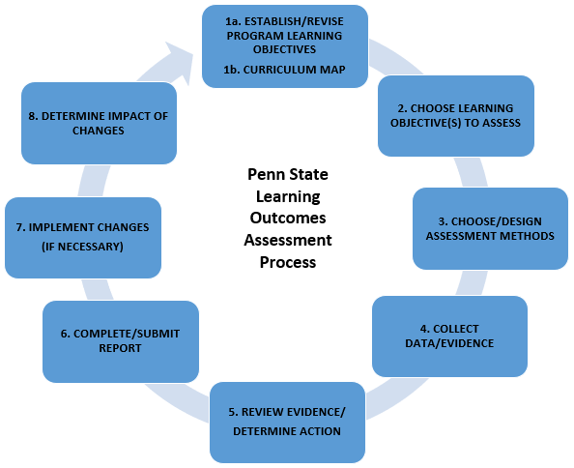

1a. Establish/Revise Program Learning Objectives
Every academic program (undergraduate, graduate, certificate) has a list of program learning objectives. PLOs are statements that encapsulate the body of knowledge, skills, values, and habits of mind that an individual completing the program should have at the point of graduation. The assessment cycle begins when program faculty articulate discrete, clear, and measurable PLOs. Graduate programs are required to align their learning objectives with a set of Scholarly and Professional goals developed by the Graduate School.

1b. Curriculum Map
A curriculum map or matrix is a graphical illustration of the relationship between a program’s courses/experiences and the program learning objectives. It shows the chronological progression of the curriculum and which courses (or milestones, in the case of graduate programs) address each of the PLOs. Together, the PLOs and the curriculum/milestone map serve as the foundation for regular assessment activities. A prose description of the relationship between PLOs and courses is an acceptable alternative to a curriculum map.

2. Choose Learning Objective(s) to Assess
At Penn State, programs are expected to assess a single objective each year, though some prefer to assess more than one objective. An assessment plan begins with choosing which learning objective to explore. The choice of which PLO is often rooted in faculty concerns or questions based on observations of student performance. A common way to begin assessment is to assess mastery of an objective, typically in a capstone or 400-level course.

3. Choose and Design Assessment Methods
If an objective is written well, it is usually not difficult to determine an effective way to measure it. The alignment between the measure and the PLO is vital. Because the goal of learning outcomes assessment at the program level is to demonstrate that students have met program objectives at or near graduation, typical measures for program assessment purposes are those in which students demonstrate mastery of the objective (see the curriculum map). These can be major assignments in capstone or other 400-level courses, internship supervisor evaluations, or program-level exams. Consider choosing a measure that will provide longitudinal evidence of maintenance or changes in student performance. At times you may want to use a different assessment method. For example, if you find students have not mastered an objective you may want to assess performance in an earlier course to investigate possible reasons for their sub-optimal performance. Once you determine what those reasons are, you can make changes and then re-assess students at the mastery level. Alternatively, you may have an assessment question that requires measurement of student performance at an earlier point, or even multiple points, in the program. The best choice of assessment measure will provide meaningful information to the program faculty.

4. Collect Assessment Data and Evidence
Once you have chosen one or more assessment methods for the PLO you intend to measure, you will need to implement a process for gathering assessment evidence. This process often involves collaborating with other faculty in your program, or in programs at other locations. Your data collection process may look different from one year to the next, depending on the PLO you are assessing and the measure you have chosen.

5. Review Evidence and Determine Action
Once assessment data is collected and analyzed, it should be shared broadly with program faculty. If performance targets were met, program faculty can have confidence that students are meeting expectations. Specific modifications, such as including an additional assignment in a specific course to address a gap in student knowledge, are better than vague ideas such as ‘improving the way a specific topic is taught.’

6. Complete/Submit Report
Assessment reports are due annually on June 30th and submitted via the University’s online Assessment Management System (AMS) which all assessment leaders should be able to access. Every for-credit graduate, undergraduate, and certificate program is in the AMS. If you do not have access to the AMS or to the appropriate program(s), contact your Assessment Liaison. Guidance related to developing PLOs, establishing curriculum maps, and using rubrics, as well as other assessment resources, can be found on OPAIR’s Assessment Resources page. Training resources for the AMS can be found on the AMS Training page.

7. Implement Changes (If Necessary)
If assessment results suggest changes should be made to the curriculum, the important next step is to implement those changes. Common changes include emphasizing certain content or skills in courses earlier in the curriculum, adjusting pedagogical approaches to make instruction of certain topics more explicit and intentional, revising a scoring guide (rubric), or revising an assessment measure.

8. Determine Impact of Changes
If changes are made as the result of assessment evidence, it is important to reexamine the PLO to determine the impact of the changes. In most cases, this means repeating the assessment in a subsequent semester, although sometimes this can be done immediately. In other instances, it may be necessary to wait several semesters or years for students impacted by the changes to progress through the curriculum to encounter the mastery-level course in which the original objective was assessed. If no changes have been made in the curriculum, these steps are skipped.

Components of Learning Outcomes Assessment
The following sections contain more in-depth descriptions, definitions, explanations, and examples of the main components of Penn State’s Learning Outcomes Assessment process as outlined in the previous section.
Program Learning Objectives (PLOs)
Step 1a
PLOs are short statements that describe the knowledge(s), skills, values, and habits of mind that students completing a given program should be able to demonstrate upon graduation. PLOs can address a range of types of knowledge and skills, including cognitive (knowledge or mental skills), psychomotor (physical/motor and kinesthetic skills and knowledge), affective (feelings and attitudes), and interpersonal/social (interpersonal and social abilities).
Exemplary PLOs are stated with clarity and specificity and include precise verbs, rich description of the content, skill, or attitudinal domain in the disciplinary context, and are stated in student-centered terms.
Most programs will have 5 to 8 PLOs. Some programs write PLOs as major categories, others include “sub-objectives” within major categories to further define student expectations.
Well-written PLOs are relatively short, specific, measurable, attainable, developmentally appropriate, and discipline or context-specific. They function best if written in student-centered language and are future oriented: “students (or graduates) will be able to…”
- Short:
PLOs are stronger if they are written in short, simple, declarative statements that do not contain multiple clauses or confusing phrasing.
- Specific:
PLOs should be specific and clearly address a single learning objective or tightly related objectives that can be credibly measured together.
- Measurable:
PLOs should be measurable which is best achieved by utilizing an observable verb that produces a product (see “Strategies for writing PLOs” on page 5).
- Developmentally Appropriate and Attainable:
PLOs should be developmentally appropriate and attainable for the student population in question. Students should be held to high standards, but only insofar as they can achieve the objective at an appropriate point in their academic careers.
- Discipline and Context-specific:
PLOs should be discipline or context specific meaning the objective should reflect the field or domain students are studying. Rather than “students will communicate effectively,” the objective could reflect a specific discipline as in “students will communicate biological ideas and concepts effectively.”

Two Approaches to Organizing PLOs
Programs develop and list their PLOs in different ways and most utilize one of two approaches: overarching objectives or nested competencies (sub-objectives).
- Overarching Objectives articulate a PLO category that describes mastery-level practice.
  - American Studies
    - Symbol and Myth Analysis. Students will be able to interpret texts from America’s past by isolating symbols and myths that were culturally meaningful to the people at the time.
- Nested competencies articulate major PLOs or PLO categories, as well as sub-categories for each PLO. Sub-categories specify essential practices or competencies that can be nested within or underneath the major PLO.
  - Human Development and Family Studies
    - Students will be able to demonstrate the ability to evaluate and apply theory and research to practice and policy.
      - Students will be able to explain the strengths and weaknesses of various research methods in assessing human behavior
      - Students will be able to integrate and apply the findings of empirical research within a theoretical framework to human development

Establishing Program Learning Objectives
The current learning outcomes assessment process at Penn State began in 2016. At that time most programs developed and submitted a list of program learning objectives. If your program is new and you have not yet developed objectives, you may find the following strategies for developing program-level learning objectives useful:
- check your disciplinary organization - some publish a list of program-level learning objectives;
- examine learning objectives in a capstone or major 400-level course and list the knowledge and skills needed for major course projects;
- for good examples, look at programs that are the same as or similar to yours but taught at a different campus or university; and
- conduct an alumni or employer survey to gather information about what is expected of graduates of your program.

Establishing Learning Objectives for Graduate Programs
The Graduate Council has developed the following Graduates School’s Scholarly and Professional Goals to serve as guidelines for each program’s learning objectives. Graduate program learning objectives must align with these goals.
- KNOW: Demonstrate appropriate breadth and depth of disciplinary knowledge, and comprehension of the major issues of their discipline;
- APPLY/ CREATE: Use disciplinary methods and techniques to apply knowledge, and—if appropriate to the degree—create new knowledge or achieve advanced creative accomplishment;
- COMMUNICATE: Communicate the major issues of their discipline effectively;
- THINK: Demonstrate analytical and critical thinking within their discipline, and, where appropriate, across disciplines;
- PROFESSIONAL PRACTICE: Know and conduct themselves in accordance with the highest ethical standards, values, and, where these are defined, the best practices of their discipline.

Strategies for Writing PLOs
Many faculty members find the following table helpful in identifying verbs to create measurable objectives. The table is based on a revision of Bloom’s taxonomy (Anderson, L.W. & Krathwohl, D.R. (2001). A taxonomy for learning, teaching, and assessing, Abridged Edition. Boston, MA: Allyn and Bacon).

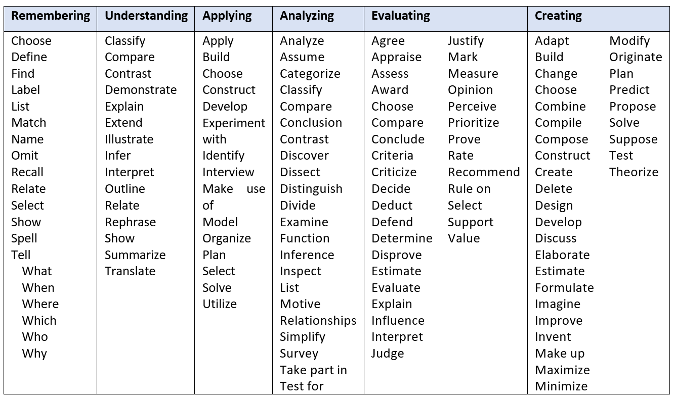

Examples of Well-written Learning Objectives

Biology (American University)
Graduates will be able to . . .
- apply information from core subjects in the biological sciences, including cell biology, genetics, and evolution.
- effectively communicate scientific ideas in both written and oral formats.
- demonstrate the scientific method through the use of hypothesis testing in the design and implementation of an experiment, analysis of experimental data, and presentation of results and conclusions.
- demonstrate informational literacy by having the ability and skills to effectively and legitimately use various sources of information required for functioning in a global, information society.
- critically analyze primary scientific literature.
- demonstrate that they can perform a set of basic laboratory skills.

English (Cal State Long Beach)
Graduates will be able to . . .
- read a variety of texts critically and proficiently to demonstrate in writing or speech the comprehension, analysis, and interpretation of those texts;
- write a literary or expository text using the conventions of standard English as stylistically appropriate, while showing a nuanced use of language (producing such a text may include invention, workshopping, research, compiling bibliographies, drafting, peer responses, revising, and/or editing);
- demonstrate knowledge and comprehension of major texts and traditions of language and literature written in English as well as their social, cultural, theoretical, and historical contexts;
- analyze and interpret texts written in English, evaluating and assessing the results in written or oral arguments using appropriate support;
- design and create texts for a variety of purposes and audiences, evaluating and assessing the effectiveness and meaning of such texts.

Examples of poorly written learning objectives
- Students will be able to understand psychological theories
Words such as understand, know, learn, and appreciate are fine for goals but are too vague to be measurable. How do you know students understand? Because they can solve equations? Because they can compare and contrast theories? Because they can describe a process? Specifying the verb helps clarify the knowledge and skills expected of students who graduate from your program and makes assessment easier.
- Students will be able to communicate orally and in writing.
Good learning objectives include a disciplinary context. Types of communication differ by discipline. A biologist needs to be able to describe a laboratory experiment clearly. An English major may need to be able to use language creatively to communicate an idea or emotion.
- Students will be provided with research opportunities.
Good program learning objectives focus on what the graduates of the program will know or be able to do, rather than what a program provides. Another way to phrase this objective could be:
Students will be able to analyze and interpret quantitative psychological data using statistics, graphs, and data tables.

Curriculum Map
Step 1b
Producing a curriculum map can provide useful information for faculty teaching within the program even before any assessment activities commence. In addition to serving the aforementioned functions, curriculum maps can be used to identify opportunities in an academic program for collecting evidence of student learning and achievement. They can be constructed in a number of different ways, but at their core they describe the alignment between the courses and experiences all students must complete in the program’s curriculum and the program’s learning objectives (PLOs).

An exemplary curriculum map lists all courses and experiences in the program in chronological order with each program addressed at all 3 levels: introduce (1), practice (2) master (3). 1’s, 2’s and 3’s are in the proper sequence and listed only for courses in which the program objective is addressed through a significant assignment.

The map allows program faculty to visually identify the courses or experiences in which students can be expected to demonstrate learning or achievement of each of the PLOs.
The following lists the advantages of creating a curriculum map, adapted and expanded from a blog written by Linda Suskie (https://www.lindasuskie.com/apps/blog/)
- identify gaps in the curriculum (program objectives not covered in the curriculum);
- identify redundancies in the curriculum (program objectives that are “over-addressed” in curriculum);
- ensure that program objectives are addressed through the curriculum through a progression of courses moving from introduction through practice and ending with mastery;
- ensure that students have the opportunity to meet learning objectives through a variety of courses and experiences;
- promote discussion among faculty about how one another are addressing curricular components;
- ensure that the curriculum is not overly complex. Suskie notes “You should be able to view the curriculum map on one piece of paper or computer screen.”
- ensure that a majority of program learning objectives are addressed during internships or field experiences, where it is expected that students will perform at the mastery level.
- identify opportunities to collect evidence of learning and achievement of objectives;

Creating a Curriculum Map
Developing a curriculum map is a team endeavor. Though the effort may be led by a program coordinator or director of graduate studies, it is important to gather input from most or all faculty in the program, as individual course instructors are best positioned to describe what they teach and if/how what they address program objectives.
Moreover, it’s often the case that a course is taught by multiple faculty in rotation, and different faculty may cover different topics, ideas, and skills. Curricular mapping provides an opportunity for faculty to discuss the curriculum from a program perspective, rather than a course perspective.
*A preferable term for curriculum maps for graduate programs is “milestone map.” In this case, the objectives are often mapped to milestones, such as a thesis, dissertation, or dissertation defense. We use the terms “curriculum map” and “course” throughout this explanation for brevity.

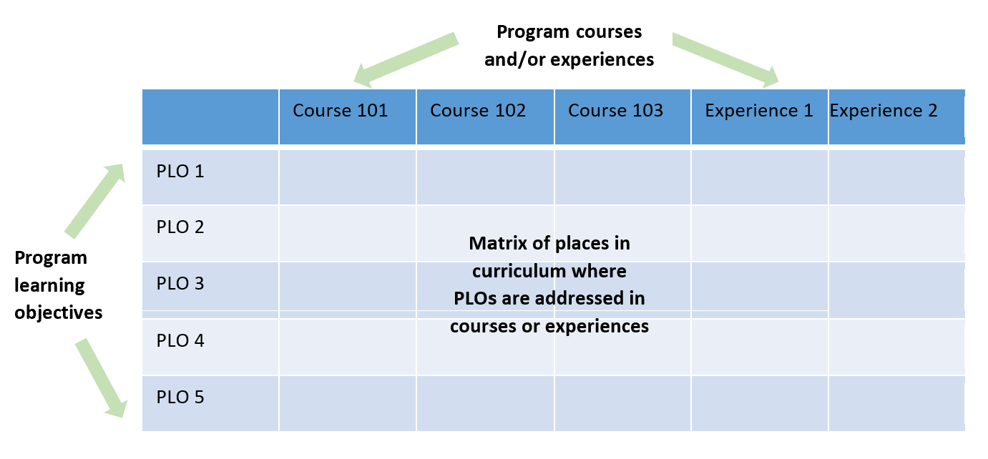

Curriculum maps also indicate the level of achievement at which faculty expect students to perform with respect to a specific PLO. Penn State’s approach for degree programs is to categorize the phase of education, or the way a course or experience forwards a PLO as Introduced (1), Practiced (2), or Mastered (3)* (see table below). Curriculum maps for certificate programs will not depict 1, 2 and 3. They will include only “” where a course addresses an objective.
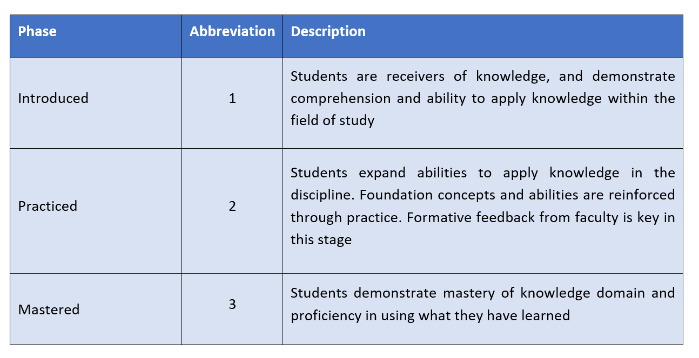

To create a curriculum map, begin with the program’s learning objectives and a list of core courses completed by all students in the major including:
- required courses offered by the home department;
- required courses offered by other departments;
- general education courses required by the major;
- restricted electives listed as course groups with titles rather than listing each course in its own line (optional); and
- specified out-of-the classroom or extra-curricular experiences (if required of all students).
Create separate tables when there are several distinct degree options, i.e. where most of the courses completed by students in the major are contained in the options. NOTE: The AMS is set up at the program level, rather than the option level, so it only allows for a single curriculum map to be entered. If your program has options, use the curriculum map in the AMS to cover only the courses and sets of restricted electives that apply to all options. The curriculum map can be exported from the AMS and then modified to reflect each of your options.
When completing a curriculum map, it is best to place courses into the table in the basic order in which students tend to take them. For certificate programs, order of courses may not be a feature of the curriculum map. Some programs prefer to describe the relationship between PLOs and courses in prose.

Example Curriculum Map for Undergraduate Programs
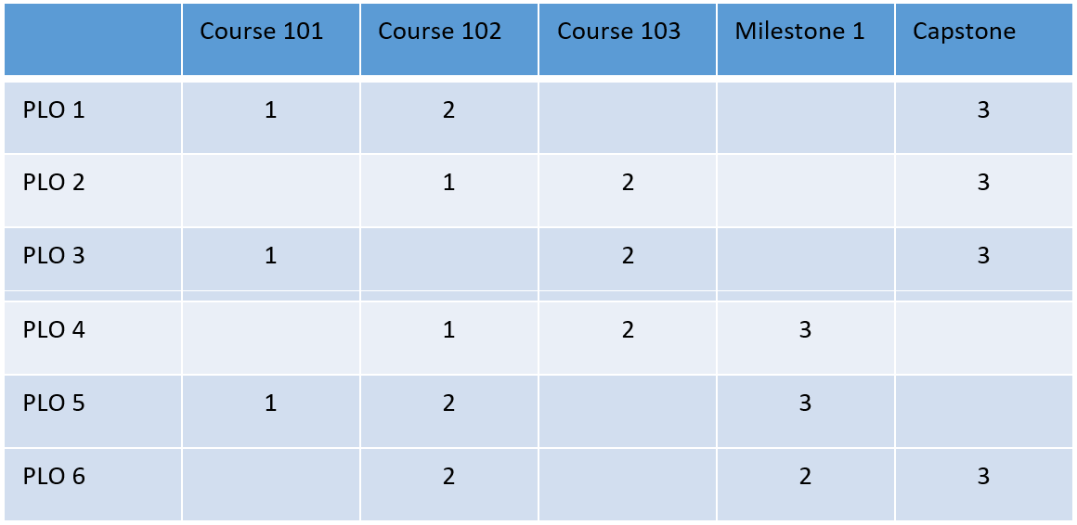

Example Curriculum Map for Graduate Programs
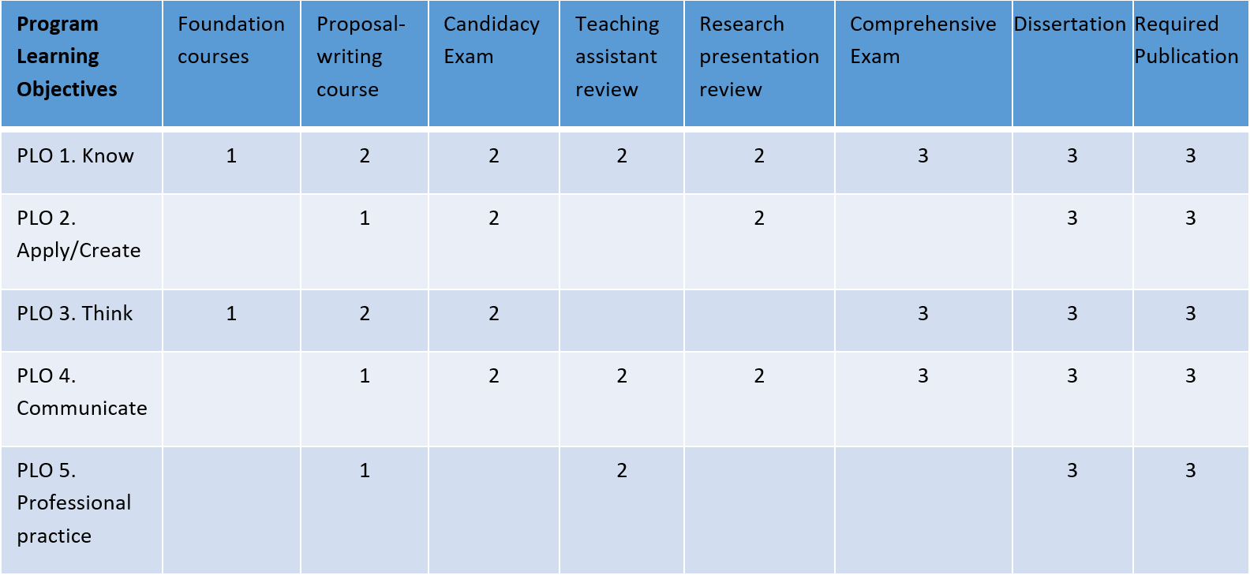

Example Curriculum Map for Certificate Programs
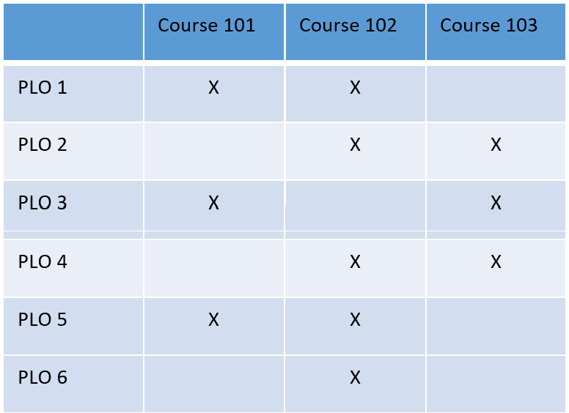

Determining Introduced/Practiced/Mastered Placement on a Curriculum Map
A 1, 2, or 3 (introduced, practiced, or mastered) should be assigned if a PLO is addressed to a significant degree in a course, i.e., is evaluated in a final exam or significant paper or project. Not all cells will have notations in them. Each PLO should be addressed at each level across the map to support student development through the curriculum.

Using a Curriculum Map to Choose Annual Assessments
- Assessments of PLOs are chosen from courses where 1, 2, 3 are marked.
- Program assessment should involve regular use of master-level assessments to measure achievement of PLOs, such as final projects or research papers, completed in the last year of degree.
- Examine introduced- and practiced-level assessments if there is a concern with mastered-level performance for one or more PLOs.
- Examine introduced, practiced and mastered-level assessments if you would like to review student development toward mastery through all years of the program, from first to last.

Example Curriculum Map with Gaps
Note that in the map below students do not have the opportunity to practice or demonstrate mastery for critical thinking. In addition, students do not have the opportunity to practice project management prior to demonstrating mastery.
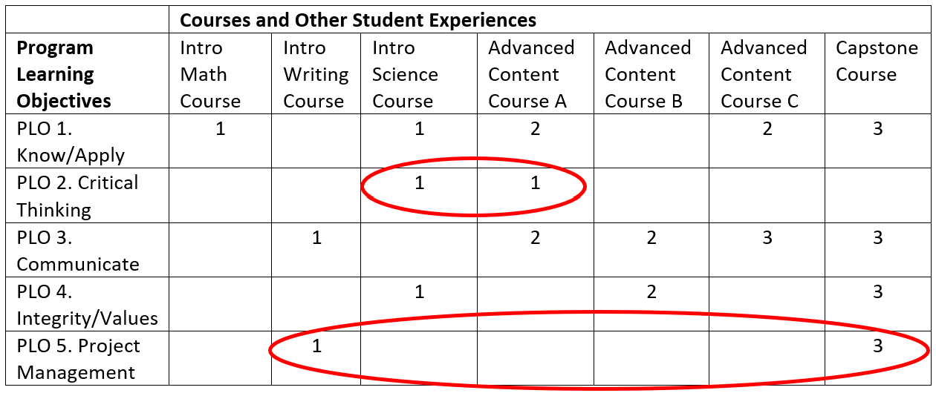

Example Curriculum Map with Skill Integration
Students can practice integrating critical thinking, communication and integrity/values in Advanced Content Course B.
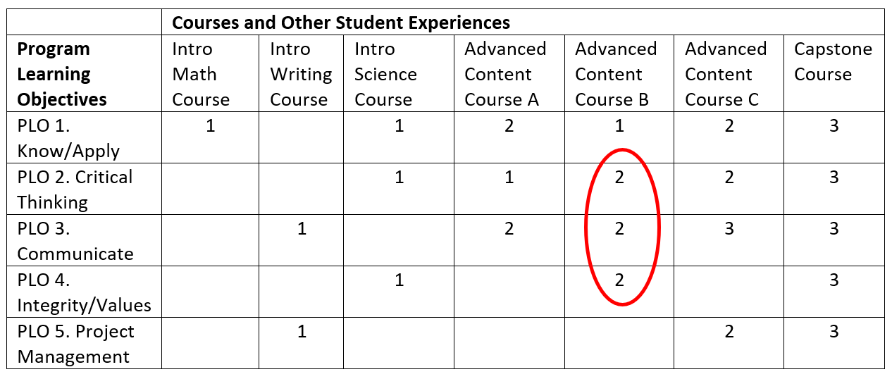
Choose a Learning Objective to Assess
Step 2
Programs are expected to assess a single objective each year, though it is fine to assess multiple objectives. An assessment plan begins with a student learning concern or question about a particular learning objective that faculty want to explore further.
There are a range or reasons for choosing a particular PLO, including that it has never been examined or has not been examined in some time. Alternatively, broader institution, college, or departmental discussions may be centered on specific knowledge, skill, or value embodied by a particular PLO. The choice of which PLO to assess is often rooted in faculty concerns or questions based on their observations of student performance. For example, faculty may notice that students are unable to solve particular problems in a 400-level course. This may lead them to choose to assess an objective related to problem-solving. The learning concern or question is what drives the assessment design.
Choose and Design Assessment Methods
Step 3
If an objective is written well, it will not be difficult to determine the most effective way to measure it. The alignment between the measure and the PLO is vital. Because the goal of learning outcomes assessment at the program level is to demonstrate that students have met program objectives at or near graduation, typical measures for program assessment purposes are those in which students demonstrate mastery of the objective (see the curriculum map). These can be major assignments in capstone or other 400-level courses, internship supervisor evaluations, or program-level exams. Consider choosing a measure that will provide longitudinal evidence of maintenance or changes in student performance. At times you may want to use a different assessment method. For example, if you find students have not mastered an objective you may want to assess performance in an earlier course to investigate possible reasons for their sub-optimal performance. Once you determine what those reasons are, you can make changes and then re-assess students at the mastery level. Alternatively, you may have an assessment question that requires measurement of student performance at an earlier point, or even multiple points, in the program. The best choice of assessment measure will provide meaningful information to the program faculty.
An exemplary assessment measure is described clearly and completely and aligned closely with the learning objective being assessed. The use of both direct and indirect measures is exemplary assessment practice.
There are 2 basic types of measures for assessment:
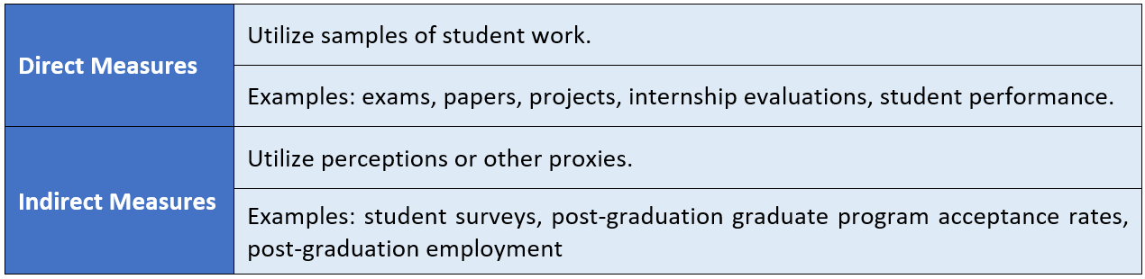
Direct evidence by itself is a stronger measure of student learning than indirect evidence by itself. The strongest assessment evidence combines both direct and indirect evidence. For additional examples, see the resource in on the OPAIR Assessment Resources page called “Direct and Indirect Assessment Measures.pdf.”
In smaller enrollment courses, data collection may constitute obtaining copies of each student’s artifact (i.e., assignment). In large enrollment programs, it may be necessary collect data from a sample of students.
Remember that this process is driven by your learning concerns or assessment questions. At the most basic level, learning outcomes assessment is about whether students have the skills and knowledge necessary for success after graduation. The most effective strategy for answering this question is to measure student performance at the demonstration of mastery level, typically in a capstone or other 400-level course, or a master’s or dissertation defense for graduate programs.
Faculty may have other concerns or interests about the program that lead to different assessment designs. Perhaps faculty believe students are not coming into the program with the necessary background. This question suggests the need to administer a pre-test in an early course. If faculty are interested in how students are developing throughout the program, measures at various points in the curriculum would be the best assessment strategy. Alternatively, faculty might want to know how demographics or experience might impact student mastery of skills and knowledge. If a language program wants to know if students who study abroad master learning objectives at a greater level than those who don’t, performance data will need to be compared between those two levels of experience.

Scoring Guides (Rubrics)
Most assessment measures, excluding multiple choice tests, surveys, and other indirect measures, can benefit from a scoring guide, often called a rubric, that facilitates scoring. According to Linda Suskie (2009), the following are advantages of rubrics:
- help clarify vague, fuzzy goals;
- help students understand your expectations;
- help students self-improve;
- can inspire better student performance;
- make scoring easier and faster;
- make a score more accurate, unbiased, and consistent;
- improve feedback to students;
- reduce arguments with students; and
- improve feedback to faculty and staff.

Chapter 9 from Suskie’s (2009) book, Assessing Student Learning: A Common Sense Guide, describes various types of rubrics and how to create can be found on OPAIR’s Assessment Resources page. One of the most effective strategies for “designing” a rubric is to find one that has already been developed and modify it to suit your needs. The Association for American Colleges and Universities (AAC&U) gathered multiple faculty members from across the country to develop a series of rubrics addressing common learning objectives. These VALUE rubrics are freely available online and are also on OPAIR’s Assessment Resources page in the Rubric Library. They are an excellent place to start.
Analytic rubrics (like the AAC&U rubrics) include descriptions of each performance level for each component of an assignment. These rubrics are recommended for program assessment because they support consistent scoring and allow analysis of each assignment component separately. This is important because it is possible for students to score high on an assignment overall, while not meeting expectations for a specific component. Using an analytic rubric and analyzing the results by component may reveal specific skills or knowledge that require additional emphasis in the program.
Exemplary assessments use well-constructed analytic rubrics for appropriate assignments that include clear and concise descriptions for each performance level and analyze performance separately for each assignment component.

Performance Criterion
The final component associated with designing your assessment measure is creating a performance criterion or benchmark, which is a statement of the level at which you would consider students to have met the learning objective. It is important that your performance criterion be in alignment with your measure. Several examples of performance targets are listed below.
- 80% of students will receive a total score of 85 or above on the essay.
- At least 85% of students will score a 3 out of 5 on each of the rubric components.
- At least 90% will receive a score of 80 or higher on the internship evaluation form.
- 95% of students will score at least a 3 on each rubric component, and 60% of students will score at least a 4 on the attached 5-point rubric.

Exemplary assessments provide a clear criterion to help determine whether students met expectations. When a scoring guide (rubric) is used, a performance target for each assignment component are described.
Collect Assessment Data/Evidence
Step 4
Once you have chosen one or more assessment methods for the PLO you are interested in measuring this year, you will need to implement your process for gathering assessment evidence. This process often involves collaborating with other faculty in your program, or in programs at other locations. However, your data collection process may look different from one year to the next depending on the PLO you are interested in assessing and the measure you have chosen.
In some programs, the number of graduates is very small. It is up to the faculty to decide what number provides meaningful results. For some small programs, it is acceptable to use the same assessment strategy for multiple years in order to increase sample size.
Keep in mind that program assessment is concerned with answering questions about student learning by majors in the program. Therefore, assessing learning in General Education courses is tricky because many students in some of these courses are not majors in the program. Performance of students who are not majors would need to be removed from analyses.

Review Evidence and Determine Action
Step 5
Once the assessment data is collected, it should be shared broadly with program faculty who will decide if the results indicate the need for modifications to the program. In cases where students have not met performance targets, the faculty decide what specific modifications may lead to improved learning.
Negative assessment results may be rooted in the learning objectives, the learning opportunities, or the assessment itself. For example, you may determine that the program objective needs improvement, or perhaps isn’t really important after all. In this case, your strategy would be to re-write, replace or delete the objective. Or, you may hypothesize that the objective isn’t being properly addressed in the course(s). Perhaps students aren’t getting enough practice, for example, or there isn’t enough emphasis by an instructor. Alternatively, it may be that the assessment itself is not constructed in a way that best addresses the objective. Perhaps the assignment directions and/or rubric need to be revised. For multiple choice questions, it isn’t uncommon for test questions to be worded in a way that results in many students missing the question even if they know the material. Item-writing rules, can be helpful when constructing a multiple-choice test. Analyzing test questions can be done using a statistical procedure called item analysis.
Negative results may also be a result of program policies or lack of adherence to policies. For example, if pre-requisites are not being adhered to, students may be moving through the curriculum unprepared.
Articulating specific modifications, such as including an additional assignment in a specific course to address a gap in student knowledge, is better than a vague idea such as “improve the way a topic is taught.”
If students have met expectations at the current level, faculty could choose to assess another PLO the next year. If, however, students are not meeting expectations, faculty may choose to assess in an earlier course to determine the point in the program where students may not be getting the practice needed to master the knowledge or skill.

Report Submission
Step 6
Reports are submitted via the Assessment Management System. The role of the Office of Planning, Assessment, and Institutional Research (OPAIR) is to support program faculty in their efforts to conduct meaningful assessment. The Report has three main components: 1) findings from the previous year’s assessment, 2) plans for the next year’s assessment, and 3) a summary of any assessment impacts. The information requested in the assessment report, including submission of additional materials such as exams and rubrics, is necessary for OPAIR staff to provide the most helpful feedback to support strong and meaningful assessment. Assessment report feedback is based on comparing information in the report to our definitions of exemplary responses for each section. These definitions are provided below and AMS users have access to a “Program – Training Exemplar” where sample exemplary responses are provided as a guide.

Program learning objectives | Exemplary program learning objectives are stated with clarity and specificity and include precise verbs, rich description of the content, skill or attitudinal domain in the disciplinary context and are stated in student-centered terms.
Curriculum/milestone map | An exemplary curriculum map or milestone map includes all courses and experiences of the program in chronological order, labels of 1, 2 and 3 in the map for each program learning objective reflecting major assignments in the courses they are aligned with. A curriculum map for a certificate program will have check marks instead of 1, 2 and 3.
Assessment methods | Exemplary assessments use measures that are described clearly and completely and aligned closely with the learning objective being assessed. An exemplary assessment strategy employs both direct and indirect measures.
Scoring guide (rubric) | Exemplary assessments use well-constructed analytic rubrics for appropriate assignments, include clear and concise descriptions for each performance level, and analyze performance separately for each assignment component.
Performance target or benchmark for measure | Exemplary assessments provide a clear criterion to help determine whether or not students met expectations. When a scoring guide (rubric) is used, performance target for each assignment component are described.
Summary of findings | Exemplary reports provide clearly presented results of student performance, derived by appropriate analyses and directly related to the objectives and the performance targets.
Interpretation of findings | Exemplary interpretations are reasonable given the objectives, criteria, methodology and results. Where applicable, interpretation includes how classes/ activities might have affected results.
Action plan(s) based on findings | Exemplary action plans, when needed, are directly related to findings of assessment and are very specific (e.g., approximate dates of implementation and where in curriculum they will occur.)
Assessment Impact | Exemplary responses to this question include strong evidence, from direct measures, supporting substantive learning improvement due to program modifications. The program responded to previous assessment results, made curricular and/or pedagogical modifications, re-assessed, and found that student learning improved. The rationale and explanation of the modifications leading to the change are clearly laid out and the impact of the change is clearly described.

If your program is just getting started with learning outcomes assessment or does not have findings from the previous year for some other reason, you will have the opportunity to note this in the report.
In some instances, no assessment data is available. For example, a program may be new and not yet have graduates to assess. Alternatively, the program may be using a multi-year data collection strategy and planning to submit data in a subsequent year. The assessment leadership may have changed hands without the necessary information being communicated to the new leadership. In all of these cases, we request that you still submit a report. Indicate why you have no evidence of student learning to report and complete the plan for the upcoming academic year, if possible.
World Campus programs must also be assessed. If the program has a residential component, then findings from this assessment should be included with residential assessment, although it is appropriate to have different methods and findings if you choose to assess the online program in a different way.
Implementing Changes and Determining the Impact
Steps 7 & 8 & A
Learning Outcomes Assessment is about improving student learning. Thus, making changes (if applicable) based on evidence is a key feature of the process. If assessment results have led to any changes to the curriculum or the assessment strategy, an important next step is to implement those changes and then, at the appropriate time to re-assess the learning objective to determine if the changes had the expected affect. If no changes have been made in the curriculum, these steps are skipped.

Program Learning Objectives (PLOs)
Begin again with 1a
Findings from prior assessment cycles should drive the plan for the upcoming year’s assessment. If assessment results have led to changes in the program learning objectives and/or curriculum/milestone map, or this is the first assessment plan submitted for a program, this new information will be included in the report. Otherwise, program faculty may use findings from assessment to determine which learning objective they will explore in the next academic year and repeat the steps of learning outcomes assessment as described above.

Where can I go with questions?
The Office of Planning, Assessment, and Institutional Research is here to help. If you have any questions or concerns, please do not hesitate to contact us at loa@psu.edu or contact your Assessment Liaison.

