Penn State Scranton Staff Advisory Council
Committee Meeting Minutes
Monday, January 25, 2021 at 2:00 p.m.

Josh McAuliffe approved minutes from November meeting.

Review of past events and budget
- Mari Donnelly reviewed budget - Beginning balance: $662.56, Bingo Prizes cost: $54, Trivia Prizes cost: $100 with $30 left over for Feb. Ending balance: 508.56

Guest Speaker Dr. Wafa
- Welcome and well wishes to all
- Hopefully there is a light at end of tunnel with the vaccine rollout. Looks like most people will not receive it until May or early summer.
- Penn State trying to become a vaccination center.
- Reminder of pre-arrival covid testing.
- Hopefully, we will know in February what the Spring semester will look like. Virus infection numbers and access to vaccine will guide the decision of getting back to campus or working remotely.
- Construction on engineering building is coming along, building looks good. He received inquiry from student asking if we would be offering electrical engineering, unfortunately only mechanical engineering at this time.
- Men were spotted working on the leaky roof of the MPB/gym.
- Admission numbers are stable considering circumstances and that Spring semester is generally harder to retain students.

Questions:
- Suzanne Morgan stated she read in the paper that there are vaccine sites that will take your name and get you on a lit; CVS pharmacy, Wright center, Diepetro Pharmcy and Wegmans in Wilks Barre.
- Jo Ann Durdan shared that the Wright center only accepts current patients and there is a 5 month wait.

Guest Speaker Marilee Mulvey - Box Migration Overview

- Most people are general users. Rob and Marilee know special cases and will notify you if there’s something different you need to do.
- Pre Migration Cleanup until Feb. 1 - clean up your Box files. Delete unneeded files. We do have a record retention Policy at Penn State. Allison Burnes is our Record Management Liaison. Contact her if you are unsure what files need to be kept and for how long.
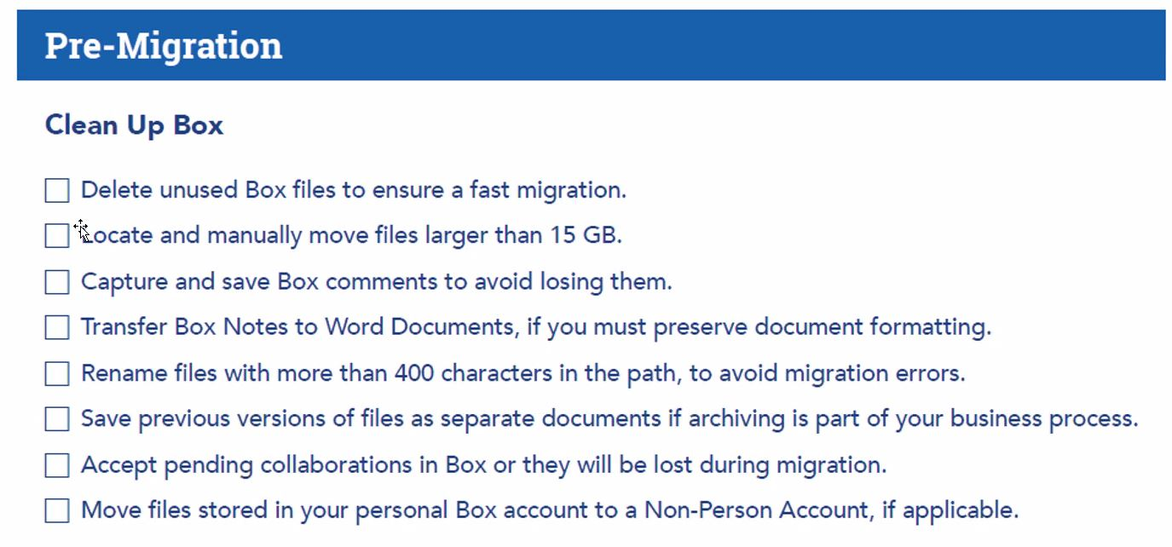
- Phase 1 begins Feb. 1 and length of time for migration will vary depending on amount of data. The process happens in the background.
  - You will be notified when phase 1 complete
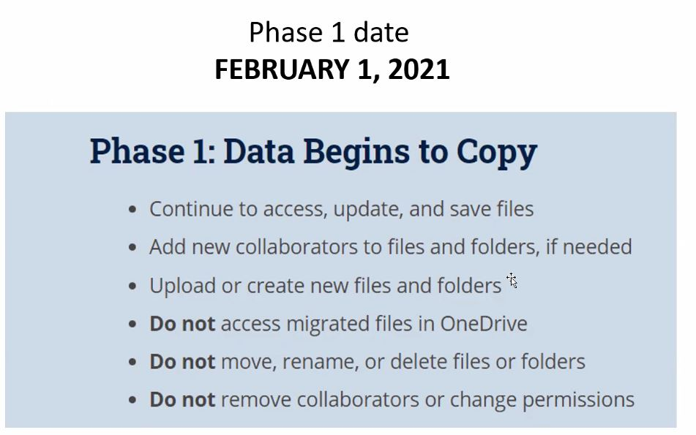

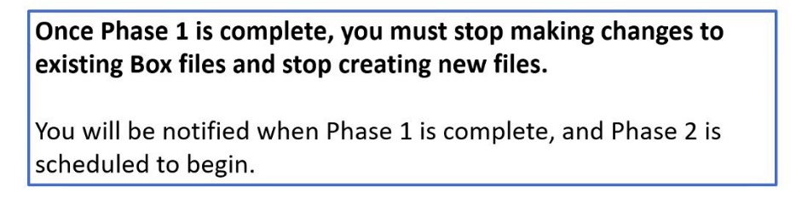

- Phase 2 is the sync process begins Feb .27/28
  - Email notification at completion of phase 2
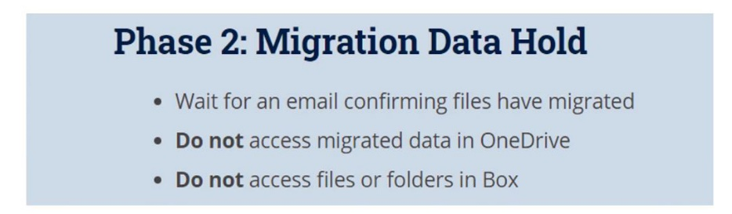

- Box sync and Box Drive will be removed remotely by Rob.
- Marilee and Rob receive reports with errors and glitches
- Has been a smooth process for other campuses
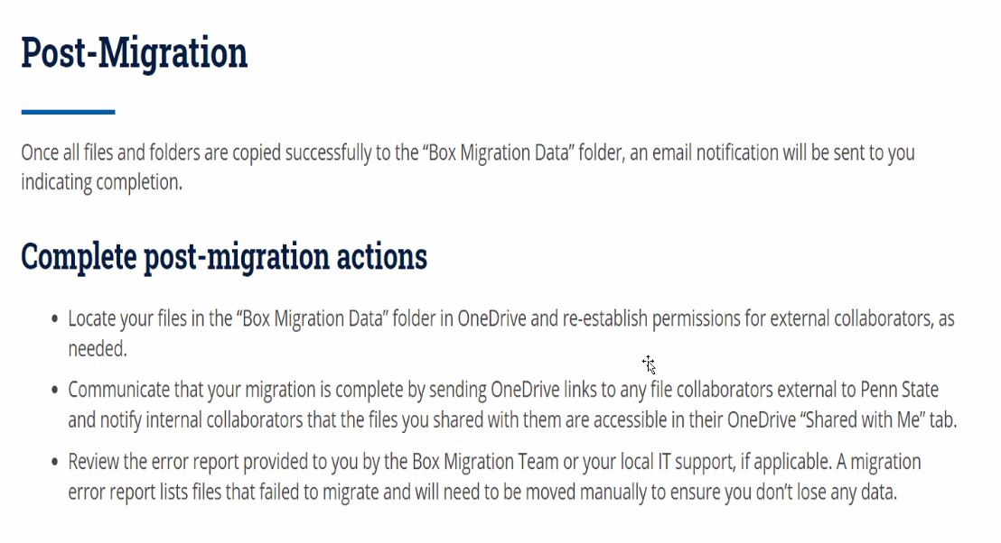
- Where are your files?
  - 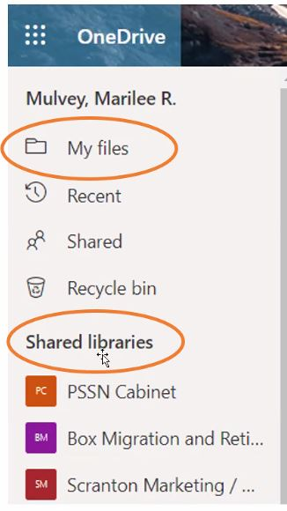

- More info:
  - More info can be found at storage.psu.edu
    - See training and resources
    - See Migration Checklist on the home page for step by step process
  - Attend a training session this week for more info:
    - Tuesday 1/26 11am-12pm
    - Thursday 1/28 9am-10am
    - Thursday 1/28 10:30 am – 11:30 am
    - Thursday 1/28 2 p.m.-3p.m

- Questions:
  - Suzanne asked if she should move files or folders manually before the migration process.
The answer is no. The migration process will take care of it.
  - Suzanne asked about folders that change owners or collaborators
    - Marilee stated the owner should be responsible for content. If they are no longer the person in charge of the content then box ownership should change before migration
  - Moving forward if we need have files that change ownership often like Undergraduate Research or Staff Council that has a rotation of committee members, then contact IT with a support ticket to get help with determining what is best for the situation, example Teams, Sharepoint or One Drive

Marissa Boyd, Student requesting feedback and ideas from staff about the renovations for the multipurpose building
- In October she surveyed students about the multipurpose building and received a great amount of feedback
- After that the Sff committee approved $50,000 for a feasibility study of the multipurpose building.
- She met with the student athletes, the general student body, and the coaches to get input from them.
  - The main things that each group would like to see: expansion of the gym/cardio room, lounge spaces, updated locker rooms, lighting and an athletic training room.

Ideas generated at this Staff Council meeting wre:
- Yoga or wellness classroom space so that academic classrooms and Conference rooms didn’t have to be used
- Retractable roof
- Pool
- Pelleton room
- Indoor Track
- Racquetball
- Game room activities
- Rock climbing

Upcoming Events
- February is Winter Blues Trivia. 30 Minute lunch hour trivia
- 3 part cooking Series starting Feb 10 on zoom with a famous chef open to staff and students
- Check out the updated HR professional Development opportunities. They have been expanded to cover diverse topics like wellness and health as well as retirement savings and other professional development training.
- Provost visit on Thursday Jan. 28 at 4:15-5Pm for faculty and staff. Joint session with WB also scheduled for students. Look for email from Marianne Gable with details.

Motion to adjourn: Matt Nied

