Lily Najjar

BOTTLING LIFE:

THE IMPLICATIONS OF BOTTLED WATER IN OUR COMMUNITY AND BEYOND

Introduction
In the spring of 1992, The Pennsylvania State University (Penn State) signed a $14-million, ten-year contract with the PepsiCo company.¹ In exchange, PepsiCo became the exclusive provider of most beverages and snack foods found on Penn State campuses.² If you have not been able to find a can of Coke in the vending machines, this is why. No direct competitors of PepsiCo can sell their products anywhere on campus.³ In the early 1990s, universities all over the country were strapped for cash, and Penn State viewed the PepsiCo contract as their “creative” solution.⁴ Despite concerns that the unusually comprehensive and exclusive sponsorship agreement would commercialize the academic institution, Penn State accepted the contract because it would prove incredibly lucrative for the University, providing the funds to build and renovate the Bryce Jordan Center, the library, the HUB Robeson Center, and other buildings across campus.⁵
Over the past twenty-five years, Penn State and their soft drink sponsor have developed an enduring, loyal relationship. In 2011, PepsiCo stood by Penn State throughout the Sandusky Scandal while many other major sponsors pulled out of their agreements.⁶ The next year, Penn State renewed their agreement with PepsiCo despite being courted by The Coca Cola Company.⁷ Next year, in 2020, Penn State and PepsiCo will once again renegotiate their contract.⁸ Given their history, many expect no radical changes in their agreement. However, this is the perfect opportunity for Penn State to reduce the university’s carbon footprint and limit plastic pollution. In the past few years, Penn State has taken steps to reduce single-use bottled water, placing water bottle fillers at key locations all around campus. However, in negotiations next year, Penn State could finally remove all single-use bottled water—namely Aquafina and LifeWater, PepsiCo’s bottled water brands—from their PepsiCo contract and campuses across the state. Other colleges, like New York University and the California State University system, have already transitioned away from bottled water in response to student-led campaigns; it would not be unprecedented for Penn State to do the same.⁹
Bottled water manufacturers produce immense amounts of waste, devastate the natural landscape, and exploit vulnerable communities in order to commodify what the United Nations has declared a human right: water access. Our university has been given a perfect opportunity to take a stand against this injustice. If the Penn State administration truly wants to demonstrate its commitment to environmental sustainability and social justice, they must negotiate Aquafina and Lifewater out of the PepsiCo-Penn State contract in 2020.

Concerns for the Environment
Advocates often cite the environmental impact of manufacturing and consuming bottled water as the principal reason to curb its usage. Bottled water manufacturers contribute significantly to pollution in our atmosphere, on our land, and in our oceans:
- Seventeen million barrels of oil are used yearly in bottled water production, enough to fuel one million cars for a year. This emits two and a half million tons of carbon dioxide into the atmosphere each year.¹⁰
- It requires three times as much water to create the bottle as it does to fill it.¹¹
- Fifty-three billion gallons of bottled water are consumed each year. Only one in five bottles are recycled, leaving 3 billion pounds of plastic waste in landfills—around 38 billion bottles in the US each year.¹²
- Americans send most of their plastic to recycling plants in China.¹³ However, in 2019 China restricted the imports of many recyclables; the cost of waste-management within the US is much more expensive, and many municipalities cannot afford it, instead, throwing their recycling away.¹⁴ Even when bottles are recycled, most are actually “downcycled;” the plastic is broken down and used to create a product that is often unrecyclable and eventually thrown out.¹⁵
- On average, it takes 450 years for a plastic water bottle to decompose. For some, it can take up to 1000 years.¹⁶
- Much of plastic waste finds its way to waterways: oceans, rivers, and lakes. Plastic ocean waste kills at least one million marine creatures.¹⁷ It is estimated that by 2050, there will be more plastic in our oceans than fish.¹⁸
Unlike some plastic pollution which, for the time being, is a necessary evil, plastic water bottles are completely expendable. By nature, they are luxury products, not necessities, and those who actually lack access to clean, safe drinking water cannot afford to buy it bottled. The consumption of bottled water occurs almost exclusively in countries with easy access to clean water (largely western, industrialized, and affluent countries), and where water is scarce, bottled water is as well.
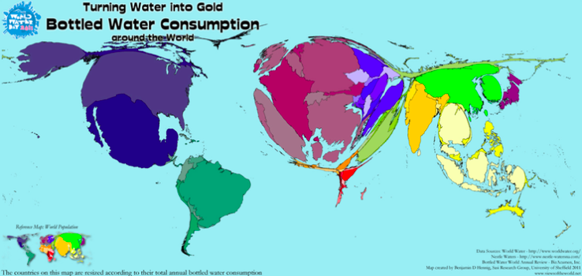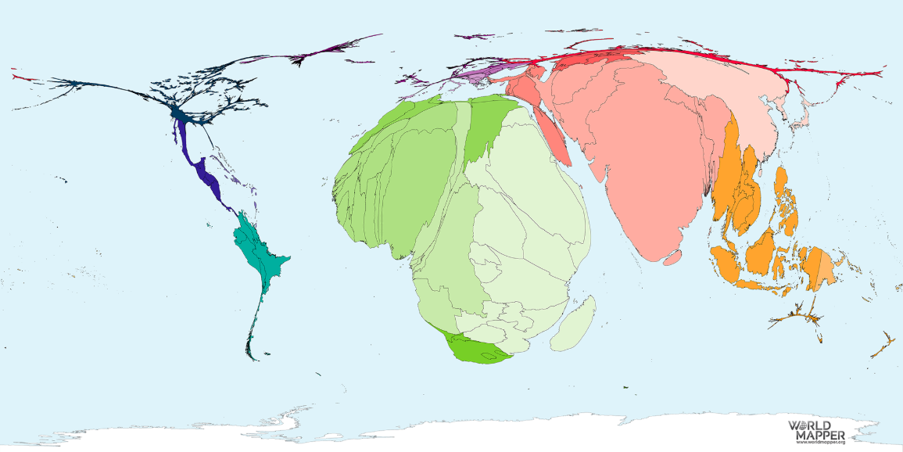
Figure 1: Bottled Water Consumption By Nation
Retrieved From: Benjamin Hennig, Bottled Water Consumption around the World, Views of the World, http://www.viewsoftheworld.net/?p=1292 (Apr. 4, 2019)

Figure 2: Water Access by Nation
Reproduced From: Benjamin Hennig, No Water Access, Worldmapper, https://worldmapper.org/maps/housing-nowateraccess-2015/ (Apr. 4, 2019)

Concerns for the Environment

Bottled water manufacturers make their profit through the exploitation of depressed rural communities, draining their resources for incredibly low fees and destroying the local landscape. Bottled water companies broker unfair contracts with small, economically suffering towns, often in areas with minimal water regulations.¹⁹ They promise new jobs and improved infrastructure in exchange for massive tax breaks and sometimes exclusive rights to the area’s springs and aquifers, from which they pump hundreds of thousands of gallons a day.²⁰ For the resources they drain, the manufacturers might pay as little as 0.000087 cents per gallon.²¹ To put that in perspective, on average tap water costs a household 0.0015 cents per gallon.²² Once the water is bottled, the manufacturers sell at nearly 10,000 times the original value, at 10 dollars per gallon.²³
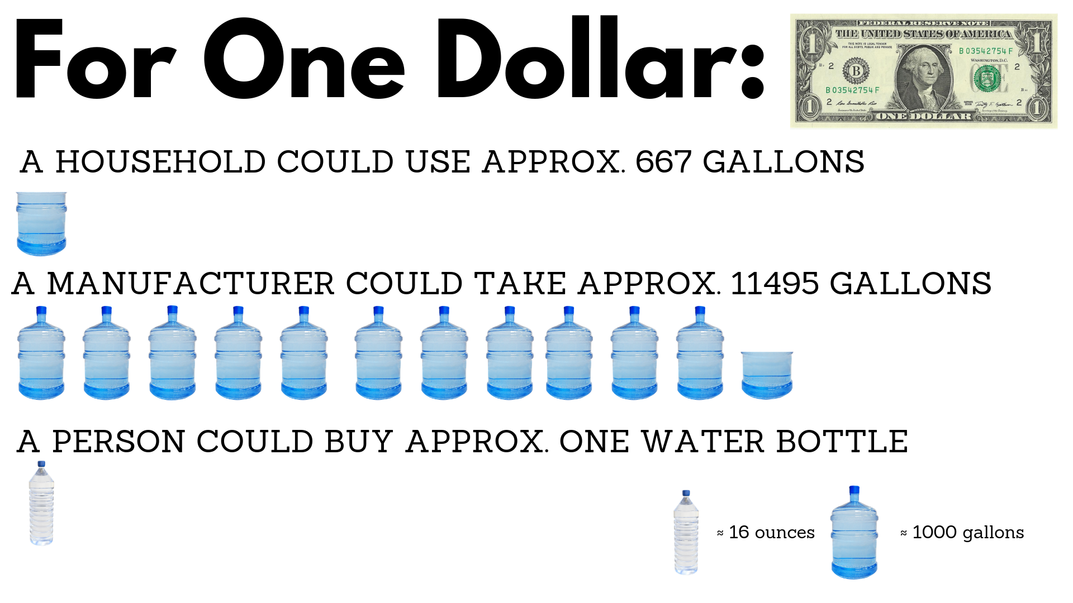
Figure 3: Relative Costs of Water
Sources: Online Education, The Facts about Bottled Water, http://www.onlineeducation.net/bottled_water (Apr. 4, 2019); Tara Lohan, Rural Communities Exploited by Nestle for Your Bottled Water, AlterNet, https://www.alternet.org/2007/05/rural_communities_exploited_by_nestle_for_your_bottled_water/ (Apr. 4, 2019)

Degradation of the American Landscape
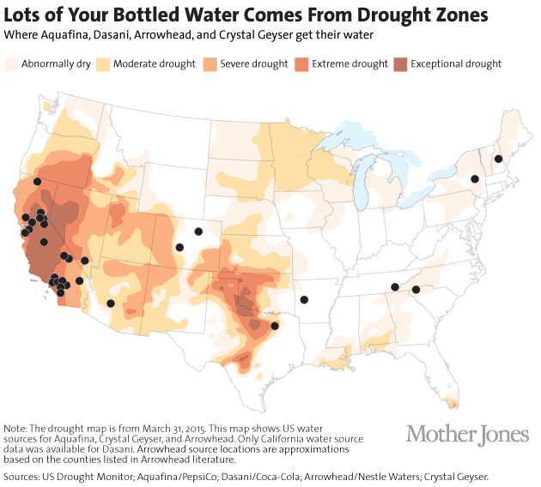
These contracts also often exempt manufacturers from any legal responsibility for the environmental consequences of their bottling plant, of which there are many.²⁴ Using water for sustainable agriculture and other regional uses can be sustainable because that the water stays within the regional water cycle, which means that the springs and aquifers from which they extract will eventually be replenished through precipitation and infiltration. However, bottling plants remove water from cycle completely, sometimes shipping it halfway across the world. Furthermore, it extracts water from its source at rates that will not allow the water supply to naturally replenish itself.²⁵ This can lead to a few serious issues for the region. First, it can cause water scarcity, which could severely depress the region’s agriculture production and also limit water resources for personal use.²⁶ Second, draining springs can severely damage the region's ecology, threatening species that rely on those resources.²⁷ Finally, emptying of aquifers (groundwater) can literally depress the topography of the region, because the above Earth loses support, and the ground sinks through a process called subsidence²⁸. This can seriously damage above-ground structures.²⁹ All of this is exacerbated by the fact that manufacturers have located their bottling plants in areas already vulnerable to drought and water scarcity. Because of carefully created contracts, bottling manufacturers are not responsible for any of these consequences, and because their main concern is profit, they have no stake in the region’s sustainability.³⁰
Figure 4: “Lots of Your Bottled Water Comes from Drought Zones”
Reproduced From: Julia Lurie, Lots of Your Bottled Water Comes from Draught Zones, Mother Jones, https://www.motherjones.com/environment/2014/08/bottled-water-california-drought/ (Apr. 4, 2019)

False Promises to Depressed Communities
The jobs that manufacturers promise the community are just as unsustainable. Once the region is drained of its water resources, all jobs opportunities will disappear. Ironically, many of the communities that manufacturers target are located in the northwest and the rustbelt, which first became economically depressed because they relied on industries that vacated when resources depleted.³¹ One resident from Michigan raised the concern of once again returning to a fickle industry:
God knows that people need jobs in this area….but one has to look at the bigger picture and think about sustainable jobs….Back in 1890 to 1920 the timber industry came to Michigan and wiped out this state. I am sure there were plenty of jobs then. They said there was 500 years of timber, and in less than 50 years it was gone. Is that what we want to see again?³²
Last year, Nestle Waters attempted to build a bottling facility in Spring Township, a part of the larger State College area, promising the same job opportunities they promised countless other depressed communities.³³ If the plant was built, Nestle would extract millions of gallons a day from local streams and groundwater sources.³⁴ Luckily, residents of Spring Township vocalized their protestations, and Nestle began pursuing plants in other parts of the region.³⁵ Centre County prevailed here, but it demonstrates how close to home this issue is for our university. How can Penn State continue to support bottling companies like Nestle through the PepsiCo contract while those companies profit off of the exploitation of communities like ours?

Concerns in the Nation and Abroad

Crisis in National Water Infrastructure
America’s water infrastructure includes structures like dams, aqueducts, and underground pipes, as well as facilities like treatment plants and sewage systems. According to the 2017 American Infrastructure Report Card, much of America’s water infrastructure was built in the mid 20th century, and its lifespan has come to an end.³⁶ This aging infrastructure has caused the water supply of entire cities to be contaminated, most famously in Flint, Michigan. As communities across the country rapidly lose faith in the safety of tap water, they have begun relying on bottled water instead. As an unintended consequence of this reliance, the pressure to update public water infrastructure has significantly decreased and minimal investment has been made in improving these systems. This created a vicious cycle wherein bottled water manufacturers are the only beneficiaries. Furthermore, they actively profit off of tragedies caused by weak infrastructure: when disaster strikes, residents are forced to rely on their products to survive. This was (and still is) the case in Flint, Michigan and natural disasters such as hurricanes and earthquakes. Obviously, this has national implications, but the impacts are also local: Penn State’s own water infrastructure is failing. If Penn State removed bottled water from their campuses, they might finally address and begin reducing the unhealthy levels of lead found in the water of many University Park residence halls.³⁷

Conflicts with Human Rights and Global Need
In July of 2010, the United Nations recognized that access to clean drinking water and sanitation was a human right.³⁸ And yet, bottled water brands like Aquafina and Lifewater have been allowed to literally bottle and sell this human right. Even if manufacturers were to behave more ethically, minimizing their footprint and respecting the communities and environments from which they source their water, the concept of bottled water would still be antithetical to human rights.

Conclusion
Next year, Penn State will sit down with PepsiCo to renegotiate their long-running contract. For the most part, this deal has provided Penn State with valuable resources for its students and staff. Much of this lucrative, largely beneficial deal could remain, and with a small compromise, Penn State could make a big difference. They could join the first wave of universities ending their support of companies which destroy our environment, exploit our most vulnerable communities, and encourage the degradation of American water infrastructure, infrastructure that keeps Americans alive and is unequivocally a human right.

Bibliography
¹ Anthony Depalma, "Penn State Got the Exclusive $14 Million, 10-Year Deal with Pepsi! Uh-huh!" New York Times, June 10, 1992 (https://www.nytimes.com/1992/06/10/news/penn-state-got-the-exclusive-14-million-10-year-deal-with-pepsi-uh-huh.html) (Apr. 4 2019)
² Penn State, AD26 Sale and Serving of Food and Beverages at University Locations, https://policy.psu.edu/policies/ad26 (Apr. 4, 2019)
³ https://policy.psu.edu/policies/ad26
⁴ New York Times, June 10, 1992
⁵ Kevin Horne, The Pepsi Tyranny Continues, Onward State, https://onwardstate.com/2012/05/25/the-pepsi-tyranny-continues/ (Apr. 4, 2019)
⁶ Sports Business Daily, Pepsi Plans to Continue Sponsoring Penn State, Football Team, despite Scandal, https://www.sportsbusinessdaily.com/Daily/Issues/2011/11/17/Marketing-and-Sponsorship/PSU-sponsors.aspx (Apr. 4, 2019)
⁷ https://onwardstate.com/2012/05/25/the-pepsi-tyranny-continues/
⁸ https://policy.psu.edu/policies/ad26
⁹ John Aspray, Students Taste Victory as Their Campuses Move Away from Bottled Water. Food & Water Watch https://www.foodandwaterwatch.org/insight/students-taste-victory-their-campuses-move-away-bottled-water (Apr. 4 2019)
¹⁰ Online Education, The Facts about Bottled Water, http://www.onlineeducation.net/bottled_water (Apr. 4, 2019)
¹¹ http://www.onlineeducation.net/bottled_water
¹² http://www.onlineeducation.net/bottled_water
¹³ Alana Semuels, Is This the End of Recycling?, Atlantic https://www.theatlantic.com/technology/archive/2019/03/china-has-stopped-accepting-our-trash/584131/ (Apr. 7, 2019)
¹⁴https://www.theatlantic.com/technology/archive/2019/03/china-has-stopped-accepting-our-trash/584131/
¹⁵ Lisa Kaas Boyle, The Myth of the Recycling Solution, Plastic Pollution Coalition https://www.plasticpollutioncoalition.org/pft/2015/8/23/the-myth-of-the-recycling-solution (Apr. 7, 2019)
¹⁶ Rick LeBlanc, The Decomposition of Waste in Landfills: A Story of Time and Materials, The Balance, https://www.thebalancesmb.com/how-long-does-it-take-garbage-to-decompose-2878033 (Apr. 7, 2019)
¹⁷ http://www.onlineeducation.net/bottled_water
¹⁸ Rebecca Harrington, By 2050, the Oceans Could Have More Plastic than Fish, Business Insider, https://www.businessinsider.com/report-2050-ocean-plastic-outweighs-fish-2016-3 (Apr. 7, 2019)
¹⁹ Caroline Winter, Nestlé Makes Billions Bottling Water It Pays Nearly Nothing for, Bloomberg
Businessweek, https://www.bloomberg.com/news/features/2017-09-21/nestl-makes-billions-bottling-water-it-pays-nearly-nothing-for (Apr. 4, 2019)
²⁰https://www.bloomberg.com/news/features/2017-09-21/nestl-makes-billions-bottling-water-it-pays-nearly-nothing-for
²¹ Tara Lohan, Rural Communities Exploited by Nestle for Your Bottled Water, AlterNet, https://www.alternet.org/2007/05/rural_communities_exploited_by_nestle_for_your_bottled_water/ (Apr. 4, 2019)
²² http://www.onlineeducation.net/bottled_water
²³ http://www.onlineeducation.net/bottled_water
²⁴https://www.alternet.org/2007/05/rural_communities_exploited_by_nestle_for_your_bottled_water/
²⁵ Nick Gromicko and Kenton Shepard, The Potential for a Water Crisis, International Association of Certified Home Inspectors, https://www.nachi.org/potential-water-crisis.htm (Apr. 4, 2019)
²⁶ https://www.nachi.org/potential-water-crisis.htm
²⁷ https://www.nachi.org/potential-water-crisis.htm
²⁸ https://www.nachi.org/potential-water-crisis.htm
²⁹ https://www.nachi.org/potential-water-crisis.htm
³⁰https://www.alternet.org/2007/05/rural_communities_exploited_by_nestle_for_your_bottled_water/
³¹https://www.bloomberg.com/news/features/2017-09-21/nestl-makes-billions-bottling-water-it-pays-nearly-nothing-for
³²https://www.alternet.org/2007/05/rural_communities_exploited_by_nestle_for_your_bottled_water/
³³ Geoff Rushton, Nestle Waters Won't Build Bottling Plant in Spring or Benner Townships, StateCollege.com,http://www.statecollege.com/news/local-news/nestle-waters-wont-build-bottling-plant-in-spring-or-benner-townships,1476199/ (Apr. 4, 2019)
³⁴ Kelsey Thomasson, How Much Water Would Nestle Waters' Proposed Facility Require? Here's What Spring Township Would Need to Do, Centre Daily Times, https://www.centredaily.com/news/article204498224.html (Apr. 4, 2019)
³⁵http://www.statecollege.com/news/local-news/nestle-waters-wont-build-bottling-plant-in-spring-or-benner-townships,1476199/
³⁶ American Society of Civil Engineers, Drinking Water, Infrastructure Report Card https://www.infrastructurereportcard.org/cat-item/drinking_water/ (Apr. 4, 2019)
³⁷ Penn State News, University Provides Update on 2016 Water Findings, https://news.psu.edu/story/485940/2017/10/03/campus-life/university-provides-update-2016-water-findings (Apr. 4, 2019)
³⁸ United Nations, The Human Right to Water and Sanitation, https://www.un.org/waterforlifedecade/human_right_to_water.shtml (Apr. 4, 2019)

