A Smart Cooling Vest for People with Thermoregulatory Disorder

Department of Mechanical Engineering, Grove School of Engineering,
City College of New York, 160 Convent Ave,
New York, NY 10031, USA

Course: ME G5400 – Advanced Mechatronics

Satesh M. Mahadeo  Masters Student  Grove School of Engineering  Email: smahade001@citymail.cuny.edu  Phone: 929 227 5872 | Artur Zych  PhD Student  Grove School of Engineering  Email: arturzych93@gmail.com
Diar Sanakov
Undergraduate Student
Grove School of Engineering
Email: sanakov.diar@gmail.com

Abstract
This paper describes the use of a body cooling system made in the form of a vest with cooled water circulating through it. Individuals who suffer from thermoregulatory disorder due to spinal cord injury will use the vest. Due to the inability of their bodies to cool itself, they can potentially succumb to heat stroke. Previous work in artificial cooling from two Japanese teams and the University of Michigan had a few unmet needs. Particularly, none of the previous designs used a control system nor had sensory capabilities. This current design uses a Peltier cooler to cool water, which circulates around the wearer’s body through a network of tubes in a vest. An electronic control system regulates the system efficiently to not draw unused power. It actively measures the wearer’s core body temperature near the armpit using thermistors mounted on the vest to determine whether-or-not cooling is required so it can turn the system on/off accordingly. Thermoregulatory disorder also means that a person’s body can be unable to heat itself. The design described in this paper has the potential of being a heating system as well as a cooling system but that remains as a future development.

CLINICAL bACKGROUND
Homeostasis is one of the human body’s most important functions, especially for body temperature since the body is a thermodynamic system. Unfortunately, the ability to regulate one’s body temperature (thermoregulation) can be lost in patients who have suffered from spinal cord injury (SCI), depending on the severity of the injury. Once, the nerves that transmit signals for the thermoregulatory system have been compromised, the patient would have no means of activating the body’s cooling mechanisms, such as sweat glands, dilation of blood vessels and increase of heart rate to induce high blood flow for heat transfer.
For this reason, an artificial means of cooling should have sensory capability in order to provide patients with the thermoregulatory ability that they have lost due to SCI. While skin temperature may vary greatly with respect to ambient temperature (see figure 1¹), core body temperature (CBT) in healthy individuals is 37±0.6°C. For the purpose of homeostasis, core body temperature must remain in this range.
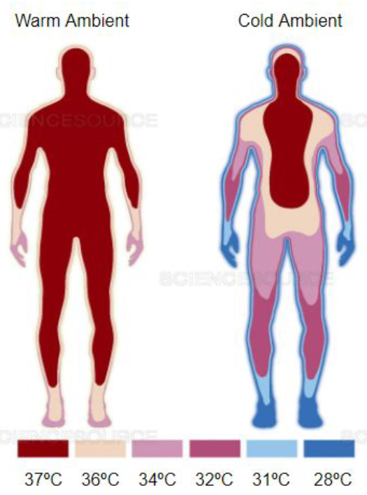
Figure 1, Core body temperature in warm and cold ambient temperature
These design requirements were determined from looking at the unmet needs of prior work done in the field of artificial cooling methods. A team from the Institute of Electrical Engineers of Japan² explored the merits of back cooling on a wheel chair by cooling an aluminum back plate with Peltier coolers. The design used powerful coolers but much cooling power was lost due to poor contact with the person’s back. Another Japanese team from the National Rehabilitation Center for Persons with Disabilities⁴ tried to apply cooling to the neck. This focused on the large blood flow through the carotid arteries. This had an inherent limitation for cooling power because temperatures below 18°C caused discomfort in the person’s neck. A team from the University of Michigan³ also made a water-cooling vest with Peltier coolers. However, their design did not use a control system. Its intended use was for surgeons who would overheat while wearing the thick x-ray shields during surgery.
The design described in this paper takes artificial cooling a step further by incorporating a closed loop control system to control the water-cooling vest. It makes good contact with the wearer’s upper body and it senses their CBT even though they may not be able to and it uses that data to regulate itself.

DESIGN SOLUTION
The design requirements met with this design are as follows:
- Safe working fluid.
- Good contact with body with uniform temperature distribution.
- Senses CBT.
- Turns itself on/off.
- Lightweight.
- High cooling capacity.

The design described in this papers aims at fulfilling the unmet needs from these previous works. Fig. 2 displays a schematic of the entire system. The black lines are for the electrical circuits and the blue lines are for the fluid circuit. The schematic shows the system divided into two domains, each surrounded by a broken line. The first is the cooling and control unit mounted away from the vest, and the other is the vest itself with the network of tubes and temperature sensors.

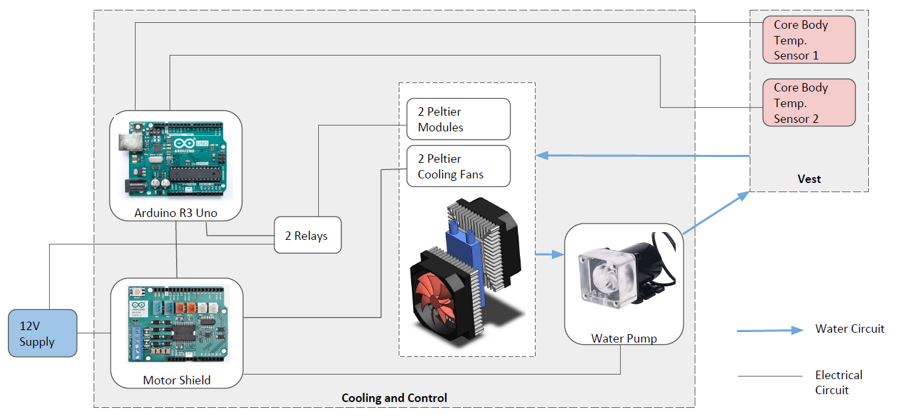
Figure 2, Schematic of electrical (black lines) and fluid (blue lines) circuits
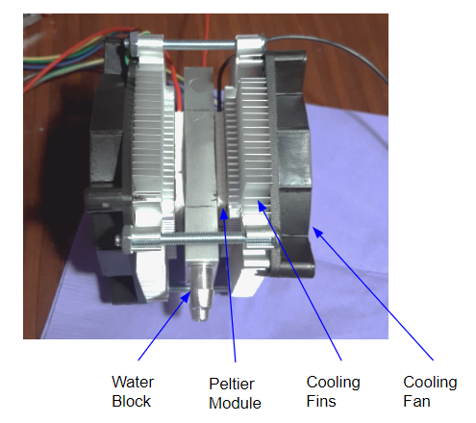
Figure 3, the assembled Peltier Cooler
The centrifugal pump induces the flow of water around the fluid circuit. The use of a centrifugal pump is safe for a soft robotic application. The advertised head of the pump was 3 meters, which was more than enough for this application.

According to studies, the metabolic rate for a human being at rest and sitting down is approximately 104 Watts. This was the target for the cooling power since a SCI patient with thermoregulatory disorder would most likely be in a wheelchair. To achieve this cooling capacity, a combination of two 60-Watt Peltier modules (model TEC-12706) gave a cooling capacity of 120 Watts.

A heat sink was glued onto each hot side of a Peltier module using thermal epoxy and similarly, each cold side was glued onto opposite sides of the water block (see figure 3). Separate relays controll each Peltier module. This will enable more control over the system in future development by controlling each Peltier cooler individually based on the wearer’s cooling requirements.

A sleeveless 3-layer vest formed the support for the network of cooling tubes. The three layers functioned as insulators to stop stray heat from the environment from entering the wearer’s torso while cooling is taking place. The tubes were sewn onto the inside surface of the vest as shown in figure 4. The inside of the vest was to be covered with a thin nylon fabric called Ripstop but instead, it was left open in case of a leak or if any other work needed to be done on the tubes.

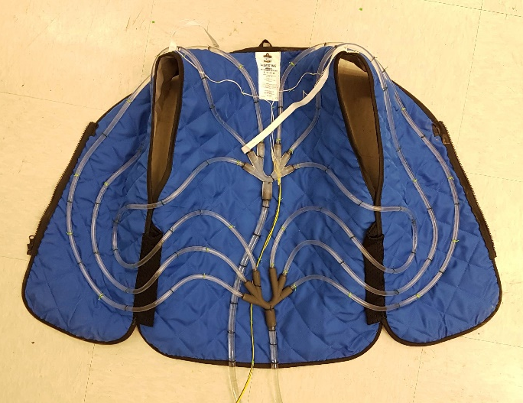
Figure 4, Tubes and water junctions sewn onto inside surface of the vest

Along the middle of the vest (figure 4), there are two water junctions where the tubes branch out. The top junction splits the flow from the pump and the bottom junction recombines the flow before sending it back to the cooler. Each water junction was 3D printed. Flow simulations in Ansys revealed that this was the superior water junction design in comparison to a few other alternative geometries.

Elastic straps sewn onto the arm openings of the vest hold the thermistors for measuring the wearer’s CBT. When the vest is in use, the thermistors make contact with the wearer’s axillae by pulling the straps under the arms. This contact ensures proper temperature reading.
The control system uses a feedback loop. It actively measures the wearer’s CBT and compares it to the reference value of 37°C; if greater, cooling system turns on; when CBT is brought down to 37°C, the system turns off. Figure 5 shows the completed prototype.

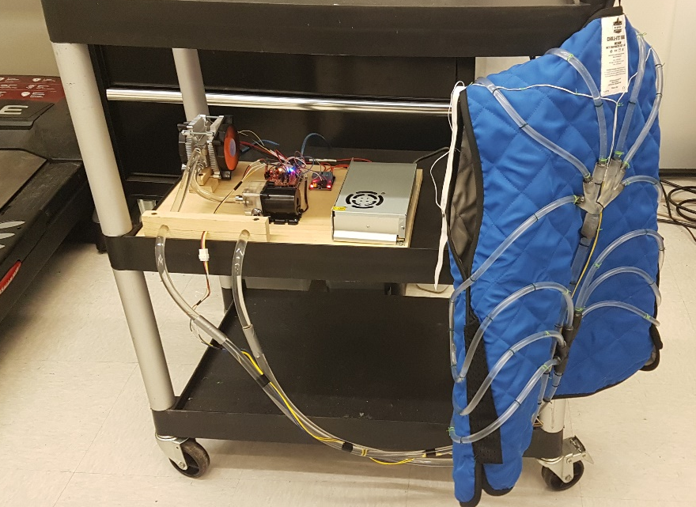

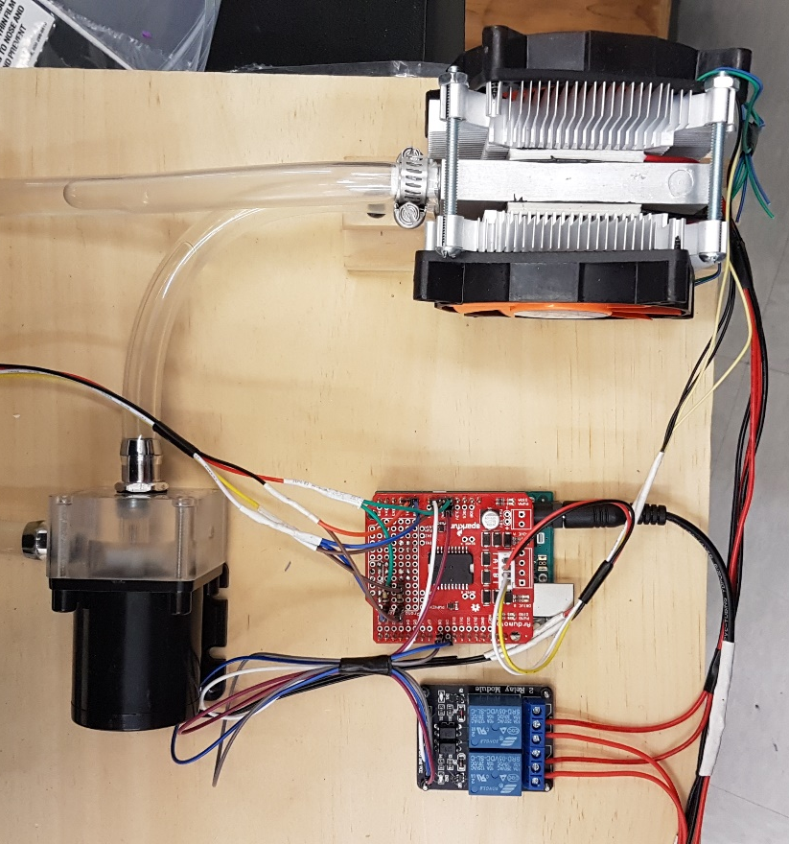
Figure 5, (top) the completed prototype with the vest turned inside out; (bottom) close-up of the cooling and control board showing (Clockwise, starting from upper left) cooler, Arduino controller, relays and pump.

Conclusion
The temeprature drop across the cooler was measured at -2°C, which when applied continuously, is enough to cool down a person’s body at rest. However, this cooling system has more potential for higher cooling because the maximum rated voltage for the Peltier modules is 16V while this prototype only used up to 12V. Replacing the relays that control the Peltier modules with an H-bridge will enable higher-level control and allow the vest to also become a heating vest and hence widen its scope as a solution for thermoregulatory disorder.

The finished cooling vest has all of the design requirements that were set at the start of the project. The system can sense the wearer’s core body temperature and use the data to determine when to apply cooling to a person that is unable to cool their own body or even sense their own body temperature. However, further testing is still in progress to quantitatively evaluate the system’s effectiveness.

Cost of prototype

Compoenent Description | QTY | Unit Cost | Ext. Cost
Water Pump | 1 | $ 19.99 | $ 19.99
G1/4" to 3/8" Barb Fitting | 1 | $ 10.98 | $ 10.98
3/8" X 1/2" Water Cooling Tubing Hose | 3 | $ 6.98 | $ 20.94
Cooling Fans | 2 | $ 14.45 | $ 28.90
Peltier Modules | 1 | $ 16.99 | $ 16.99
#15 Stainless Steel 3/8" Fuel Injection Hose Clamps | 1 | $ 14.00 | $ 14.00
Water Block 40x 80mm White | 1 | $ 13.98 | $ 13.98
Barb Splicer Mender 3/8" ID Hose Fitting | 1 | $ 7.99 | $ 7.99
Pipe Sealant Tape | 1 | $ 4.14 | $ 4.14
Cooking Thermometer | 1 | $ 18.99 | $ 18.99
Thermal Interface Products Heat Sink Thermal Tape | 2 | $ 9.79 | $ 19.58
Thermal Compound Paste | 1 | $ 8.99 | $ 8.99
Tenacious Ergodyne Work Gear Vest | 1 | $ 30.00 | $ 30.00
Relays | 1 | $ 8.99 | $ 8.99
1/4" ID, 5/16" OD PVC Tube | 1 | $ 0.90 | $ 0.90
10K Ohm 37Deg C Disc Insulated Thermistors | 4 | $ 18.64 | $ 74.56
Total Cost |  |  | $ 299.92

Table 1, Bill of materials for producing prototype.

REFERENCES
[1] Claus Lunau; Bonnier Publications; Science Source. https://www.sciencesource.com/archive/Core-body-temperature-maintenance-SS2254230.html
[2] J. Suzurikawa, et al; Effects of Back Cooling with Peltier Devices on Thermoregulatory Responses in a Hot Environment, Institute of Electrical Engineers of Japan; 2016.
[3] Y. Chi, et al. Water Cooling Vest, University of Michigan, 2008.
[4] A. Takashima, et al; Construction of a Soft Wearable Body Cooling System for Persons with Spinal Cord Injury, National Rehabilitation Center for Persons with Disabilities, Japan; 2017.

ACKNOWLEDGEMENTS
We would like to thank the researchers at the Biomechatronics and Intelligent Robotics (BIRO) Lab for their invaluable support and insight into the workings of our design. Your constructive feedback about the control and automation of the cooling vest was instrumental in establishing our innovation in the field of artificial cooling for persons with spinal cord injury.

