

Definition of Combined Air/Land Challenge

Guidelines

Prepared By: Penn State EOC

**

|  |  |  |  |  |
| --- | --- | --- | --- | --- |
| Rev. | Reason | Name | Date | Int. |
| -- | Original | J. Searle | 09/11/2014 |  |
| A | Updated Helicopter payload | J. Searle | 01/14/2015 |  |
| B | Updated Diagram of Hanging Payload | J. Searle | 03/17/2015 |  |
| C | Update new logo | P. Ward | 11/01/2016 |  |

1. Introduction 1
   1. Purpose 1
   2. Scenario 1
   3. Definitions 1
2. Challenge 1
   1. Air 2
      1. Requirements 2
      2. Air Drop off/ pickup Zone 3
      3. Key Design Points 4
   2. Land 5
      1. Requirements 5
      2. Object Definition 5
      3. Land Drop Point Definition 5
      4. Operation zone 6
      5. Key Design Points 6
   3. Course Layout 7

#### iii

1. **Introduction**
   1. ***Purpose***

The purpose of this document is to define the combine Land/Air course of the of the Sea, Air, and Land Challenge.

## Scenario

There are people trapped in a city building after an earthquake. Supplies must be air lifted in due to the destruction of the road network in the aftermath of the earthquake. The surrounding area has been determined to structurally unsound to send personal in yet. The task is to land in the designated safe zone and release the ground robot to deliver the supplies to the trapped victims. After the supplies are delivered the robot must return to the air vehicle to be returned to a safe area for reloading and refueling.

## Definitions

**Tele-Operated** (or remote controlled) – References a type of robot that has an operator making decisions about the operation of the robot. Sensory data from the robot or other device (video, telemetry, etc.) is delivered in near real time to the robot operator, and the operator makes decisions about what the robot is supposed to do (e.g. turn left/right, speed up/down, deposit a payload etc.). This is the type of operation used by hobbyists and may also be called operator in the loop. This can either be accomplished by wireless of wired communications, although most applications dictate wireless communication.

**Autonomous** - The robot has a sensor package that collects data, and based on computer processing, makes decisions without an operator on how it is to operate and what it is to do. The general rules of an autonomous robot are:

* Gain information about the environment (Rule #1)
* Work for an extended period without human intervention (Rule #2)
* Move either all or part of itself throughout its operating environment without human assistance (Rule #3)
* [Avoid situations that are harmful to people](http://en.wikipedia.org/wiki/Three_Laws_of_Robotics), property, or itself unless those are part of its design specifications (Rule #4)i

# Challenge

To design and build two vehicles to cooperatively complete a task that cannot be successfully

completed by only one vehicle.

##### Air Team:

The Air team is responsible for designing a tele-operated or autonomous vehicle that can perform the following tasks to complete the air portion of the challenge.

* Secure the land vehicle inside the payload bay of the air vehicle
* Find and Navigate to unload(landing) zone
* Be able to determine when air vehicle is safely on the ground
* Release the land vehicle from payload bay of air vehicle
* Be able to determine when it is safe for air vehicle to take off
* Determine “optimal” look out vantage point
* Find deliver point for first object
* Find delivery point for second object
* Find pickup zone
* Secure the land vehicle inside payload bay of air vehicle
* Be able to determine when it is safe to return home.(egress)

##### Land team:

The Land team is responsible for designing a tele-operated or autonomous ground vehicle that can perform the following tasks to complete the land portion of the challenge

* Be secured inside the payload bay of the delivery vehicle
* Be able to unload itself from the payload bay of the air vehicle(egress)
* Navigate terrain from unload zone to first deliver zone
* Find deliver point for first object and unload this object.
* Find and secure second object for delivery
* Navigate terrain from first delivery zone to second deliver zone
* Find delivery point for second object and unload this object
* Find and navigate to rendezvous point
* Reload itself into the payload bay of the air vehicle(access)

The team will be unable to see the course during the run. The course will also be changed between teams, so that knowledge of one course is no advantage.

* 1. ***Air***

### Requirements

To receive maximum score on the air course the vehicle must complete the following

* + - * Must secure land vehicle
      * Must navigate course by verbal commands to pilot
      * Successfully detect when delivery vehicle has “landed”
      * Must detect when look out height of 50’ has been reached
      * Payload must weigh less than 11lbs including land vehicle and provided carrier.
      * Payload must conform to either the hanging or hard mounting specifications

### Air Drop off/ pickup Zone

Drop off pick-up (landing) zones will have the following identification

* + - * Will be marked by a rectangle
      * Each zone will have a unique high visibility color
      * Each zone will have a unique number identifier

Note: Teams can add unique marking types if desired BUT must be approved by challenge coordinator

### Carrier

There can be two different carrier types used in the combined challenge. Each of these carriers will be inspected by the pilot for strength and balance.

### Hanging Carrier

The hanging carrier will be suspended under the helicopter. Team will build their own carrier from material of their choice. The following are requirements for the carrier.

* + - * The material used to suspend the carrier must not exceed ½”
      * The carrier must not exceed 20”x20”x15” (LxWxH)
      * The combined payload weight must not exceed 11lbs
      * Carrier must balance when held from suspension material.

### Attached Carrier

The attached carried will be mounted to the gear of the helicopter and function as the gear of the helicopter. The strength of this carrier is critical because failure would have catastrophic consequences to the air vehicle and endanger bystanders. Carrier will be attached by pilot and pilot will provide material for attaching payload to helicopter.

* + - * The carrier must be build out of ¾” pvc or equivalent material
      * The carrier must not exceed 20”x15”x15” (LxWxH)
      * The carrier must conform with the mounting location provided in Figure 1.
      * The combined payload weight must not exceed 11lbs
      * The carrier must pass a strength test from the pilot before test and challenge day.

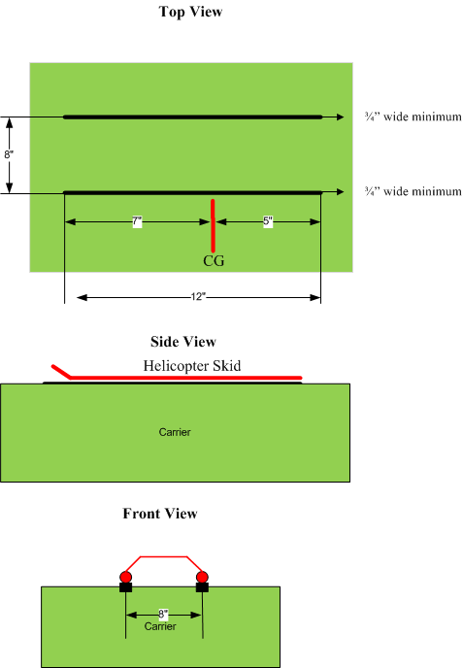

**Figure 1 Attached carrier mounting dimensions**

### Key Design Points

The following bullets are some key design points that will be instrumental to the success of your vehicle.

* + - * Have a field of regard of 360 degrees
      * Able to indicate when delivery vehicle is on ground
      * Able to secure land vehicle inside air payload bay
      * Able to detect high above ground
      * Able to detect when land vehicle is clear of air payload bay
      * Able to detect when land vehicle is loaded on the air payload bay
      * Identification of land/pickup zone(s)
      * Identification of land deliver zone(s)
      * Able to fit in payload carrier with ground vehicle
      * Able to meet combined payload weight

## Land

### Requirements

To receive maximum score on the air course the vehicle must complete the following

* + - * Must fit inside of supplied carrier
      * Must be able to carry object of 2.5”x 2.5” x 2.5” by 0.5 lbs
      * Must be able to transverse rough terrain
      * Must be able to pick up object of 2.5”x 2.5” x 2.5” by 0.5 lbs
      * Payload must weigh less than 12lbs including land vehicle and provided carrier.

### Object Definition

The objects will have the following characteristics:

* + - * Each target will have a unique high visibility color
      * Each object will have a unique number identifier
      * Each object will be 2.5”x 2.5” x 2.5” by 0.5 lbs

Note: Teams can add unique marking to the objects if desired BUT must be approved by challenge coordinator.

### Land Drop Point Definition

The drop points will have the following characteristics:

* + - * Each drop point will have a unique high visibility color that matches the object
      * Each drop point will have a unique number identifier that matches the object
      * Each drop point will be 12”x12”

Note: Teams can add unique marking to the drop points if desired BUT must be approved by challenge coordinator.

* + 1. **Operation zone**

Land operation zones will have the following identification.

* + - * Will be marked by a circle
      * Each zone will have a unique high visibility color
      * Each zone will have a unique number identifier
      * Each zone will have a unique drop off location
      * Each zone will have a unique pick up location

Note: Teams can add unique marking to the zones if desired BUT must be approved by challenge coordinator.

### Key Design Points

The following bullets are some key design points that will be instrumental to the success of your vehicle.

* + - * Identification of 2nd delivery object
      * Identification of object deliver point(s)
      * Able to carry 1st or 2nd delivery object
      * Able to unload(egress) from payload carrier
      * Able to reload(access) onto payload carrier
      * Able to cross rough terrain
      * Able to be secured to payload bay.
      * Able to meet combined payload weight

#### 6

***2.3 Course Layout***

* + - * The course will have four landing zones.
      * The course will have four object drop/ pickup zones
      * Each land operation zone will have a package drop point and a new package pickup point
      * The second object picked up will indicate the second operation zone to be reached.
      * The second object picked up will also indicate the pickup zone.

Figure 2 is a possible course layout derived from the above given description. This a template for the combined air/land course and not meant to be a implementation diagram.

#### 7

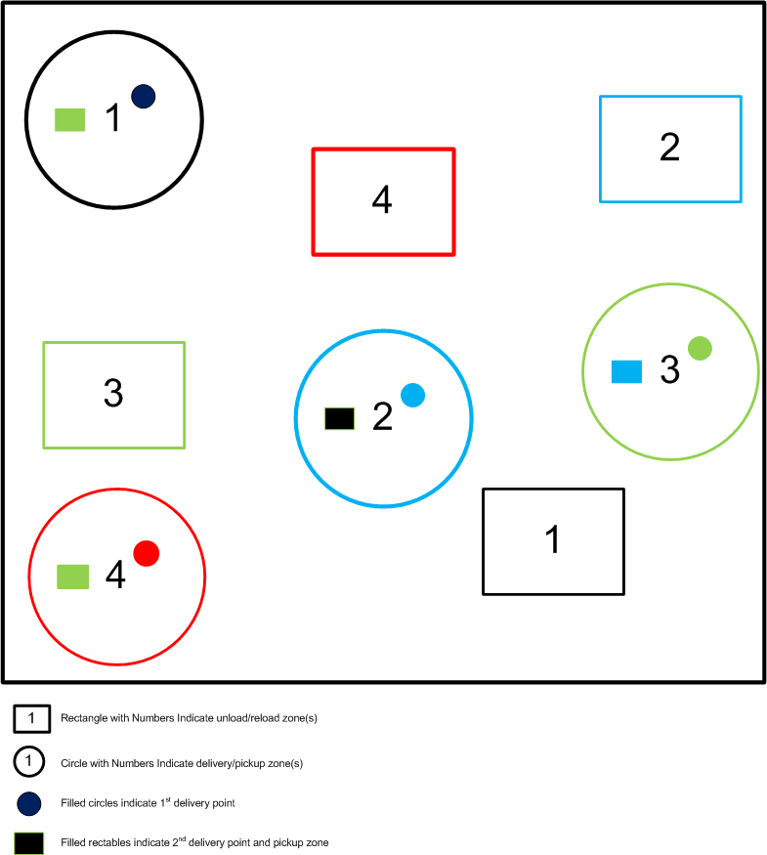

**Figure 2 Course Layout**

i <http://en.wikipedia.org/wiki/Autonomous_robot>