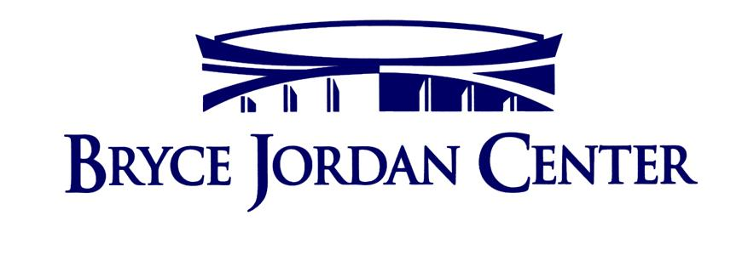
We’re Hiring!
Bryce Jordan Center Food Services

Looking for work beginning in the Fall Semester?
Become a part of a ROCK STAR team! Earn money and gain invaluable experience working in an arena setting serving the STARS! We are hiring for Concessions and Catering at the Bryce Jordan Center to start in the Fall.
Positions available are Catering Supervisors and Assistants, Concession Stand Managers, Cashiers, Head Cashiers, Cooks, In Seat Servers, and Expeditors. Apply today and lock up your position for the Fall!
Please contact Brandon Girts, Concessions Manager, for more information.

Brandon L Girts
Concessions Manager
127 Bryce Jordan Center
University Park, PA 16802
Blg169@psu.edu
Office (814) 863-6359

