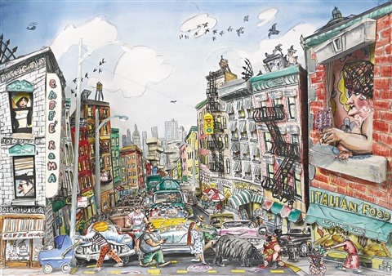

Red Grooms, *Maquette for Little Italy*,1989, watercolor, lithographic crayons and string on paper sculpture, 27 x 38 1/2 x 16 1/2 in.

For more information or to register, contact:

Dana Carlisle Kletchka, Ph.D. Curator of Education 814.863.9188 | dck10@psu.edu

Join us for an exploration of contemporary art within the spaces of everyday life. This summer we will examine the contemporary art practice known as socially engaged art, a mode of art practice that blurs boundaries of conceptual art, performance art, social action, and education. Contemporary art practice viewed in this way offers possibilities to explore interdisciplinary responses to contemporary issues through art. We will consider concepts, artists, and strategies of socially engaged art for use in k-12 learning contexts.

PSU_SICA

groups/PennStateSICA

sites.psu.edu/sica

Palmer Museum of Art

Penn State School of Visual Arts

This publication is available in alternative media on request.

The Pennsylvania State University encourages qualified persons with disabilities to participate in its programs and activities. If you anticipate needing any type of accommodation or have questions about the physical access provided, please call 814-865-7673 in advance of your participation or visit.

Penn State is an equal opportunity, affirmative action employer, and is committed to providing employment opportunities to minorities, women, veterans, individuals with disabilities, and other protected groups. U.Ed. ARC 15–224

BEYOND THE CLASSROOM

ART + SOCIAL ENGAGEMENT

2017 Summer Institute on Contemporary Art

June 20 -23, 2017