Getting started with Starfish

Log in to Starfish
- Go to starfish.psu.edu
- Click the “Log in to Starfish” button
- Enter your WebAccess and DUO credentials

Set up your Starfish profile and preferences
Review and update your contact information, and set baseline preferences for appointments and email from Starfish.

Navigate to your Profile
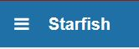
- Log in to Starfish
- Go to your Profile by
  - Clicking the triple bar or "hamburger" icon in the upper left
  - Then click on your name

Update your Institutional information
All Starfish users should update contact information, regardless of how much or little they intend to use Starfish. Your contact information is visible to students who have a connection to you through a Starfish role.
- Select the Institutional Profile tab.
- Click Upload Photo to add a photo.
- Add information to the General Overview section. Use this section to indicate how you can help students.
- Add information to the My Biography section. What are your areas of expertise that are relevant to students who might talk with you?

Select your Appointment Preferences
- From your profile, select the Appointment Preferences tab.
- If you will let students schedule their own appointments, set a scheduling deadline for them, (e.g., by 5:00 pm the day before).
- Under My Locations, add your office address.
- If you would like someone else to be able to add student appointments to your calendar, add a Calendar Manager. You can select any other Starfish user. Many people add their unit’s support staff person.
- Click Submit to save your information.

Select your email and calendar preferences
- From your profile, select the Email Notifications tab.
- Under appointment notifications:
  - Tell Starfish when it’s OK to send you emails about your upcoming appointments.
  - Check boxes to tell Starfish to send your external calendar a calendar attachment for every change to your appointments and office hours.
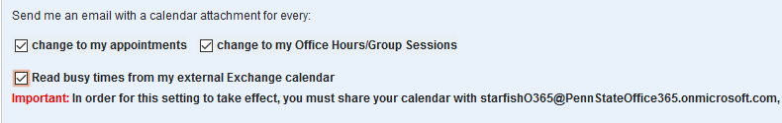
  - Check the box to tell Starfish to read your O365 calendar.
  - Select summary email frequency for tracking items and appointment activity.
  - Select your tracking item notification preferences.
    - HINT: Choose one summary email, and make sure you have Unchecked the box for an immediate email whenever a tracking item is raised.

Define your availability to students
Scheduled meetings can be one less thing for you to manage, and assures students that you have time for them.
For students to schedule their own appointments with you, three conditions must be met:
- The student must have a connection to you through at least one of your Starfish roles.
- You must be visible to the student through a one-to-one connection (assigned adviser, instructor) or listed as a member of a student-facing service.
- You must make appointments available to students using one of the options detailed below.
Once you create this availability, students with a connection to you can see your open appointment times, and select the appointment that fits their schedule. Students can only see times that are available.
Decision point: Are you only allowing walk-ins? If yes, use Method A. If no, are the times you would offer to students regularly recurring? If yes, use Method A. If no, use Method B.

Method A: Add Office Hours Button: Walk-in and Regularly Recurring meeting blocks
Use to add walk-in hours or use when availability recurs on a repeating pattern that rarely or never changes.
- Click the hamburger icon.
- Click Home or Appointments.
- Click the Office Hours button on your Starfish Home page or Appointments page.
- This opens the Add Office Hour form.
- Enter a Title (name) for this block of time. Students will see this name when they view your calendar. The title will also help your or others managing your calendar identify different types of office hours.
- Select What day(s) and indicate any recurrence (e.g. Repeats every 1 week).
- Use the What time fields to enter the start and end time for the office hours.
  - Important Note: Once this office hour block is saved, you will not be able to edit the days on which the office hours occur or the type of frequency (e.g. weekly) but you will be able to edit how often the block recurs (e.g. 1 week vs. 2 weeks) and the specific times available.
- Select Where meetings will be held using the checkbox(es) next to your location(s).
  - If you choose more than one location, the student will be able to choose his/her preferred location for the meeting.
  - To add additional locations options, go to the Appointments Preference page of your profile.
- Select the Office Hour Type for meetings you will hold during this block.
  - Select Scheduled And Walk-ins if you will be using the kiosk/waiting room features, and you plan to take walk-ins between appointments.
  - Select Scheduled Appointments Only if you will not take any walk-ins between scheduled appointments.
  - Select Walk-ins Only to show the time as available to students, but disallow anyone from making advance appointments.
- Select How long meetings can be by selecting a minimum and maximum duration. If you do not want students to select the appointment duration, choose the same value for minimum and maximum.
- Select the Appointment Type you will use for this block of availability. Appointment Types dictate:
  - which students can schedule during this time (based on the role that connects you),
  - the appointment reasons shown to students,
  - which SpeedNotes will display, and
  - which roles can view the appointment and its notes.
- Use the Instructions box to enter instructions to students scheduling with you during this block of time. Instructions are required for blocks that allow Walk-ins.
- Click the Start/End Date tab to set a time frame for a repeating office hour block, and select an End Date for the block. For the End Date, you may choose: Never, End of Term, on a specified date, or after a specified number of occurrences.
  - NOTE: If you do not set an end date, it will default to Never
- Click the Submit button to save your Office Hour block.
Need to Edit or Cancel office hours? See instructions here: https://pennstate.service-now.com/kb_view.do?sysparm_article=KB0011367

Method B: Scheduling Wizard: Non-Recurring, non-patterned appointment blocks
Ideal when availability needs to fit around other calendar items in a non-patterned way. This method allows you to create multiple, separate blocks of availability, and easily cancel or modify only specific blocks if needed.
Note: This method will only allow you to set up availability for scheduled meetings. Use Method A: Add Office Hours button to create Walk-in availability (see instructions in the previous section).
- Click the Scheduling Wizard button from your Starfish Home page or Appointments page.
- Enter the Title, location (Where?), duration (How long?), Appointment Types and Instructions that should be applied to all of the office hour blocks that are to be created.
  - NOTE: Choose the same minimum and maximum appointment length.
- Click the Next button
- The date and time page of the wizard is displayed using a Monday through Friday grid for the current week. The date range is displayed in the top right corner of the grid.
- Use the < > controls to the right of the date range to navigate to the week in which you want to begin scheduling the office hours.
- In the selected week, enter the start and end times for each block in the appropriate day columns. You can schedule multiple office hour blocks on any day within the week.
- If you need to schedule more than three blocks on any day, select the “Add Another Block” link in the column for that day.
- To add blocks to another week, use the < > controls to move to the next week and repeat until you have entered all of the blocks you wish to add at this time.
- Click the Finish button to create all of the office hour blocks.
- A summary is presented that includes a list of hours that could not be created due to conflicts between the blocks you specified and existing calendar items. Make a note of failed blocks before clicking Finish to exit the wizard.

Scheduling a Single Appointment
- Click the Appointment button, search for the student, and select the appointment day, time, and reason.
- Receive the .ical to your external calendar.
- Student receives an appointment notification email to their PSU account.

How to document outreach to students
Find your students
- Go to the Students tab under the hamburger icon.
- Make sure you’re on the My Students tab.
- Choose the Assigned Adviser connection from the drop-down menu.
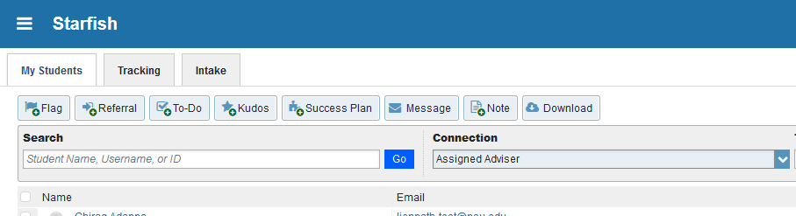
- Click the check box to select a student. You can select all on a page by clicking the check box next to Name in the header.
  - If you have more than 25 assigned advisees, you need to select all on each page.
- Decide whether someone else needs to know you sent this message to students.
  - If No, no one else needs to know, choose Message. This sends a BCC email to each of the selected students that only you can see in their Starfish folders.
  - If YES, someone else does need to know, choose Note. This sends a BCC email to each of the selected students and records the note in each of the student’s Starfish folders, visible to those with view permission for advising notes.
- If adding a message visible to others, click the Note button.
- Select Advising Note from the Note Type menu.
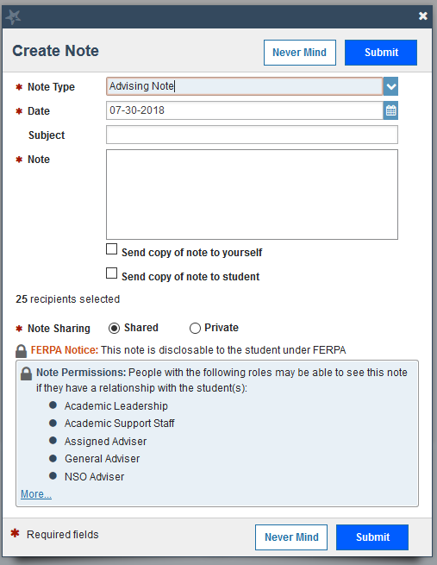
- Add a subject line, just as you would when writing an email.
- Type the body of the message, just as you would when writing an email.
- Check the Send copy of note to student checkbox.
- Click Submit.
Bonus: When using Starfish to send emails to students, you can see when the message was sent and when it was viewed.

Documenting meetings with students
Keeping brief, accurate summaries of your advising meetings with students is important. It is both an ethical obligation of advising and a time saver for you in the long run. Documentation in Starfish aids:
- Collaboration and consistency between different people who interact with students
- Allows us to help students without relying solely on students to translate instructions/needs
- Helps us correct errors that we make (because we do, and will, but not on purpose)
- Helps us hold students accountable

What should and shouldn’t I document? Use this guide:
- If you recommended that the student do something, summarize that recommendation.
- When sharing information about the student, share information that others should know in order to better help the student. For example, if the student aspires for a particular career path, note that so others can also help if the occasion arises.
- Ask yourself, “Am I documenting my judgment, or stating a fact?” (hint: stick to facts)
- Do not “out” the student on private matters or health diagnoses. If a big issue is relevant to their academic progress, use general language, but omit the details.
- Above all, remember that these notes are part of a student’s FERPA rights.
More on documentation guidelines is here under User Policies: http://starfish.psu.edu/resources-training/training/

How to document meetings
- Log in to Starfish
- Your scheduled meetings are visible in several places in Starfish:
  - The Appointments box on your Dashboard (home screen)
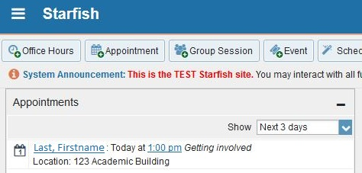
  - In the Appointments section.
    - Click the hamburger icon and click on the Appointments section
      - Agenda view (pictured below)
      - Daily view
      - Weekly view
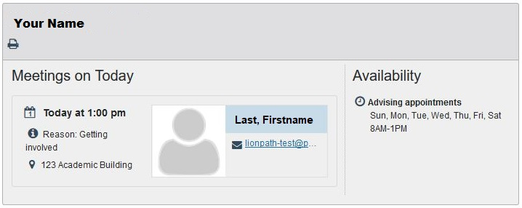
- Hover over the calendar icon anywhere you find it.
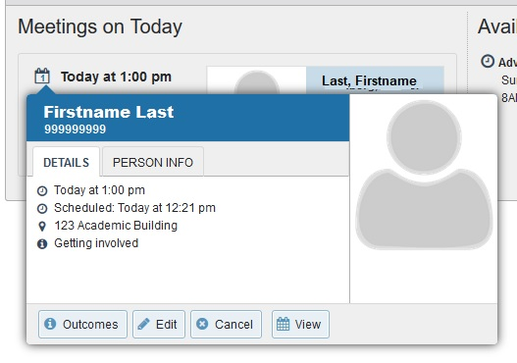
- Click Outcomes
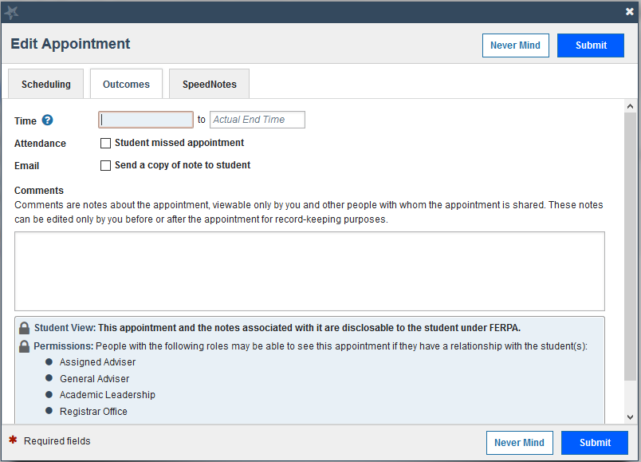
- Type your comments in the Comments box.
- Check the appropriate SpeedNotes.
- Click Submit.

Getting information out of Starfish
Filters allow you to find students who meet particular criteria. For example:
- Find students who haven’t met with you yet
- Find students who have EPR flags that haven’t been addressed

- Go to the Students tab under the hamburger icon.
- Make sure you’re on the My Students tab.
- Choose the Assigned Adviser connection from the drop-down menu.
- Click the Add Filters button.
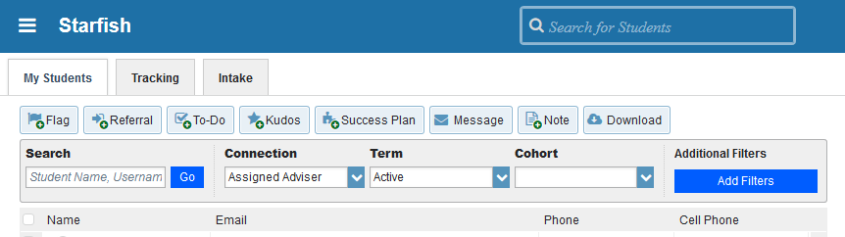
- Select the desired filtering criteria from the dialog box.
  - NOTE: This is an AND filter, so it will return results for students who fit ALL of your selected criteria.
- Your list of students shortens to only the students who fit your selected filtering criteria.
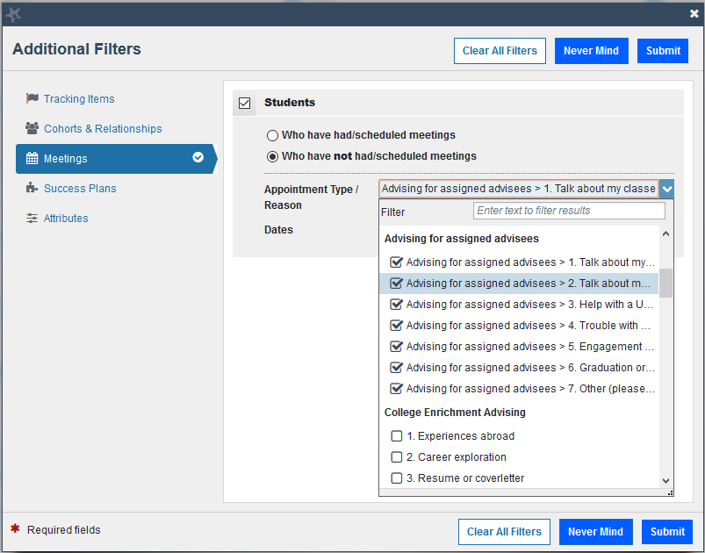
Example 1: Find students who have not yet scheduled an appointment with you:
- Click the Add Filters button.
- Choose the Meetings tab.
- Check the Students box.
- Click the radio button for students Who have not had/scheduled meetings. (Conversely, if you need to report how many students HAVE met with you, choose the other radio button).
- Choose the Advising for assigned advisees appointment type and check the boxes for its associated reasons.
- Select Start and End dates.
  - Click Submit.

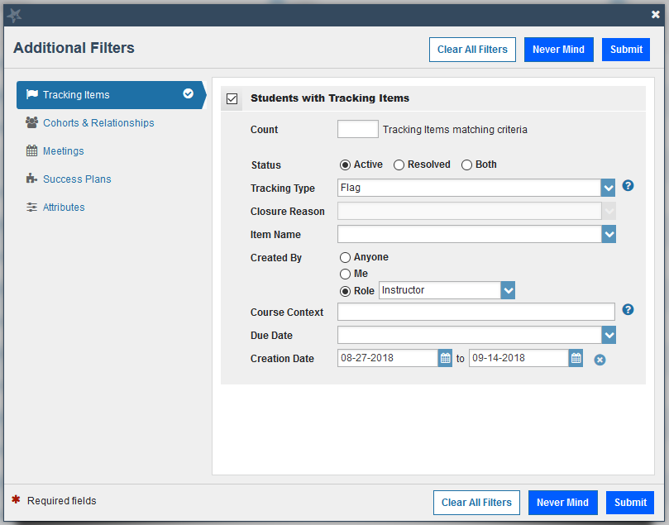
Example 2: Find students who have EPR flags that haven’t been addressed
- Click the Add Filters button.
- Choose the Tracking Items tab.
- Select Active
- Select tracking type: Flag
- If you want to see flags you raised, select Me. If you want to see flags raised by all instructors, choose Role: Instructor
- Set beginning and end dates.
- Click Submit.

Progress reporting
At critical times of the year, Instructors are encouraged to report progress for two reasons:
- Help students assess where they stand in your course and whether or not they need to make changes in order to be successful in the course.
- Help others find students who are in trouble across multiple courses so they can offer help.
It is important to note: Starfish users can only see a student, not the course, so no feedback is impossible for a user to interpret as good news. It is simply an absence of information. The most helpful practice is to provide every student some kind of Starfish indicator during progress reporting season.
The reporting campaign creates a progress report survey, which packages a subset of Flags and Kudos, but instructors can use any of the available Starfish methods to provide feedback to students.
There are three ways to alert students using Flags and Kudos:
- Complete a progress survey – Most intuitive, but labor intensive for large classes. If you use one of the other methods below, click the Submit button on the survey to stop automated reminder emails.
- Manually raise Flags or Kudos – Use if a progress survey is not available (e.g., submitted the survey too soon, or want to provide feedback outside of a reporting campaign period).
- Use the Canvas grade and the Zoom In feature – Most useful for large courses. Course must use the Canvas gradebook and be set to a Penn State compatible grading scheme.
Step-by-step instructions are available here: starfish.psu.edu/user-roles/instructors/early-progress-reports/
Flags and Kudos are available for use at any time of the semester. When raised, each Flag or Kudo generates an email message to the student and the student's assigned adviser using the template language. Any comments you choose to add are included in this email. All message templates are available on the Starfish Info website (starfish.psu.edu).
How instructors choose to use the tool makes the difference between this being an exercise in meeting a bureaucratic requirement or it being a chance to call students and others to action.
When a student talks with someone about the issue raised, that person will hopefully close the loop and let the instructor know. This doesn’t mean the problem was solved, but it does mean the flag was successful in getting someone’s attention and in causing an action.

