Unit Strategic Plan: Penn State Berks
2014/2015 through 2018/2019
A more detailed version of this plan can be found at:
http://www.bk.psu.edu/Information/2014-2019-strategic-plan.htm

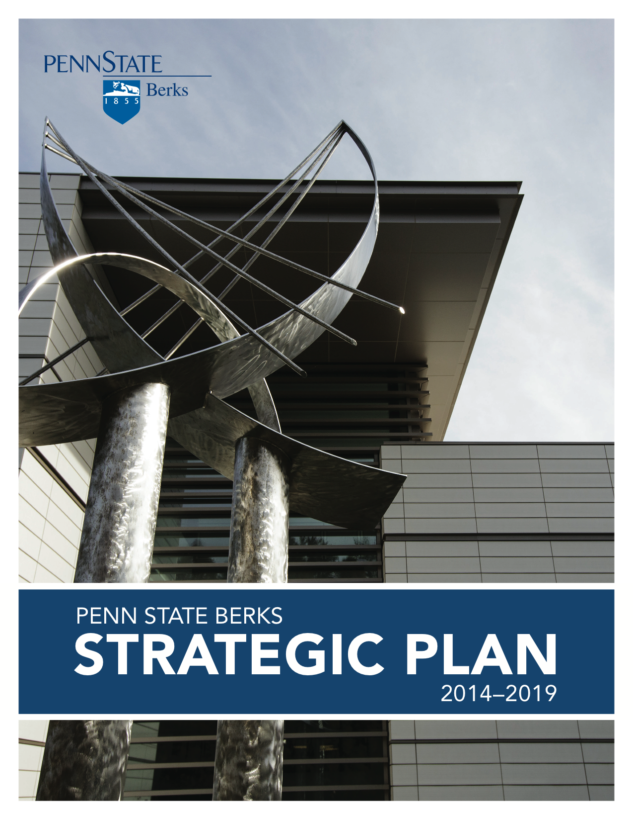

Penn State Berks Strategic Plan 2014-2019

Vision
Penn State Berks, a learning-centered college, will be the recognized regional leader in higher education by fulfilling its land-grant mission of providing high-quality, creative, affordable, and accessible education that prepares students to be responsible and contributing members of society. A broad range of academic programs will be offered through a supportive and acclaimed faculty using leading-edge technologies to connect students to research programs and community engagements to enhance their learning experience.

Mission
Penn State Berks, a learning-centered college, provides a Penn State education in a small campus setting that integrates high-quality teaching, research, and dynamic community outreach. As part of a premier land-grant institution, the college stresses excellence in all areas while providing opportunities for students from a range of abilities to reach their full potential. Berks is committed to engaged learning that encourages individual growth, cultural awareness, ethical decision-making, and civic responsibility for all members of the community.

Strategic Goal I
Engage all students in high impact learning experiences that
stimulate their intellect, curiosity, and enthusiasm for learning.
A learning-centered college seeks to create active, engaged, and critically thinking learners working in a problem-based, collaborative, and flexible learning environment. All college faculty, staff, and students embrace and model the values of curiosity, inquiry, and academic integrity. Focus is on learning–not simply the dissemination of facts and knowledge.

Key Priority 1:
Launch a campaign to position Penn State Berks as a “learning-centered” institution in the minds of current and future students, faculty, staff, employers, and other stakeholders.
Action Items:
- Create common meaning of the term “learning-centered.”
- Develop the campaign with both messages and time frame.

Key Priority 2:
Design assessment tools that measure the effects of learning-centered approaches.
Action Items:
- Review current assessment tools available in the education market.
- Design and test assessment tools.

Key Priority 3:
Implement assessment methods to evaluate the benefits and gains of learning-centered approaches.
Action Item:
- Assessment plan designed and administered across all segments of the college community.

Key Priority 4:
Maintain a knowledge repository where faculty and students can post and share best practices, student-centered success stories, templates, helpful hints, etc.
Action Item:
- Develop an on-line repository.

Key Priority 5:
Develop faculty and staff workshops that assist in creating and managing learning-centered environments and initiatives.
Action Item:
- Workshops planned and implemented.

Key Priority 6:
Work with non-profit and for-profit organizations in the community to identify meaningful student projects for experiential learning.
Action Items:
- Develop a targeted listing of appropriate community organizations.
- Meet with representatives from each organization.
- Establish student projects.

Key Priority 7:
Create more opportunities for out-of-class learning.
Action Items:
- Enhance undergraduate research, co-ops, and internships.
- Increase opportunities for service learning.

Key Priority 8:
Establish more leadership opportunities for students.
Action Items:
- Establish peer mentor programs across all disciplines (include undergraduate researchers as research mentors; student workers in teaching, supplemental instructors, tutors, etc.)
- Increase student involvement in the overall functions of the college, including serving on committees and expand student on-campus job opportunities.
- Create a formal, non-credit, leadership development program offering training, seminars, and opportunities for applying and refining skills.

Strategic Goal II
Utilize the digital technologies of teaching and learning
to energize and increase student learning.
Penn State Berks provides a high quality undergraduate education that strives to foster a learning atmosphere with a sense of continuity that is not constrained by the conventional boundaries of the classroom and laboratories. In light of the rapidly changing face of higher education coupled with stiff competition from all sectors, the college reflects an intense focus on teaching and learning innovations in reaching out to students, nurturing them in such a way that they feel encouraged to take the major share in the ownership of learning.

Key Priority 1:
Offer a wide variety of instructional delivery methods.
Action items:
- Offer more online, blended, and accelerated course delivery formats.
- Support faculty and instructional design through training.
- Increase course material storage.
Key Priority 2:
Create opportunities for faculty development in teaching and learning.
Action items:
- Create an incentive and/or reward system for teaching excellence and innovation.
- Expand instructional design resources.
- Increase grant opportunities for Teaching, Learning, and Innovation grants.

Key Priority 3: Adaptation of cutting-edge delivery methods to enhance teaching and learning.
Action Item:
- Support of faculty to learn and utilize instructional design capabilities.

Strategic Goal III
Enrich student learning and career preparation and success through extensive community partnerships that involve students, faculty, and staff in community and economic development.
Outreach and engagement are a core part of the University’s mission. As a college within the University that will offer more than 25 baccalaureate and associate degrees by the end of the five-year period, Penn State Berks has a significant set of resources that will be further strengthened to focus on community needs by providing degree programs, non-credit professional development programs for working adults, and training programs for industry. In addition, the college will expand the depth and breadth of the academic and co-curricular programs that enable outreach and engagement by which students become involved in the communities that the college serves.

Key Priority 1:
Determine the scope of all Penn State Berks outreach, service learning, and engaged scholarship activities, inside and outside the classroom.
Action Items:
- Assess all outreach, service learning, and engaged scholarship activities at the college.
- Define high impact, high priority outreach and engagement, which the college will aspire to moving forward.
- Define which types of activities will be included in the desired scope of activities, the criteria for reporting activities, and how that determination will be made.
- Develop a database to collect and share information on engaged scholarship and outreach activities across all divisions, offices, and clubs.
- Track engaged scholarship through faculty and staff use of Student Activity Fee funds.
- Track engaged scholarship through faculty FARs.

Key Priority 2:
Determine the perceptions and needs of the local community and identify those needs that best align with the unique strengths of the college.
Action Items:
- Conduct a research study to determine the public’s perception of Penn State Berks as a community resource.
- Develop a comprehensive understanding of the community service agencies in our service area and their needs.
- Compile a database of community service agencies and their needs.
- Determine which agencies and agency needs best align with the unique strengths of the college and its faculty.
- Develop a plan for which agencies and the college will work with each year.

Key Priority 3:
Increase the perceived value of engaged scholarship within both the campus community and its community partners.
Action Items:
- Create a task force composed of faculty, staff, students, and advisory board members to guide the process.
- Communicate and reinforce to faculty the importance of increasing the level of engaged scholarship at division meetings and other venues.
- Identify and where possible remove barriers to performing community service.
- Identify and where possible implement incentives for faculty to increase level of engaged scholarship in the classroom environment.
- Encourage faculty to incorporate engaged scholarship activities in First-Year Seminar.
- Assign administrative responsibility for ensuring increased levels of engaged scholarship.
- Encourage faculty and staff to apply for funding (i.e. college budget, endowments, Student Activity Fee) to be used for out-of-class experiences that support engaged scholarship.
- Create enthusiasm among faculty, staff, students, and Advisory Board members for engaged scholarship within the campus community.

Key Priority 4:
Determine whether new programs and “centers” should be established to better service community outreach efforts
Action Items:
- Explore new programs that will enable new forms of engaged scholarship.
- Consider the appropriateness of establishing new “centers” related to STEM, Creativity, and Engaged Scholarship

Key Priority 5:
Strengthen community outreach activities.
Action Items:
- Identify opportunities in the local community.
- Respond to opportunities that align the unique strengths of the college with appropriate types of engaged scholarship.
- Develop higher levels of community support and visibility by communicating results of community service activities via an annual report.
- Hold an annual event celebrating community service initiatives with our community partners.

Key Priority 6:
Increase the number of staff and faculty members actively engaged in community organizations and events.
Action Item:
- College leadership encourages faculty and staff to engage more in community service.

Strategic Goal IV
Recruit, retain, and graduate an increasingly diverse student body
that represents all aspects of the communities we serve.
Penn State Berks plans to increase its full time equivalent enrollment to 3,000 students by the end of the planning period. The goal for its six year graduation rate is 60 percent. These enrollment targets are set in the context of stable high school enrollments within the service area, an increasingly diverse and larger enrollment of underrepresented students, and a growing array of academic degree programs that address the needs of traditional, adult, and transfer students.
Key Priority 1:
Develop the public’s understanding of Berks as a comprehensive four- year college. Action Items:
- Expand marketing efforts, particularly within the college’s service area.
- Create and utilize a new college website.
- Expand presence in social media.

Key Priority 2:
Analyze outcomes of current retention initiatives, such as learning communities, Seizing Success, ASPIRE, Special Living Options, and similar programs.
Action Item:
- Undertake systematic studies for all college retention related programming.

Key Priority 3:
Increase the number of enrolled students from historically underrepresented and underserved groups.
Action Items:
- All recruitment and marketing materials intentionally include appropriate diversity representation, including but not limited to, Veterans, LGBTQ, International, Minority, Out-of-State, Adult Learners, and Transfer students.
- Identify community organizations whose efforts promote education and establish a formal connection with these efforts.
- Expand the ASPIRE program to enroll as many commuting students as residential students.
- Develop mechanisms for involving faculty in the recruitment process for underrepresented students.
- Develop a faculty mentoring program.
- Strengthen academic and personal advising support for underserved students.
- Determine whether an ESL (English as a Second Language) program is appropriate.
- Develop a student recruitment plan that specifically addresses strategies to increase the diversity of the undergraduate student population.
- Finalize articulation agreements with Reading Area Community College.

Key Priority 4:
Expand physical space and programming options for athletics and fitness activities.
Action Items:
- Complete the artificial turf field.
- Undertake a needs assessment for the proposed addition to Beaver Community Center.
- Develop a cost estimate for the project.
- Secure necessary approvals and budgetary support.

Key Priority 5:
Plan and implement additional inter-collegiate athletic programs that appeal to new student markets, and are compatible with NEAC (athletic conference) scheduling and priorities and the college’s facilities.
Action Items:
- Conduct an assessment of potential new inter-collegiate programs.
- Determine order in which programs will be added.
- Add new inter-collegiate programs.

Key Priority 6:
Support private housing relationships that will offer convenient and affordable student housing near campus.
Action Item:
- Meet with all interested developers to inform them of the market environment and what will be expected for successful student experiences.

Key Priority 7:
Increase the availability of endowed scholarships administered by Berks for new and returning students by 5% each year during the planning period.
Action Item:
- Identify key prospects for scholarship support

Key Priority 8:
Strengthen the college’s commitment to its Diversity statement.
Action Items:
- Increase the promotion of diversity by the college’s senior leadership.
- Demonstrate the college’s commitment to diversity through intentional inclusion of diversity statement in all college print and electronic media.
- Add a diversity statement to each class syllabus.
- Student Government Association (SGA) establishes its own plan for supporting diversity and inclusion goals of the college.
- Develop and implement programs that support diversity initiatives in local schools.
- Integrate diversity and multiculturalism into co-curricular activities.
- Achieve the designation of the premier “Hispanic-serving” higher education institution in Berks County.
- Achieve the designation of the premier “Military-friendly” higher education institution in Berks County.

Key Priority 9:
Develop an active, inclusive community among faculty, students, and staff.
Action Items:
- Implement programs that increase the diversity competencies of faculty, staff, and administration through training for best practices in teaching and learning.
- Insure that informational resources and programming are available to all members of the community.
- Insure that timely and coordinated responses are made in cases of discrimination, hate crimes, sexual assaults, harassment, and violence.
- Review all University employee and organizational performance evaluation forms (SRDP) to include criteria related to supporting diversity.

Key Priority 10:
Improve services to retain underrepresented and underserved student populations.
Action Items:
- Assess essential programs such as academic advising, tutoring, student aid, career services, and testing that lead to higher graduation rates.
- Conduct an assessment of underrepresented students in co-curricular/campus “connector” leadership positions (e.g., SGA, Resident Assistants, Lion Ambassadors, Orientation Leaders, Student Employment, etc.).
- Engage all faculty, staff, and students in a review of current operations to identify barriers to student success, and develop and implement intervention activities to help students be more successful.
- Determine if the college should develop and support a supplemental transportation option linking existing BARTA locations to the campus or special shuttles from key Reading locations to the campus.

Key Priority 11:
Develop and retain a high quality and diverse workforce.
Action Items:
- Emphasize diversity-related activities and professional development in employee performance evaluations.
- Campus-wide Diversity/Cultural Competency Training offered to new and current faculty and staff.
- Ensure diverse representation on search committees and provide complete information about expectations regarding candidates' skills in managing diversity.

Key Priority 12:
Strengthen support for international students and the fostering a global perspective.
Action Items:
- Support of campus diversity events by the administration, where the administration (dean, division heads, etc.) attend these events and encourage faculty/staff participation.
- Link international and diversity events to class requirements through a stronger relationship between the Offices of Campus Life and Support Services and faculty.
- Enhance scholarship and subsidized funding for study abroad programs.

Key Priority 13:
Develop a diverse management team at all levels of the institution.
Action Items:
- Require demonstrated skills in managing diversity as a standard qualification for all leadership positions.
- Cultivate diverse management teams at all levels of the college.
- Explore more inclusive models of leadership that bring individuals from various campus areas and job titles to management teams.
- Practices and policies regarding recruitment and hiring, promotion, performance management, merit, and succession planning will align with and support diversity and inclusion goals.
- Pursue funding that supports training for faculty, staff, and administrators with the topics of diversity and inclusion.
- Establish leadership education and mentoring programs for talented staff from diverse groups that provide avenues for professional growth, network development, and career advancement.

Key Priority 14:
Strengthen the process by which the college oversees its diversity initiatives and planning.
Action Items:
- Restructure the Committee on Diversity and Inclusion to have broader representation from all segments of the college community, particularly students.
- The Diversity Committee will develop and recommend a comprehensive college-wide program that promotes and supports a culturally diverse community.
- Climate survey will be administered in the base year and throughout the planning period.
- Enhance existing college-based funding opportunities for diversity programming and educational initiatives.
- Develop a campus reward structure that supports the core value of diversity.

Strategic Goal V
Support, model, and expand disciplinary and cross-disciplinary inquiry, research, and creativity across the college.
In a learning-centered college, faculty, staff and students embrace the values of curiosity and academic integrity through their research and creativity. Learning is enhanced through an integration of information and knowledge that draws upon multiple theories, practices, and disciplines.

Key Priority 1:
Increase the average number of refereed publications and creative accomplishments per faculty member with research obligations from 1.26 to 1.5 per year.
Action Item:
- Academic leadership encourages and supports initiative.

Key Priority 2:
Increase the amount of externally sponsored research grants by $500,000 each year of the planning period.
Action Item:
- Academic leadership encourages and supports initiative.

Key Priority 3:
To increase the amount of yearly endowed financial support for research provided to faculty and staff to $45,000 by the end of the planning period.
Action Item:
- Raise designated funding in the amount necessary to achieve the desired support.

Key Priority 4:
Increase the number of classes that are co-taught to enhance curricular integration across the three academic divisions.
Action Item:
- Academic leadership encourages and supports co-taught classes.

Key Priority 5:
Expand learning communities.
Action Items:
- Evaluate where additional learning communities would be most appropriate.
- Academic leadership encourages faculty to consider offering or becoming involved in a learning community.

Strategic Goal VI
Educate and prepare students for ethical and responsible citizenship in a
diverse, global, and interdependent society and world.
Penn State Berks works towards a culture of ethics and integrity that goes well beyond compliance to rules and regulations to attain a culture that strengthens the moral development of all its members including faculty, staff, students and alumni. Through our educational practices, our expectations for working and living with one another, and our intention for all persons to have a right to basic needs supported by a healthy environment, we practice the values of sustainability and interdependence.

Key Priority 1:
Develop an Ethics and Integrity Team for the college.
Action Items:
- Develop a team of faculty, staff, and students to help oversee and guide the initiatives (programming, evaluation of professional resources, promotional activities) related to ethics and integrity.
- Determine if a portion of a staff or faculty member’s time is required to provide the leadership for the team’s efforts.
- Develop an ethics and integrity page on the Penn State Berks website with links to various contacts, web pages, questions/concerns, and upcoming programming related to the topics.

Key Priority 2:
Enhance Ethics, Integrity, and Civility components of the First-Year Seminar.
Action Items:
- Provide a one-week module on Ethics, Integrity, and Civility in the new First-Year Seminar format.
- Strengthen the educational resources available to instructors and make them more specific to Penn State Berks.

Key Priority 3:
Establish an annual Ethics and Integrity Week for the college community.
Action Items:
- Conduct an Ethics and Integrity Week at Penn State Berks to coincide with the FYS module dates which may include films, seminars, and a college-wide convocation focused on these issues.
- Develop and utilize an assessment tool to determine how the program addressed the desired learning outcomes.

Key Priority 4:
Determine the strengths and gaps in the college’s efforts regarding academic integrity.
Action Item:
- Review and select the assessment guide from the International Center for Academic Integrity (ICAI) or a similar assessment tool that helps to inform needed improvements.

Key Priority 5:
Utilize the resources of the International Center for Academic Integrity (or similar professional association).
Action Items:
- Become an active member of the ICAI (or similar organization). Review and utilize resources available from the professional organization beyond any assessment tools.
- Participate in national or regional conferences and other training opportunities offered by professional associations addressing the issue of academic integrity.
- Offer expertise that may be developed through our faculty and staff as resources to other Penn State campuses or other colleges in the region.

Key Priority 6:
Evaluate the need to create a Center of Ethics and Integrity.
Action Item:
- Review and determine if there is a need for a formal designation of an individual’s time or a Center related to Ethics and Academic Integrity that would serve as a college-wide resource for FYS, as well as a resource for faculty and students, and would provide leadership for workshops, training, and programming.

Key Priority 7:
Incorporate sustainability learning opportunities into daily life across the college, including the built environment and service and program delivery.
Action Item:
- Create visible demonstrations of sustainability facilities and grounds that teach (e.g. Gaige sustainability signs, native plantings, storm water management).

Key Priority 8:
Develop and promote academic programs that address sustainability.
Action Items:
- Infuse sustainability into first-year seminars, service learning, senior capstone, undergraduate research, internships, and course projects. Current examples include micro grid research and shipping container re-tasking project.
- Develop an interdisciplinary “Sustainability Conference” for local high school students modeled after the Math & Science Options program for high school girls and a STEM conference for 11th grade students.

Key Priority 9:
Create sustainability focused programs and learning opportunities for external constituents.
Action Items:
- Include sustainability in Outreach programs with area companies including PPL, East Penn, Cyber Security, and Scitor.
- Partner with Office of Physical Plant to create opportunities for Building Information Modeling workshops and programs.

Key Priority 10:
Utilize the Center for Service Learning and Community Based Research and The Learning Factory projects to identify and advance sustainable practices, programs, and solutions.
Action Item:
- Identify appropriate projects.

