Penn State shield logo with black text and blue shield

Unit Strategic Plan: Penn State Hershey College of Medicine

2014/2015 through 2018/2019

A more detailed version of this plan can be found at:

<https://faculty.med.psu.edu/strategic-plan/>

Penn State Hershey College of Medicine Logo with Penn State shield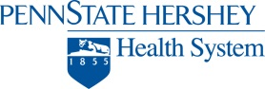Penn State Hershey Milton S Hershey Medical Center Logo with Penn State shield

inspire it forward in blue text

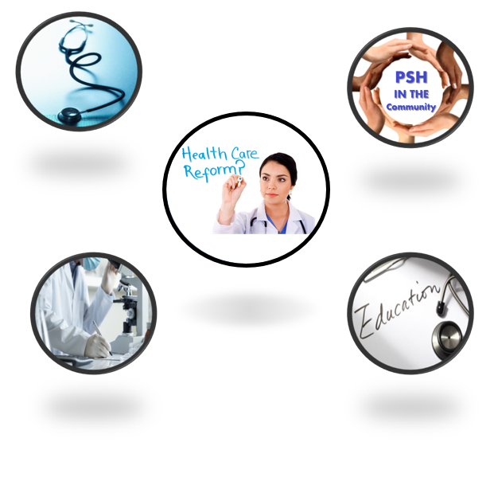

**Strategic Plan**

# PREAMBLE

**Successful strategic plans are most often characterized by their ability to become a significant part of the lives of all employees. The goal of our planning process is to align departmental and organizational efforts, develop goals that cross all mission areas, incentivize employees, maximize resources and “move the needle” on our shared vision.**

# MISSION

**We are committed to enhancing the quality of life through improved health, the professional preparation of those who will serve the health needs of others, and the discovery of knowledge that will benefit all.**

# VISION

**Inspiring Innovation to be the best at Improving Health**

CORE VALUES **(*Under review for modifications)***

**Respect – for everyone**

**Trust – honesty and integrity in everything we do**

**Teamwork – internally and externally**

**Equity – in resource allocation, responsibilities,**

**rewards and governance**

**Compassion – for everyone**

**Diversity – of our workforce, patients, students**

**and leaders**

**Excellence – in everything we do**









# PENN STATE HERSHEY STRATEGIC IMPERATIVES

1. **Achieve the Highest Level of Quality,**

**Safety and**

1. **Educate and Invest in Creating a Diverse**

**and Inclusive Workforce that strives for**

**Personal and Professional Success**

1. **Create an Extraordinary Patient**

**Experience**

1. **Create Innovation through Research**

1. **Develop & Differentiate our Regional**

**Integrated Academic Healthcare System**

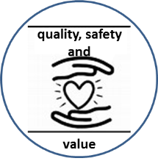





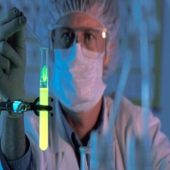

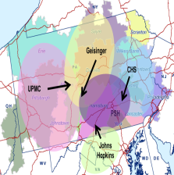

**Defining Our Imperatives**

## **Achieve the Highest** Level of Quality, Safety and Value

**In an environment where there is rising shift from fee-for-service to**

**fee-for-value, it is perhaps more important than ever that we make a**

**commitment to providing high quality, safe, patient-centered care, in**

**an efficient manner. We recognize that patient safety, most certainly**



**begins at the bedside. But ensuring a patient’s safety and providing optimal patient care involves everyone – even those who don’t have contact with the patient. To achieve our goal of becoming a top 10 academic medical center in quality, we transformed our quality infrastructure into a robust, two layered system. The UACTs (Unit-Based Accountable Care Teams) empower front-line staff on each inpatient unit and outpatient practice site to work in an interprofessional fashion to ensure only the highest level of care is delivered across all quality domains. A second tier of hospital-wide teams organized around mortality, hospital acquired infection, process measures, complications, safety, and readmissions integrates these local initiatives and ensures best practices are put in place globally across the enterprise. In the past year, we achieved a #3 ranking in Safety among all academic medical centers and have made great progress across all domains in quality.**

**Quality also applies to the education we provide to our students, residents and fellows as well as the level of research we provide. These will be addressed in their own sections below.**

**As for value, the Center for Enterprise Innovation has been exploring methods of reducing unnecessary costs while continue to contribute to improving quality. Through the use of Rapid Improvement Events (RIEs), teams of people are working collaboratively to identify opportunities and implement solutions.**

**Value in the research mission can be achieved by increasing the resource utilization of Core Laboratories. Initiatives are underway to provide education on the state-of-the-art equipment and techniques that are available in these labs. In addition, increasing collaboration with nearby universities (where they can utilize our research core services) will add to the value.**

## Educate and Invest in Creating a Diverse and Inclusive Workforce that strives for Personal and Professional Success

## 5 people looking at computer screens

**Continuous professional development has always been an expectation for the members of the healthcare workforce. Today new learning needs have rapidly taken center stage as dedicated individuals are asked to function as integral participants within an evolving healthcare system. This change has led to new and expanding knowledge and processes focused on improving the health of populations and the quality of healthcare delivery. It brings the need for new learning to the current workforce and the need for new educational design in developing the next generation of health care professionals.**

**Healthcare delivery is rapidly shifting from a physician-centric to a patient-centric framework, from care of the individual to care of populations, from office-based to the system and community-based, and from disease-focused to health-focused. In the evolving model of patient-centered care, the health professional is a part of a much larger system of healthcare needs and healthcare capabilities. The patient accesses care through a team of providers who bring a broad range of knowledge and skills. In addition, care can be accessed through venues ranging from the office or hospital to community based resources.**

**With the change from physician-centric to patient-centric care come new workforce needs. Some needs center around engaging new partners in the delivery of patient care. Other needs focus on helping the current workforce learn knowledge and processes that were not a part of their earlier professional preparation. Yet other needs focus on looking at the broad range of determinants of health and the importance of cultural humility in approaching each patient’s care. These shifts call for a diverse and inclusive workforce of individuals who will enrich each other as they bring breadth and depth to the team-based delivery of healthcare.**

**Education leaders and health systems leaders within the Penn State Hershey health system are coming together at the educational design table to ensure that educational programs and system needs are aligned to create today and tomorrow’s workforce. The traditional two-pillar medical education framework of basic science and clinical care worked well when the goal was to educate for the personally expert physician. It no longer suffices as healthcare and the healthcare workforce transform. At Penn State the two pillar structure is transforming to a four-pillar framework of humanities, basic science, clinical science and systems science to align education with health system needs. The humanistic, systems physician, who is grounded in humanities and systems science, must be adaptive, critical-thinking, collaborative and scholarly. This is a physician who professional formation is defined by patient-centeredness, teamwork, and interdependence. This four-pillar framework will guide us in creating new curriculum design and structures in all phases of medical education from undergraduate to graduate and on to continuing professional education. This framework need not be limited to physician education but rather help to frame education within the health professions workforce more broadly.**

**As we tackle the challenge of educating learners about new content and processes, we have uncovered an important gap. Our teachers were themselves educated at a time when key topics such as value based care, safety and quality, respectful learning environment, health care delivery science, and interprofessional teamwork were not a part of their professional preparation. Among our challenges is the need to educate our teaching workforce in the new content and knowledge that form the underpinnings for today’s healthcare system. Our strategic plan includes a tactic for the development of a Center for Health Systems Learning that would serve as an educational home for faculty as they engage in new learning in Health Care Delivery Science.**

**We have yet another challenge before us. We cannot provide the breadth and diversity of providers and resources that form the foundation of a patient-centered framework of care until we have a workforce that can bring that breadth and diversity to the arenas of education and care delivery. Among our goals within our education imperative is a diverse and inclusive workforce.**

**Our imperative to “educate and invest in creating a diverse and inclusive workforce that strives for personal and professional success” reflects our vision of creating a culture where learning is ongoing, incorporated into performance goals, and a personal responsibility for all.**

**As an academic medical center, we are committed to the education of our students, residents, fellows, faculty and staff. We are also committed to creating an environment of diversity and inclusiveness.**

**The drive to diversify the healthcare workforce of tomorrow is critically important.  As has been noted in research from the 1990’s and corroborated since that time, patients feel better cared for when they are working with a concordant healthcare workforce.  With the increasing diversity of Central Pennsylvania, whether from migration or immigration, a healthcare workforce that is proficient in working with colleagues and patients of different life journeys is essential. In order to achieve that goal, attention must be given to all aspect of the campus including bringing potential applicants to our campus, encouraging students to participate in activities and discussions around diversity topics, offering learning opportunities to campus members, encouraging campus members to reflect on their own beliefs and values, educating our senior leadership and aligning the message around diversity. The endpoint is to have that drive to diversify be an organic process.**

**With the creation of a single, dedicated Office for Diversity and Inclusion for the College of Medicine and the Penn State Hershey Medical Center, the institution is affirming its commitment to welcoming people of all backgrounds to our campus, whether to work, learn or to receive care.  With the single office, Penn State Hershey is able to align its efforts and messaging across the entire campus, leverage common curriculum elements around Health and Healthcare disparities and move the campus from competent to proficient in its Diversity and Inclusion campus climate.**

## Create an Extraordinary Patient Experience

**We recognize that simply focusing on patient-centered, high quality**

**care is no longer enough. We are committed to providing a “Wow”**

**moment for all of our patients and families. We are committed to be at or**

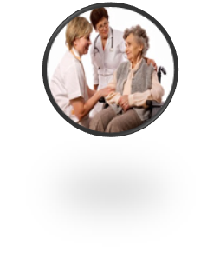

**above the 75th percentile in Patient Satisfaction in all areas, Inpatient, Outpatient and the Emergency Department. By conducting “visioning sessions” with key constituencies, we have designed and defined the ideal patient experience at Penn State Hershey. An employee education curriculum is being designed for educational course as well as a sustainability model and work plan. The goal is to improve in such areas as access to care, telephone abandonment rates, waiting times, communication, and hospital cleanliness and quietness.**

**As an academic medical center we are also committed to educating the providers of tomorrow with these same values and behaviors. In the research mission, even greater commitment is being made to identifying methods of healing patients and preventing disease. All of this ties into our Vision of *“Inspiring to be the best at improving health.”***

## Create Innovation through Research

### Establish Penn State Hershey as a Leader in Clinical Studies

### Surgeon

**Clinical research - the translational point between bench research and clinical care - focuses on identifying the effectiveness and safety of interventions in relation to specific disease types. As industry, non-profit and governmental sponsors look to expand collaborations with entities that have established programs to facilitate clinical research, Penn State Hershey will leverage its status as the only academic health center in Central Pennsylvania in an effort to increase accessibility to clinical research studies for our region’s patients, while expanding collaborations with private industry and other key partners such as clinical research organizations.**

**The Penn State College of Medicine, through the Office of the Vice Dean for Research and Graduate Studies and the Penn State Clinical and Translational Science Institute, will grow its clinical research program by making Penn State Hershey more attractive for industry-sponsored clinical trials. This includes developing an online, patient-friendly, searchable database of available clinical trials and increasing the diversity of clinical study enrollment within the communities we serve. We will expand our infrastructure to support clinical research by improving the usability of electronic medical record (EMR) data for researchers and constructing a clinical research specimen processing core to support sample preparation and handling for investigator- and industry-sponsored clinical trials. Furthermore, we plan to invest in the next generation of clinician-scientists by establishing a mentoring program for junior faculty members interested in conducting clinical trials.**

### Grow our Technology Commercialization Platform

**In recent years, the significant reduction in research and development within the life sciences industry has led biotechnology, pharmaceutical, medical device and other health care-related industries to seek innovation from universities. Penn State Hershey’s geographic proximity to the life sciences hub of Greater Philadelphia/New Jersey/ New York and its substantial concentration of venture capital, innovation and biotechnology companies present significant opportunities. However, given the substantial lead-time necessary for emerging life sciences technologies to achieve a significantly “de-risked” stage, Penn State College of Medicine must build the long-term infrastructure required to attract potential industry collaboration.**

**Over the next several years, the Office of Technology Development (OTD) at the Penn State College of Medicine will increase the pipeline of marketable technologies by investing substantially in a technology development proof-of-concept (POC) program to address early-stage funding gaps in the commercialization process, and encourage technology commercialization through the creation of new faculty start-ups while continuing to ensure sustainability. OTD will expand its internationally-recognized Innovation Café programming to foster values of innovation, entrepreneurship and economic development, while strengthening Penn State Hershey’s connections and brand within the local and regional life sciences ecosystem. We will also strengthen the education of faculty, students and staff in the technology transfer process by launching a new graduate student and post-doctoral technology transfer fellowship program, while increasing faculty and trainee participation in the Penn State Hershey Techcelerator program.**

### Develop our Next Generation of Research

**In concert with the research goals of the University, we will develop transformative and translational research that impacts society in meaningful ways. We will incentivize and nurture high risk innovative research that has a strong potential to be paradigm shifting. Research in basic science is a critical component of this endeavor, but we will also promote research that leverages the infrastructure of the Clinical and Translational Science Institute (CTSI) to support human health. We will foster the convergence of biomedical, engineering, materials and physical science expertise via partnering in the development of Penn State Center for Convergence of Biomedical, Engineering and Material Sciences (CoBEAM), as envisioned in the Strategic Plan for Penn State Research. Current and future attention will be paid to strategies for encouraging interdisciplinary research including: financial support for the PSU Pathway to Partnership Program and the Innovation & Impact Pilot-Research Program; engagement in joint faculty hires with colleges on the University Park campus (e.g., Engineering, Computer Science); and establishing a symposium on convergent science.**

**Enhanced efforts to recruit clinician-scientists will foster translational research by increasing the critical mass of research-savvy clinicians and the collaborative opportunities for basic and public health scientists. This will be achieved by the launch of the Physician-Scientist Program, and the simultaneous expansion of internal research funding opportunities for new investigators. Banking on the next generation of scientists to embrace interdisciplinary and convergent scientific opportunities is inherent in the focus on early stage investigators for inter-college recruitments highlighted above. Prioritizing mentoring of these new hires by more senior faculty will be achieved by clear expectations of best practices, support for professional development and incentives. The ultimate goal is to craft a research faculty that capitalizes on the wealth of opportunities on the disciplinary fronts and visualizes the impact a discovery in one area could have on an entirely different field.**

### Expand our Capabilities in Personalized/Precision Medicine across Disciplines

**Personalized or precision medicine is the area of clinical practice that relies on the strategic use of genomics and molecular diagnostic tools to precisely define disease subtypes and understand root causes of disease. The molecular definition of disease incidence, as well as the molecular tracking of disease progression and therapy, will ultimately lead to improved outcomes for patients. The Penn State Hershey Institute for Personalized Medicine serves to catalyze research in precision medicine by facilitating collaborations between clinician-scientists and researchers from disparate departments across Penn State.**

**To strengthen our capabilities in personalized/precision medicine, the College of Medicine will establish the intellectual and physical infrastructure necessary for applying genetic data to the delivery of health care for patients. Some methods of achieving this include developing a Clinical Laboratory Improvement Amendments (CLIA)-certified laboratory to focus on clinical applications of genomic information in the delivery of patient care, expanding research collaborations to institutes and departments at University Park, broadening bioinformatics and high performance computing capabilities in order to exploit the opportunities presented by “big data,” and constructing an essential research sample storage facility to allow for long-term archival storage of irreplaceable samples.**

### Grow Graduate Education Component of Research Mission

**With a strong and distinguished cadre of educators reflecting the breadth of research at a competitive academic health center, Penn State College of Medicine provides aspiring graduate students with an unparalleled opportunity and distinctive setting to obtain their training via multiple graduate programs offered both on campus and via the web-based World Campus.**

**To further this aim, the Office of Graduate Education will launch a Doctor of Public Health program to provide the highest level of instruction in fields relating to public and population health. The Office of Graduate Education leads the effort to both encourage and support the submission of individual and institutional fellowship and other career development awards.**

**Given the many diverse and rewarding career opportunities in the biomedical workforce, the Office of Graduate Education will continue to develop programming that supports student’s discovery and exploration of these opportunities.**

## Develop & Differentiate our Regional Integrated Academic Healthcare System

***“Academic medical centers must evolve rapidly or risk becoming***

***high-priced, anachronistic institutions in a landscape***

***of highly organized health systems.”* Tom Robertson, “UHC endurance Project:**

**Reading the AMC for a Decade of Change,”**

**University Health System Consortium, 2012**

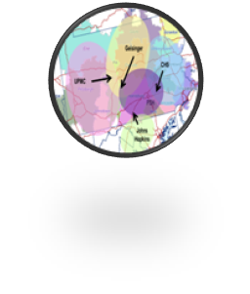

**The goal of Penn State Hershey is to grow a regional healthcare system through strategic partnerships to enable the development of population health management approaches in central Pennsylvania. While some of this is underway with plans for acquisition of St. Joseph’s Medical Center and the creation of Penn State Health with a partner like Pinnacle Health, plans for the future continue. We are committed to identifying and prioritizing the top 10 opportunities for service expansion and implementation in our region. At the same time, we will develop and implement an approach to improve quality, increase efficiency and reduce costs for PSU covered lives in State College. Also in State College, we plan to expand research trials and develop a full medical curriculum for a regional campus.**

**Finally, we participated in a collaborative Health Needs Assessment with Pinnacle Health and Holy Spirt Health System for a five county region. The top three priorities were: the promotion of healthy lifestyles, health education and access to affordable health care. The goals will be to complete all of the goals in the next two years.**

**When health system leaders and education leaders come together at the educational design table, the gap between health system needs and current educational programs becomes glaringly visible. The IOM’s Global Forum on Health Professions Education is calling for a new paradigm in health professions education, one that is not restricted by any current educational structures. Penn State College of Medicine has the opportunity to create an education innovation hub at its State College regional campus. This hub could serve as a laboratory for innovation in medical education that leverages the rich interprofessional, academic and community resources of State College. By expanding its curriculum from a clinical campus to a full curriculum campus, the State College program has the opportunity to implement and study educational innovations that will bring health system needs and education into alignment.**

# STRATEGIC IMPERATIVES, GOALS AND METHODS

#### Achieve the Highest Level of Quality, Safety and Value

1. **Be among the top 10 Academic Medical Centers in Quality and Value in the Country**
   * + 1. **Reduce mortality (O/E) to 0.65 by FY 2016-17**
       2. **Reduce CAUTI and CLABSI (infections) to 82 by FY 2016-17**
       3. **Reduce cost per discharge (adjusted for CMI and wage index) by 5% by FY 2016-17**
       4. **Increase resource utilization of Core Labs**

#### Educate and Invest in Creating a Diverse and Inclusive Workforce that strives for Personal and Professional Success

* + 1. **A diverse workforce of faculty, staff and students will engage in new learning opportunities targeted toward organizational priorities and individual growth**

1. **New learning opportunities targeted toward organizational priorities and individual growth will be recorded and measured through the Learning Management System (LMS), Continuing Medical Education (CME) and core curricular activities**
2. **Learning activities will be developed around institutional priorities of quality, value and process improvement**
3. **Learning activities will be developed that promote job competency and career advancement**
4. **Increase participation of teaching faculty in OSLER regional and national educational workshops and programs for advancement in their educational skills and scholarship**
   * 1. **Create a diverse and inclusive workforce of faculty, staff, students, residents and fellows**
5. **Increase opportunities to connect to potential campus members including recruitment fairs and a recruitment process focused on recruiting women and minorities**
6. **Connect with local educational institutions, particularly those that  have an understanding of the importance of diversity and encourage mentoring and advising opportunities with those institutions**
7. **Continue to improve the campus climate around diversity and inclusion encouraging organic change throughout the campus**
8. **Focus curriculum changes to include health and healthcare disparities**
9. **Align the messaging around Diversity and Inclusion across the campus using the full complement of tools**
10. **Ensure that the spectrum of Diversity and Inclusion educational opportunities are coherent in their goals and objectives**

#### Create an Extraordinary Patient Experience

* 1. **Be at or above the 75th percentile in patient satisfaction for all areas of the National Research Consultants (NRC) UHC Benchmarking Group**
     1. **Conduct visioning sessions with all key constituencies to design and define the Penn State Hershey experience**
     2. **Design and implement Penn State Hershey Medical Center experience management and employee education curriculum**
     3. **Develop sustainability model and work plan**
     4. **Identify and address areas of emphasis for outpatient care (Medical Group)**
     5. **Identify and address areas of emphasis for inpatient care**
     6. **Identify and address areas of emphasis for emergency department care**

#### Create Innovation through Research

* 1. **Advance our Leadership in Biomedical Research and Commercialization**
     1. **Establish Penn State Hershey as a leader in clinical studies**
     2. **Grow our technology commercialization platform**
     3. **Develop the next generation of research**
     4. **Expand our capabilities in personalized/precision medicine across disciplines**
     5. **Grow graduate education component of research mission**

#### Develop & Differentiate our Regional Integrated Academic Healthcare System

* 1. **Grow a regional healthcare system through strategic partnerships to enable the development of population health management approaches in central Pennsylvania**

1. **Identify and prioritize the top 10 opportunities for service expansion in our region; with implementation of at least two new service contracts/relationships by FY 2016-17**
2. **Develop and implement an approach to improve quality, increase efficiency and reduce costs of care for PSU covered lives in State College, with the goal of achieving a reduction in the cost increase curve of 2%**
3. **Complete the goals of the three-year Community Health Needs Assessment for a diverse population by 2016-17**
4. **Expand clinical research trials at the Regional Medical Campus and with Cancer Care Partnership in State College by reinstating oncological clinical trials**
5. **Develop a full medical curriculum regional campus at State College that takes advantage of the resources in and around University Park**