Unit Strategic Plan: Finance and Business
  - 2014/2015 through 2018/2019
A more detailed version of this plan can be found at:
https://fandb.psu.edu/sites/fandb/files/fb_strategic_plan.pdf

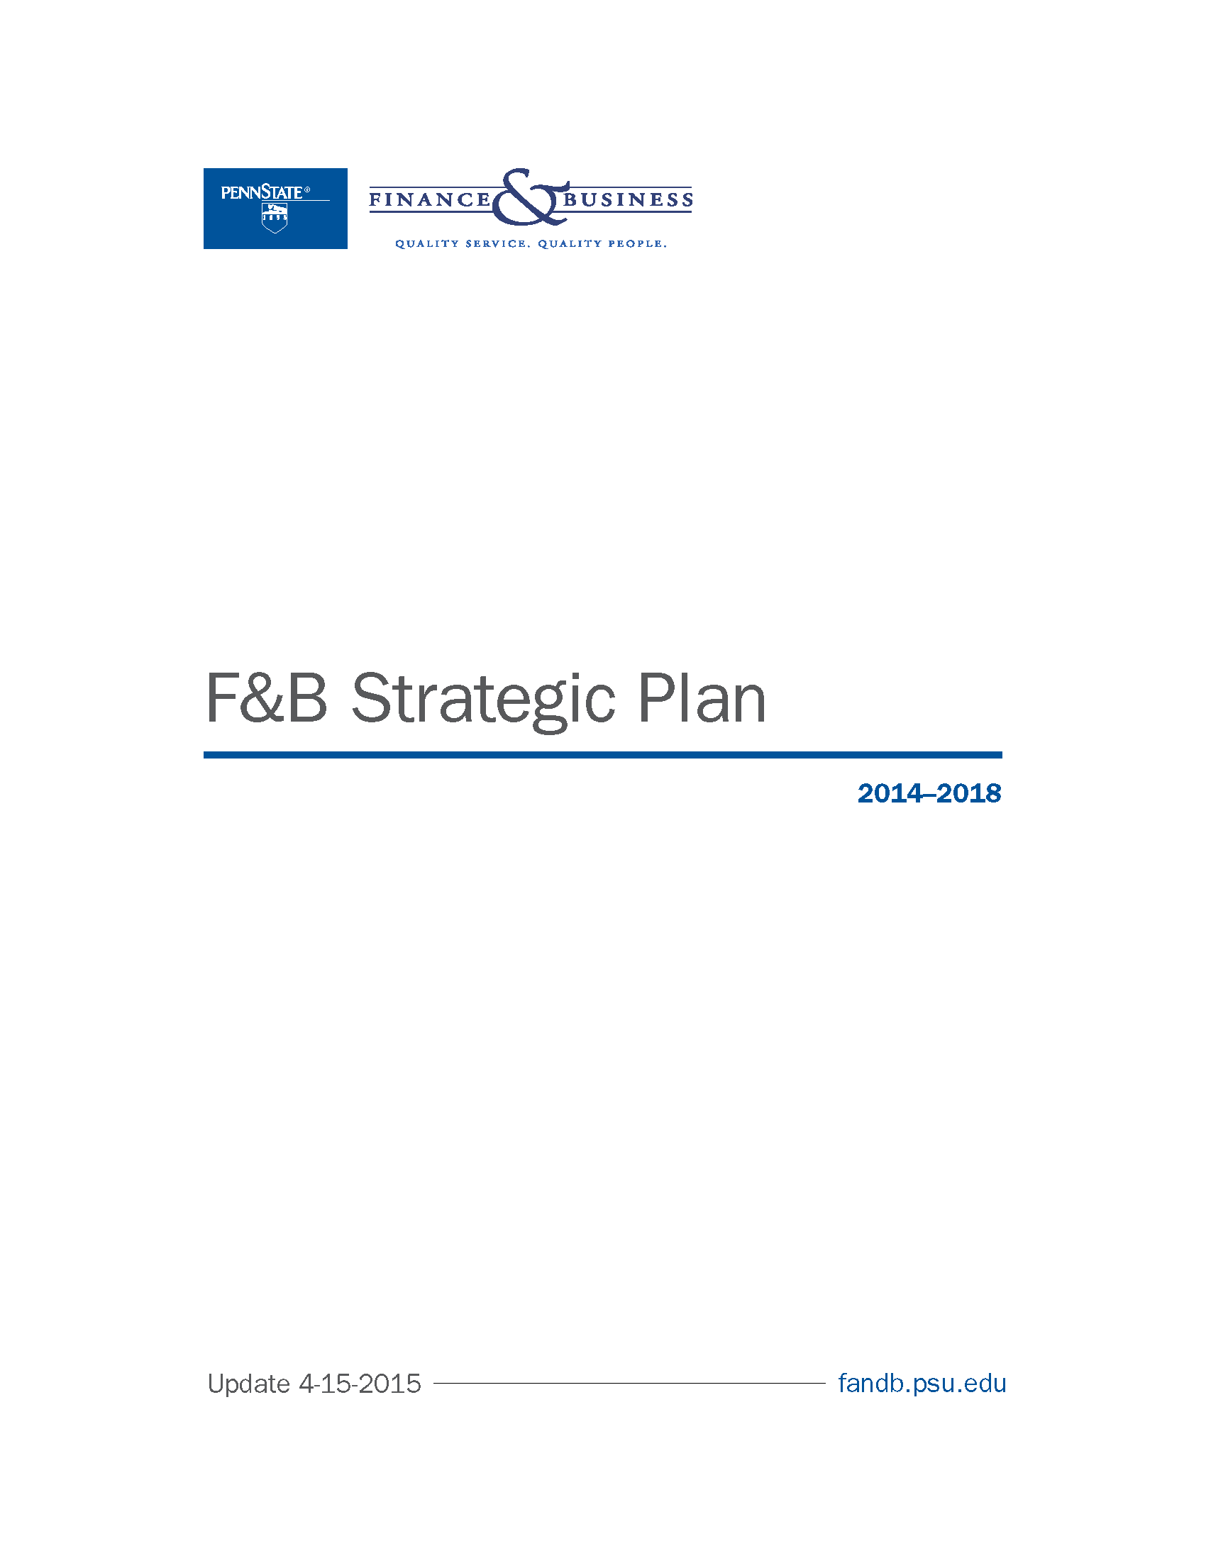

Table of Contents
FINANCE & BUSINESS AT PENN STATE 2
Mission & Vision 2
Organizational Profile 2
F&B Situational Analysis 2
F&B Alignment with University Priorities 3
STRATEGIC PRIORITIES 4
Business Process Transformation 4
Advancing Diversity & Inclusion 5
Economic and Structural Review of Finance & Business Systems 5
Transformation of Information Technology (IT) Services 6
Workforce Excellence & Vitality 7
STRATEGIC PRIORITY TIMELINE 8

FINANCE & BUSINESS AT PENN STATE

Mission & Vision
Finance and Business (F&B) is a service organization that supports Penn State students, faculty, staff, and the public. We are responsible for the stewardship, planning, and management of the University’s human, financial, physical, and environmental resources. Our vision is to make Penn State better for current and future generations by focusing on sustainability, excellence, and quality in our service, people, and stewardship.

Organizational Profile

F&B Situational Analysis

F&B Alignment with University Priorities
The strategic priorities and themes identified within the F&B Strategic Plan promote the broader University priorities established by the University Strategic Planning Council (USPC).

Sustainability
F&B’s theme for the 2014-2018 strategic plan is sustainability in the broadest possible sense. F&B is a critical partner in the University's contribution to sustainability through its students, research and service. We refer not only to environmental sustainability, but also to the organizational, financial, physical, and social impacts of our decisions.
For F&B, sustainability is about considering the full costs of our actions and decision-making on the university and the world. In short, all dimensions of sustainability are important if Penn State is to prosper and serve effectively in the years ahead.

Excellence & Stewardship
Core to the mission of F&B is stewardship of the University’s human, financial, physical, and environmental resources. We operationalize President Barron’s Initiative of Excellence through management and stewardship of Penn State’s resources, specifically through how business process and operations reflect the University’s values, mission, and principles.

IT Transformation
Economic & Structural Review
Business Process Transformation
F&B Priorities

Diversity Planning
F&B is committed to being a leader at Penn State as it relates to diversity & inclusion. We believe that the strongest teams are diverse teams. Our forward focus is on growing and enriching the diversity of our workforce through improved recruitment and retention efforts.
Workforce Excellence & Vitality
Diversity & Inclusion
F&B Priorities

STRATEGIC PRIORITIES
F&B’s vision of the future is an organization that is more agile, more responsive and optimized in all facets of business operations in service to students, faculty and staff. We strive to exceed expectations of our stakeholders by adopting the highest standards of excellence and support transformation through our focus on process, people and technology.

Business Process Transformation

Purpose
Finance & Business will lead the organizational change management and transformation of University business processes needed to implement sustainable enterprise systems that enable efficient, responsive, and seamless service

 | Goals | Goal Objective | Strategic Performance Indicators
1 | Identify, evaluate, and prioritize critical business processes and policies in need of redesign and transformation in close coordination with enterprise systems implementation efforts | - Catalog all business process in preparation for process redesign to maximize efficiency and effectiveness | - Improved service response times  - Reduced number of system integration points
2 | Design, develop, implement, and adapt processes, policies, and controls grounded in well documented best practices in close coordination with enterprise systems implementation efforts | - Increase efficiency in the management of student services, human resources, payroll, financial and facilities resources and information through enterprise software solutions | - Reduced complexity of business processes  - Minimized number of shadow/ 3rd party systems
3 | Establish appropriate portfolio and project management frameworks to support and enable the implementation of enterprise services and systems while maximizing the utility of selected existing services and systems | - Maximize returns on our ERP investments through the implementation of sustainable enterprise services and systems | - ROI Analysis  - Total Cost of Ownership
4 | Develop and articulate a clear enterprise-wide strategy for Business Intelligence to drive data-informed decision making through analytics | - Enterprise-level analytics capabilities that support timely, data-informed decision- making | - Percent of total, reliable enterprise data available for query  - Utilization of enterprise reporting tools  - Increased confidence in data-informed decision-making over baseline

Supporting Tactics
Supporting tactics include inventory of business processes, policies, service delivery impacts/systems; identification of opportunities for process and policy redesign; evaluation of system governance structure, strategies, architecture and lifecycles.

Advancing Diversity & Inclusion

Purpose
To build and sustain a diverse workforce in F&B as we strengthen a welcoming and respectful climate for all

 | Goals | Goal Objective | Strategic Performance Indicators
1 | Increase the racial/ethnic makeup of the Finance & Business workforce through proactive recruitment efforts | - An ethnically and racially diverse workforce | - Diversity of applicant pool
2 | Sustain a diverse F&B workforce by improving the retention of racial/ethnically (R/E) diverse employees | - An ethnically and racially diverse workforce | - Retention rates amongst underrepresented groups
3 | Eliminate fear of retaliation when reporting acts of intolerance and unfair treatment based on discrimination | - Increase trust and respect within F&B and eliminate the fear of retaliation | - Decline of respondents reporting fear of retaliation against baseline results  - Performance indicators identified in Task Force report
4 | Implement specific diversity & inclusion accountability metrics and meaningful measures for all F&B employees, departments, and programs | - Hold ourselves accountable for diversity and inclusion through clear expectations and metrics | - Integrated diversity metrics within F&B
5 | Coordinate and integrate diversity & inclusion (D&I) initiatives throughout F&B using centralized communication efforts | - Integrate Diversity & Inclusion initiatives throughout F&B | - Results scorecard

Supporting Tactics:
Supporting tactics include development of standardized hiring protocol to improve diversity, utilization and implementation of diversity metrics, and collaborating to advance diversity initiatives.

Economic and Structural Review of Finance & Business Systems

Purpose
The Economic and Structural Review Strategic Priority committee will conduct reviews of services provided by Finance & Business, and recommend options on how best to deliver those services while focusing on our guiding principles, including sound financial management, customer service, continuous improvement, and sustainability.

 | Goals | Goal Objective | Strategic Performance Indicators
1 | Create a prioritized list of F&B services for review | - Identification of services within F&B that provide potential value for increased efficiencies | - ESR prioritized recommendations
2 | Develop the processes that will be used to conduct the review of F&B services | - Establish a formal F&B Services Review program, and the methodologies needed, for identifying the best possible ways of providing services across all F&B units | - Completion of the Review Team Operations Manual
3 | Perform a detailed and objective analysis of a selected service | - Highlight opportunities for attaining financial and/or organizational sustainability across F&B’s services | - Detailed service review and analysis of all F&B units

Supporting Tactics:
Supporting tactics include development of a standardized methodology for review, prioritization of inventory of opportunities and generating recommendations for senior leadership.

Transformation of Information Technology (IT) Services

Purpose
Finance & Business will lead the University in transforming the management of information technology resources, in ways that will continually reduce redundancies, increase efficiencies, and expand capabilities, offering quality services to both internal and external customers.

 | Goals | Goal Objective | Strategic Performance Indicators
1 | Create the organization required to transform the management and delivery of information technology services across all of Finance & Business. | - Unify the delivery and implementation of IT across F&B by eliminating silos that currently inhibit efficient planning, and by leveraging central IT solutions wherever possible | - Reduced number of computing facilities  - Increased capacity of IT organization
2 | Create and implement a sustainable governance structure that will guide future IT decisions, establish priorities, and allocate resources
3 | Develop and implement standardized and consolidated desktop, network, and server services and support across F&B. | - Standardize and consolidate services and support | - Ratio of accounts on central vs. department domains, centrally-managed servers vs. department-managed servers  - Number of switch ports and/or subnets and firewalls that are converted to standardized network architecture  - Server room reduction  - Use of standardized methods for desktop software deployment  - Reduced number of development platforms
4 | Develop and implement standardized and consolidated practices for the delivery of application development services and support across F&B.
5 | Implement and test F&B-wide disaster recovery and business continuity plan | - Address business continuity | - Logs of successful tests

Supporting Tactics:
Supporting tactics including conducting inventory on infrastructure and resources, cataloging applications and services and implementing standardized practices.

Workforce Excellence & Vitality

Purpose
Within the next five years, through our unique contributions within Finance & Business, we will pursue sustainable organizational excellence by enabling and modeling workforce strategies that lead to the attraction, retention, and engagement of a talented and diverse workforce.

 | Goals | Goal Objective | Strategic Performance Indicators
1 | Support healthier lifestyles and congruous health care decisions through workplace flexibility, education, resources, and incentives | - Enhance organizational success and sustainability. | - Reduced health care spend, health care claims and average number of risk factors per subscriber  - Positive trending results from assessments of wellness/fitness behaviors and attitudes
2 | Promote a culture of learning and career growth through robust employee and supervisory development opportunities | - Promote a culture of learning and career growth | - Increased favorable responses in climate surveys on learning and growth opportunities  - Improved retention rates of high performers
3 | Reward and recognize high performance and employee engagement in a consistent and meaningful way | - Create an engaged workforce | - Increased favorable responses in climate surveys on recognition programs
4 | Ensure that F&B supports personal sustainability for all F&B employees | - Provide opportunities for employees to feel valued and successful | - Internal promotion opportunities

Supporting Tactics:
Supporting tactics include connecting performance management to career development, creating an environment supportive of healthy behaviors and “self-care” and rewarding for high performance.

STRATEGIC PRIORITY TIMELINE

