Unit Strategic Plan: Penn State Altoona
  - 2014/2015 through 2018/2019
A more detailed version of this plan can be found at:
https://altoona.psu.edu/offices-divisions/academic-affairs/planning-institutional-research/strategic-plan

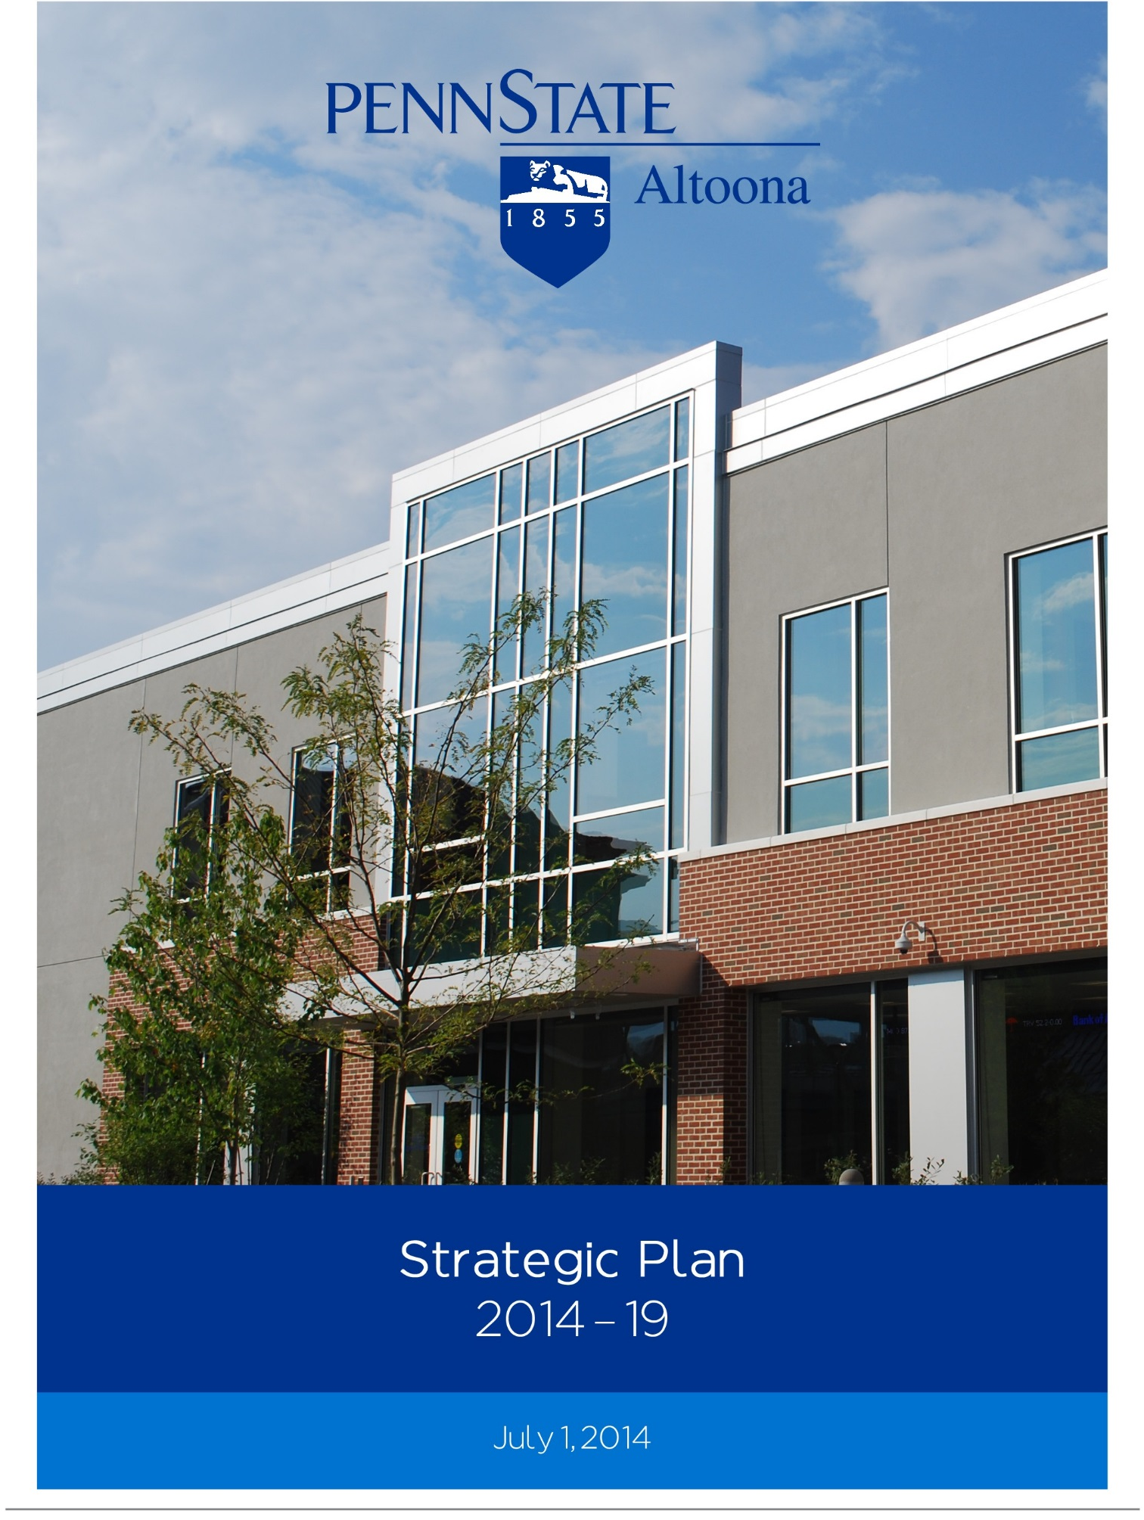

Penn State Altoona
Strategic Plan, 2014-2019

Introduction

Penn State Altoona’s 2014-19 Strategic Plan builds on the success of previous plans and leverages our College’s strengths in pursuit of our mission and vision. Penn State Altoona strives to be the premier campus college at Penn State, distinguished by our innovative, high-quality academic programs; student-centered engagement experiences; innovative research and creative activities; and purposeful educational, economic, and cultural collaborations with our community. The mission and five-year vision of our College are reflected in the goals, strategies, and action items of our 2014-19 plan. The strategic direction of Penn State Altoona’s plan also aligns with Penn State President Eric Barron’s imperatives, the strategic planning pillars from University Provost Nick Jones, and our University’s broader commitment to the land-grant mission.

This condensed version of our plan highlights our College’s resource priorities and key initiatives over the next five years. However, resource constraints remain the greatest challenge to Penn State Altoona’s ability to realize our mission and vision. Penn State Altoona recognizes the continued efforts of the Provost and the Vice President for Commonwealth Campuses to revise the current incremental budget model that has hindered our efforts to strategically invest in key people, programs, services, and facilities at our College. Penn State Altoona looks forward to continuing to work with University administration on changes to the budget model that will allow our College to retain a higher percentage of our tuition income and advance the strategic goals in our 2014-19 plan.

Mission

Penn State Altoona’s mission is to cultivate a vibrant learning environment through excellence in teaching, research, creative activities, outreach and the advancement of personal, social, and intellectual growth, and to empower a diverse student body with the knowledge and skills to be critical thinkers, lifelong learners, and civically-engaged global citizens.

Vision

Penn State Altoona strives to be the premier campus college at Penn State, renowned for our innovative, high-quality programs, student-centered engagement in the undergraduate classroom and in cutting-edge research and creative activities, effective service to the academy, and purposeful outreach to the community.

Goals

Goal 1: Cultivate academic excellence by supporting engaged student learning; advancing high-quality teaching, research, and service; strengthening academic programs and support services; enhancing student life programs and co-curricular activities; and increasing service to our communities.

Goal 2: Promote strategic growth of our College by increasing enrollments, developing new sources of non-tuition income, and reducing costs through improved efficiencies.

Goal 3: Create a more inclusive, diverse, civil, and ethical learning community.

Goal 4: Integrate sustainability and environmental stewardship into teaching, research, and outreach.

Strategies and Action Items

Goal 1: Cultivate academic excellence
Strategies:
- Build on learning assessment and accreditation accomplishments to advance a college-wide culture of continuous quality improvement in support of student learning.
Action Items:
- Continue to consult our University’s assessment resources in regular reviews, assessments, and accreditations of academic programs and use assessment results for continuous quality improvements.
- Maintain and secure accreditation, where applicable, for academic degree programs.
- Incorporate results from phase one and implement phase two of our two-tiered (pre-major/program) advising pilot program.
- Expand learning outcome initiative for programs offered through Student Life.

- Enhance existing and develop new, more effective strategies for supporting high-quality teaching, research, and service.
Action Items:
- Enhance support for research needs of our College by increasing infrastructure in Office of Research and Sponsored Programs.
- Promote research strategies that support President Barron’s Invest Penn State research initiative which emphasizes economic development, entrepreneurship, innovation and transfer, and student career success.
- Increase support for teaching by working with faculty to identify potential initiatives for our College to sponsor and by developing a plan to establish a unit within Academic Affairs dedicated to teaching and learning.
- Analyze and determine effectiveness of current array of internal funding programs and other resources in support of faculty research and grantsmanship.
- Consider adoption of recommendations from task force reviewing Office of Research and Sponsored Programs.
- Promote culture of peer collaboration in teaching, e.g., the establishment and assessment of policies and procedures for periodic review of part-time faculty.
- Continue strategies to increase percentage of courses taught by full-time faculty.
- Encourage faculty to seek external funding for energy-, sustainability-, health-, and environmental-related research.
- Hire full-time instructional designer to provide pedagogical support to faculty by enhancing instructional strategies in residential, hybrid, and online learning environments; facilitate the development of online and hybrid offerings; and establish learning design unit at our College.
- Emphasize engaged learning and service opportunities for Penn State Altoona students, faculty, and staff.
- Develop staffing, space plan, and timeline for creation of a Center for Student and Civic Engagement within the Division of Student Affairs that will focus on strengthening our relationship with social services, non-profit, local industry, and volunteer agencies in our community.

- Establish writing center and develop programming and student learning outcomes for support activities.
- Encourage participation in community-based learning initiatives by highlighting existing programs and providing additional community service and service learning opportunities.
- Expand Education Abroad programs by developing a sustainable mix of short-term and summer programs, increasing collaboration with other Penn State campuses, and expanding global opportunities on campus.
- Enhance the academic focus of student internships by improving the quality of internship sites available for our students and encouraging students to participate in Harrisburg and Washington, DC internship programs.
- Seek to collaborate with regional school districts and industry partners on an innovative educational program based on STEAM (Science, Technology, Engineering, Arts, and Mathematics) and MCL (Mass Customized Learning).
- Grow the Penn State Altoona Honors Program to 120 students by increasing scholarship support and continuing internal and external recruitment activities.
- Establish undergraduate research as a centerpiece of the Penn State Altoona experience.
  - Increase funding to support undergraduate research, e.g., Research Development Grants, summer stipends, and on-campus paid internships.
  - Explore revisions to local promotion and tenure guidelines to reflect the importance our College places on faculty-supervised undergraduate research.
- Engage Altoona and surrounding communities in lifelong learning by promoting teaching and learning in a variety of venues, locations, and forms, and serving as a center for the arts and cultural activities.
  - Continue to offer business workshops to our community at the Sheetz Center for Entrepreneurial Excellence.
  - Continue to host and enhance community events and programs, including, but not limited to, the African American Heritage Festival, the Blair County Arts Festival, Kids’ College, Sense-ational Endeavors, and our numerous arts and cultural activities.

Goal 2: Promote strategic growth of our College
Strategies:
- Develop innovative, high-quality academic programs with high student and market demand and strong faculty interest and expertise.
Action Items
- Identify and add degree offerings through program development process that matches student interest and demand with faculty interest and gives due consideration to our University’s emphasis on student career success and economic development.

Program | Status/Date | Start Date | Justification
Entrepreneurship minor through World Campus | Proposal Submission | Fall | Faculty expertise, strong market/student demand
Biology major, Health Science Option | Proposal Development | 2016 | Faculty expertise, strong market/student demand, STEAM
Global Language and Culture minor | Proposal Development | 2016 | Faculty expertise, critical life skills, strong market/student demand
Accounting major | Proposal Development | TBD | Faculty expertise, strong market/student demand
Kinesiology major | Proposal Development | TBD | Faculty expertise, strong market/student demand
Sociology major | Prospectus | TBD | Faculty expertise, strong market/student demand
Entrepreneurship major | Early Stages of Development | TBD | Faculty expertise, strong market/student demand
Materials/Nanoscience major | Early Stages of Development | TBD | Potential shared program, faculty expertise, strong market/student demand, STEAM
Master’s degree/s | Early Stages of Development | TBD | Explore sharing program w/ University partner
Mechanical Engineering major | Early Stages of Development | TBD | Faculty interest, strong market/student demand

- Marshal resources to advance growth of our College.
Action Items
- Strategically identify and pursue capital projects that advance our College mission and vision, including the expansion of the Adler Athletic Complex and the purchase of buildings downtown that support the reallocation and growth of space on our Ivyside campus and further the development of our downtown pre-professional hub, e.g., the Penn Building.

- Strategically add and/or reallocate faculty in light of program needs, research foci, and budgetary constraints to support enrollment growth and curricular initiatives.
- Work with faculty and College and University administration on plan to address inequities in faculty salaries.
- Invest in technology and equipment upgrades for instructional and research classrooms and laboratories.
- Implement space plan to consolidate our library, expand the Learning Resources Center, and provide additional space for our engineering programs.
- Develop plan to expand our Preschool in the Cypress Building to a Pre-6th grade school.
- Improve the recruitment and retention rates of our College.
Action Items
- Reconvene Retention Council to develop data-driven recruitment and retention initiatives that target critical populations and encourage degree completion at Penn State Altoona.
- Consult with appropriate Undergraduate Admissions staff and New York, New Jersey, and Washington, DC/Maryland/Delaware regional representatives to identify Penn State Altoona interest at out-of-state high schools in each area.
- Promote degree offerings to key external constituents, including prospective students and potential community and industry partners.
- Develop an expanded summer SOAR orientation initiative for incoming first year students, transfer students, and their families: The plan is to follow the lead of University Park into a 1.5 day SOAR schedule with expanded opportunity for direct interaction programming from Student Affairs staff to students and parents.
- Create and implement a plan to address the increasing number of students with disabilities who require testing accommodations.
- Explore the feasibility of early start summer programs at Penn State Altoona, e.g., LEAP.
- Work with University partners to increase scholarships directed towards upper-division students who stay at Penn State Altoona to complete their baccalaureate degrees.
- Collaborate with local colleges and universities on the development of articulation agreements that support the educational plans of students and facilitate entrance into Penn State Altoona degree programs.
- Create career-oriented certificates that provide continuing education opportunities for adult students.
- Increase prevention and health promotion programming in identified high-risk areas, including alcohol and substance use/abuse and sexual assault prevention and education, and pursue partnerships with local area health providers to increase service availability for campus students.
- Increase philanthropy to support fulfilment of College mission and vision.
  - Identify, assess, cultivate, solicit, and steward donors in an effort to create new endowments for need-based and merit-based scholarships, provide stipends allowing students to take advantage of internships, field research, study abroad, undergraduate research, and student leadership opportunities, and provide scholarship support for international and minority students.
  - Seek to create faculty endowments that will allow us to attract and retain prominent faculty members.
  - Offer and assess programs, events, and activities that meet the social, cultural, educational, and professional needs of alumni and related constituencies and that strengthen their relationships with Penn State Altoona.
- Implement initiatives that improve efficiencies, reduce costs, and free up additional income to better meet the needs of Penn State Altoona’s mission and vision.
  - Identify opportunities to share administrative resources with partners across the University.
  - Continue to look for means of reducing departmental office expenses such as utilizing work-study positions, sharing resources such as copiers and printers, encouraging the use of digital documents, and minimizing travel expenses and office meals.
  - Continue to leverage central and/or hosted information technology services in order to reduce redundancy of services, examine the use of a virtual desktop to reduce number of unique computers on campus, and adopt a campus-wide document service.

Goal 3: Create more inclusive, diverse, civil, and ethical learning community
Strategies:
- Recruit and retain diverse, highly-qualified faculty, staff, and students.
Action Items
- Hire an admissions counselor with primary responsibility in ethnic minority recruitment.
- Produce strategic plan for admissions that focuses recruiting efforts on high schools that generate the greatest ethnic minority student interest in Penn State Altoona.
- Continue to inform each employee search committee about the University Park-generated Diversity Talent Pool, encourage the use of list-serves to advertise vacancies at minimal cost, encourage efforts to determine minority candidates’ background before finalizing on-campus interview decisions, and work with the University to increase funds for advertising and interviewing.
- Encourage employees to consult diversity training opportunities provided by the University through the Center for Workplace Learning & Performance.
- Promote a climate where faculty, staff, and students can work, study, and learn together celebrating the differences and commonalities of people, their ideas, and opinions.
Action Items
- Review the vacant position of Director of Institutional Equity to determine appropriate duties and purview.
- Expand New Student Orientation/Welcome Week initiative to incorporate focused programming modules in areas to include diversity/multicultural, physical and emotional health/wellness, and academic foundational support through study skills programming, transition connection, and ethical behavior/academic integrity; goal is to create a 6-8 week programming model to run beyond the initial Move-In/Welcome Week timeframe.
- Assess and improve Mosaic Diversity Training which increases awareness of various forms of diversity found within the Penn State Altoona community such as race, ethnicity, religion, ability, age, gender, and sexual orientation.
- Continue to hold, promote, and enhance events that explore issues of diversity and community, e.g., our annual diversity conference and Interfaith Awareness Week.
- Reexamine, visibly display copies of, and strengthen commitments to Diversity Mission Statement.

- Promote integrity and ethical behavior among faculty, staff, and students.
Action Items
- Engage our College community in a discussion about our University’s unified statement of core values and how they will inform our actions over the next planning cycle.
- Develop process for the proposal, development, and approval of College-wide policies, which will increase transparency, accountability, and also ensure that our policies are consistent with our values, mission, and vision.
- Create and distribute an instrument to measure the organizational ethical climate at our College and include results in a periodic report that also analyzes our College-specific results from the 2013 Penn State Values and Culture Survey.
- Assess and promote the integration of ethics into the learning outcomes of academic and student affairs programming.

Goal 4: Integrate sustainability and environmental stewardship
Strategies:
- Increase the number of courses that incorporate experiential learning and sustainability.
Action Items
- Develop discipline-specific class modules that incorporate sustainability concepts into existing disciplinary courses.
- Promote the development of sustainability service learning courses with faculty sponsorship that use campus projects to teach and apply sustainability principles by creating a workgroup of the Sustainability Council to study and recommend how best to incorporate sustainability in Penn State Altoona curriculum, by providing faculty incentives and training, and by assessing the consumption of sustainability service courses.
- Hire an Environmental Studies faculty member to support sustainability initiatives on campus.
- Develop the Seminar Forest Educational Center.
  - Create physical structures to provide opportunities for the facilitation of team building exercises and outdoor education.
  - Expand Earth Day activities to include events in the Seminar Forest, e.g., require classes such as ENVST 200 to include individual projects related to Earth Day.
  - Develop community programs and events.
- Increase the number of undergraduate research projects that include sustainability as a research objective or metric.
  - Secure permanent funding for one sustainability internship position per semester.
  - Establish an undergraduate research award for sustainability related research.
- Engage and educate faculty, staff, students and the community in strategies for sustainability and establish ‘buy-in’ for sustainability through the development of a comprehensive communications strategy to educate participants, share successes, and build commitment.
  - Publish an annual report outlining the progress of the program on the Sustainability website.
  - Launch a multimedia educational campaign that highlights sustainability projects around the campus.
  - Partner with local businesses surrounding the campus that are popular with students to develop sustainable initiatives.
- Decrease waste by expanding pilot projects related to outdoor recycling containers and decreasing amount of organic waste going into the garbage (landfill) stream.
  - Launch an educational campaign using peer-to peer education.
  - Pursue replacing disposable catering utensils, cups and plates with compostable products.
  - Work with Intermunicipal Relations Committee to start a campus composting program.

Updates and strategic indicators for our 2014-19 plan will be posted on Penn State Altoona’s strategic planning webpage.

