Unit Strategic Plan: Penn State Lehigh Valley
  - 2014/2015 through 2018/2019
A more detailed version of this plan can be found at:

https://pslvplanning.com/campus-strategic-plans/campus-strategic-plan-2014-2019/

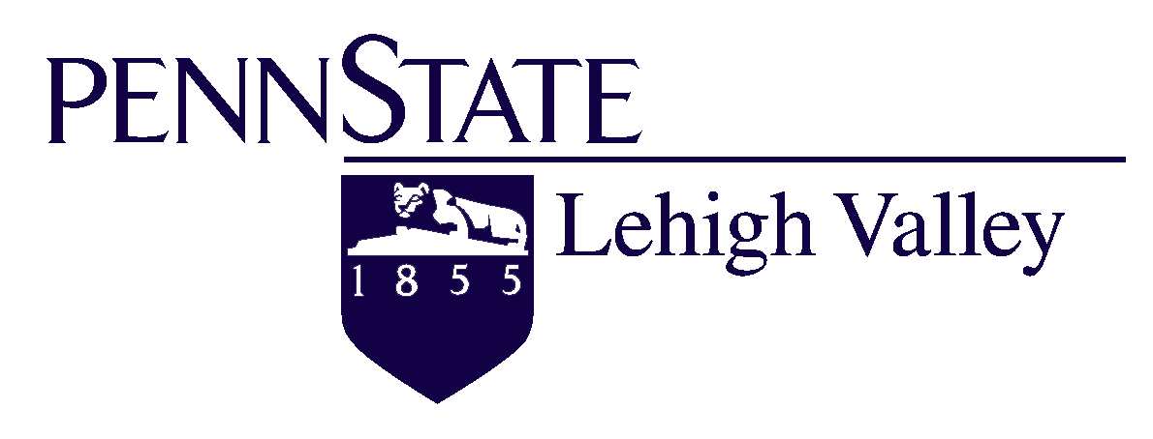

Campus Strategic Plan 2014-2019
BRIEF

INTRODUCTION
This document is a brief overview of the full 2014-19 Strategic Plan for Penn State Lehigh Valley. The campus has taken great pride in creating a strategic plan that outlines its vision and mission as an institution. Included are its broad goals for the next 5-plus years based on a comprehensive needs analysis conducted in the months prior to the plan’s development. A series of strategic initiatives and action plans supports each goal. A thorough assessment plan, with performance measures and indicators, is established to aid in the tracking of progress and success. The full plan also includes the three sub-plans of diversity, sustainability, and ethics, and these elements are interwoven throughout the larger plan. The planning process at PSU-LV was open and inclusive, with numerous faculty, staff, and student contributions, as well as advisory board input and stakeholder consideration.
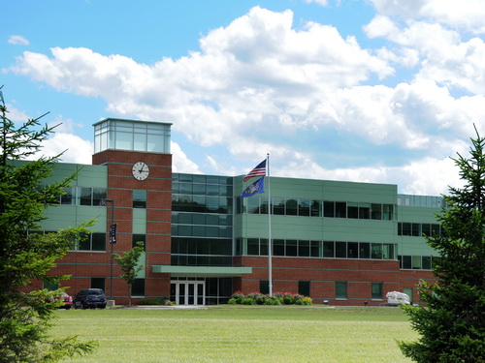

One Campus,
Part of One University,
Within Larger Society

www.pslvplanning.com
Campus Strategic Plan 2014-19 Page

TABLE OF CONTENTS
- Campus Foundation 2
- Needs Analysis 3
- 2014-2019 Campus Goals 4
- Strategic Initiatives by Goal 5
- Performance Measures & Assessment 6
- Ethics, Diversity, & Sustainability Elements 7
- Progress-To-Date 8
- Next Steps & Planning Website 9
- Response Letter to Strategic Plan Review Team 10

The Penn State Lehigh Valley Campus
Penn State Lehigh Valley has had a long tradition in the Lehigh Valley, being the oldest continually-running
campus outside University Park. In 2009, PSU-LV successfully relocated to Center Valley, PA, where it tripled its
square footage and gained a prime location in the Lehigh Valley- a growing area of 62 inter-connected
municipalities with over 650,000 diverse residents, 12 higher education institutions, and a robust workforce development system, all in proximity to major cities, such as Philadelphia and New York. Today, PSU-LV is considered
one of the growth campuses within the Penn State system. Campus enrollment has steadily increased, with a growth
of over 35% in the past decade. Projections show that the campus could enroll approximately 1500 students by 2020, provided PSU-LV remains competitive in the region with its academic offerings, facilities, scholarships, and
intercollegiate opportunities, while continually upholding the standards of excellence for a Penn State campus.

CAMPUS FOUNDATION

See pages 5 and 6 for Statements in the full strategic plan.
See pages 33-40 for information about the Visioning Committee.

Penn State Lehigh Valley’s Articulated Vision for 5-10 years
Penn State Lehigh Valley will offer an integrated Penn State collegiate experience for all students which focuses on academic excellence in and out of the classroom. The campus will develop a strong, marketed portfolio of academic offerings and support services to attract high quality students and faculty members of diverse backgrounds who can bring varying academic perspectives to Penn State Lehigh Valley. There will be an enhanced focus on innovative teaching, research, and service to continue the strong Penn State tradition for the entire campus community (faculty, staff, students, alumni, community members and stakeholders). Penn State Lehigh Valley will pursue creative development opportunities, utilizing its significant connections with industry and alumni, while simultaneously serving as an economic engine for the Lehigh Valley by providing highly-skilled students who remain in the area and can contribute to the local workforce and economy. The campus, in order to be competitive among many Lehigh Valley colleges and universities, will need to provide adequate facilities for basic infrastructure, academics, and athletics, all of which may require campus expansion in the future. The ultimate goal of Penn State Lehigh Valley will be to create well-rounded, well-prepared citizens who can contribute to their local and global societies.

NEEDS ANALYSIS

Based on Local and Global contexts, pages 11-22, of the full strategic plan.

2014-2019 CAMPUS GOALS

Goal 1: One Campus
Enhance academic excellence to provide students with an integrated collegiate experience

- Innovative Teaching and Learning
- Faculty/Student Research
- Student Support Services
- Appropriate Resources and Spaces for Success
- Pathways to a PSU Education
Aligns with President Barron’s Imperatives | Supports Provost Jones’ Themes
- Excellence  - Student Engagement  - Technology & Curriculum Delivery | - Transforming Education and Access  - Enhancing Our Health and Well-Being  - Leveraging Our Digital Access  - Strategy: Academic Infrastructure and Support

Goal 2: Part of One University
Operate as a viable and sustainable campus within the larger university system

- Fiscally Responsible Practices
- Enrollment Monitoring
- Effective Marketing and Communication Plans
- Professional Development for Faculty/Staff
- Assessment Practices

Aligns with President Barron’s Imperatives | Supports Provost Jones’ Themes
- Diversity & Demographics  - Access & Affordability | - Transforming Education and Access  - Managing and Stewarding Our Resources  - Leveraging Our Digital Access  - Strategy: Business Processes

Goal 3: Within Larger Society
Serve as a leader in our local and global societies through engaged citizenship and professional, academic collaborations

- Service-Learning Opportunities
- Community College Connections
- Business/Industry Collaborations
- Alumni Base Engagement
- Global Study Abroad Programs

Aligns with President Barron’s Imperatives | Supports Provost Jones’ Themes
- Student Engagement  - Student Career & Economic Development | - Transforming Education and Access  - Exploring and Promoting Our Cultures  - Strategy: Outreach and Engagement

STRATEGIC INITIATIVES BY GOAL
*Each strategic initiative has its own complete set of actions. Each action has a timeframe, primary leadership, and performance indicators/assessment tools assigned to it. Also outlined are main resources needed and the cost/benefit of each strategy. Refer to pages 58-75 of the strategic plan for these full action plans.

One Campus
Goal 1:
Enhance academic excellence to provide students with an integrated collegiate experience
Strategies
1.1 Embrace innovative teaching and learning
1.2 Enhance faculty and student research opportunities
1.3 Provide a strong infrastructure of support services for students that facilitates personal and professional growth
1.4 Design programming to engage students and offer opportunities for leadership, life, and social skills
1.5 Recruit academically-focused students by enhancing existing pathways to a PSU-LV education and articulating new ones
1.6 Provide appropriate facilities and spaces for student success and continued campus growth
1.7 Enhance global education and international opportunities

Part of One University
Goal 2:
Operate as a viable and sustainable campus within the larger university system
Strategies
2.1 Remain a fiscally responsible campus
2.2 Continue to monitor enrollment, retention, and service area data in order to continue growth patterns
2.3 Design effective external marketing campaigns and internal communication tools.
2.4 Build a community of professionals to maintain and support the high workplace standards of PSU-LV
2.5 Distinguish our strengths within the University system and partner with other Commonwealth Campuses and University Park
2.6 Utilize evidence-based assessment practices to ensure continuous quality improvement

Within Larger Society
Goal 3:
Serve as a leader in our local and global societies through engaged citizenship and
professional, academic collaborations
Strategies
3.1 Provide seamless transition from academic programs to the workforce
3.2 Pursue ongoing connections with local and global institutions
3.3 Further develop opportunities by the campus that enhance the education of our local communities
3.4 Serve as an economic engine for the Penn State Lehigh Valley service area
3.5 Uphold the campus’ commitment to serving as an agent of change and advocate for the common good

PERFORMANCE MEASURES & ASSESSMENT

Below is a series of selected performance indicators and measures by campus goal. Refer to pages 77-84 in the full plan for complete Performance Measures Charts by Goal. Also included in the plan are Assessment Continuums for 2014-15 and 2015-16, which outline the schedule and usage of various assessment tools (program reviews, surveys, strategic planning reviews, faculty/staff reviews, etc.). Continuums will be updated for subsequent planning years. Refer to pages 85-86 for the current Assessment Continuums.

Goal 1: Academic Excellence
Selected Indicators (Tools) | Selected Measures (Targets)
- Learning Outcomes/Program Reviews | All outcomes updated and available on website; Program Reviews conducted for all programs and utilized for program updates/revisions
- Faculty Activity Reports (FARs) | Evidence of innovative practices (Flex-Learning, International Education, etc.)
- Student Programs Participant Data | Increase of programming opportunities and participants
- Student Satisfaction Survey Data | Maintenance or increase in rates of satisfaction of all factors
- Honors Program Enrollment | Increase in HP enrollment (increased admission of higher GPA students)
- Support Services Data | Evidence of retention strategies and use of data to support (Lion Academy, Retention Cohort Study, Advising Program)

Goal 2: Viability and Sustainability
Selected Indicators (Tools) | Selected Measures (Targets)
- Development Reports/Data | Increased development; hiring of Development Director; increased potential donor lists and contacts
- Enrollment and Retention Tracking | Increased enrollment (including increased yield rates for application and paid accept); Retention rate increase above 80%
- Service Area Data | Continued collection of demographics; connection with Planning Commission/LVEDC resources; use of resources in committees
- University Relations Plan Reports | Increase in social media usage and followers; increased marketing opportunities; evidence of marketing campaign; use of Google Analytics to track increased website traffic and marketing tactics
- Faculty/Staff Professional Development | Offering of at least 2 programs per semester (diversity, sustainability, Women’s Commission, COLT, etc.); increased participation by faculty/staff
- Assessment Practices & Reporting | Evidence of assessment use, transparency, and progress

Goal 3: Local and Global Leader
Selected Indicators (Tools) | Selected Measures (Targets)
- Internship Data | 100% of students in PSU-LV program complete internship
- Community College Partnerships | Finalization of articulation agreements; evidence of partnerships; increase in transfer students
- International Education Data | Increase in Study Abroad Participation; increased sites, collaborations
- Workforce Development Reports | Ongoing CCE programming and contracts; evidence of collaborations with LVEDC, Chamber, etc.; increased academic programming connections
- Alumni Data | Increase in Alumni Society Membership; events; use of Constant Contact
- Advisory Board Committee Reports | Sub-committee progress towards action plans- advancement of student/community engagement and planning as related to LV service area

* The campus has spent 2014-15 collecting benchmarking data so that progress over the next four years of the strategic planning cycle can be measured and assessed. This data, both qualitative and quantitative, is captured in the newly drafted 2014-2019 Campus Priorities report (more information is on page 8 of this document).

ETHICS, DIVERSITY, & SUSTAINABILITY ELEMENTS

Within the 2014-19 Campus Strategic Plan are three sub-plans: Diversity, Sustainability, and Ethics & Integrity. These elements and concepts are woven throughout the entire strategic plan in a variety of places, including the strategic initiatives, action plans, and performance measures. Below are excerpts of importance from each of these plans.

Ethics & Integrity Plan (pages 91-94)

Ethics and Integrity Mission Statement
Penn State Lehigh Valley, as a campus of the Pennsylvania State University, will provide a professional, academic environment based on the principles of honesty, equity, confidentiality, and safety. We are committed to encouraging all members of our community to seek and state the truth as they see it without fear of repercussion or persecution. We will uphold a series of values and actions in order to achieve this mission for the common good of our students, our colleagues, our academic institution, and the society in which we live and operate.

Diversity Strategic Plan (pages 95-121)

Diversity Mission Statement
We are dedicated to creating an inclusive environment that affirms the dignity, value, voice, and uniqueness of each member of our campus community. We will also support the campus diversity strategic plan, and focus on the appreciation and respect for individual and cultural differences. We will provide, promote, and increase opportunities for the open exchange of different beliefs, experiences, and points of view through educational programming and outreach.

The mission of the Penn State Lehigh Valley Diversity Committee is to foster respect and promote the diversity of our students, faculty, staff, alumni, and the community at large. The committee welcomes, encourages, and supports all diverse programming efforts on the campus and will regularly assess the quality and effectiveness of our commitment to providing an inclusive environment. We will strive for continuous improvement and quality of inclusion and diversity.

Sustainability Strategic Plan (pages 122-134)

Sustainability Commitment
The 2014-19 Sustainability Plan for Penn State Lehigh Valley outlines the campus’ commitment to the integration of sustainability in campus curriculum, research, operations, governance, and public engagement.
The plan lays out three main focuses that are based on the three goals of the University’s Sustainability Plan:

Learn- Creating an environment that is steeped in the understanding of sustainability
This represents stage 1 of the campus’ sustainability efforts. (Year 2014-15)

Live- Developing initiatives that promote sustainability practices and policies
This represents stage 2 of the campus’ sustainability efforts. (Years 2015-16)

Lead- Connecting teaching and research to wide-ranging, society-based initiatives
This represents stage 3 of the campus’ sustainability efforts. (Years 2016-2019)

PROGRESS-TO-DATE

After submission of the Campus Strategic Plan to the Provost’s Office and the Office of Planning and Institutional Assessment (OPIA), the campus engaged in a series of actions to start the implementation process on campus:

- July 2014: Submission of Plan

- August 2014: Presentation of Final Plan and Next Steps to the entire campus at All Campus Day (with presentation and information emailed to the campus list-serv for those who could not attend; posting of full plan and related documents to the Planning website for ongoing use)

- September-October 2014: Updates to the Planning website; review of strategies and beginning of action planning by various campus committees and groups

- November 2014: Presentation of full plan to Advisory Board for the Fall Retreat; engagement of Board sub-committees in the drafting of a Priorities document to outline the main objectives and key data in the full plan within a concise document of 20 pages*

- December 2014: Strategic Plan Review received from University Park; Campus Institutional Planning met with Senior Management and Faculty Senate to review content and recommendations; Letter prepared and sent to OPIA in appreciation and response/further clarification (see page 10 of this brief).

- January-March 2015: The campus focused on the progression of campus goals. These goals (and supporting strategies) were used in a variety of ways, including:
-Pre-College Data Enrollment Retreat
-Retention Cohort Study and corresponding retention strategies
-Certificate in College Teaching (COLT) for PSU-LV faculty
-Review of Sightlines (contracted consultant) findings related to master planning
-Undergraduate Research Symposium and ongoing research efforts
-Targeted marketing of undergraduate programs and new Enrollment Marketing Coordinator
-Professional Development Events, such as Faculty Speaker Series and Diversity Programming

- March-April 2015: Priorities Document finalized and distributed;* Brief of full Strategic Plan compiled and shared with campus/sent to University Park

*With the news that Chancellor Ann Williams will be retiring in summer 2015 and with a national search underway to fill this position, the Office of Institutional Planning worked with the Advisory Board sub-committees (with representation of board members, faculty, and staff) to develop a document entitled “2014-19 Priorities for Penn State Lehigh Valley.” The purpose of this document is to highlight the major priorities within the larger plan, present key data to support the progression to-date of these priorities (utilizing 2014-15 data), and to lay-out a series of next steps for future growth within each of these areas. Each Chancellor Candidate finalist (there were 3) were provided a copy of this document.

Access the Priorities Document:
https://institutionalplanninglv.files.wordpress.com/2013/08/2014-19-priorities-for-penn-state-lehigh-valley.pdf

NEXT STEPS & PLANNING WEBSITE

Penn State Lehigh Valley is well-poised to continue the planning and implementation process.
Next steps include:

Summer 2015:
- Ongoing collection of key data and overview report for progress made in Fall 2014-Spring 2015 (based on Priorities document)
- Review of Campus Strategic Plan with new Chancellor and development of detailed next steps based on this new administrative leadership
- Updating of the Campus’ Enrollment Strategic Plan (for 4th year) based on action plans and targets in campus plan
- Creation of a Collaborative Marketing Calendar/Plan for University Relations, Enrollment, and CCE

Fall 2015-Spring 2016:
- Review of Campus Goals and Strategies for 2015-16 at Fall All-Campus Day
- Implementation of these strategies through fall and spring semesters
- Launch of Student Satisfaction Survey and Faculty/Staff Survey for data collection, among others
- Review of Undergraduate Degree Programs, as defined on Assessment Continuum

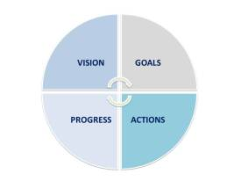

++++++++

All facets of the planning process, as well as all documents including the full strategic plan, are available on the Penn State Lehigh Valley Institutional Planning website: www.pslvplanning.com

The website offers the campus individual tabs of information for use by campus administration, faculty, staff, students, alumni, Advisory Board members, and the general public interested in data and reports related to PSLV. Information is updated regularly.
- Campus Strategic Plans- Links are provided to current strategic plans, including both campus-level and departmental plans, and updated progress matrixes and reports.
- Enrollment Data- Official enrollment numbers and breakdowns of the student population by various characteristics, retention and graduation data, and other enrollment information is readily shared for benchmarking and tracking purposes.
- Service Area Demographics- Local Lehigh Valley population figures and projections, high school graduation data, and workforce development statistics are shared via a range of local, state, and national resources.
- Surveys- A compilation of data highlight reports, including satisfaction and interest surveys, are available for campus use.
- Planning Resources- Links are provided to grant resources and other planning websites.
- Fast Facts about PSLV- A user-friendly, one page overview is available for quick reference regarding PSLV’s current figures and data.

The website’s homepage also functions as a blogging site, where each month the Office of Institutional Planning updates the campus about current information and news related to national, state, and local planning efforts and research. A monthly email is sent to all faculty and staff via the campus list-serv outlining the new additions to the blog. These include:
- Planning News from the Office of Institutional Planning and Assessment at University Park
- Articles of Interest for Higher Education Professionals, available via the Association for Institutional Research (AIR)
- Localized Reports from the Lehigh Valley Planning Commission, Lehigh Valley Workforce Investment Board, and the Lehigh Valley Economic Development Corporation, and others

REVIEW RESPONSE LETTER 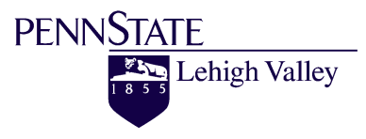
Penn State Lehigh Valley
Response to 2014-15/2018-19 Unit Strategic Plan Review
Reviewers: Maney, Bean, Shultz, Welshofer, Dillon, Pursel, Dooris, Warcholak

The Penn State Lehigh Valley campus would like to thank the reviewers of our unit plan for their feedback and suggestions. We have been actively implementing the plan throughout the Fall 2014 semester and are looking forward to continuing our work and assessing our progress over the next 5 years.

In regards to the review document, we would like to share information and updates we have made to the plan before posting the plan to the campus community at-large:

*An Executive Summary of the plan was drafted in anticipation of Provost Nick Jones’ visit to our campus in Spring 2014. The summary outlined our new campus goals, articulated vision, and selected strategies. This document was updated prior to the submission of our plan to OPIA and was made available to the campus (faculty, staff, and Advisory Board members) as a precursor to the full plan. We have now included that Executive Summary in the beginning of the campus strategic plan, as recommended in the reviewer feedback. It is also available on the Planning website (www.pslvplanning.com) as a quick “reference guide” to the full plan for those who are interested in downloading a copy.

*The review mentions a lack of specific performance indicators, and it references page 44 as the starting point for a discussion of these. Instead, our Performance Measures and Indicators are actually outlined in the section beginning on page 76: “Assessing: Evaluating and Measuring Our Progress and Programs,” with 8 pages of charted Performance Measures & Indicators by Goal. We will be using these charts as an ongoing guide to assess our progress of each of our goals over the next 5 years. The first year of our plan contains reference to a number of performance measures that require benchmarking as a starting point for data collection.

*Additional follow-up to our Learning Outcomes will be completed during the Learning Outcomes Review Process in Spring 2015 and again during the Academic Degree Program Reviews in Spring 2016 (as noted within the Assessment Continuums on pages 85-86). Furthermore, our new webmaster is working with all program coordinators to ensure that Learning Outcomes are current and accessible.

*Our new Green Team plans to begin meeting in the Spring 2015 semester to jumpstart our new Sustainability Plan. Through this committee, it is anticipated that additional metrics and strategic indicators will be developed to assess our progress towards a more sustainable campus. We are looking forward to making this a larger, campus-wide effort.

*We continue to monitor our Unit Budget and commit to ongoing fiscal responsibility while awaiting news about the new budget model.

*Recognizing that our unit plan is rather large at 170+ pages, we will be adding colored tabs to each section within the plan for easy navigation throughout the document. Hard copies of the plan will be provided to each department (1/dept.) and to all senior and academic managers and program coordinators. The PDF of the plan will be housed on the Planning website (along with a link on the campus homepage) and news about the review process and further implementation of the plan will be shared at All Campus Day, January 2015.

Once again, thank you for your time and expertise in reviewing our plan and providing feedback. We anticipate the next five-plus years will be a successful time period for both our campus and the University!

Campus Office of Institutional Planning, 12/17/2014, on behalf of Chancellor Ann Williams and the PSU-LV Campus

