Ivory Coast

Basic Information
Name: Forces Nouvelles (FN), Northern Ivory Coast
Year of Birth: 2002. Seizure and occupation of territory during civil war:
“The First Ivorian Civil War was a conflict in the Ivory Coast (also known as Côte d'Ivoire) that began in 2002. Although most of the fighting ended by late 2004, the country remained split in two, with a rebel-held Muslim north and a government-held Christian south.” (Wikipedia “First Ivorian Civil War.”)
How Born: Seized northern half of country by violent uprising.
Merger of MPCI, MPIGO, and MJP; MPCI was dominant and had existed since 2001, intending to remove President Laurent Gbagbo.
Year of Death: 2010
How Died: Voluntary reunification with host state, after Guillaume Soro made Prime Minister under Gbagbo in 2007. Disarmament was slow and incomplete through 2010, however, and although government officials returned to North, rebels were still primary authorities in some regions and kept hold of financial structure as outlined below. To the extent that the Forces Républicaines were the same as the FN, the FN did eventually become the state.
Connection to Other Groups: Forces Nouvelles, Ibrahim Coulibaly faction; Liberian and Sierra Leonean fighters.

Physical or Political Characteristics
The map below shows the territory controlled by the Northern Ivory Coast Territorial Contender, the buffer zone established by the French intervention, and the territory controlled by the government. The Territorial Contender made up all of Danguele (30,600 km²), Savanes (40,323 km²), Bafing (8,720 km²), Worodougou (21,900 km²) provinces, and half of Zanzen (38,251 * 0.5 = 19,126 km²) and Haut-Sassandra (23,940 * 0.5 = 11,970 km²) provinces, and two-thirds of Vallee du Bandama (28,530 * 0.66 = 19,001 km²) and Dix Huit Montagnes (31,050 * 0.66 = 20,679 km²) provinces (all area figures are from “Provinces Data” file or from the Wikipedia page for that Province). Adding these figures together the area of this Territorial Contender was 172,319 km².
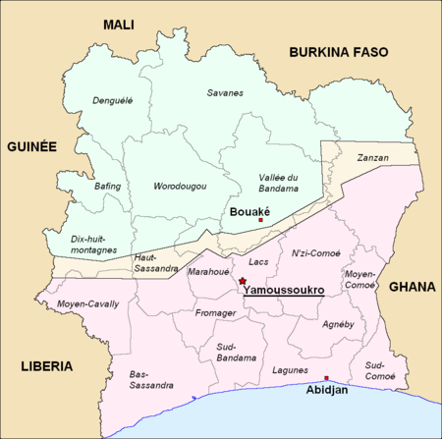
Source: Wikipedia “First Ivorian Civil War?

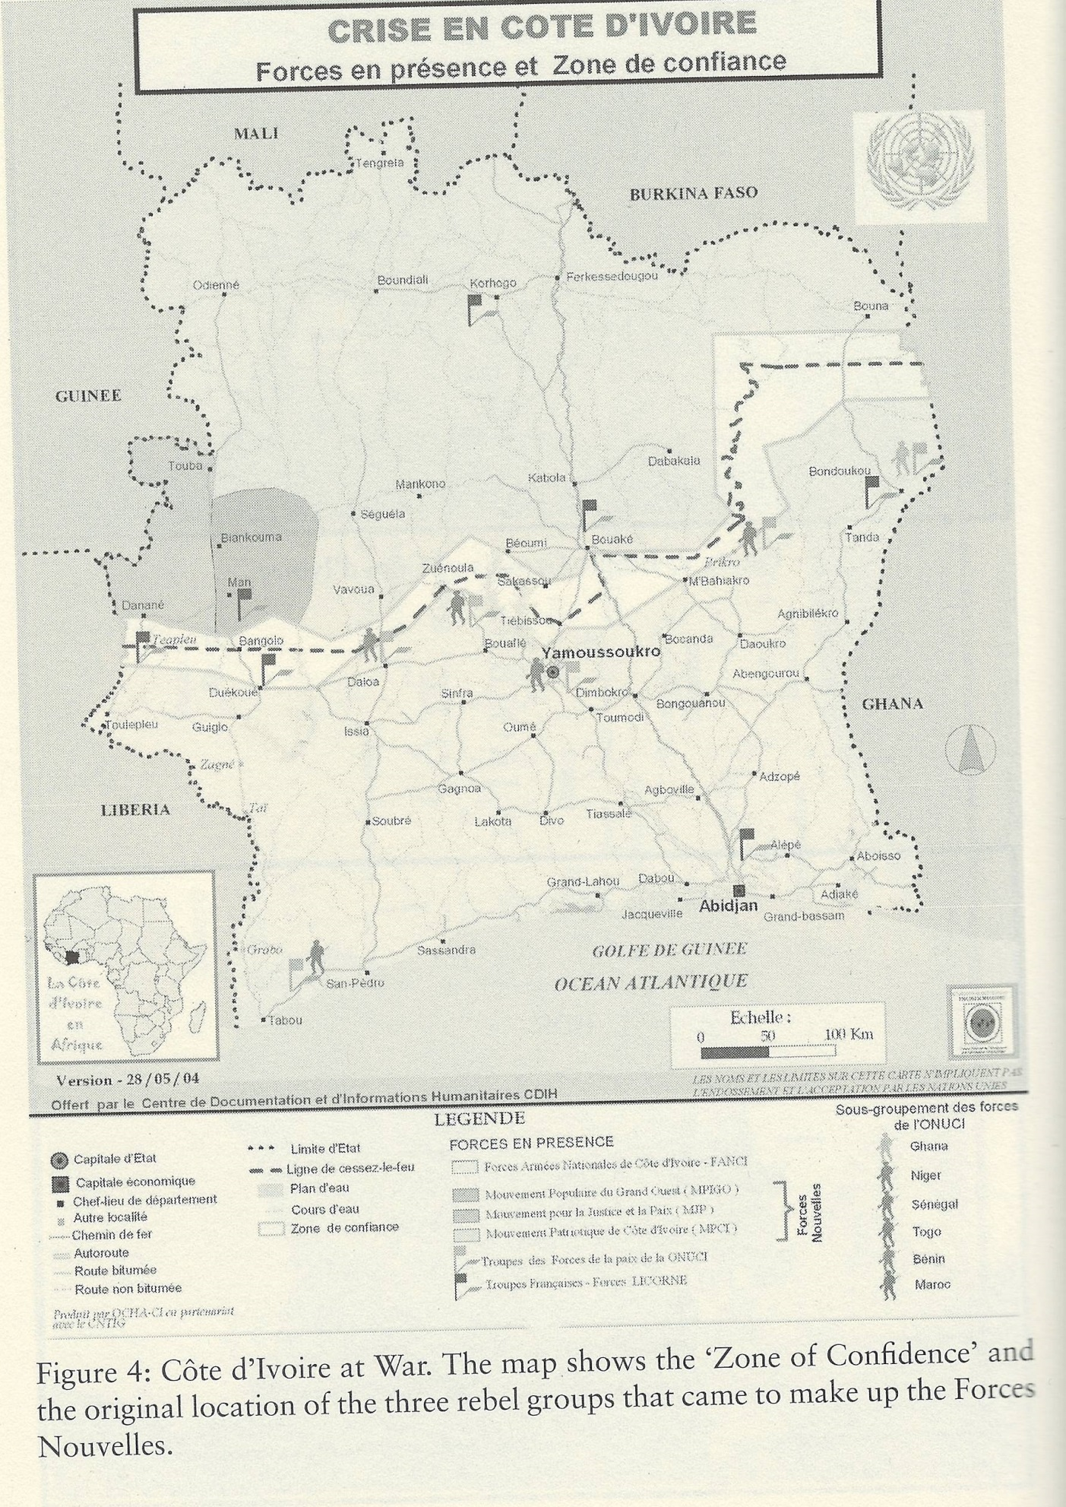Characteristics of Area: Mountains in the West of the country; the North is high savannah and the South consists of beaches and forest. Natural resources include petroleum, natural gas, diamonds, manganese, iron ore, cobalt, bauxite, copper, gold, nickel, tantalum, silica sand, clay, cocoa beans, coffee, palm oil, and hydropower.
Population: Populstat (www.populstat.info) reports historical population estimates for Ivory Coast at the Provincial level for 1998 and 2001. I use these figures (discounting the provinces the Territorial Contender had partial control of) to calculate a trend between these years, which I then extrapolate forward to cover the 2002-2010 period in which this Territorial Contender existed.
Regime Type Characteristics: Never attempted to create new regime, but developed parallel economy and administration. Had a civilian secretariat with units responsible for Justice, Education, Environment, and other areas, though not efficient for services. Particularly notable was the extensive tax structure, which relied on natural resources, vehicles, transportation, and goods. Tax and customs organization la Centrale was created in 2004. La Centrale oversaw laissez-passer fee for trucks to enter rebel territory, escort fee for guards to accompany trucks, and schedule of merchandise taxes. Delivery of education was coordinated through non-governmental organizations.
The quote below indicating the leader was “appointed” to lead the FN indicates some authority external to the leader, and thus justifies a partially free coding.
Military: “During the civil war, the MPCI leaders commanded some 10,000 soldiers…” (Wikipedia “Patriotic Movement of Cote d’Ivoire”)
Sovereign Recognition: No.
Miscellaneous: Northerners tend to have lower levels of education than southerners, in part because formal education competes with Muslim schools and many northerners are Muslim. In fact, a significant proportion of northerners are immigrants from Ghana, Mali, or Burkina Faso.

“International Relations”
Wars or Conflicts:
Uppsala/ACD records 543 battle fatalities in combat between the MPCI and rest of Cote d’Ivoire’s army in 2002, with no fatalities thereafter. It records the conflict as ending by peace agreement, and thus with no victory by either side. War onset and ongoing war in 2002. No war loss or victory in any year.
Alliances: None, though received help from Burkina Faso and Liberia.
Treaties: None, but Soro met with president of Niger, president of Burkina Faso, and planned talks with Benin, Senegal, and Mali. Also, Burkina Faso and Mali invested in some places in rebel territory like Korhogo.
Arms Transfers: “The rebels were immediately well armed, not least because to begin with most were serving soldiers; it has been claimed they were also given support by Burkina Faso.” (Wikipedia “First Ivorian Civil War”) “It has been claimed…” is not specific enough.
Timber, Drugs, Diamonds, Crime: Several diamond-mining areas in the North (Séguéla, Tortiya, Bobi, Diarabana, Toubabouko). Value of diamond trade estimated at $9-$23 million in 2006 and $12.5-$21 million in 2008. Some timber in South; also see description of geographical area above. There was an illicit cocoa trade through Ghana.

Descriptive Narrative:
Origins
The Forces Nouvelles Territorial Contender was the anti-government belligerent in the first civil war of the Ivory Coast (2002-2007). Its emergence can be viewed as the result of a long chain of economic and political developments during the two previous decades. In the mid-1980s to early 1990s, economic hardship—including falling world prices of cocoa, new international competition in the coffee sector, austerity measures, and a sharp decrease in the value of the Ivorian currency—led to unrest and the switch from a single-party-dominant political system to one with multiparty elections. With this change, politicians began to manipulate ethnic, religious, or regional differences to gain votes. Specifically, 1994 presidential candidate and incumbent Henry Konan-Bédié introduced the concept of Ivoirité, or “Ivorianness,” which argued that immigrants and their descendants—in contrast to the native-born—could not claim Ivorian nationality and were not Ivorian citizens. He used these xenophobic, ultranationalist ideas to deny rival Allassane Ouattara as well as many of his northern Muslim supporters the right to participate in the election. Nationality and citizenship policies were made even more exclusionary under President Laurent Gbagbo, who came into office in 2000. He initiated a stricter identification program with requirements like a statement of origin from one’s village committee, and discrimination against northerners by the government, especially security forces, intensified. By this time, following election turmoil, a coup, and a brief military junta, politics had become increasingly militarized. Northern soldiers who had defected from the army felt they needed to organize and formed an armed operation to remove Gbagbo called Mouvement Patriotique de Côte d’Ivoire (MPCI).
The MPCI was originally led by Ibrahim Coulibaly, a former bodyguard of Ouattara and figure during the military junta. Its very first members were army mutineers; it subsequently recruited youth volunteers, traditional hunters, and foreign fighters, at one point comprising “several thousands” of troops. Moreover, it was looked upon favorably by most northerners, who shared their sense of injustice. It is believed to have received direct support—technological assistance or arms, training, and a safe haven—for the coup attempt from Burkina Faso and its president Blaise Compaoré, along with indirect support from Mali.

Rebellion
The MPCI launched an uprising on September 19, 2002 in Abidjan, the Ivory Coast’s economic capital. Here it targeted military facilities, but was ultimately unable to take the city due to French protection. It then moved on to Bouaké, a large city which housed 40 percent of national military equipment in barracks as well as a branch of the Central Bank. Bouaké became their stronghold and headquarters, from which they later made radio and television broadcasts. Korhogo and other northern towns also came under their control, so that by the end of the month, they claimed the upper half of the country. Furthermore, they were “militarily capable of sanctioning, by the force of arms, the partition…between the northern and southern zones.” In contrast, Gbagbo’s army was weak, poorly equipped, unmotivated, and thus failed to put up much resistance; indeed, it saw many members defect to the rebel side. Besides Burkina Faso, it was the primary source of weapons and ammunition for the MPCI.
The MPCI had expected overthrowing Gbagbo would be a quick and easy affair. “Initial funding” for the rebellion came from bank robberies totaling $31 million, Liberian president Charles Taylor, and wealthy landowners in the North. But soon its strength and resources declined, and still the government was not able to completely suppress the rebellion. As battles continued, the rebels entered into negotiations with the government with a list of specific demands. They wanted Gbagbo to resign, new elections to be held, a review of the constitution and citizenship regulations, reintegration into the military, amnesty, and greater political participation for northerners. Of course, the government was unwilling to make so many concessions—one month after the rebellion began, the only progress was a France and United Nations-enforced buffer zone.
France acknowledged the validity of its grievances against Gbagbo’s exclusionary policies, but would not recognize the MPCI as a legitimate political actor. It would not provide military or financial help to the MPCI. Without international backers, the MPCI lacked leverage against the government and power to enforce peace agreements, so it sought out an alliance with two other rebel groups in the West instead. On November 28, 2002, the Mouvement Populaire Ivoirienne du Grand Ouest (MPIGO) and the Mouvement Pour la Justice et la Paix (MJP), Liberian-sponsored armed movements in the far West of the country, officially joined the MPCI’s rebellion. They were quickly absorbed by the politically and militarily stronger MPCI; descriptions went as far as labeling them its “satellites” or “extensions” of the latter. Led by Felix Doh, MPIGO was “mainly composed of Ivorian Yacoubas, Sierra Leonean, and Liberian fighters…became associated with Liberian mercenaries.” It was known for being a “proxy force” of Taylor and committing acts of extreme violence against civilians. It occupied Danané and held Bloléquin, along with a gold mine during the first year of the conflict. MJP, under Gaspard Déli, was smaller and based in Man. Close to bankruptcy, the MPCI hoped bringing in the two groups would give it access to profits from the agricultural activity in the West—notably, cocoa and coffee—and possibly San-Pédro, a port in the South. It would also expand the ranks of rebel fighters so they posed a greater challenge to the army. Together, MPIGO and MJP captured Toulepleu and Touba both in the West, and by 2003 had secured the area of the Ivory Coast bordering Liberia.
In order to better coordinate their activities, the MPCI, MPIGO, and MJP united in name under the title of Forces Nouvelles (FN), or “New Forces,” as early as 2003. The MPCI retained a dominant position. Since Coulibaly, the “mastermind” of the MPCI, had been in exile and arrested, Guillaume Soro rose as the General Secretary of the FN. Along the lines of the MPCI’s previous condition of a review of the constitution, the FN demanded the end of Gbagbo’s identification program, naturalization for immigrants, the repeal of a law limiting land ownership to citizens, and new elections. Since its goal was to redefine eligibility for citizenship and for northerners to regain political power, it did not necessarily reject the authority of the state; on the contrary, it insisted its actions “should not be seen as reflecting a will or decision to secede.” Nonetheless, it kept a joint military force called the Forces Armées des Forces Nouvelles (FAFN), or Armed Forces of the New Forces. Integration was complete in a year, and the FN “counted some 35000 fighters.” The same year, peace talks were held in Paris and the army signed a ceasefire with all three rebel groups.

Territorial Contender
The FN not only seized territory; it divided the territory into ten zones, each headed by a commander, and within the ten zones acted in various ways as a replacement of the government. It operated its own institutions in its regions, such that there were “two parallel economies and administrations” in the Ivory Coast. For one, it established an “extensive tax structure” which used roadblocks and the transport of lucrative natural resources such as diamonds and cocoa to generate revenues. In 2004 it created a formal tax and customs organization, la Centrale, which oversaw a fee for trucks to enter rebel territory, an escort fee for guards to accompany trucks, and merchandise taxes. These were significant sums in terms of funding for the rebellion because the North had several diamond-mining areas—by one account, the rebel diamond trade was worth up to $23 million. Likewise, taxes on the cocoa trade earned $30 million annually. Additional economic resources “solidified” the FN’s power in the North.
La Centrale and the tax system were structurally important to the FN, as well, because they constituted a framework that reinforced centralized control. Taxes were collected in each zone, commanders assessed spending needs within their zones, and the rest was remitted to la Centrale. This organization presented a “unified front against Gbagbo…enabled the rebels to maintain the stalemate with the government.”
Humanitarian issues were not the FN’s priority, although it did spend a small amount on schools and hospitals. It apparently assembled a Committee on Schools and Exams, attempting to reopen schools in the North, West, and central region that had had to close because of the war and organize national exams. It coordinated the actual delivery of education through non-governmental organizations, which also played an important role in providing basic public services, as the FN’s secretariat was not effective in this regard.
The FN was not perfectly cohesive; it experienced internal struggles between the Coulibaly faction and the Soro faction from the MPCI. They were ideologically divided over the solution to the rebellion—those loyal to Coulibaly opposed participation in the government and a negotiated peace, while Soro insisted on a peace plan and political agenda. The disagreement was complicated by the factions’ control over different towns in the North, such that the towns run by the Coulibaly faction were more independent and it was difficult to discipline dissident soldiers. Coulibaly attempted to reclaim leadership of the FN, but after clashes with Soro’s faction, Soro emerged the winner.

Reunification
After the ceasefire, multiple attempts at peace required a new government be formed incorporating members from Gbagbo’s party, the opposition party, and the FN, or exchanged political reforms on the part of the government for the FN’s disarmament. However, the peace process broke down four times as parties were reluctant to compromise their stances, failed to meet their obligations, rearmed, and the war stalemated 2005-2006. Finally, Gbagbo, Soro, and the president of Burkina Faso met for negotiations in 2007 and produced the four-part Ouagadougou Accord. Among other agreements, this suspended Ivoirité as a basis for national identity, recombined the army and the FAFN, removed the buffer zone, decided Gbagbo would remain president while Soro would become prime minister, and charged them with implementing presidential elections by 2008. They declared the civil war was over and government officials returned to the North, with a priority of recovering financial administration. In reality, demobilization and disarmament were very slow and FN structures were retained through 2010. It thus “maintained effective control of the borders, customs, and taxation” in the North.
Likewise, presidential elections were delayed until late 2010. When Gbagbo refused to concede victory to Ouattara and had himself named president by allies on the Constitutional Council, violence erupted between the two sides again. The difference was that the FN now included defectors from pro-Gbagbo forces and had changed its name to the “Forces Républicaines de Côte d’Ivoire” (FRCI), meaning 2010-2011 could be considered an extension of the civil war. Gbagbo was internationally condemned, deposed by the FRCI, and arrested in 2011, at which time Ouattara took his place as the new president.

Sources
Aloisi, S. (2002, Oct 8). Ivory Coast rebels vow to step up fight. The Globe and Mail (Canada). Retrieved from www.lexisnexis.com/hottopics/lnacademic.
Anti-French Ivorian protests. (2003, Feb 18). BBC News. Retrieved from http://news.bbc.co.uk/2/hi/africa/2773731.stm.
Balint-Kurti, D. (2007). Côte d’Ivoire’s Forces Nouvelles. Chatham House. Retrieved from https://www.chathamhouse.org/sites/files/chathamhouse/public/Research/Africa/ivorycoast0907.pdf.
Bøås, M., & Dunn, K. C. (Eds.). (2007). African guerrillas: raging against the machine. Boulder, CO: Lynne Rienner.
Charbonneau, B. (2012). War and Peace in Côte d’Ivoire: Violence, Agency, and the Local/International Line. International Peacekeeping, 19(4), 508-524. Retrieved from http://dx.doi.org.ezaccess.libraries.psu.edu/10.1080/13533312.2012.709776.
Côte d’Ivoire. (2002, Nov 30). African Times. Retrieved from http://search.proquest.com/docview/218332148?accountid=13158.
Côte d’Ivoire. (2012). Washington: Superintendent of Documents. Retrieved from http://search.proquest.com/docview/1543673976?accountid=13158. Background Notes Series (Online).
Côte d’Ivoire: MPCI foreign affairs coordinator outlines movement’s goals. (2002, Nov 6). Agence France Presse. Retrieved from http://wnc.eastview.com/wnc/article?id=36334845.
Côte d’Ivoire: Political forces (2008). New York: The Economist Intelligence Unit. Retrieved from http://search.proquest.com/docview/466524051?accountid=13158.
Côte d’Ivoire politics: New fighting breaks out in west. (2003). New York: The Economist Intelligence Unit. Retrieved from http://search.proquest.com/docview/466309871?accountid=13158.
Côte d’Ivoire politics: New PM will struggle. (2003). New York: The Economist Intelligence Unit. Retrieved from http://search.proquest.com/docview/366521875?accountid=13158.
Côte d’Ivoire: Reportage analyzes roles of individual players in crisis, effect on solution. (2003, Sep 14). Jeune Afrique-L’Intelligent. Retrieved from http://wnc.eastview.com/wnc/article?id=35593973.
de Tessières, Savannah. (2011). Reforming the ranks: public security in a divided Côte d’Ivoire. Small Arms Survey Yearbook, Chapter 7. Retrieved from http://www.smallarmssurvey.org/fileadmin/docs/A-Yearbook/2011/en/Small-Arms-Survey-2011-Chapter-07-EN.pdf.
Englebert, P. (2009). Africa: unity, sovereignty, and sorrow. Boulder, C.O.: Lynne Rienner.
Fofana, M. (2011). Des Forces nouvelles aux Forces républicaines de Côte d’Ivoire. Politique africaine, 122(2), 161-178. Retrieved from http://www.politique-africaine.com/numeros/pdf/conjonctures/122161.pdf.
French hopeful Ivory Coast talks will resolve conflict. (2003). Candy Industry, 168(1), 11. Retrieved from http://search.proquest.com/docview/218747640?accountid=13158.
Guichaoua, Y. (Ed.). (2011). Understanding collective political violence. Palgrave Macmillan. Chapter 1.
Hazen, J. M. (2013). What rebels want: resources and supply networks in wartime. Cornell University Press. Chapter 5.
International Criminal Court. Rapport sur les Forces Nouvelles. Office of the Prosecutor. Retrieved from http://icc-cpi.int/iccdocs/doc/doc1710477.pdf.
International support mounts against government’s opposition to Côte d’Ivoire peace accord. (2003, Feb 28). African Times. Retrieved from http://search.proquest.com/docview/218340749?accountid=13158.
Ivory Coast profile. (2014, Nov 5). BBC News. Retrieved from http://www.bbc.com/news/world-africa-13287585.
McGovern, M. (2011). Making war in Côte d’Ivoire. Chicago: University of Chicago Press. Introduction, Chapter 3, Chapter 6, Chapter 7.
Sany, J. (2010). Education and Conflict in Côte d’Ivoire. United States Institute of Peace. Retrieved from http://www.usip.org/sites/default/files/SR235Sany_final_lowres-1.pdf.
Uppsala Conflict Data Program. Retrieved from http://www.ucdp.uu.se/gpdatabase/gpcountry.php?id=40&regionSelect=2-Southern_Africa#.

