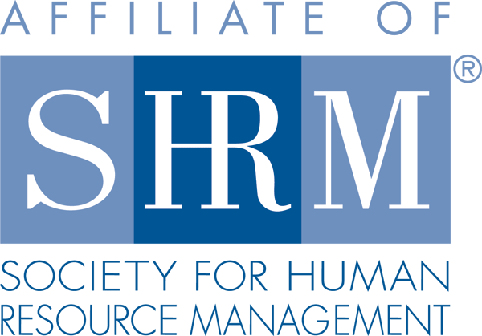

**Welcome!**

The Society of Human Resources Management was founded over seventy years ago with a simple but lofty purpose of serving the Human Resources community. Thanks to this, HR professionals have a centralized and trusted source of information and training to meet their professional goals as well as the strategic needs of their respective organization. The society has become a world-renowned authority on emerging HR topics, practice, and the profession. However, they are much, much more. The society offers a sense of community where HR professionals and aspiring students can cultivate knowledge, network, and grow their careers (SHRM, 2017).

Penn State is also a leader in creating community and furthering knowledge. In response to the Great Depression and its debilitating impact on student attendance at the main campus, Penn State was among the first universities in the country to bring the “college” to the student by opening branch locations throughout the commonwealth of Pennsylvania (Penn State, 2015). Luckily, their outreach didn’t stop there and today we have the privilege to attend one of the best online schools in the nation (Penn State World Campus, 2017).

SHRM and Penn State World Campus are a perfect and inevitable match! Our purpose for the virtual SHRM chapter at Penn State World Campus is no less lofty than the organizations we represent – *To connect World Campus HR/LER students to professional and educational resources while offering a community to further HR knowledge, practice, and scholarship.*

As we embark on this new chapter, honoring the tradition and purpose of SHRM and Penn State, we encourage you - as members, leaders, and scholars - to make this chapter yours! Foster the ***community spirit*** through participation so it may offer an enduring and valuable service to world campus students and the HR profession.

Specific ways to engage:

* Join us on [LinkedIn](https://www.linkedin.com/groups/8593128) where you’ll find job information, interesting and trending developments in the HR field, and network with fellow HR/LER World Campus Students.
* Visit the [website](https://sites.psu.edu/virtualshrmpennstate/) where you may post, read, and engage with other members on blogs focused on furthering HR knowledge, practice, and scholarship. Plus, find more information on the chapter, SHRM, and HR.
* Email the chapter officers with engagement ideas you may have or features/resources you’d like to see at [VirtualSHRM@outreach.psu.edu](mailto:VirtualSHRM@outreach.psu.edu) or individual emails listed on the website.

SHRM Virtual Chapter

***IN THIS ISSUE***

**Welcome!**

**Member Graduations**

**Important Dates**

**Monthly Newsletter**

**Issue**

**01**

**May 2017**

[](https://sites.psu.edu/virtualshrmpennstate/)[../../../Desktop/In-2C-59px-TM.png](https://www.linkedin.com/groups/8593128)

**Find Us!**

Member Graduations



On behalf of the Chapter, congratulations to Spring 2017 graduates. Wherever you journey, we wish you happiness and continued success.

Special shout out to Jaclyn Sukich for her hard work and campaign to make this chapter a reality and to Caroline Loftin for her contributions as Director of Operations in starting us off on the right foot!

*Bachelor’s in Labor and Employee Relations:*

Monica Keller, with a minor in Political Science

*Master of Professional Studies in Human Resources and Employee Relations:*

Robert Ames

Rachel Dagenheart

Jeanne Damon

Kendra Davis

Sarah DeVuyst

Trini Fares

Caroline Loftin

Kristine Lorah

Taiwah Z. Nyorkor

Nakeisha Simic

Jaclyn Sukich

Stephen Verigood

Stephanie White

Mark your Calendars!

Sunday, June 4th at 4PM EST –Chapter Kickoff

Join Meeting Link: https://psu.zoom.us/j/820130786

* **Chapter introduction, more details on upcoming events and details on chapter materials.**

Sunday, June 11th at 4PM EST –Chapter Chartering Ceremony

Join Meeting Link: https://psu.zoom.us/j/472848332

* **Guest speakers include our chapter SHRM Representative and Faculty Advisor**

References:

Penn State. (2015). *Our History.* Retrieved from <http://www.psu.edu/this-is-penn-state/our-history>

Penn State World Campus. (2017). *Home Page.* Retrieved from <http://www.worldcampus.psu.edu/?cid=CPCO17815&gclid=Cj0KEQjwuZvIBRD-8Z6B2M2Sy68BEiQAtjYS3GsdJX-xf-LcFJoUrxr-lJoBdUm02Cb5wJtPYR4Mva8aAmXn8P8HAQ>

SHRM. (2017). *About SHRM.* Retrieved from <https://www.shrm.org/about-shrm/pages/default.aspx>